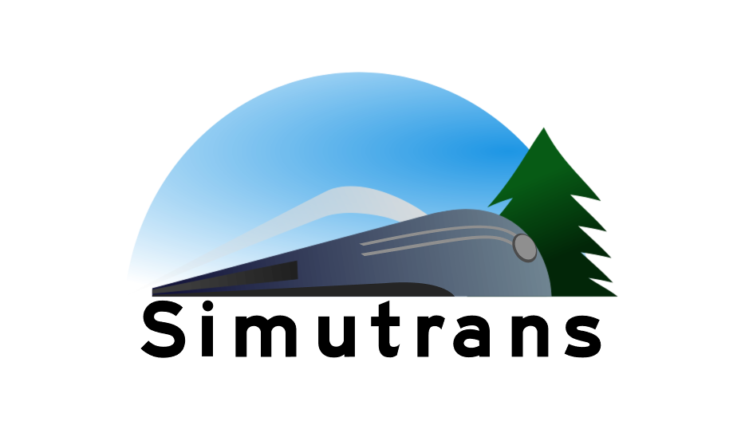

Pak128.Nordic

Table of Contents
Preface 3
General guidelines 3
Style 3
Dimensions and scale 3
Light 3
SketchUp to Blender 4
Railway 5
Tracks 5
Platforms 5
Narrow gauge 6
Roads 6
Water Transport 6
Air Transport 6
Trams 6

Preface
Pak128.Nordic is a pakset for Simutrans. The pakset is based on Pak128.Sweden-Ex and is planned to be a continuation of said pakset along with expanding it to the other three Nordic countries of Denmark, Finland and Norway.

General guidelines
These guidelines are common for everything in the pakset unless otherwise stated.

Style
The graphic look and feel should be clean and not cluttered. Do not use photos as textures as this will look out of place and not photorealistic due to the lack of perspective.
A photo may however be used as a reference or template to produce a clean, less detailed texture.

Dimensions and scale
A Simutrans tile is 128x128 pixels with the RGB565-colorspace (16 bit). Trains are scaled to 24 m/tile and yields 1.5 pixels per Simutrans step.
Buildings will have a scale of 20 m/tile as a base and may be adjusted if need be.

Light
In Simutrans Standard it’s said that the sun is 60º from South and the sky is always clear. As the Nordic countries are further North means the sun has different angles depending on the season. To capture this, Pak128.Nordic will have a different set of shadows for summer and winter, reflecting the position of the sun at 12:00.

The sun
To ensure the pakset is consistent, the sun’s angle is calculated from Longitude 57°42'00.0"N (57.700000) and Latitude 16°00'00.0"E (16.000000) which is the rough midpoint between Copenhagen, Helsinki, Oslo and Stockholm. For each season the middle date has been chosen at 12:00.
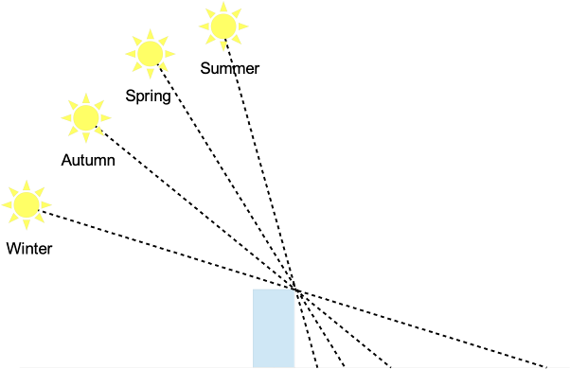

Season | Sun’s angle | Shadow factor
Summer | 54.52º | 0.91
Spring | 42.41º | 1.4
Autumn | 23.29º | 0.43
Winter | 11.72º | 0.21

Shadows
The shadow length is calculated by and going from south to north. To calculate the shadow length, take the object height and divide it with the shadow factor from the table above.
Example: An 8 pixel high wall casts a pixel shadow in the Summer and pixel shadow in the winter.
Although the sun in Simutrans is defined to always be in south, the shadows get boring. A suggestion would be to redefine the sun’s position in such a way that the shadows are a bit off but still in an angle that makes it easy to paint by hand.

Sun colors
When the sun is at a low angle, the Rayleigh scattering shifts the colors towards red (due to scattering of blue green wavelengths). This means all surfaces are receiving more red light. This can be simulated in two ways: either we intensify the red color component, or decrease the green and blue color components with a factor depending on the season.
One exception to this is the winter because the snow is reflecting the UV light and shifts the colors towards blue in addition to red. This can be done either by using a different factor for blue during winter.
While it’s nearly impossible to calculate the true color shift, a number of color samples were made from photographs taken at daylight during the four seasons. By looking at the RGB composition in a grey area, a rough estimate could be done. The smallest difference between all seasons are at 12:00. It might only be useful to use a normal color scale for summer and then just increase the blue component about 1.1 to 1.2 in the winter.

SketchUp to Blender
To export the drawings, select “File -> Export 3D…” and 3D Studio Max (.3ds) as filter. Click “Options” and use Meter as the unit and uncheck everything except “selection”.
In blender, set the unit to Meter and scale to 24 if you want to use one Blender unit per tile. Set the scale to 2 if you want to use two Blender units per tile (or the scale you need to translate correctly).
Import the .3ds, and your SketchUp Drawing should be in the correct scale (24 m/tile).

Railway
This section applies to standard gauge (1435mm) railway-related vehicles and buildings unless otherwise stated.

Tracks
Pak128.Nordic uses standard gauge (1435 mm) tracks. See “Narrow Gauge” for more information about narrow gauge railways.

Platforms
There are three platform heights in the Nordic countries: Low, medium and high. The low and medium are used for passengers while the high platforms are used for goods.
In Pak128.Nordic we will use the medium height platforms for passengers/mail and high platforms for goods. The height differences are the height above top of rail (ATR).
Platform | ATR
Medium | 580 mm
Large | 730 mm

The distance from track-centre to platform edge is always 1700 mm.

Narrow gauge
To be written

Roads
To be written. Including buses, trucks, roadways and required infrastructure.

Water Transport
To be written. Including ships, canals and required infrastructure.

Air Transport
To be written. Including aircraft, airports and required infrastructure.

Trams
To be written

