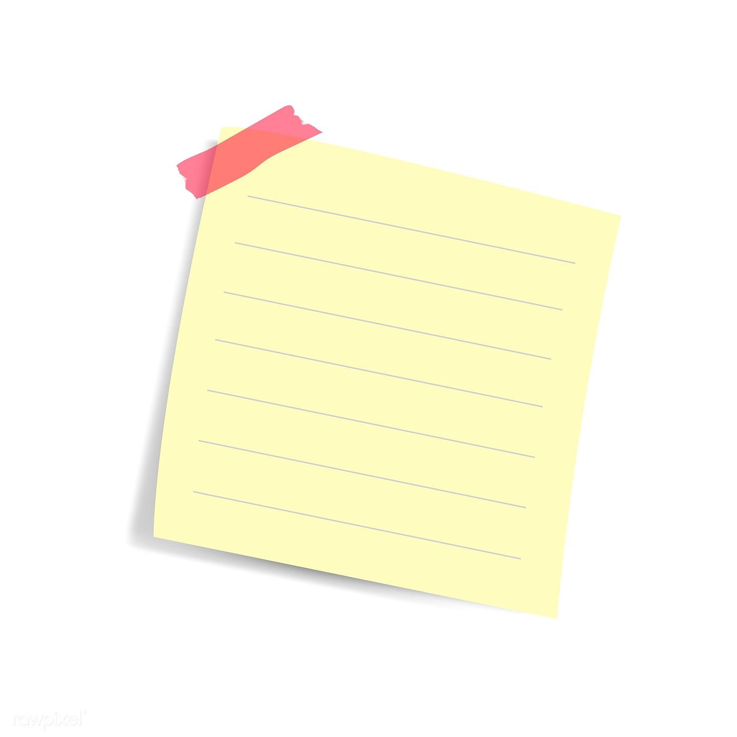

**Manual barricades!**

1. **Press E on it to pick it up.**
2. **Break the glass**
3. **Press the button to emplace**
4. **Profit???**