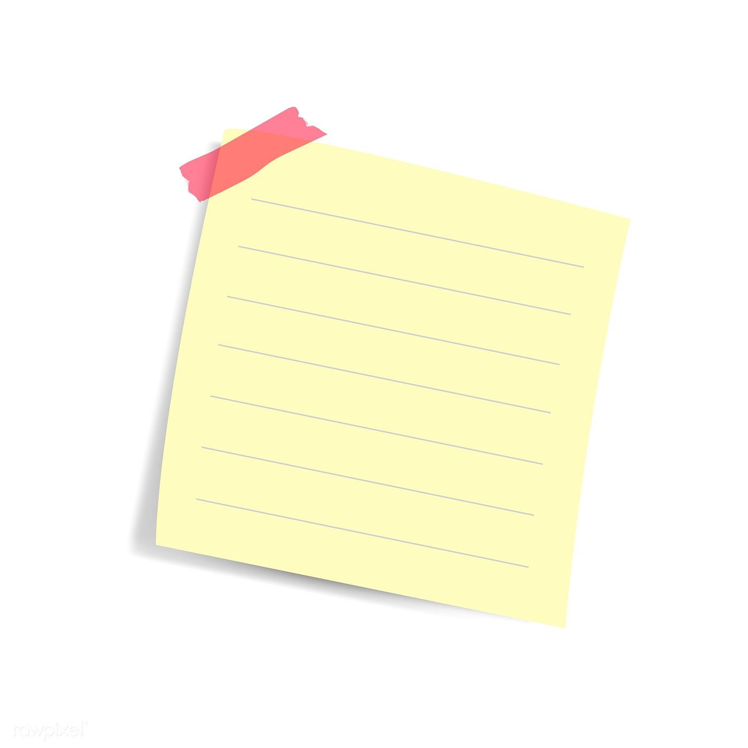

**This room is about as stable as a tower of marbles.  
Please don’t go in here!**

* **Kleiner**