Tạo Dockerfile

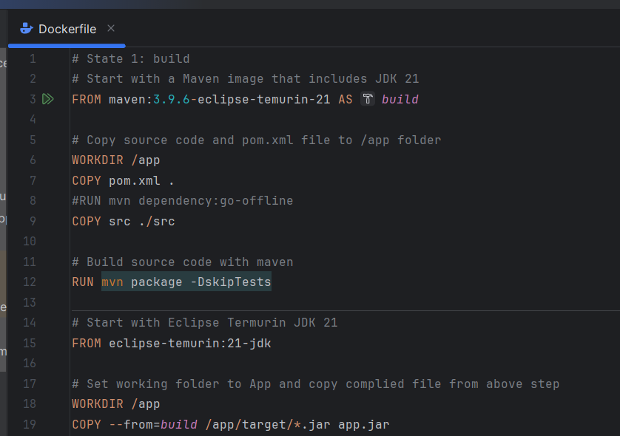

Build Docker file

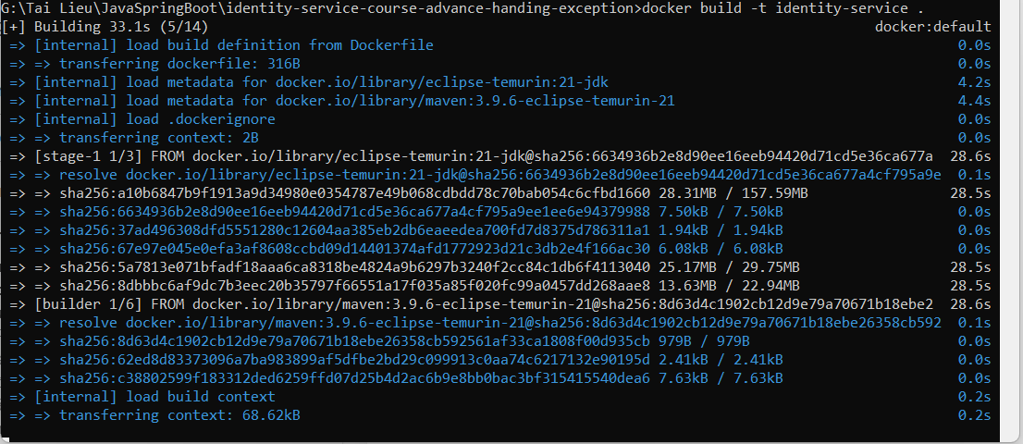

Step 3: Verify the Docker Image

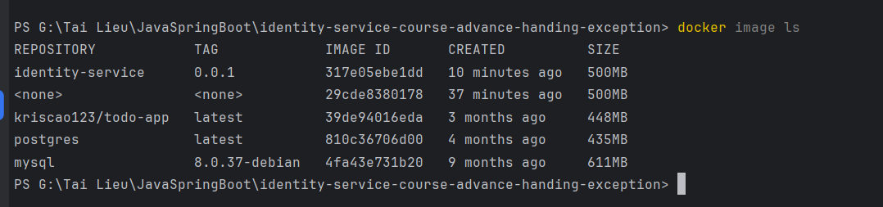

Step 4: Run the Docker Container

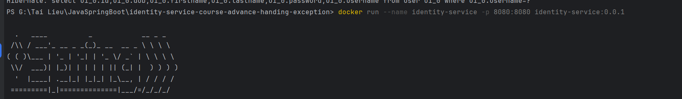

Step 5: Test application

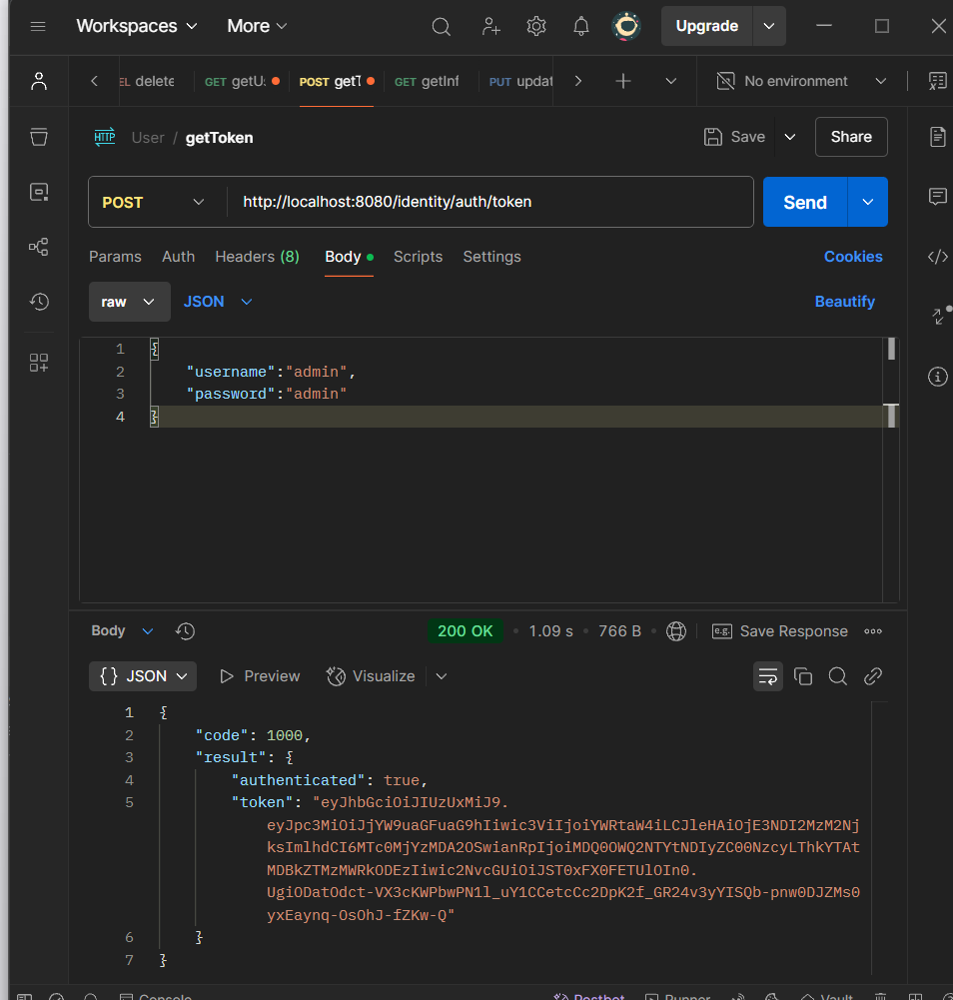

Step 6: Export the Docker Image



Step 7: Load the Docker image on the Target Machine

Step 8: Run the Docker container on the Target Machine



Step 9: Test application

