UNIMERCH: A CENTRALIZED MERCHANDISE
MANAGEMENT SYSTEM FOR SORSOGON
STATE UNIVERSITY

Kris Angela E. Bon, Ralph James G. Gasid, Loren G. Monzales,
Cyrene Jane C. Teodocio

College of Information and Communications Technology
Sorsogon State University - Bulan Campus
Bulan, Sorsogon

E-mails: kabon@sorsu.edu.ph; ralphjamesgasid@gmail.com; lorenmonzales2@gmail.com; cyrenejanecayetano03@gmail.com

1 Introduction
This section presents the background of the study which establishes the context of the research. This background explains why it was crucial to conduct research on this particular topic.
  - Project Context
Technology has played a major role in the business process, be it in terms of service, transaction, or even communication. E-commerce websites are required for the process of delivering goods and maintaining accounts. With the increasing number of students and courses offered, the Sorsogon State University Bulan Campus keeps growing. In terms of business operations and goods handling, the campus experience difficulties due to increased demands for supplies and goods within the campus. Previously, the activity of allocating and managing educational institution supplies in Sorsogon State University – Bulan Campus was highly dependent on manual processes, individual notifications, and transactions.
The system had some weaknesses, which included delayed information sharing, lack of receipts, the presence of outstanding debt, which meant that the student associations were obliged to pay their debts, lack of communication, lack of transparency between the university departments and the students’ associations, and long queues, which prevented the students from attending classes. Manual processing was inefficient, causing problems such as data entry mistakes, administrative burden, and accounting errors [3]. For an educational institution, there is a need for a more improved system for financial analysis administration and product distribution.

UniMerch, a mobile responsive web application, has been designed and developed by the proponents to overcome these challenges. This has been made possible due to the inclusion of user-friendly functionalities for buyers, sellers, as well as for the administrator that aid in enhancing the efficiency and effectiveness of the entire process.
The Office of Business Affairs will be given an administrative dashboard, which will be used in collecting sales and other relevant performance figures and monitoring the income-generating activities and transactions in real time. The software contains a system whereby it ensures that all the goods put up for sale adhere to university policies.
For the University Cashier, dashboard will be given to manage and sell the walk-in products (uniforms, ID cards, lab gowns, and others), find a student by name or reference number, and indicate walk-ins as paid without using any logbooks manually, as well as confirm other sales from other organizations' sellers.
For student organizations, there will be one place where all their products could be uploaded, managed, and displayed through one organizational account. The password for this account would be known only to the officers who have access to the dashboard (Treasurer, President, VP Finance, and other officers), who arrange shifts in managing the dashboard. All mandatory products for the university as well as those that are meant for earning additional money could be displayed through the organized catalog to which access is available to everyone interested. The sellers have three options when listing their products, namely 'Available Now', 'Pre-Order', and 'Interest Check'.
All registered buyers will have access to the product catalog. In the case of registered buyers who belong to the campus community, such as students and faculty members, some products may be shown based on their course or department, but the general listings remain visible to all buyers, including external ones. In terms of transaction procedures, there are two types of procedures that can be used: online payment through GCash and in-person payment. To address the problem of misplaced receipts and disputed order claims, the system generates an HMAC SHA256 signed QR Order Voucher for each confirmed transaction, which buyers can display or download and sellers can scan for verification. Additionally, the Pasalo PIN feature allows a buyer to securely transfer order pickup to another registered user through a six-character PIN.
Moreover, the system includes in-app messaging, which links messages to specific orders, ensuring buyers and sellers have access to a trackable and relevant communication platform without using any third party apps. Buyers can contact sellers within three days of receiving a damaged product, track their order history by switching through seven tabs in the order history section and even request for a refund.
UniMerch encompasses the functionalities of inventory management, sales analysis, transactions, product catalog management, and communication features in one single application. It helps in communication between buyers, sellers (students' organizations and the University Cashier), and administration (Business Affairs Office [BAO] and University Cashier). It caters to specific campus-based requirements and helps in scaling up operations according to the continuous development of SorSU-Bulan Campus.
1.2 Purpose and Descriptions
In this section, the following is discussed regarding the importance of developing the UniMerch: A Centralized Merchandise Management System for Sorsogon State University. At present, the manual process for conducting transactions for the sale of goods in SorSU Bulan Campus has various problems such as misplaced receipts, unremitted down payment that results in the organization paying for the total balance due, and a long queue that prevents students from attending their classes. This proves that there is an importance in developing a system that will create a deeper analysis of the transactional setting within the campus. The system is considered significant to the following:
To the Business Affairs Office. The BAO is given a dashboard that allows the tracking of all sales and approval of posting of items from the student organizations. Also, it calculates the royalty fees for items with the university logo and it will be able to have control on all system records for financial audits.
To the University Cashier. The University cashier willl be given a dashboard to manage an inventory of walk-in shop (uniforms, IDs, lab gowns, and supplies), searching for the name of the student or reference number in order to make sure the money is being paid and also the confirmation of payments made to other organizations as well without having any logbooks.
To the Student Organizations. The system does away with the problem of 50% down payment, where there are budget loss due to non-delivery of orders by making a provision of making payments 100%. Each organization has one shared password and they all work together to know when to access the shared account.
To the Buyers. Buyers refer to all registered users that plan on buying items via platform. Such include Sorsogon State University – Bulan Campus students, teaching, and non-teaching personnel as well as external individuals from different universities who could access the system to purchase available products. Buyers can navigate the list of products offered, make purchases using GCash or through cash transactions, get a QR order receipt, check orders in their order history featuring seven tabs, interact with the seller via in-app messaging and request for a refund for damaged products three days after the items received.
To Future Researchers. The paper will be useful for researchers who want to develop an ecommerce platform for another campus as it may serve as a source of inspiration.
1.3 Objectives of the Study
This study focused on developing UniMerch: Centralized Merchandise Management System for Sorsogon State University which will automate and centralize the management of the merchandise, providing a better alternative to the existing manual, paper-based, and decentralized system of the campus. The objectives are as follows:
- To determine the information requirements needed to establish a coordinated, transparent, and role-based merchandise management workflow among the Business Affairs Office, University Cashier, Student Organizations, and Buyers.
- To design and develop a system solution that addresses the major operational processes involved in campus merchandise management such as:
  - Transaction Management;
  - Inventory Management;
  - Sales Reporting;
  - Product Catalog, and;
  - In-App Messaging
- To evaluate the developed system using the ISO/IEC 25010:2023 Software Product Quality Model in terms of:
  - Functional Suitability;
  - Performance Efficiency, and;
  - Interaction Capability

1.4 Scope and Limitations of the Study
The scope of this study covers in developing UniMerch: A Centralized Merchandise Management System for Sorsogon State University-Bulan Campus. This system has proposed to improve the purchasing, claiming and stock control in campus. Its major functions involve cataloging of goods, management of product catalogs, stocks inventorying, purchasing, claims verification, and administration. The users have different roles wherein every individual will perform activities within his capacity as per their position. A dashboard will be used to monitor the activities with insight into sales, stock levels and transaction validation.
The intended users of the system are comprised of Buyers, student organizations, the University Cashier, and the Business Affairs Office. Buyers include students, faculty, and non-teaching employees of SorSU–Bulan Campus, as well as external individuals from other universities or institutions. As sellers, the student organization and University Cashier have their listings registered under organizational accounts. It is the role of the Cashier to ensure validation and that the listing complies with the institution’s policies. The solution will be designed as a mobile-friendly Web-based application.
The proposed system does not cover bookkeeping software that can automate accounting processes, payroll management, business-to-business marketplaces, delivery services, or transactions within the campus. It does not accommodate third parties except for GCash and transactions concerning banks. The use of advanced technology, such as predictive analytics or artificial intelligence is not incorporated into the process. The system requires an Internet connection, which makes it impossible to use without an Internet connection. Up-to-date information on enrollments is critical to the process.
2.0 Review of Related Systems
An analysis of relevant literature and existing systems is vital in understanding how modern technology has attempted to solve the challenges that UniMerch hopes to overcome. Below are the subsections which provide a general review of the literature and system reviews regarding the five main features of the UniMerch system. namely transaction management, inventory management, sales reporting, product catalog and in-app messages. Each section reviews what has been done before on the respective topic, explains how this literature/systems relate to the proposed system, and pinpoints areas the requires improvement.
2.1 Transaction Management
Management of transactions forms an essential foundation for any system of e-commerce or resource management. It has been proven by Turban et al. [1] that digital systems of transactions greatly improve accuracy and accountability in comparison to manual systems. Order processing from the stage of ordering until delivery was shown to be extremely important by them. Similarly, according to Laudon and Laudon [2], the enterprise information systems must ensure end-to-end transaction processing including payment authorization and accounting.
With regard to the university-centered approach, Aguilar et al. [3] provided a campus-based solution in a Filipino learning institution whereby QR codes were used to improve the effectiveness of delivery services. It was noted that there was a significant decrease in transaction mistakes after switching from manual registers to computerized systems. Likewise, in the analysis of the university merchandise system, Santos and Reyes [4] discovered that verifying digital payments led to a decrease of unverified payments of over 60%.
The above-mentioned studies have great importance for UniMerch due to its extensive range of functions regarding payment processing, including GCash payments as well as payments made by cash, as per the defined responsibilities. In all the studied systems, one common problem was found in that there is no dual confirmation system where both the buyer and the seller confirm the completion of the transaction. This problem can be overcome by the use of Buyer Receipt Confirmation and Pasalo PIN transfer in UniMerch.
2.2 Inventory Management
Inventory management is critical for institutions that handle multiple product categories across different organizational units. Abdulrahman et al. [12] found that centralized inventory systems significantly reduce discrepancies in stock records by maintaining a single source of truth across departments. Their study on retail inventory platforms demonstrated that automated stock tracking, as opposed to manual logbook-based monitoring, minimized overstock and stockout incidents. In a similar vein, web-based inventory management systems were found by Sharma and Gupta [13] to allow real-time stock visibility, enabling administrators and sellers to make faster and more accurate restocking decisions.
Further, the integration of barcode scanning and database-driven tracking mechanisms has been shown to reduce data entry errors and streamline stock audits [14]. Enterprise systems such as those studied by Ramos et al. [15] extended inventory features to include product variant tracking, batch processing, and expiry monitoring, all of which contributed to operational efficiency. Iterative and modular development approaches, such as Rapid Application Development (RAD) used by Cruz [18], have also been shown to accelerate inventory system delivery while preserving flexibility for future enhancements.
These findings are relevant to UniMerch, which manages inventory across multiple seller types — the Supply Office and student organizations — each with distinct product lines and stock levels. The system automates stock decrements upon order placement and provides sellers with real-time inventory dashboards. However, existing inventory systems reviewed were designed for general commercial or enterprise use and do not account for multi-role academic environments where different organizational units share the same platform. UniMerch fills this gap by implementing a shared organizational account model with role-based inventory access, allowing multiple authorized officers within a student organization to collaboratively manage stock without requiring separate accounts.
2.3 Sales Reporting
Sales reporting is a key component of financial governance in institutional settings. Delos Reyes and Manalo [21] found that institutions utilizing digital sales dashboards were better equipped to monitor revenue trends, identify top-performing products, and generate accurate financial summaries for administrative review. Their study on a university bookstore management system highlighted that automated report generation reduced the time spent on manual financial consolidation from an average of three hours per week to under 20 minutes. Similarly, dashboard-based analytics tools studied by Fernandez et al. [15] enabled administrators to detect sales anomalies and enforce compliance with institutional financial policies in near real-time.
Key performance indicators (KPIs) such as stock turnover rates, order accuracy, and transaction volume are widely used to evaluate the performance of institutional sales systems [12]. Simulation models and data visualization tools further support decision-making by enabling administrators to analyze patterns and forecast demand [16]. These features are considered standard in enterprise-grade systems; however, their adoption in academic merchandise platforms in the Philippines has been limited.
These studies strongly support the inclusion of a BAO Transparency Dashboard in UniMerch, which consolidates sales data, inventory summaries, and organizational performance indicators for the Business Affairs Office. The system also generates exportable financial reports per organization to support accountability. A key gap identified in the literature is the absence of royalty fee computation in academic merchandise platforms. UniMerch addresses this by automatically calculating a 3% royalty fee for products bearing the university logo — a governance feature not found in any of the reviewed systems.
2.4 Product Catalog
Product catalog management is a foundational e-commerce feature that determines how products are displayed, filtered, and accessed by users. Kim and Park [5] studied consumer behavior in role-based e-commerce platforms and found that personalized product visibility — where users see only the items relevant to their profile — significantly increases purchase intent and reduces decision fatigue. Their research supports the use of course- and department-based product filtering as a mechanism for improving the relevance of product displays in academic settings. Likewise, Chaffey [6] noted that structured product catalogs with clear categorization, detailed descriptions, and availability indicators are essential for maintaining user trust and reducing abandoned transactions.
In campus-specific systems, Buenaventura et al. [7] developed an online ordering system for a Philippine higher education institution in which products were organized by college and department. Their study reported a significant improvement in order accuracy when buyers were shown only items applicable to their enrollment status. Enterprise-level systems studied by Ramos et al. [15] further demonstrated that catalog management tools — including product approval workflows, bulk listing management, and flash discount activation — contribute to both operational efficiency and buyer satisfaction.
These studies are directly applicable to UniMerch, which implements a product catalog with optional role-based filtering for registered campus users based on their course, department, or organizational membership, while also making general listings accessible to all registered buyers, including external individuals from other institutions. The system further supports three listing types — Available Now, Pre-Order, and Interest Check — each with distinct approval routing through the BAO. A significant gap in the reviewed literature is the absence of an institutional policy compliance layer embedded in the catalog workflow. None of the reviewed systems included a governing office that must approve product listings before they become publicly visible. UniMerch addresses this gap through a mandatory BAO pricing approval mechanism with written rejection justification.
2.5 In-App Messaging
As more and more e-commerce systems add in-app messaging to facilitate communication between buyers and sellers, this functionality is being viewed as an important part of the purchasing process. Gefen and Straub [8] discovered that communication responsiveness positively influences user trust in online transaction systems. Additionally, the research indicates that systems with incorporated messaging capabilities have higher satisfaction rates, and fewer dispute claims than systems that rely strictly on external means of communication (i.e., email and text). Moreover, Ives and Learmonth [9] recognised that users would receive post-purchase support based on their experience with in-app communications. Accordingly, these communications help resolve a wide variety of post-purchase customer problems (e.g., defective merchandise, order delays, and clarification issues) without having to leave the purchasing system.
In the context of higher education in the Philippines, many campuses rely on informal messaging apps like Facebook Messenger and group messaging to communicate in regards to transactions, resulting in increased miscommunication and unrecorded dispute claims [10]. In their study of an e-commerce pilot at a state university, Ignacio and Villanueva [11] noted that the absence of an integrated messaging feature led to a lack of clarity in communication between buyers and sellers in regard to order status, claim schedules, and refunds. In order to create a record of all communications relating to each transaction, the authors suggested that colleges should incorporate messaging directly into their ordering interface.
The relevance of these findings to UniMerch is direct. The system integrates an in-app messaging feature that allows buyers and sellers to communicate within the context of a specific order, ensuring that all communication is logged, traceable, and accessible to administrators for dispute resolution. A prominent gap in the reviewed literature is that existing Philippine campus systems have not yet implemented an in-platform messaging system tied to specific orders. UniMerch fills this gap by providing a contextual messaging thread per transaction, eliminating the need for external communication channels and maintaining a clear audit trail of buyer-seller interactions.
The literature review shows that a successful campus merchandise and resource management system relies on a well-organized combination of several key elements. These include managing transactions, controlling inventory, reporting sales, handling product catalogs, and using communication tools effectively. Although many of these features have been addressed in individual systems (both commercial and academic), there does not appear to be a single system reviewed that offers a coherent integration of all five features within a university context that also meets institutional policy compliance, and offers role-based access to multiple stakeholders.
The UniMerch: A Centralized Merchandise Management System for Sorsogon State University can be used as a complete solution to these common issues and provides a single access point that is role-based, governance-driven, and meets ISO/IEC 25010:2023 Software Product Quality Model.
3 Technical Background
This chapter discusses a brief discussion on the software and hardware technologies to be applied to the project. This chapter also describes the system requirements of the user and the technical terms applied to the entire research paper.

3.1 System Development Specifications
This part highlights the hardware and software specifications that the proponents apply to develop and implement UniMerch.

3.1.1 Hardware Specifications
This section lists the hardware specifications used during development. The table below shows the recommended setup based on the actual units used by the proponents.

Table 3.1.1 System Hardware Requirements
Particular | Recommended Requirements
Processor | AMD Ryzen 7 7435HS, 3.10 GHz
Memory | 8 GB DDR4 RAM or Higher
System Type | 64-bit operating system, x64-based processor
Storage | 512 GB SSD

Processor. The study makes use of an AMD Ryzen 7 7435HS CPU having a clock speed of 3.10 GHz. Such a configuration provides sufficient performance while working with the interface of the system and ensures reliable execution of actions made by users on the UniMerch system.

Memory. The requirement of at least 8 GB of RAM is suggested. Such resources provide secure storage of data, ensuring stable system operation, allowing performing actions in several opened tabs, managing the processes of the UniMerch system, avoiding any crashes of the system, providing downloading and uploading user data and QR payments, and storing data.

System Type. A system of a 64-bit type with the x64-based processor should be installed to ensure multitasking, efficient performance, and compatibility necessary for development.

Storage. It is necessary to have a 512 GB SSD to store the operating system, locally cached npm packages, files of the system, backup files, project course files, and development tools used in the UniMerch system.

3.1.2 Software Requirements
This section describes the software specifications adopted by the proponents in the process of developing the UniMerch system. The table below contains the list of software adopted in the development of the system.

Table 3.1.2 System Software Requirements
Particular | Recommended Requirements
Operating System | Windows 11 Home Single Home Language
Web Browser | Google Chrome version 120 or higher
Integrated Development  Environment (IDE) | Visual Studio Code version 1.97
Frontend | React.js v18 with Tailwind CSS v3.” (component-based UI + utility-first styling)
Backend | Node.js v20 LTS with Express.js v4.18 (REST API)
Database Management | PostgreSQL v15 via Supabase (with Row-Level Security)
UI / UX Design Tool | Figma

Operating System. Windows 11 Home 24H2 (64-bit) is chosen to guarantee compatibility among the software tools and databases.
Web Browser. Google Chrome is used as the browser due to its fast performance and full support for the web application features required during development and testing.
Integrated Development Environment. Visual Studio Code v1.97 is the IDE used by all team members for coding, debugging, and API testing via the Thunder Client extension.
Frontend. The frontend development in UniMerch is carried out using React.js v18, a JavaScript library that utilizes component rendering for implementing order status updates and QR vouchers in real time. The use of Tailwind CSS v3.4 allows for building layouts that will automatically adjust to different screen sizes using the predefined sm: 640px, md: 768px, lg: 1024px responsive breakpoints starting from 320px to 1920px screens without any horizontal scrollbars. Lucide React v0.383 is used for providing an icon set in SVG format.
Backend. For the server-side development in UniMerch, The proponents decided to use Node.js v20 LTS as the server runtime environment and Express.js v4.18 as the web framework.
Database Management. PostgreSQL v15 via Supabase is adopted as the system database. PostgreSQL is best suited for its ACID compliance, complex relational schema support with foreign key constraints, Row-Level Security (RLS) for role-based data access, and native JSON support. Supabase provides a fully managed instance with connection pooling via pgBouncer and automatic backups.
UI / UX Design Tool. Figma is used in designing the wireframes of the UniMerch system, facilitating easy visualization of interface designs for all role-based dashboards, registration flows, and payment screens.

3.2 User’s System Specification Requirements
This section presents some of the system specifications necessary for the effective running of the UniMerch web application from the user’s viewpoint. These specifications will aid the user in determining whether their device supports the system. Since this is a web application, users only need an accessible browser and internet connection to access the system.

Table 3.2.1 User Hardware and Software Requirements
Particular | Minimum | Recommended
Processor | Intel Core i3 / AMD Ryzen 3 or equivalent | Intel Core i5 / AMD Ryzen 5 or better
Memory | 4 GB RAM | 8 GB RAM or higher
Storage | 1 GB free space (browser cache) | 5 GB free space
Operating System | Windows 10 / macOS 10.15 / Android 9 / iOS 10 | Windows 11 / macOS Ventura / Android 12 / iOS 15
Browser | Google Chrome v109, Firefox v109, Safari v15 | Latest Chrome, Edge, Firefox, or Safari
Internet Speed | 3G / Wi-Fi | 4G LTE or higher / Wi-Fi
Device Type | Desktop, Laptop, Tablet, or Smartphone | Desktop, Laptop, Tablet, or Smartphone
The Table 3.2.1 outlines the minimum and recommended specification requirements for accessing UniMerch web application. Minimum hardware specification required for using UniMerch web application is the computer equipped with an Intel Core i3 or AMD Ryzen 3 processor and with 4 GB of RAM. UniMerch requires at least 3G/4G LTE connection or a Wi-Fi internet connection to be used. Since UniMerch runs entirely within the browser, no installation is required on the end-user's device. UniMerch is accessible on all smartphones running on Android 9 and iOS 14 or above. The recommendations are made to ensure better performance when dealing with feature-heavy parts such as BAO Transparency Dashboard and file uploads.

3.3 Technical Terms
The following are the conceptual and operational definitions of terms that will be used in the study:
Centralized Merchandise Management System. Refers to a unified digital system that centralizes campus merchandise operations, including inventory, transaction management, sales reporting, product catalog, and in-app messaging, into a single accessible platform.
Functional Suitability. Refers to how well the system provides functions that meet user needs and requirements.
In-App Messaging. Refers to a built-in communication feature within the system that allows buyers and sellers to send and receive messages in the context of a specific order, enabling traceable and contextual buyer-seller interaction without relying on external communication channels.
Interaction Capability. Refers to how easily users can interact with the system and perform tasks.
Inventory Management. Refers to the process of tracking, updating, and controlling the stock levels of products.
ISO/IEC 25010:2023 Software Product Quality Model. Refers to an international standard used to evaluate the quality of software systems.
Merchandise Management. Refers to the process of handling, organizing, and controlling the buying, selling, and tracking of products within the system.
Performance Efficiency. Refers to how effectively the system performs tasks while using resources such as time and processing power.
Product Catalog. Refers to the organized listing and display of available products within the system.
Report Generation. Refers to the creation of system-generated documents that summarize data such as sales, inventory, and transactions.
Role-Based Access. Refers to a system feature that allows users to access functions and data based on their assigned roles.
Sales Reporting. Refers to the process of collecting and presenting data related to product sales for monitoring and decision-making.
Transaction Management. Refers to the process of recording, processing, and monitoring all buying and selling activities within the system.
UniMerch. Refers to the proposed system named UniMerch: A Centralized Merchandise Management System for Sorsogon State University. It is a digital platform that supports the management of merchandise operations within the campus.
4 Design and Methodology
This chapter discussed the procedures, techniques, and tools used in the study. Documentation aids were utilized, including several diagrams, figures, and tables to help explain the methodology visually. In addition, the development model, development approach, software development tools, schedule and timeline, team responsibilities, budget, and verification and validation plan used in the conduct of this study are presented.
4.1 Concept
UniMerch was the objective of the capstone project – a dynamic and responsive website that serves as a merchandise management system at Sorsogon State University - Bulan Campus. This web-based tool acts as an avenue that brings together Buyers and Sellers (student organizations and the University Cashier). Buyers include any registered user — whether students, faculty, employees, or external individuals from other institutions — who accesses the platform to purchase campus merchandise. The university administration will also play a role in the use of this system through the BAO.
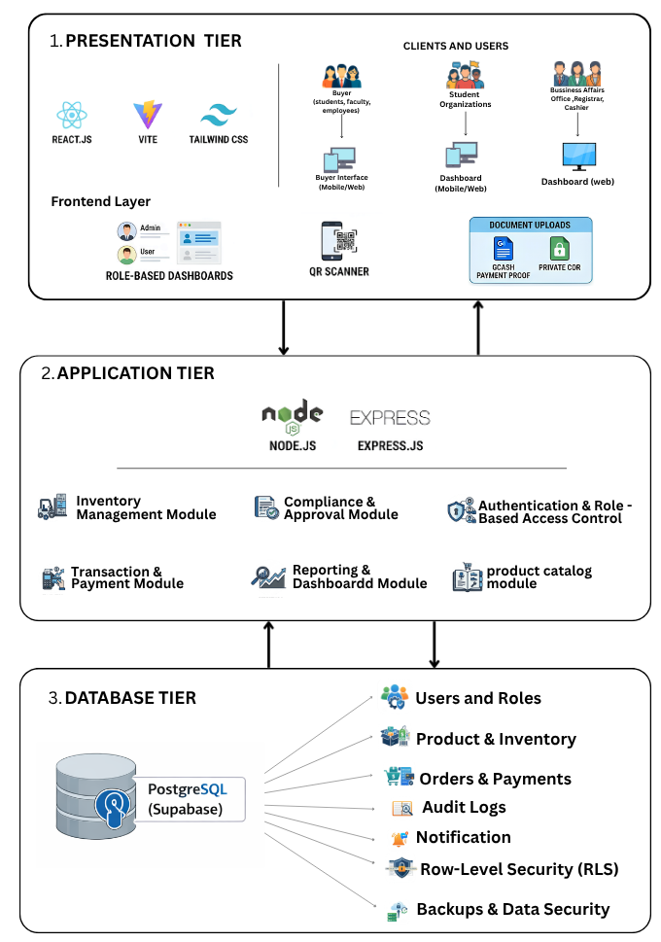

Figure 4.1 System Architecture of the Proposed System
The architectural diagram of the UniMerch system was illustrated in Figure 4.1. UniMerch's architecture is based on a structured tiered design that represents the system's architecture. UniMerch's web-based interface, which is built with React, in the presentation layer makes it possible for different types of users such as buyers, students organizations, and administrative offices to interact with system functionalities, upload documents, and gain access to their dashboards. Node.js and Express.js were used to build the backend services responsible for handling authentication, inventory management, approvals, transactions, and reporting functionalities, which represent the application layer. The database layer utilizes Supabase to store data about users, products, orders, payments, and logs using PostgreSQL and security measures such as row-level security.
4.2 Analysis and Design
The analysis and design of UniMerch followed the Object-Oriented Analysis and Design (OOAD) framework, as well as a development life cycle that utilized an iterative approach. Specifically, the Use Case Diagram, Class Diagram, and Activity Diagrams of the Unified Modeling Language (UML) were utilized by the proponents to model and communicate the system’s structure and behavior.
The Data Flow Diagram (DFD) Level 0, also known as the Context Diagram, provides a high-level overview of the UniMerch system and its interactions with all external entities. It treats the entire system as a single process and shows the data flows between the system and its six external actors.

4.2.1 Data Flow Diagram
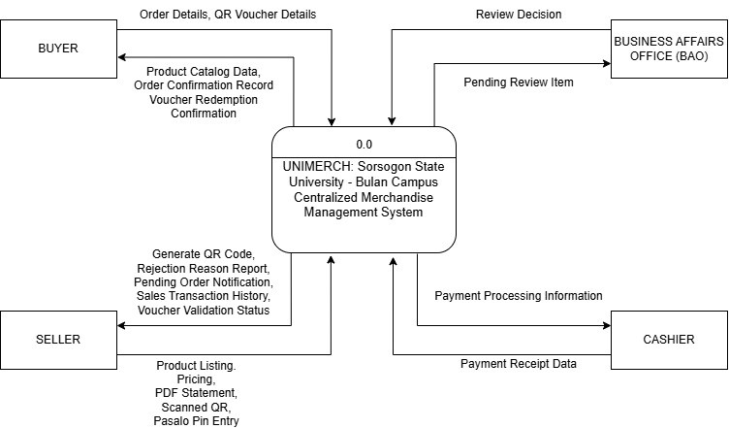
Figure 4.2 Data Flow Diagram of the Proposed System (Level 0)
The Context Diagram depicts the process fllow of the UniMerch: A Centralized Merchandise Management System for Sorsogon State University in relation to the external entities, namely Buyer, Seller, Cashier and Business Affairs Office (BAO). Buyers will be able to browse products and make purchase orders as well as be notified of any other confirmation and voucher redemption. Sellers, on the other hand, will be able to update the product listing, product pricing and QR code creation along with any transaction notification and voucher verification. The Cashier will be responsible for the actual payment and will notify the system of the receipt of payments to validate the transaction.

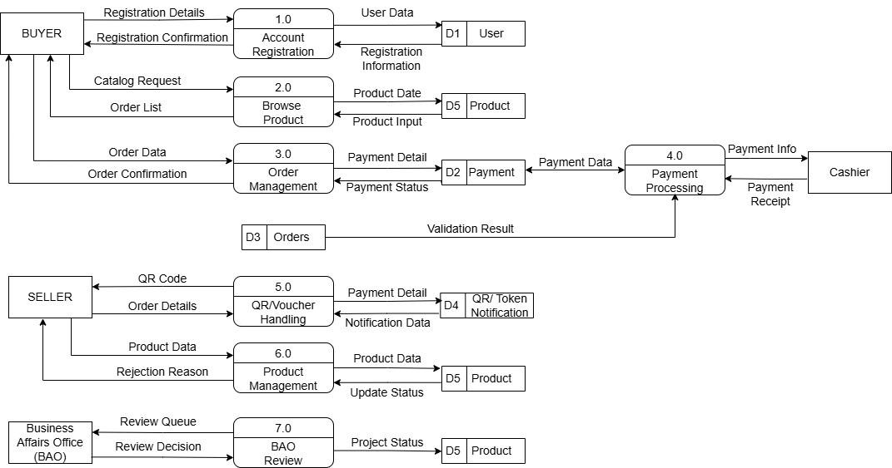
Figure 4.3 Data Flow Diagram of the Proposed System (Level 1)
The Context Diagram and Level 1 Data Flow Diagram provide an overalll description and process of UniMerch: A Centralized Merchandise Management System for Sorsogon State University. In the Context Diagram, the system is portrayed as one process and interacts with the external entities like the Buyer, Seller, Cashier, and Business Affairs Office(BAO). The Buyer can view products, orders and receive confirmation and voucher details. When it comes to the Seller, the seller can manage porducts and vouchers/QR transactions. Payment and transaction verification processes are performed by the Cashier while BAO evaluates pending transaction items and decides whether to give approval. At the same time, in the Level 1 DFD, the system is depicted as having a number of processes such as account registration, product browsing, orders management, payment management, QR/vouchers management, product management and BAO management. This happens alongside with other databases such that all necessary tasks related to user information, products information, transactions and payment verification are carried out.
4.2.2 Use Case Diagram
The use case diagram captured the actors' information and their transactions in the system. It depicted the visual transactions between various parts of the system, detailing the events and flow of events in the system. The Use Case Diagram depicted the functionality of the UniMerch system to be developed, providing a comprehensive overview of how various users interacted with the system and the functions that made up the operations of the system.
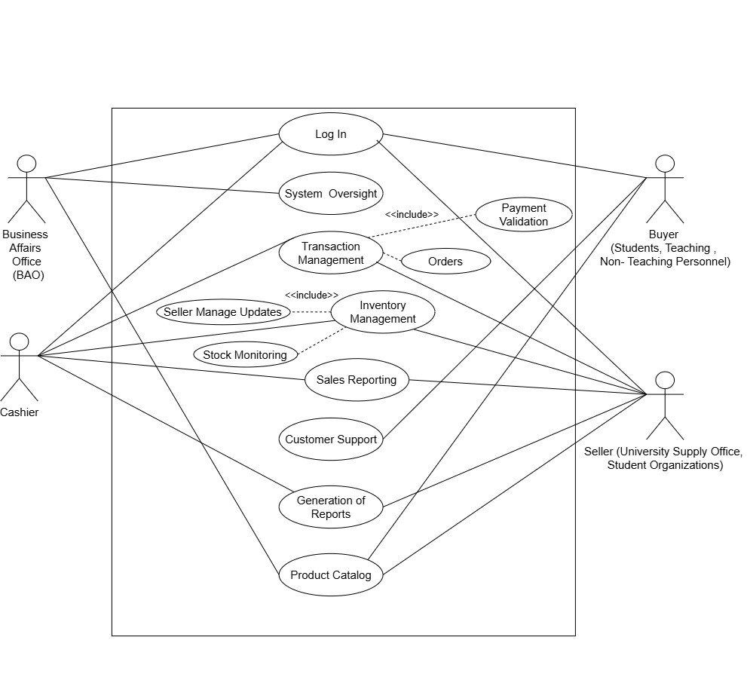
Figure 4.4 Use Case Diagram of the Proposed System
Figure 4.4 highlights the Use Case Diagram of the UniMerch system showing how key user participants such as the Buyers, Sellers, University Administration, and other users interface with the main features. Buyers access the system through the Product Catalog and Transaction Management to view products, place orders, and follow up on their status. Buyers may include students, faculty, employees, and external individuals from other institutions who are registered on the platform. Sellers utilize the Inventory and Sales Reporting feature to edit the list of products and keep track of sales. The Business Affairs Office ensures proper functioning of the system and manages user access, while the Cashier validates transactions and creates reports.

4.2.3 Class Diagram
A class diagram refers to the visualization of the classes present in the system. It provided information on how the class structure, attributes, specifications, and behavior existed in the system, particularly their interactions with one another. Class diagrams belonged to static structure diagrams, which can be used for modeling Object-Oriented systems. It is necessary to use a class diagram when developing a system because it helped the developers design and structure the system well.
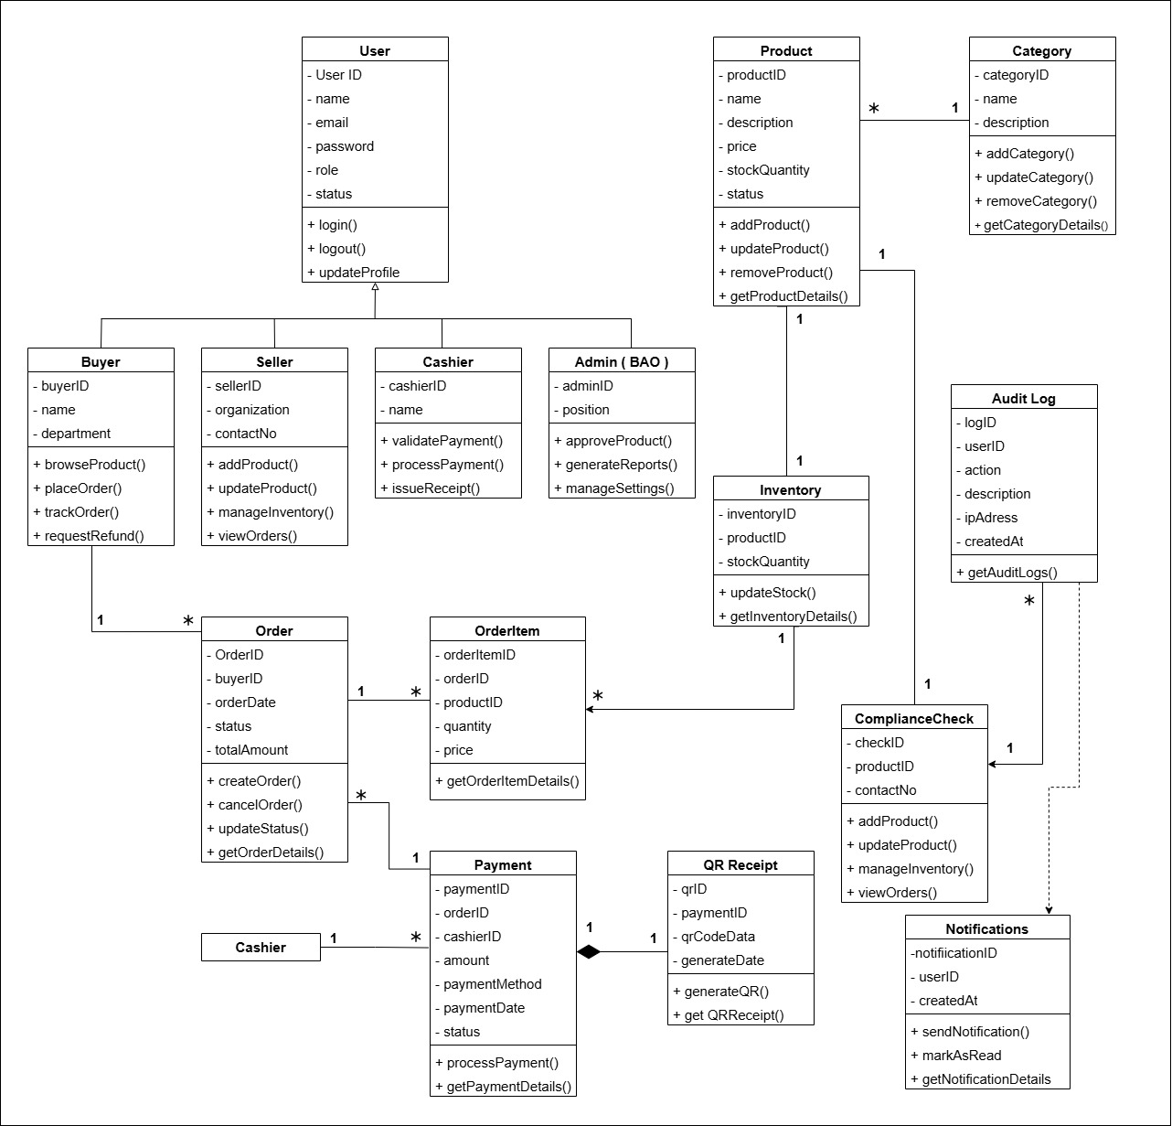
Figure 4.5 Class Diagram of the Proposed System
The structural design of the UniMerch system can be seen in Figure 4.5 below. From the diagram above, the User super class acts as the centralized management of global authentication and credentials, which is further developed by the StudentUser, SellerUser, and AdminUser sub classes to implement role-based access control and unique functionalities. In the catalog subsystem, the Product class has a property known as "type," categorized into available, preorder, or interest to determine how the product approval and inventory management processes will be conducted.
Similarly, in the transactional framework, inheritance is implemented to support multiple payment methods. The base class of Order is extended to the GCashOrder and WalkInOrder sub classes to separate electronic transactions from cash-based transactions.
4.2.4 Activity Diagrams
The Activity Diagram was another kind of flowchart in UML used to show how each activity transitions into the next one in the system. This type of diagram depicted the various dynamic facets of the system, detailing the process of each step in the activity and the sequence it followed, beginning with its initial point and ending with its final point. Figures 4.4 to 4.6 illustrated the activity flow of the main users of UniMerch.
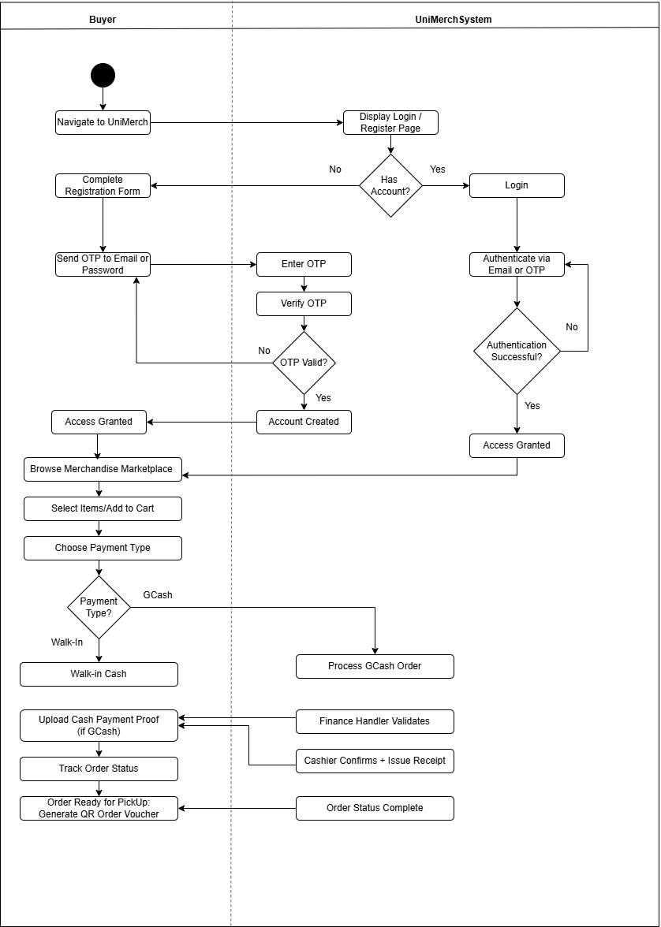
Figure 4.6 Buyer Activity Diagram
The behavioral workflow of UniMerch app is shown which is divided into two swimlanes; Buyer actor and UniMerch System. The process starts with a user visiting the website, which creates a condition for them to be either registered or not, thus directing first-time users to undergo the process of registering and going through OTP verification loop until account is created, whereas returning users login using the standard procedure. Upon successful authentication, the buyer starts browsing, picks out some products, and chooses from two transaction methods available. If the transaction is done using GCash, the entire order process becomes automated, and the buyer must send a copy of payment receipt, which is verified by the finance handler and cashier, whereas walk-in takes process through cash payment process. In both cases, transactions will converge once the order status changes to “complete,” creating a QR code voucher for buyer to pick up the products on campus
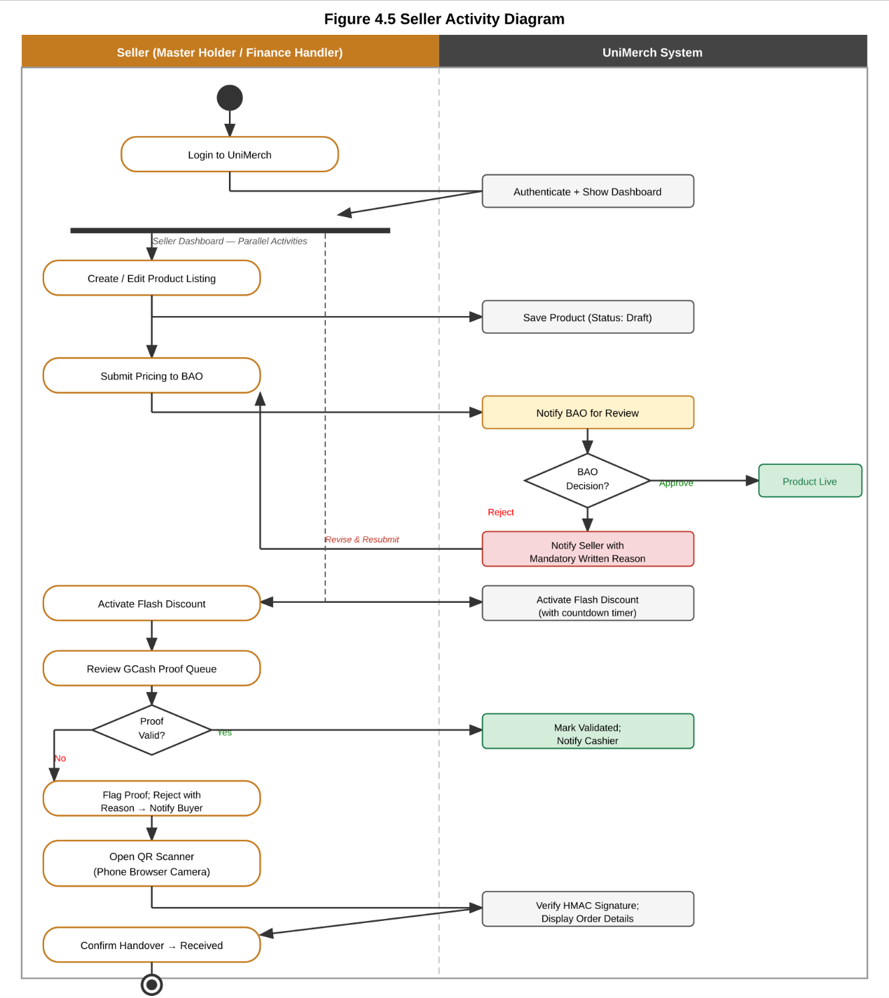
Figure 4.7 Seller Activity Diagram
The Seller Activity Diagram is illustrated in Figure 4.7. The sellers login to the shared organizational account and manage the listing of products. Items that are Available Now and Pre-order need to be approved by the BAO, whereas Interest Check listings get published without requiring any approval. The payment received through GCash can be verified automatically through the Bulk PDF Auto-matching system, or manually by sellers using the QR code scanner on their mobile browser. The buyer gets a notification once the scanning process is completed.
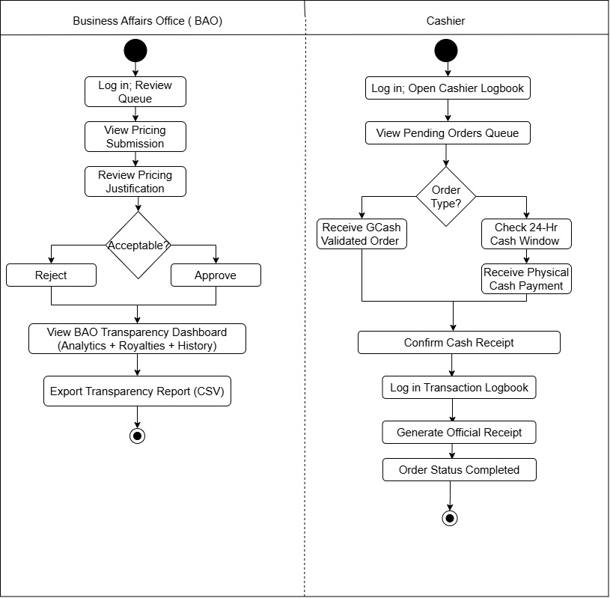
Figure 4.8 University Administration Activity Diagram
The Figure 4.8 illustrates the University Administration Activity Diagram. The BAO evaluates and either accepts or rejects the pricing proposals submitted using a mandatory written rationale. The University Cashier verifies cash payments made personally at the counter and oversees the walk-in store operated by the Cashier.
4.2.5 Requirement Analysis
Requirement analysis plays a very important role in designing the UniMerch web application since it was during requirement analysis that the requirements of the client and end-users were determined concerning the functionality of the UniMerch web application. An Object-Oriented Approach was utilized for both requirement analysis and design. The following tables provide details on the Functional and Non-Functional Requirements of the system.
4.2.5.1 Functional Requirements
The Functional Requirements gave the features incorporated by the developers into the system to enable the users to achieve their goals. The Functional Requirements of the UniMerch system were shown in Table 4.1, including the task descriptions and task references.
Table 4.1 Functional Requirements
Task Requirements | Task
The system must enable the students to create an account via filling up of forms, which must be reviewed and approved by the BAO before the creation of the account. | Student Account Registration
The system must enable Sellers to control the following types of listing: Available Now (requires BAO approval), Pre-order (requires BAO approval, and delivery date), and Interest Check (publishes instantly without BAO approval or purchase). | Three-tier Listing Type with Conditional Approval Routing
The system shall allow student organizations and the University Cashier to manage their store through a single shared organizational account, with the password known only to authorized officers. | Shared Organizational Account Model
The system shall enable Buyers to register interest in Interest Check listings and receive notifications when the listing converts to a purchasable item. | Interest Check Notification
The system shall allow Buyers to place orders using GCash, or walk-in cash, with payment verified by the Seller or Cashier. | Order Placement and Payment Processing
The system shall display a payment method notification popup when a buyer selects Online Payment or Walk-in Cash, with Accept and Cancel (X) buttons” informing the buyer of key terms before proceeding. | Payment Method Notification Popup
The system shall generate an HMAC-SHA256 signed QR Order Voucher for confirmed orders that Buyers can display or download, and Sellers can scan ”Ia phone browser camera. | QR Order Voucher and Item Pickup Verification
The system shall require the Buyer to confirm receipt in-app after the Seller marks an order as received (awaiting-confirm status), with a Report path if the buyer disputes the claim. | Buyer Receipt Confirmation (Dual-Validation)
The system shall enable Pasalo PIN transfer: the original Buyer shares a 6-character PIN with a classmate who claims the item at the pickup window, and the Buyer validates or disputes the Pasalo claim in-app before the order Is released. | Pasalo PIN Order Transfer and Validation
The system shall allow Buyers to view their order history in a 7-tab view: All, To Pay, To Process, To Receive, Claim”d, Return/Refund, Cancelled. | 7-tab Buyer Order History
The system shall allow the BAO to approve or reject Available Now and Pre-order pricing submissions with mandatory written rejection reasons, and access the BAO Transparency ’dashboard for analytics. | BAO Pricing Review and Transparency Dashboard
The system should have the capability for the University Cashier to handle a walk-in store, confirm walk-in cash payments, and make entries into the system without relying on manual logbooks. | Walk-in Cashier Store and Payment Confirmation.

4.2.5.2 Non-Functional Requirements
Non-Functional Requirements (NFRs) were distinguished from functional requirements in that they were not related to the system’s specific functionality, but rather defined how the system performed. Table 4.2 presented the Non-Functional Requirements of the UniMerch system.
Table 4.2 Non-Functional Requirements
Task Requirement | Task Reference
The system shall perform all required functions correctly and consistently across all user roles without errors. | Functional Suitability
The system shall handle multiple concurrent users and process requests with fast response times and optimized resource usage, even under high usage conditions. | Performance Efficiency
The system should provide an easy-to-use interface, enabling convenient interaction with all aspects of the system, including form entry, dashboard viewing, QR code scanning, popup payments, and notifications. | Interaction Capability

4.3 Development Model
In the development of the UniMerch, the supporters adopted the Iterative Development Model as their primary Software Development Life Cycle (SDLC) model. This is a type of SDLC process model whereby the system undergoes development in incremental steps known as iterations. In other words, the iterative development method involves developing the system in several steps, with each step resulting in a functional version of the system which can then be tested for further improvements.
The iterative development model suits the development of UniMerch, considering its multi-role nature consisting of Buyers, Sellers, and University Administration. The figure below depicts the iterative development model employed in this research study.
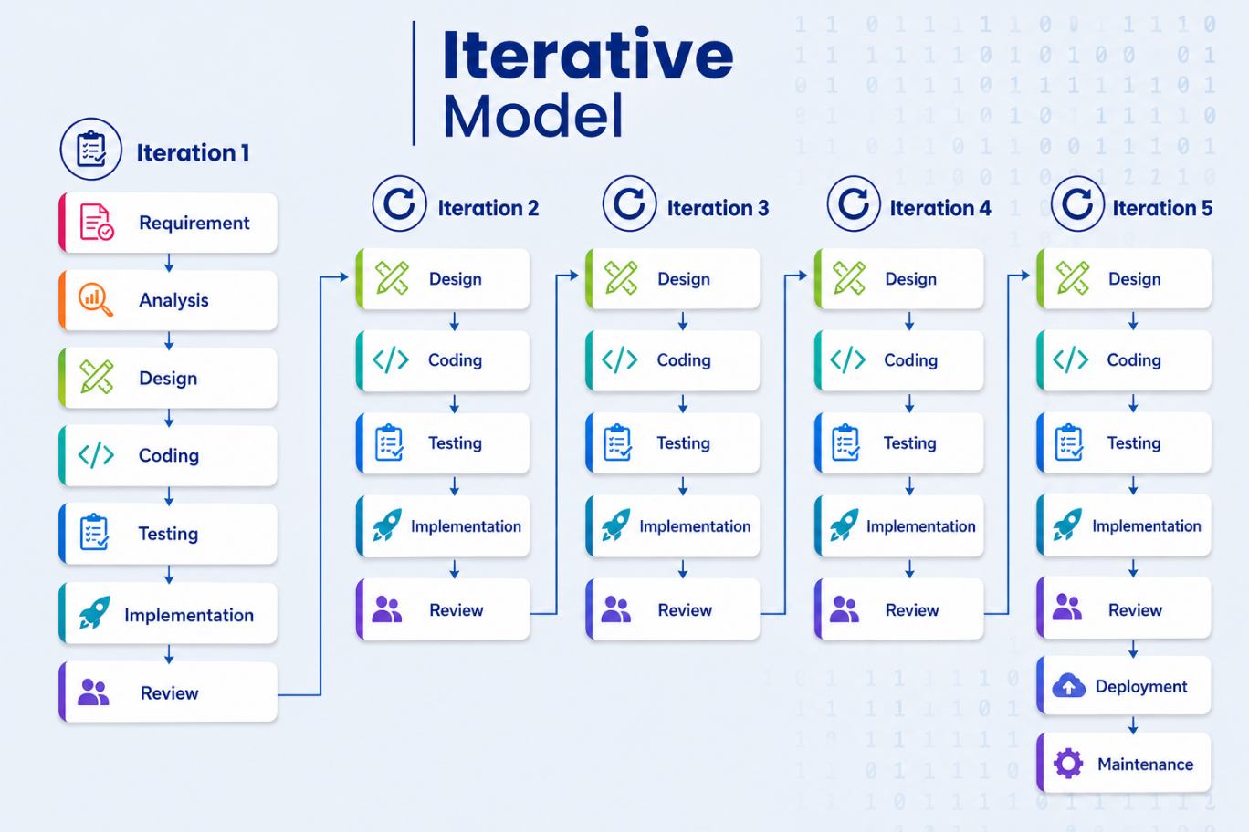
Figure 4.9 Iterative Development Model
For the development of the UniMerch project, the Iterative Development model has been selected as the primary Software Development Life Cycle model. In this model, software development occurs through iterations, during which the system development happens in increments, whereby each iteration entails building an enhanced version of the system for testing and reviews. Such flexibility allows continuous software development while ensuring reviews and stakeholder inputs are incorporated in every phase, which is quite critical to the UniMerch system since its architecture will meet the requirements of various stakeholders including Buyers, Sellers, and the University Administration. As can be observed from the Iterative Development model illustrated above, the whole software design process will be done iteratively over five iterations. While Iteration 1 will form the basis of the others in terms of sequential activities of Requirement, Analysis, Design, Coding, Testing, Implementation, and Review to conduct interviews with the stakeholders, scope the system, and conduct setups, Iterations 2, 3, and 4 will see iterative processes of Design, Coding, Testing, Implementation, and Review to design the system architecture, Buyers/Sellers Module, and Admin/Finance Module.
Table 4.3 Development Iterations
Iteration | Phase | Key Activities
1 | Requirement, Analysis, Design, Coding, Testing, Implementation, Review | Stakeholder interviews, system scoping, role definition, technology selection, GitHub repository setup
2 | Core Architecture | Design, development, testing, implementation, and review of database schema, Supabase configuration, authentication (JWT), role-based access control, and API scaffolding
3 | Buyer & Seller Modules | Design, development, testing, implementation, and review of product listings, ordering system, shared organizational accounts, GCash payment processing, and QR Order Voucher generation.
4 | Admin, Finance & QR Modules | Design, development, testing, implementation, and review of BAO dashboard, cashier module, QR scanner, Pasalo PIN validation, and payment notification system.
5 | Integration, Testing & Deployment | Design, integration, testing, implementation, and review of all system components, bug fixing, performance optimization, cloud deployment preparation, CI/CD setup, and documentation.
Requirements Phase. The Requirement Phase will act as the base phase in the first iteration in which the proponents will visit each customer personally and interview them and have certain meetings in which they will acquire all important information regarding the UniMerch system. During these sessions with the administration staff at SorSU-Bulan, Finance Handlers, and students, the proponents will gain some vital information that is how the Transparency Dashboard is to be developed by the BAO, how the 3% royalty fee is to be automatically calculated for merchandise bearing university logos, and how the process of payments through GCash and cash walk-ins is to be done. In conjunction with a document study of the existing manual workflow processes in order to place an order of merchandise, gathering all this direct information from the customers will prove to be the ultimate guiding factor for the development of the system.
Design Phase. Since the project is going to implement an iterative methodology for its development across five iterations, the Design Phase shall occur five times as well, wherein the team will gradually formulate and polish the design aspects of the system. During each iteration, the supporters will organize UML diagrams, such as the architecture diagram, use case diagram, class diagram, and activity diagram, together with Data Flow Diagrams. Also, the visual components of the wireframes will constantly be formulated using the Figma tool, after which the design will be submitted to the capstone adviser and technical panels before coding.
Development Phase. The same as the design phase, the Development Phase will be undertaken in multiple rounds in the five phases to develop the UniMerch system. The software application will be developed using the following technologies: React.js and Tailwind CSS for the frontend development, Node.js and Express.js for backend API development, and PostgreSQL through Supabase for database management. In each of the five development rounds, the developers will undertake coding of all important core system components such as the QR Order Voucher system, the web-based QR Scanner, the Pasalo PIN validation process, and the payments notification popup window.
Testing Phase. Testing Phase is a continuous process performed not only during but also after every one of the five iterations in order to guarantee quality with each newly added feature. In each iteration, the incrementally constructed system will first be subject to Alpha testing for bugs within the system, followed by Beta testing to find any possible bugs with the real user interface. As the testing procedure repeats five times, it guarantees the continuous debugging needed to make sure that the system is constantly reaching the required levels of functional suitability, usability, and reliability.
Deployment Phase. Deployment Phase will happen once at the end of the project when all five iterations and corresponding testing procedures are done successfully. In this phase, the whole integrated application of UniMerch will be deployed using Vercel for the React.js front-end website deployment, Render.com for the Node.js/Express.js back-end API deployment, and Supabase for the PostgreSQL database hosting. Lastly, GitHub Actions will be used to create a Continuous Integration/Continuous Deployment (CI/CD) pipeline.
4.4 Development Approach
The design incorporated the Top-Down Development Approach along with OOP methodologies. The advocates started from the highest architectural level of the system and moved on to the lower levels through consultation with the stakeholders. The OOP methodologies were employed as follows: Encapsulation encapsulated the logic of each module in service classes, such as AuthService, PaymentService, QRService, and BAOService; Inheritance permitted StudentUser, SellerUser, and AdminUser to inherit from the User class; Polymorphism ensured that the same interface for order processing would act differently for GCash and walk-in cash orders; and Abstraction concealed complicated processes like HMAC-SHA256 QR authentication and auto-cancelation of walk-ins after 12 hours.
4.5 Software Development Tools
The following tools and applications were used to develop the UniMerch system. They were chosen based on popularity among professionals, the open-source nature, the compatibility with the technical requirements of the project, and affordable prices for a student capstone project.
4.5.1 Frontend Development Tools
UniMerch Frontend – Developed using React.js v18 to build a responsive component-based user interface and improved performance with concurrent rendering. This is needed to facilitate features such as live order tracking and generation of QR vouchers.
Vite. A fast tool for frontend builds that also serves as a development server offering nearly instant Hot Module Replacement (HMR). Production version deployed on Vercel.
Tailwind CSS v3.4. A utility-first CSS framework for responsive layout, typography, and color theming. Automatic responsive layout from 320px mobile all the way up to 1920px desktop, without requiring horizontal scrolling. Breakpoints include sm: 640px, md: 768px, lg: 1024px. UniMerch uses the SSU maroon colors via Tailwind extend colors map.
React Router v6. Client-side routing with route guards based on user roles restricting unauthorized users from navigating to pages that do not belong to their role.
React Hook Form. State management and client-side validation for all system forms, including the multi-step buyer registration form, and payment proof submission.
Axios. HTTP client responsible for all RESTful requests from the React.js frontend to the Node.js backend with request interceptors for attaching JWT tokens and response interceptors for logging out the user on token expiration.
Zustand. Simple state management library used to manage authentication state (user's profile and JWT token) without storing the information in the localStorage.
Qrcode.react. Rendering a scannable QR code of Buyer's QR Order Voucher using high error correction levels (H).
Html5-qrcode. Used for implementing Seller’s QR Code Scanner page by making a request to the Web MediaDevices API (navigator.mediaDevices.getUserMedia) on the web browsers (Chrome, Firefox, Safari) for getting the device camera data without installing any native application on the phone/laptop.
HTML5 Canvas API. Used on client-side to draw QR Receipt with order number, buyer name, student ID, item information, total cost, and Pasalo PIN; no server request required for this functionality.
4.5.2 Backend Development Tools
Node.js v20 LTS. Node.js v20 LTS is the programming language used for the UniMerch backend that creates an event-driven and non-blocking environment for performing operations of dealing with many simultaneous user requests at once. Express.js v4.18 is employed as a web framework that enables building REST API routing, middleware, and error handling. The node-postgres/pg library makes it possible to interact with the PostgreSQL database using parameterized queries. The bcryptjs module helps hash passwords of users and validate passwords and other credentials such as PINs, whereas jsonwebtoken is responsible for authentication via tokenization and setting their expirations. Student documentation and transaction evidence are uploaded using Multer with file size and extension validation.
4.5.3 Database and Cloud Tools
PostgreSQL 15 via Supabase. PostgresSQL is the RDBMS chosen to store all UniMerch database information. Supabase offers PostgreSQL 15 services with Row Level Security policies, connection pooling through pgBouncer, and automatic backup services.
Supabase Storage. The service utilized to store confidential files, such as GCash payment proof images and receipts in PDF format. The files will be accessible through signed URLs that expire in 10 minutes, avoiding any unauthorized access
Supabase Realtime. Web Socket service to provide real-time subscriptions that ensure automatic order status update in the buyers' order history without refreshing the page.
4.5.4 Version Control and IDE
The following are integrated in the UniMerch app to meet operational requirements:
Resend. Transactional email service with a limit of sending 3,000 free emails monthly. The service is utilized to send automated email notifications in case of account approval or rejection, order status updates, and walk-in cash order window expiration notifications.
Node-cron. Cron scheduler to run background jobs every 5 minutes in order to auto-cancel pending walk-in cash orders that expire after their 12-hour window period.
Morgan. An HTTP request logger middleware that logs the HTTP method, endpoint URL, status code, and response time in milliseconds. Configured with "dev" during development mode, while production uses "combined" format and can be accessed from the Render.com deployment dashboard.
Express-rate-limit. Rate-limiting middleware for protecting critical API endpoints where the limit is set at 20 HTTP requests per 15-minute period for an IP address. Responds with HTTP 429 if exceeded, safeguarding against brute force attacks for login purposes.
Compression. Compression middleware that uses gzip to compress responses from the server larger than 1 KB for better performance within campus networks with limited internet bandwidth.
Sentry. Error monitoring and handling for the Node.js server application and React.js web application. Logs uncaught exceptions with stack trace and other request parameters. Sentry's free plan (5,000 error reports per month) is enough to track error reports.
PDFKit. A library that renders receipts as official PDF documents for each transaction on Cashier's end for confirmed cash transactions or completed GCash transactions. Receipts have order number, buyer name, student number, list of purchased products, total price, payment type, and timestamp. The document is stored in the cloud using Supabase Storage service with direct download links.
Swagger UI Express. Generates interactive API documentation at the /api/docs endpoint using the OpenAPI 3.0 specification, documenting all 27 REST API endpoints with HTTP methods, required parameters, request body schemas, authentication requirements, and expected response formats.
4.6 Schedule and Timeline
The figure below showed a visual overview of the project schedule, highlighting the timeline, specific activities, and their dependencies. The UniMerch project is developed over two academic semesters, covering the requirements gathering, design, development, testing, and deployment phases
Table 4.4 Gantt Chart
ACTIVITIES |  |  |  |  |  |  |  |  |  |  | OUTPUT(S)
 | Mar | Apr | May | Jun | Jul | Aug | Sep | Oct | Nov | Dec
REQUIREMENTS
Requirements Gathering &  Interviews |  |  |  |  |  |  |  |  |  |  | Documents/Deliverables
Writing Chapter 1:  Introduction |  |  |  |  |  |  |  |  |  |  | Documents/Deliverables
Writing Chapter 2: Related  Systems |  |  |  |  |  |  |  |  |  |  | Documents/Deliverables
Writing Chapter 3: Technical  Background |  |  |  |  |  |  |  |  |  |  | Documents/Deliverables
DESIGN
Writing Chapter 4: Design &  Methodology |  |  |  |  |  |  |  |  |  |  | Documents/Deliverables
Creating Wireframes (Figma) |  |  |  |  |  |  |  |  |  |  | Documents/Deliverables
DEVELOPMENT
Iteration 1 |  |  |  |  |  |  |  |  |  |  | Working Software
Design |  |  |  |  |  |  |  |  |  |  | Documents/Deliverables
Coding |  |  |  |  |  |  |  |  |  |  | Documents/Deliverables
Testing |  |  |  |  |  |  |  |  |  |  | Documents/Deliverables
Implementation |  |  |  |  |  |  |  |  |  |  | Documents/Deliverables
Review |  |  |  |  |  |  |  |  |  |  | Documents/Deliverables
Iteration 2 |  |  |  |  |  |  |  |  |  |  | Working Software
Design |  |  |  |  |  |  |  |  |  |  | Document/Deliverables
Coding |  |  |  |  |  |  |  |  |  |  | Document/Deliverables
Testing |  |  |  |  |  |  |  |  |  |  | Document/Deliverables
Implementation |  |  |  |  |  |  |  |  |  |  | Document/Deliverables
Review |  |  |  |  |  |  |  |  |  |  | Document/Deliverables
Iteration 3 |  |  |  |  |  |  |  |  |  |  | Working Software
Design |  |  |  |  |  |  |  |  |  |  | Document/Deliverables
Coding |  |  |  |  |  |  |  |  |  |  | Document/Deliverables
Testing |  |  |  |  |  |  |  |  |  |  | Document/Deliverables
Implementation |  |  |  |  |  |  |  |  |  |  | Document/Deliverables
Review |  |  |  |  |  |  |  |  |  |  | Document/Deliverables
Iteration 4 |  |  |  |  |  |  |  |  |  |  | Working Software
Design |  |  |  |  |  |  |  |  |  |  | Documents/Deliverables
Coding |  |  |  |  |  |  |  |  |  |  | Documents/Deliverables
Testing |  |  |  |  |  |  |  |  |  |  | Documents/Deliverables
Implementation |  |  |  |  |  |  |  |  |  |  | Documents/Deliverables
Review |  |  |  |  |  |  |  |  |  |  | Documents/Deliverables
Iteration 5 |  |  |  |  |  |  |  |  |  |  | Working Software
Design |  |  |  |  |  |  |  |  |  |  | Documents/Deliverables
Coding |  |  |  |  |  |  |  |  |  |  | Documents/Deliverables
Testing |  |  |  |  |  |  |  |  |  |  | Documents/Deliverables
Implementation |  |  |  |  |  |  |  |  |  |  | Documents/Deliverables
Review |  |  |  |  |  |  |  |  |  |  | Documents/Deliverables
Deployment |  |  |  |  |  |  |  |  |  |  | Documents/Deliverables
Maintenance |  |  |  |  |  |  |  |  |  |  | Documents/Deliverables
TESTING
System Evaluation (ISO/IEC 25010) |  |  |  |  |  |  |  |  |  |  | Evaluation Report
DEPLOYMENT
Cloud Deployment & Maintenance  (Post-Implementation Support) |  |  |  |  |  |  |  |  |  |  | Deployment Report

Table 4.4 Gantt chart shows the planned schedule for the project according to the iterative software development methodology. In accordance with this methodology, the work will be carried out in different stages, which will consist of the cycles of activity. At the first stage, the gathering of requirements and writing of preliminary documentation should be done, in order to understand what the system will be developed and its goals should be formulated.
At the second stage, system design takes place, i.e., it involves the description of the system structure and its interface. During the next phase, the development process itself takes place; in order to implement it correctly, we need to proceed in several iterations. Thus, in each cycle, only certain modules will be developed, but not the whole system.
During this stage, the system will be improved and modified, which will facilitate identifying problems during the work. Then, the evaluation of the software product is performed with regard to its conformity to such characteristics as functionality, reliability, and usability according to the ISO/IEC 25010 standard.
4.7 Responsibilities
This capstone project is composed of four IT students who worked as a team with designated roles aligned with developing and designing the UniMerch — Online Campus Merchandise Management System. The responsibilities of each role were as follows:
Project Leader. Loren G. Monzales. The project leader ensured that the group remained aligned with the project goals by providing team support, coordinating between all team members, and facilitating communication with the capstone adviser and university stakeholders.
System Analyst. Ralph James G. Gasid. The System Analyst studied various system components to identify objectives and ensured that every component is developed to accomplish those goals. The System Analyst also created and maintained the UML diagrams, DFDs, and system architecture documentation.
System Developer. Kris Angela E. Bon. The Developer implemented the frontend (React.js/Tailwind CSS), backend (Node.js/Express.js), database schema (PostgreSQL via Supabase), and all core system modules including the QR Order Voucher system, QR Scanner, Pasalo PIN dual-validation workflow, payment method notification popup, and GitHub CI/CD pipeline.
Technical Writer. Cyrene Jane C. Teodocio. The Technical Writer also participated in decisions regarding system features and ensured that all project documentation is clear, concise, accurate, and compliant with the capstone format.
4.8 Budget and Cost Management
This project required a budget to cover materials, supplies, services, and other operating expenses for both system development and documentation. The tables below presented the estimated costs and how the budget is utilized throughout the project.
Table 4.5 Materials and Supplies Budgetary Requirements
Item | Quantity / Duration | Estimated Cost (PHP)
Bond Paper (70 gsm, 500 sheets, Letter) | 3 reams | 600
Ink Set (for documentation printing) | 1 set | 1,000
Laptop (for development) | 1–2 units (existing) | 0 (personal)
Table 4.5 presented the estimated cost of essential materials and supplies required throughout the project. Three reams of bond paper were budgeted at Php 200.00 per ream for a total of Php 600.00, used for printing project documentation and other hard copy requirements during the capstone period. A complete ink set for documentation printing is budgeted at Php 1,000.00 to support all printing activities throughout the development and documentation phases. The development laptops used by the proponents were personal equipment, incurring no additional cost to the project budget. The total cost for materials and supplies was Php 1,600.00.

Table 4.6 Services Budgetary Requirements
Service | Duration | Estimated Cost (PHP)
Internet Service (Broadband) | 6 months | 2,097
Supabase (Database, Storage, Auth, Realtime) | Free Tier | Free
Render.com (Backend Hosting) | Free Tier | Free
Vercel (Frontend Hosting) | Free Tier | Free
GitHub (Version Control & CI/CD) | Free Tier | Free
Resend.com (Email Notifications) | Free Tier | Free
Sentry (Error Monitoring) | Free Tier | Free
Figma (UI/UX Design) | Free Starter Plan | Free

Table 4.6 listed the cost for internet and cloud services which were among the necessary components during the whole capstone development process. The internet provided online collaboration, testing, cloud platform usage, and communication between team members and stakeholders. The internet plan costs Php 699.00 per month, covering a period of six months which aligns with the duration of the project, amounting to a total cost of Php 2,097.00. Supabase, Render.com, Vercel, GitHub, Resend.com, Sentry, and Figma are among the list of cloud services used in the project, all offered for free and hence costing the project nothing. The proponents were convinced that the free tiers of these cloud services would suffice the needs of the capstone development, testing, and deployment stages.

Table 4.7 Maintenance and Other Operating Expenses
Item | Duration | Estimated Cost (PHP)
Transportation (Site visits / client meetings) | 6 months | 1,800
Miscellaneous (printing, binding, photocopies) | — | 1,500
The transportation and miscellaneous costs needed for the project’s logistical purposes are detailed in Table 4.7. The transportation expenses include the cost of transportation to meetings with the clients, on-site meetings at SorSu – Bulan Campus to conduct interviews for the project, and other activities during a -month period, with an estimate cost of Php 3,600.00. The miscellaneous expenses involve printing, document binding, and photocopying costs, totaling an estimated cost of Php 1,500.00. Thus, the budget for the maintenance and other operating costs totals Php 5,100.00.
4.9 Verification and Validation
The verification and validation process were done by the proponents in determining if the system is in accordance with the requirements of the clients. To evaluate the software product quality of UniMerch system, the proponents used a 5-point Likert Scale based on the ISO/IEC 25010:2023 Software Product Quality Standards.
4.9.1 Verification
It is necessary to ensure that the system is designed according to the required specifications. Verification checks whether each of the components, from initial to the code stage works as expected and whether the overall system works properly. More specifically, it aids in detecting and solving problems or defects at an early development stage, thus avoiding costly mistakes at later stages.
Verification was carried out at all the levels of development of the UniMerch system. At the designing level, the proponents went through UML diagrams, data flow diagrams, and wireframes in an effort to verify if the design of the software will meet the requirements before coding. On the development level, the proponents did code reviews of each module including account registration procedure, BAO approval, QR code vouchers, Pasalo PIN verification, and walk-in cashier store.
The system went through the process of being verified based on the functional requirements as specified in the Table 4.1, where every single requirement was mapped to the respective feature implemented in order to ensure that all the requirements have been covered. The non-functional requirements were reviewed on the basis of system configuration, including the rate limiting, gzip, WebSockets subscriptions, and JWT expiration.
4.9.2 Validation
Unimerch will be validated through the ISO Questionnaire based on the ISO/IEC 25010:2023 Software Product Quality Model. The tool evaluates the effectiveness of the system, its usability, and general quality. As indicated by the aims of the study, the ISO Questionnaire contains three major parts, namely Functional Suitability, Performance Efficiency, and Interaction Capabilities.
In the evaluation stage, the ISO questionnaire will be used by the proponents to evaluate the functionality of the UniMerch System which includes transaction processing, accessing of the product catalog, QR voucher generations and management of system altogether. It will score every aspect of this using the Likert Scale, ranging from 1 to 5.
Below are the different levels of scores and their corresponding interpretation through their range means.
Table 4.9.2 Likert Scale
Rating | Mean Range | Verbal Interpretation
5 | 4.21 - 5.00 | Excellent
4 | 3.31 - 4.20 | Very Good
3 | 2.61 - 3.30 | Satisfactory
2 | 1.81 - 2.60 | Fair
1 | 1.00 - 1.80 | Poor

4.9.3 System Evaluation Matrices
The following tables detail the sub-characteristics evaluated under each main ISO/IEC 25010:2023 characteristic, specifically tailored to the features of the UniMerch web application.
Table 4.9.3 Functional Suitability Characteristics
Sub- characteristics | Description
Functional Completeness | The system contains all the required elements, such as multi-level registration, 7-tabs order history and 3 types of listings – Available Now, Pre-order and Interest Check.
Functional Correctness | The system filters the available product range depending on the buyer's course, department, or organization, calculates 3% royalty for SSU-logo products.
Functional Appropriateness | The system features like HMAC-SHA256 signed QR Order Voucher and validation ’f 6-digit Pasalo PIN make the process secure by their uniqueness.

Table 4.9.4 Performance Efficiency Characteristics
Sub- characteristics | Description
Time Behavior | The system works quickly, updating the order status through the use of WebSockets subscription without requiring the buyer to manually reload the page.
Resource Usage | The system works efficiently on the desktop, tablet, and’smartphone, offering a responsive interface designed with the help of Tailwind CSS without significant data loss.
Capacity | The Node.js back-end allows running multiple users at once without slowing down because of the campus merch launches.

Table 4.9. 5 Interaction Capability Characteristics
Sub- characteristics | Description
Appropriate Recognizability | Users will be able to distinguish easily their role-based dashboards, which may include the BAO Transparency Dashboard and the University Cashier walk-in store.
Operability | Features like uploading payment proof in GCash and using the mobile phone browser’s camera for scanning QR codes are straightforward to use.
Error Prevention. | This feature is incorporated into the system through payment method alerts pop-up (Accept/Cancel) and required written justification for rejection of pricing submissions by the BAO.
Learnability | Consumers will not require extensive instructions on how to browse the marketplace, select the payment methods, and view the 7-tab order history screen.

4.10 Testing
Functional Testing. In order to establish whether the functions of the system perform effectively according to expectations and specifications, functional testing has been undertaken. The testing of significant functions involving user registration, login, product browsing, order placement, transaction, QR generation, and administration are included in this test. The results indicate that the functions performed well and accomplished their objectives successfully.
Performance Testing. The effectiveness of the system while in operation was also evaluated through the performance testing process. The tests were undertaken in order to determine the efficiency of the system in terms of speed, reaction time, and ability to cope with the user load simultaneously.
Interaction Testing. In order to assess how easy it is for users to interact with the system, interaction testing was carried out. A group of users was allowed to interact with the system and give feedback about its navigability, interface, overall usability, and instructional quality. It can be observed from the results that there were no problems experienced when interacting with the system.

