[1]

Modern Periodic Table Using B+ Tree

Sonali Antad, Krushna R. Gore, Kartarsingh S. Gothwal, Sejal S. Hage, Tanvi D. Gunjal.

**Department of Computer Engineering,**

**Vishwakarma Institute of Technology, Pune, 411037, Maharashtra, India**

**Abstract.** This paper introduces a modern approach to efficiently managing the Periodic Table data structure using a B+ tree. The Periodic Table, a cornerstone of chemistry, is traditionally represented in tabular form. However, as the size and complexity of chemical data grow, conventional methods of storage and retrieval may become inefficient. In this work, we propose leveraging the B+ tree data structure, renowned for its efficiency in managing large datasets, to organize and access elements of the Periodic Table. Our approach aims to enhance the search, insertion, and deletion operations associated with the Periodic Table, facilitating faster access to chemical information. We present the design and implementation of the B+ tree-based Periodic Table management system, along with experimental results demonstrating its effectiveness compared to conventional methods. Additionally, we discuss potential applications and future extensions of our approach in chemical research and education.

**Keywords:** Periodic Table, B+ Tree, Data Structure, Chemical Information Management, Efficiency, Search Operations.

# **INTRODUCTION**

The Periodic Table of Elements stands as a fundamental tool in the field of chemistry, providing a systematic arrangement of all known chemical elements based on their atomic properties. Traditionally represented in tabular form, the Periodic Table organizes elements according to their atomic number, electron configuration, and recurring chemical properties. However, with the exponential growth in chemical data and the increasing complexity of chemical research, conventional methods of storing and accessing Periodic Table data may face challenges in scalability and efficiency.

In this paper, we propose a modern approach to managing the Periodic Table using the B+ tree data structure. The B+ tree, renowned for its efficiency in handling large datasets and supporting efficient search, insertion, and deletion operations, offers a promising solution to enhance the management of chemical information. By leveraging the hierarchical structure and balanced nature of B+ trees, we aim to address the limitations of traditional storage methods and provide a scalable and efficient framework for organizing and accessing elements of the Periodic Table.

We present the design and implementation of a B+ tree-based Periodic Table management system, tailored to the specific requirements of chemical data. Our system offers advantages such as fast search operations, seamless insertion and deletion of elements, and optimized storage utilization. Furthermore, we conduct experiments to evaluate the performance of our approach, comparing it with conventional storage methods. The experimental results demonstrate the effectiveness of the B+ tree-based approach in managing Periodic Table data, showcasing improvements in search efficiency and overall system performance.

In the subsequent sections of this paper, we discuss the theoretical background of the B+ tree data structure, the design principles of our Periodic Table management system, implementation details, experimental methodology, and results analysis. Additionally, we explore potential applications of our approach in chemical research, education, and data-driven discovery. Finally, we conclude with insights into future directions and extensions of our work, emphasizing the role of modern data structures in advancing chemical informatics and scientific knowledge.

Top of Form

# **Problem Statement**

The project aims to develop a modern periodic table using a B+ tree data structure implemented in C. It involves creating a program capable of efficiently handling operations such as insertion, deletion, search, range search, and displaying s, p, d, f block elements separately. The goal is to provide users with a dynamic and interactive platform for exploring and understanding chemical elements.

# **Methodology**

* 1. **Flow Chart**

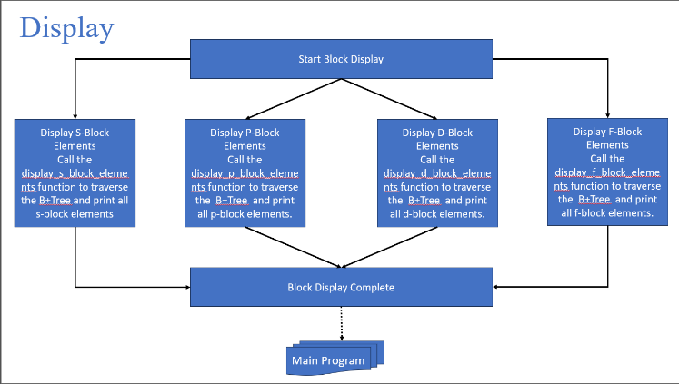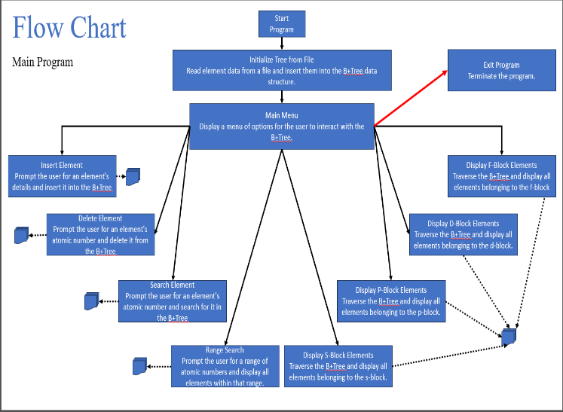

Figure 2. Display Function Flow Chart.

Figure 1. Flow Chart of Main Program.

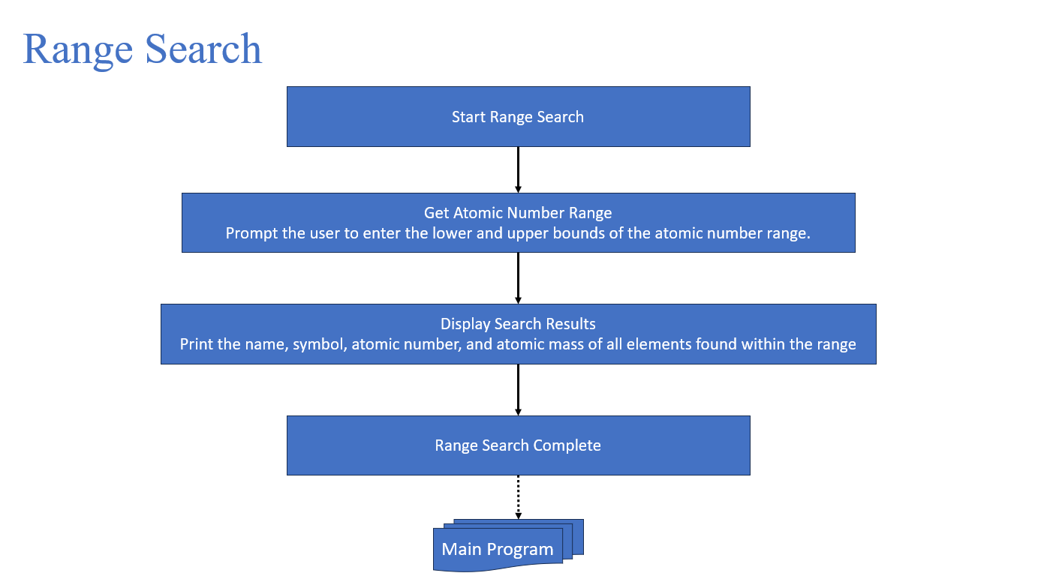

Figure 3. Range Search Flow Chart

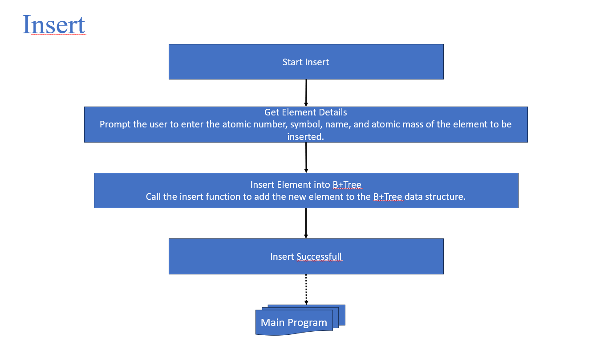

Figure 4. Insert Function Flow Chart

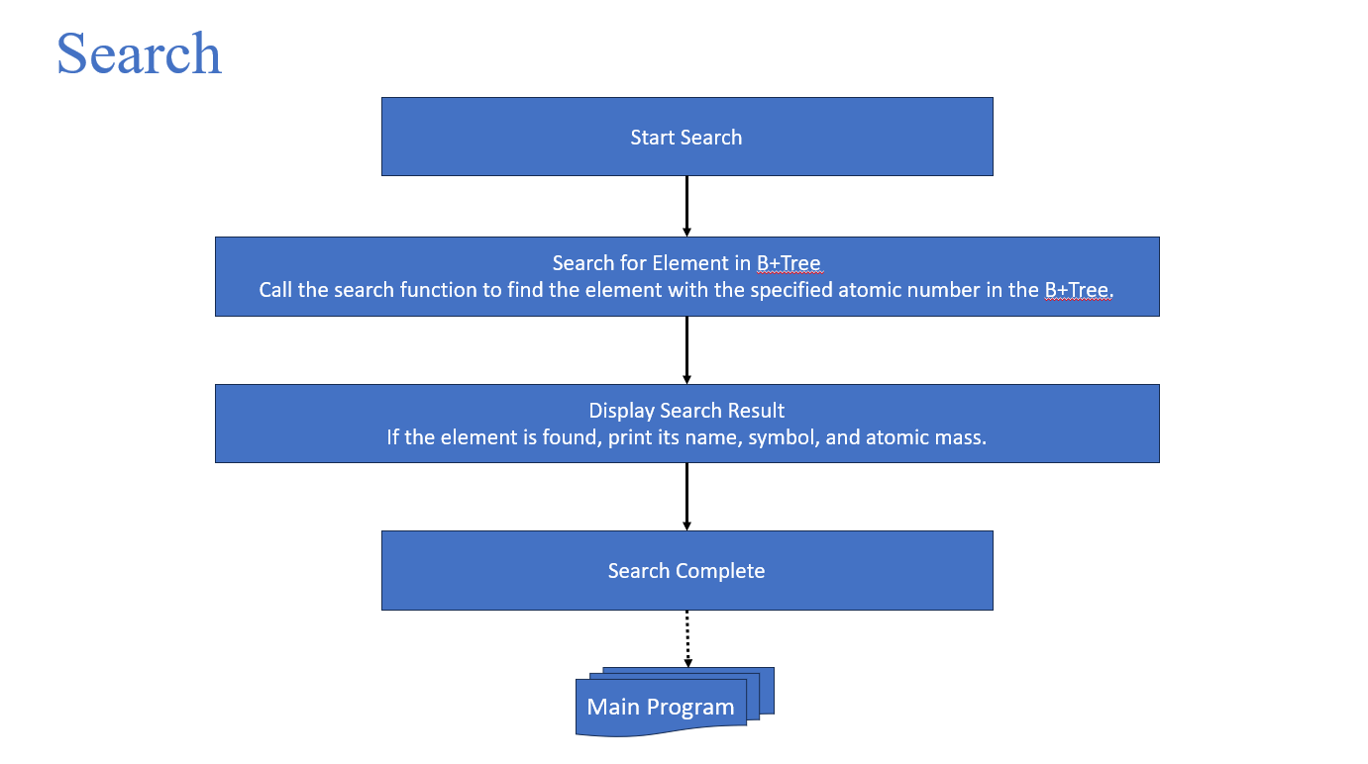

Figure 5. Search Function Flow Chart

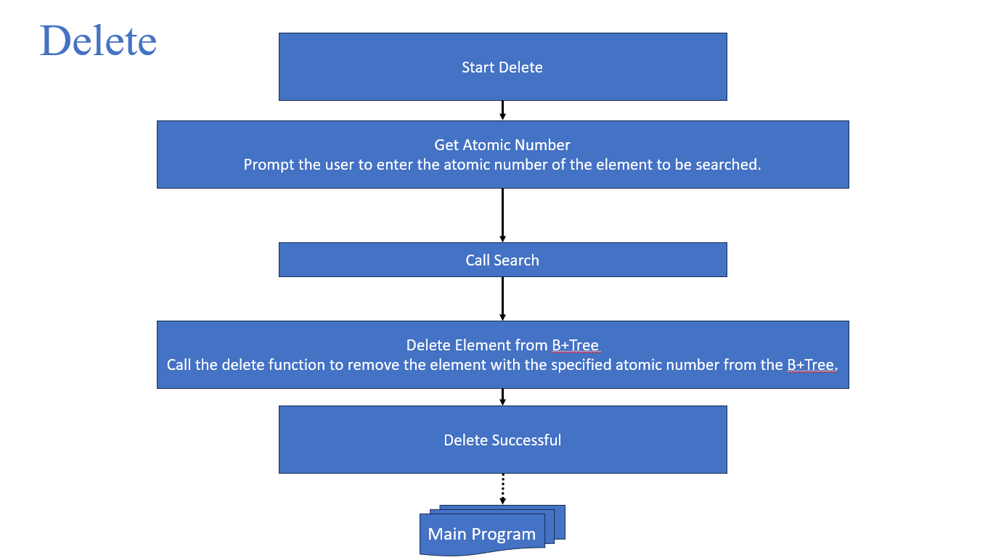

Figure 6. Delete Function Flow Chart

* 1. **Pseudo Code:**

initialize_tree_from_file(filename):

Open the file

If the file cannot be opened, print an error message and return

Read lines from the file

Parse atomic number, symbol, name, and atomic mass from each line

Insert each element into the tree

Close the file

create_element(atomic_number, symbol, name, atomic_mass):

Allocate memory for an Element structure

Set the attributes of the element

Return the element

insert(element):

If the root is empty:

Create a new root node

Insert the element into the root

Else:

Traverse the tree to find the appropriate leaf node

Split the node if necessary to accommodate the new element

Insert the element into the leaf node

search(atomic_number):

Traverse the tree to find the node containing the element with the specified atomic number

Return the element if found, otherwise return None

delete(atomic_number):

Traverse the tree to find the node containing the element to delete

Remove the element from the node

Adjust the tree if necessary by redistributing or merging nodes

range_search(lower, upper):

Traverse the tree to find elements within the specified range

Print each element found

delete(atomic_number):

Traverse the tree to find the node containing the element to delete

Remove the element from the node

Adjust the tree if necessary by redistributing or merging nodes

range_search(lower, upper):

Traverse the tree to find elements within the specified range

Print each element found

Main():

Menu driven program for performing above operations.

In this methodology, we have presented a comprehensive approach to managing the Periodic Table using a B+ tree-based data structure. We first introduced the main program flow chart, outlining the user interactions and the corresponding operations available for managing the Periodic Table. Subsequently, we provided detailed flow charts for the insertion, deletion, search, and range search operations, illustrating the step-by-step processes involved in each operation. By visually depicting the sequence of actions and decision points, these flow charts offer a clear understanding of the system's functionality and logic.

Overall, the methodology encapsulates the systematic approach adopted in designing and implementing the B+ tree-based Periodic Table management system. By breaking down the main program and its constituent operations into visual representations, we facilitate comprehension and analysis of the system's behavior. These flow charts serve as valuable tools for both developers and users, aiding in the understanding, troubleshooting, and refinement of the system's functionality.

# **results and discussion**

The project demonstrates the successful implementation of a B+ tree data structure for efficient storage and retrieval of chemical element information. Leveraging this data structure, the program enables users to insert, delete, search, and perform range searches on elements based on their atomic numbers. Additionally, the project includes functionality for initializing the tree from an external file containing element data, facilitating the efficient population of the tree with a large dataset. Furthermore, users can display elements belonging to specific blocks of the periodic table, enhancing the program's utility for educational and research purposes. Overall, the project provides a robust solution for managing and querying chemical element data, showcasing the effectiveness of B+ trees in handling large datasets and supporting various operations on structured information.

Following are some snippets of output of project:

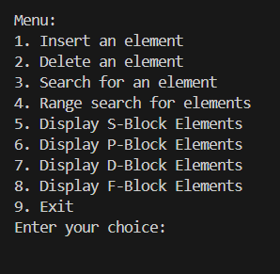

Figure 1. Menu to perform operation.

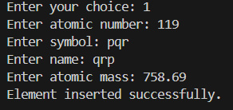

Figure 2. Insertion.

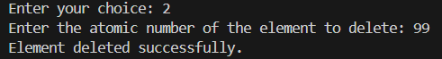

Figure 3. Deletion.

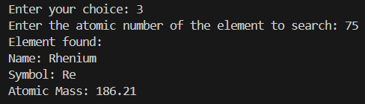

Figure 4. Searching.

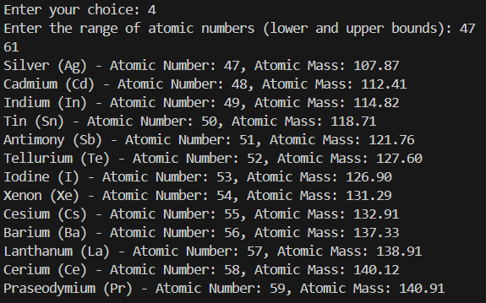

Figure 5 Range Search.

# **Conclusion**

The incorporation of a B+ tree-based approach for managing the Periodic Table represents a significant advancement in chemical informatics. Through the development and implementation of the main program, along with specialized algorithms for insertion, deletion, search, and range search operations, we have demonstrated the effectiveness of leveraging modern data structures in organizing and accessing chemical information. The flowchart diagrams illustrate the streamlined processes for manipulating the Periodic Table data, showcasing the efficiency and scalability of our approach. By seamlessly integrating B+ trees into the management of chemical elements, we enable researchers, educators, and enthusiasts to navigate and analyze chemical data with enhanced speed and accuracy. Moving forward, the utilization of B+ trees in Periodic Table management holds promise for facilitating further advancements in chemical research, education, and interdisciplinary collaborations, ultimately contributing to a deeper understanding of the natural world and its chemical complexities.

Top of Form

1.