WALKABLE: Turning a Single Drone or Handheld Video into a Metric, Walkable 3D World
A reproducible Structure-from-Motion → 3D Gaussian Splatting → browser-physics pipeline that runs end-to-end on a 6 GB laptop GPU

1. Project Objectives
# | Objective
O1 | Single video → walkable 3D world, one command. Convert an ordinary drone or handheld video into a photorealistic, navigable 3D world through one fully automated command — no manual modelling, no cloud dependency.
O2 | Metric, measurable reconstruction. Recover true metric scale and orientation from minimal operator input (a single speed or height anchor), so distances, areas, and ground surfaces in the model are physically meaningful.
O3 | Walkability, not just visuals. Derive physics-valid ground and collision geometry from the neural reconstruction, enabling first-person walking and autonomous agent navigation in the scanned scene.
O4 | Falsifiable quality on consumer hardware. Run every stage on a 6 GB laptop GPU and gate each build on automated acceptance tests (blind visual review, scripted walk tests), not subjective judgment.
Table 1. Project objectives for the selected idea: single video → metric, walkable 3D world.

2. Impact Statement
This work lowers the cost of producing a usable 3D replica of a real place from hours of expert photogrammetry and expensive licensed software to a single command on an ordinary laptop. Because the output is metric and walkable rather than a view-only render, it directly serves disaster damage assessment, border and strategic area mapping, construction progress monitoring, archaeological documentation, urban planning, and mission rehearsal — domains where decisions depend on measuring and moving through a scene, not merely looking at it. By combining the geometric guarantees of classical methods with the visual fidelity of neural rendering, and by refusing to ship any result that fails automated measurement, the pipeline provides a reproducible, low-cost foundation that researchers, engineers, and field teams can build upon.

3. Research Literature Survey

3.1 Core Reconstruction Methods
[1] Mildenhall et al. (2020) — NeRF: Representing Scenes as Neural Radiance Fields for View Synthesis (ECCV 2020). Stores a scene as a network mapping 5-D coordinates to colour and density, trained per scene by differentiable volume rendering. Photorealistic, but hours to train and with no explicit surface — nothing to measure, collide with, or stand on.
[2] Schönberger & Frahm (2016) — Structure-from-Motion Revisited (COLMAP, CVPR 2016). The reference incremental SfM pipeline, and still the accuracy baseline for neural pose estimators. We adopt it as our pose solver: it fits a 6 GB budget and yields survey-grade registration, at the cost of runtime and fragility on blur, low texture, and rotation-only motion.
[3] Kerbl et al. (2023) — 3D Gaussian Splatting for Real-Time Radiance Field Rendering (ACM TOG / SIGGRAPH 2023). Represents a scene as 10⁵–10⁶ anisotropic 3-D Gaussians rasterised at interactive rates, reaching NeRF-class fidelity in minutes on consumer hardware — our appearance stage. Its known gap, that a splat cloud is not a surface, defines our geometry problem.

3.2 Application-Domain Literature
[4] Nex & Remondino (2014) — UAV for 3D Mapping Applications: A Review (Applied Geomatics 6(1)). The classical UAV-photogrammetry baseline — platforms, sensors, flight planning, georeferencing, and accuracy with and without ground control — and thus the reference against which our anchor-based metric recovery is positioned.
[5] Rakha & Gorodetsky (2018) — Review of UAS Applications in the Built Environment (Automation in Construction 93). Identifies automated, repeatable capture as the enabler of construction progress monitoring, which is the basis of our time-series scenario: re-fly the same route, rebuild, and diff the geometry.
Synthesis. The literature splits into classical photogrammetry (accurate, measurable, slow), deep SLAM (fast, scale-ambiguous), and neural rendering (photorealistic, surface-free); none of the three yields a metric, walkable world from one video on consumer hardware. Converting neural-rendering quality into physically usable geometry with verified scale — the gap across [1]–[5] — is the contribution of this project.

4. Application Domains
(i) Border and strategic area mapping. A single drone pass over remote or sensitive terrain becomes a measurable 3-D model within minutes on a field laptop, with no cloud link required — critical where connectivity is denied. Metric terrain supports line-of-sight analysis, route planning, and change detection between repeat sorties over the same corridor.
(ii) Disaster damage assessment. After earthquakes, floods, or landslides, responders can film a structure or slope and obtain a walkable, measurable model before physical access is safe. Comparing pre- and post-event models quantifies deformation, debris volume, and accessible paths, while the walk-test layer verifies that simulated rescue routes are genuinely traversable.
(iii) Urban planning and smart cities. Planners gain photorealistic, navigable site models for design review, shadow and sight-line studies, and public consultation — stakeholders can walk through a proposal at true scale, and per-site models form the high-fidelity local layers of a city-scale twin.
(iv) Construction progress monitoring. Weekly re-flights of the same route yield comparable 3-D snapshots: earthwork volumes, structural completeness, and as-built vs. as-planned deviation become measurable quantities [5]. Because the pipeline is one command and laptop-class, it fits the cadence and budget of real construction sites.
(v) Archaeological documentation. Excavations and heritage structures can be recorded non-invasively at each dig phase, producing a permanent, measurable 3-D archive even as the site itself is altered or backfilled [4]. Walkable models support remote scholarship, virtual museum exhibits, and condition monitoring of fragile monuments.
(vi) Military reconnaissance and mission planning. A reconnaissance sortie's footage becomes a walkable rehearsal environment: teams can virtually traverse the objective area, measure sight lines and cover from the scanned geometry, and plan insertion routes against a navmesh baked from the real terrain. All processing is offline and laptop-class, matching denied-communications field constraints, on Apache/BSD/MIT components with no usage restrictions for this scope.

5. Methodology
The methodology runs in three phases, shown in Figure 1.
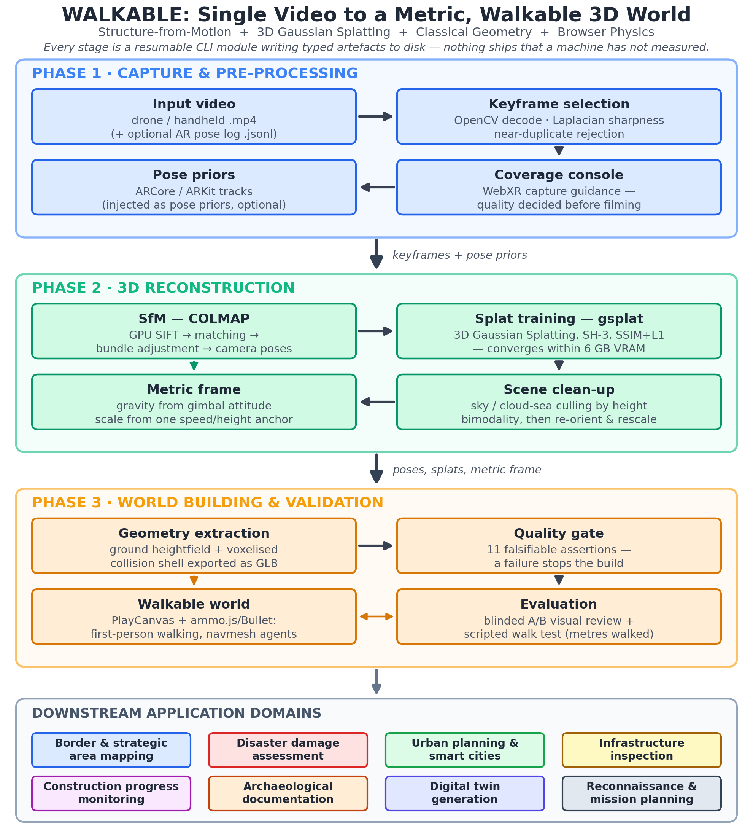
Figure 1. End-to-end methodology of the WALKABLE pipeline: Phase 1 capture and pre-processing; Phase 2 3D reconstruction; Phase 3 world building and validation — feeding the downstream application domains.
Phase 1 — Capture and pre-processing. An ordinary video (drone or handheld), with an optional ARCore/ARKit pose log, is decoded with OpenCV, scored by variance-of-Laplacian sharpness, and reduced to a diverse keyframe set. A WebXR capture console colours each surface patch by how many distinct viewing directions have covered it, so quality is decided at capture time rather than discovered at training time.
Phase 2 — 3D reconstruction. Keyframes are registered by COLMAP, with phone AR tracks injected as native pose priors that rescue rotation-heavy footage and carry a metric translation into registration. Those poses seed gsplat training (spherical harmonics degree 3, SSIM+L1, hard Gaussian cap) within 6 GB of VRAM; orientation comes from gimbal attitude, scale from exactly one named anchor, and sky and cloud-sea splats are culled by a height-histogram bimodality test.
Phase 3 — World building and validation. Splat means are rasterised into a ground heightfield and a voxelised collision shell exported as GLB; an eleven-assertion quality gate fails the build rather than shipping a broken world. The validated assets load into a browser runtime (PlayCanvas + ammo.js/Bullet) for first-person walking and navmesh agents, and acceptance is scored two ways: blinded A/B visual review against real frames, and scripted traversal in metres walked.
Design principles. Each stage is a separate CLI module with typed artefacts on disk, so runs are resumable and inspectable; re-running a stage invalidates everything downstream; and the neural stage is trusted with appearance only — never geometry, orientation, or scale.

6. Work Done
The pipeline is implemented and validated end-to-end: ~18,000 lines of first-party Python 3.12 and JavaScript across 35 resumable stage modules, driven by one command (mvp.bat run <scene>), with a ~550-assertion test suite and a vendored browser runtime that needs no build step. Table 2 lists measured outcomes on the target hardware (RTX 3050 6 GB laptop).
Result | Evidence
Hardware budget | Peak training VRAM 1.26 GB at the high preset — 5× headroom under the 6 GB card
Visual quality | 10/10 blinded A/B pairs judged to be the same scene, no disqualifying artefact
Walkability | 65.3 m walked, 16/16 waypoints reached, 0 falls (from 19.9 m, 1/20 before fixes)
Ground correctness | Viewer vs. physics ground discrepancy reduced from 0.101 m to 0.000 m
Metric priors | Synthetic 12 m AR walk reconstructs at scale 1.0000, 7 mm max camera deviation
Table 2. Measured outcomes of the implemented pipeline (target hardware: RTX 3050 6 GB laptop).
Eleven engineering iterations are documented with the measurement that changed each decision, and 2 of 8 test scenes still fail the route gate — the build reports this rather than hiding it.

References
[1] Mildenhall, B., Srinivasan, P. P., Tancik, M., Barron, J. T., Ramamoorthi, R., & Ng, R. (2020). NeRF: Representing scenes as neural radiance fields for view synthesis. In European Conference on Computer Vision (ECCV), 405–421.
[2] Schönberger, J. L., & Frahm, J.-M. (2016). Structure-from-motion revisited. In IEEE Conference on Computer Vision and Pattern Recognition (CVPR), 4104–4113.
[3] Kerbl, B., Kopanas, G., Leimkühler, T., & Drettakis, G. (2023). 3D Gaussian splatting for real-time radiance field rendering. ACM Transactions on Graphics, 42(4), Article 139.
[4] Nex, F., & Remondino, F. (2014). UAV for 3D mapping applications: A review. Applied Geomatics, 6(1), 1–15.
[5] Rakha, T., & Gorodetsky, A. (2018). Review of unmanned aerial system (UAS) applications in the built environment: Towards automated building inspection procedures using drones. Automation in Construction, 93, 252–264.

