**Name: Gondaliya Krish D(19BCE072)**

**Hadiya Pratik D (19BCE072)**

**Date: 10/11/2022**

**Course: Blockchain Technology (2CSDE93)**

**Practical 5**

**Aim:** To perform thorough study and installation of Remix IDE and Truffle IDE for deploying Smart Contracts and Decentralized Applications (dapps) and create and deploy a Smart Contract for any application such as finance, healthcare etc.

This is a group activity. The groups are formed by students and will be evaluated accordingly.

The group will create smart contact for the application of their interest as specified for the term paper evaluation.

**Code:**

pragma solidity >=0.5.3;

contract Open_Source

{

    struct Tools

    {

        address id;

        string author_name;

        string tool_name;

        string contribution_type;

        string Github_link;

    }

    struct user

    {

        address id;

        string user;

        string User_type;

        Tools tool;

    }

    struct issue

    {

        address id;

        Tools tool;

    }

    issue[] private Reports;

    user[] private Users;

    user[] private userdata;

    Tools[] private authordata;

    Tools[] private all_tools;

    Tools[] private GUI_tools;

    Tools[] private Website_tools;

    Tools[] private Database_tools;

    Tools[] private AI_tools;

    Tools[] private Blockchain_tools;

    function GUI_contribution(string memory author_name,string memory _tool,string memory _link) public

    {

        GUI_tools.push(Tools(msg.sender,author_name,_tool,"GUI_tool",_link));

        all_tools.push(Tools(msg.sender,author_name,_tool,"GUI_tool",_link));

    }

    function show_GUI_tools() public view returns(Tools[] memory)

    {

        return GUI_tools;

    }

    function Website_contribution(string memory author_name,string memory _tool,string memory _link) public

    {

        Website_tools.push(Tools(msg.sender,author_name,_tool,"Website_tool",_link));

        all_tools.push(Tools(msg.sender,author_name,_tool,"Website_tool",_link));

    }

    function show_Website_tools() public view returns(Tools[] memory)

    {

        return Website_tools;

    }

    function Database_contribution(string memory author_name,string memory _tool,string memory _link) public

    {

        Database_tools.push(Tools(msg.sender,author_name,_tool,"Database_tool",_link));

        all_tools.push(Tools(msg.sender,author_name,_tool,"Database_tool",_link));

    }

    function show_Database_tools() public view returns(Tools[] memory)

    {

        return Database_tools;

    }

    function AI_contribution(string memory author_name,string memory _tool,string memory _link) public

    {

        AI_tools.push(Tools(msg.sender,author_name,_tool,"AI_tool",_link));

        all_tools.push(Tools(msg.sender,author_name,_tool,"AI_tool",_link));

    }

    function show_AI_tools() public view returns(Tools[] memory)

    {

        return AI_tools;

    }

    function Blockchain_contribution(string memory author_name,string memory _tool,string memory _link) public

    {

        Blockchain_tools.push(Tools(msg.sender,author_name,_tool,"Blockchain_tool",_link));

        all_tools.push(Tools(msg.sender,author_name,_tool,"Blockchain_tool",_link));

    }

    function show_Blockchain_tools() public view returns(Tools[] memory)

    {

        return Blockchain_tools;

    }

    function get_authordata() public

    {

        for(uint i=0;i<all_tools.length;i++)

        {

            if(all_tools[i].id==msg.sender)

                authordata.push(all_tools[i]);

        }

    }

    function show_author_data() public view returns (Tools[] memory)

    {

        return authordata;

    }

    function use(string memory user_name,string memory user_type,string memory tool_type,uint tool_index) public

    {

        if(keccak256(abi.encodePacked(tool_type)) == keccak256(abi.encodePacked("GUI")))

        {

            Users.push(user(msg.sender,user_name,user_type,GUI_tools[tool_index]));

        }

        else if(keccak256(abi.encodePacked(tool_type)) == keccak256(abi.encodePacked("Website")))

        {

            Users.push(user(msg.sender,user_name,user_type,Website_tools[tool_index]));

        }

        else if(keccak256(abi.encodePacked(tool_type)) == keccak256(abi.encodePacked("Database")))

        {

            Users.push(user(msg.sender,user_name,user_type,Database_tools[tool_index]));

        }

        else if(keccak256(abi.encodePacked(tool_type)) == keccak256(abi.encodePacked("AI")))

        {

            Users.push(user(msg.sender,user_name,user_type,AI_tools[tool_index]));

        }

        else if(keccak256(abi.encodePacked(tool_type)) == keccak256(abi.encodePacked("Blockchain")))

        {

            Users.push(user(msg.sender,user_name,user_type,Blockchain_tools[tool_index]));

        }

    }

    function get_userdata() public

    {

        for(uint i=0;i<Users.length;i++)

        {

            if(Users[i].id==msg.sender)

                userdata.push(Users[i]);

        }

    }

    function show_user_data() public view returns (user[] memory)

    {

        return userdata;

    }

    function Report_issue(string memory tool_type,uint tool_index) public

    {

        if(keccak256(abi.encodePacked(tool_type)) == keccak256(abi.encodePacked("GUI")))

        {

            Reports.push(issue(msg.sender,GUI_tools[tool_index]));

        }

        else if(keccak256(abi.encodePacked(tool_type)) == keccak256(abi.encodePacked("Website")))

        {

            Reports.push(issue(msg.sender,Website_tools[tool_index]));

        }

        else if(keccak256(abi.encodePacked(tool_type)) == keccak256(abi.encodePacked("Database")))

        {

            Reports.push(issue(msg.sender,Database_tools[tool_index]));

        }

        else if(keccak256(abi.encodePacked(tool_type)) == keccak256(abi.encodePacked("AI")))

        {

            Reports.push(issue(msg.sender,AI_tools[tool_index]));

        }

        else if(keccak256(abi.encodePacked(tool_type)) == keccak256(abi.encodePacked("Blockchain")))

        {

            Reports.push(issue(msg.sender,Blockchain_tools[tool_index]));

        }

    }

    function show_reports() public view returns(issue[] memory)

    {

        return Reports;

    }

}

Output:

**Output:**

Deployed Smart Contract for Blockchain Based Open-Source Tools.

New GUI_contribution Added

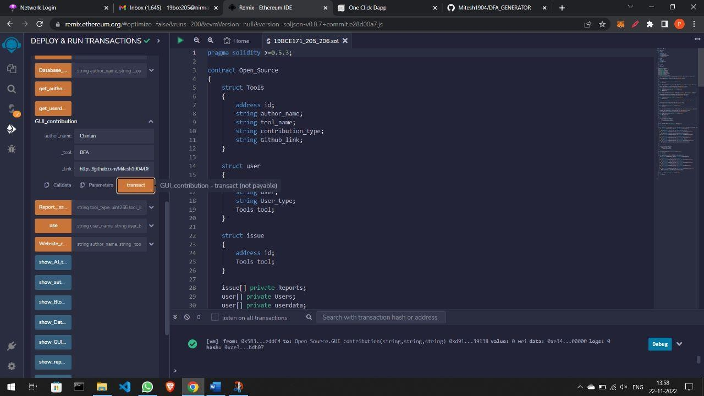

Show GUI Contribution:

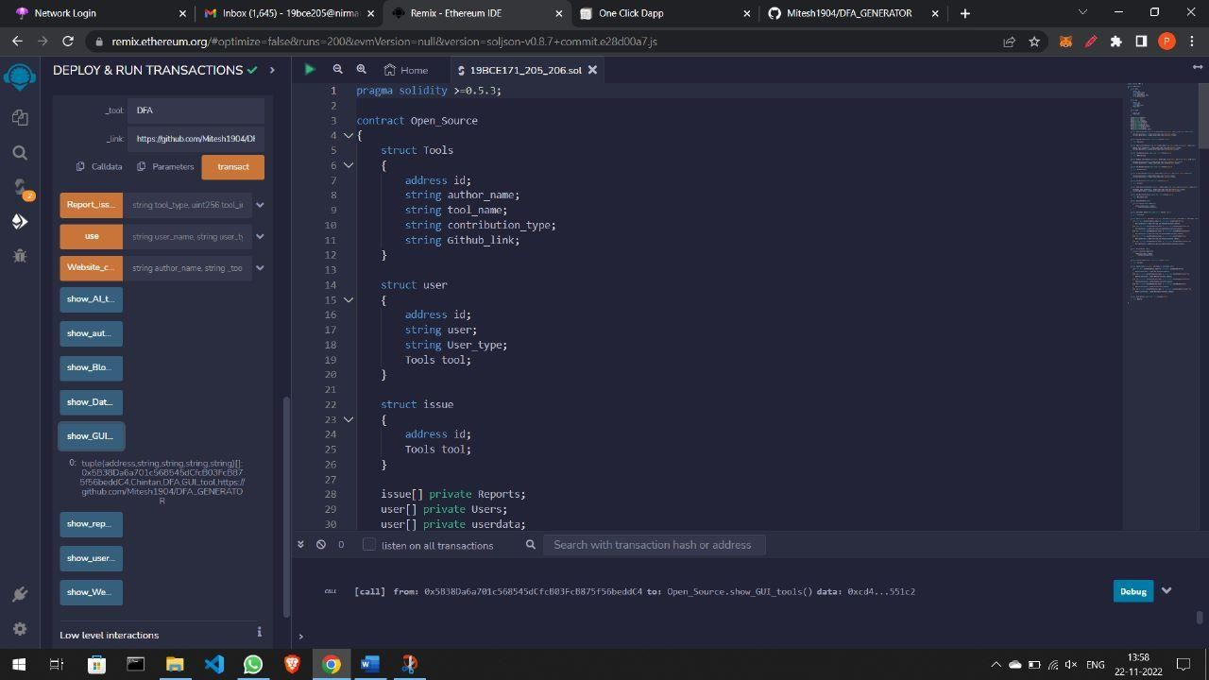

New User added:

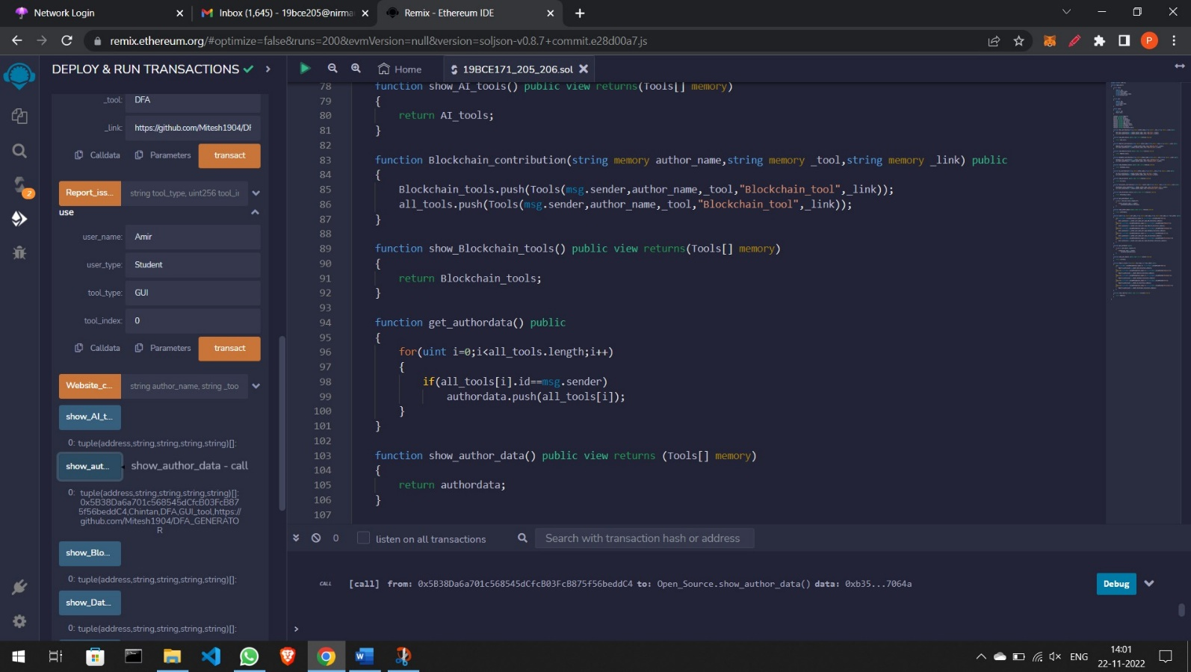

Show user:

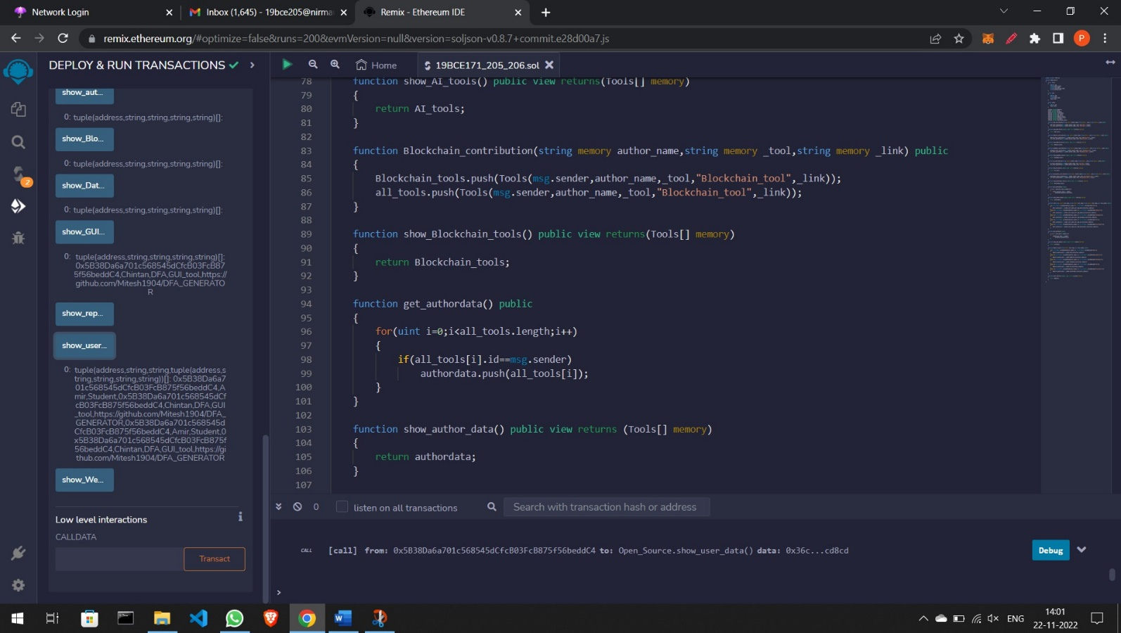

**Report Issue:**

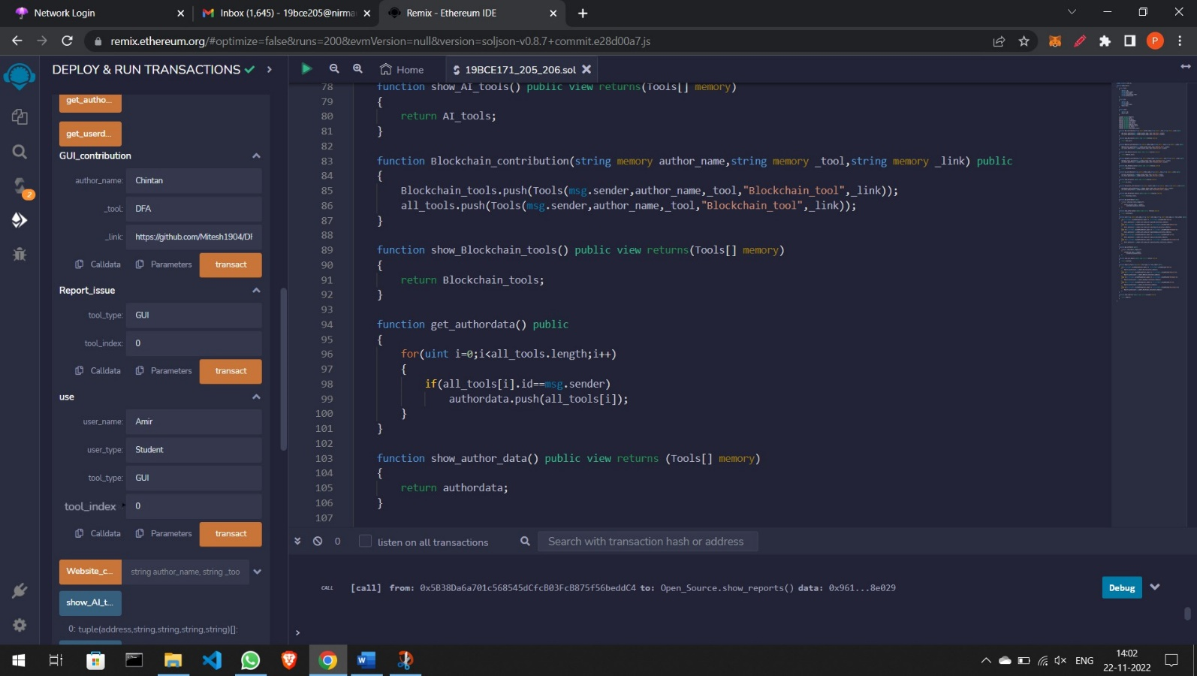

**Show Report Issue:**

