**Roll number – 19BCE072**

**Name – Gondaliya Krish D**

**Blockchain Technology**

**Practical – 7**

**Aim :** To perform a thorough study of blockchain development on Hyperledger Fabric using Composer

**Implementation Details :**

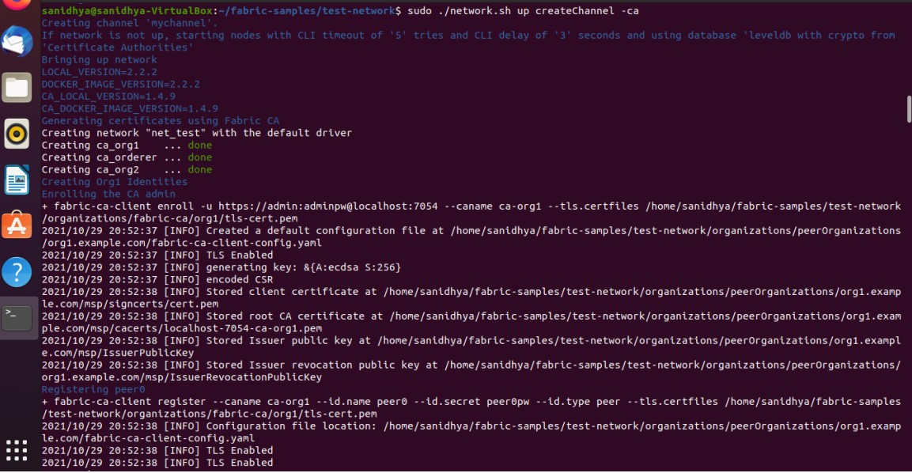

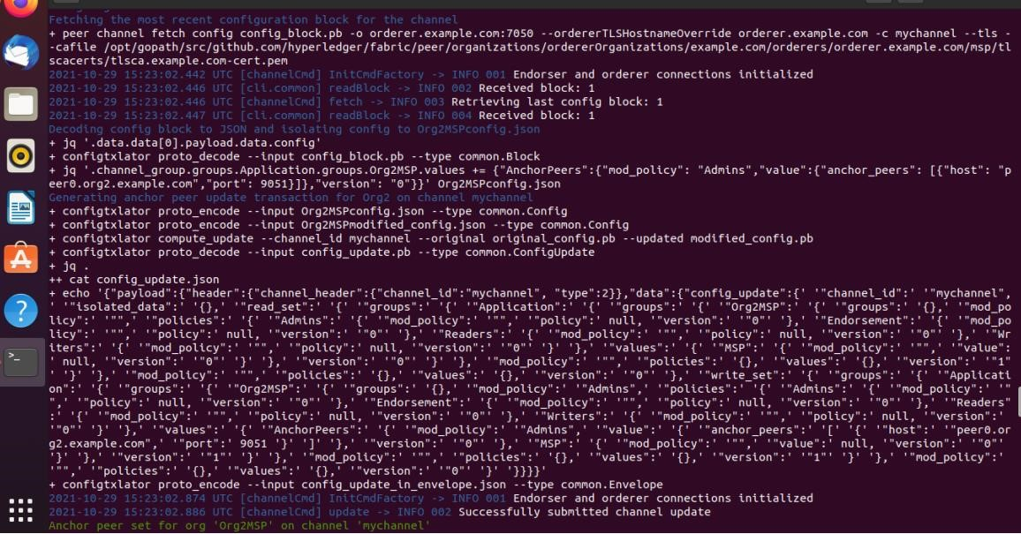

* It creates a channel named mychannel and also allows two peers, org1 & org2 to join mychannel. Now we can run the sample chaincode in this channel between the two peers. The chaincode is the ERC-20 token contract, previously deployed in Practical 4. This version is writing in Golang and can be deployed using the following command:

sudo ./network.sh deployCC -ccn token_erc20 -ccp ../token-erc20/chaincode-go/ -ccl go

