**Roll number – 19BCE072**

**Name – Gondaliya Krish D**

**Blockchain Technology**

**Practical – 8**

**Aim :** To design and develop end-to-end decentralized applications (Dapps).

**Solidity Code :**

// SPDX-License-Identifier: MIT

pragma solidity ^0.8.0;

contract Autonomous {

address public caller;

struct Owner {

string name;

uint age;

uint location;

bool exists;

bool is_info_exchange;

}

struct Avs {

string name;

uint location;

bool exists;

}

mapping(address => Owner) owners;

mapping(address => Avs) avs;

constructor() payable {

caller = msg.sender;

}

function viewBalance() view public returns(uint) {

return address(this).balance;

}

function addOwner(address _id, string calldata _name, uint _age, uint

_location) external {

owners[_id].name = _name;

owners[_id].age = _age;

owners[_id].location = _location;

owners[_id].exists = true;

owners[_id].is_info_exchange = false;

}

function getOwner(address _id) view public returns (string memory, uint,

uint, bool) {

return (owners[_id].name, owners[_id].age, owners[_id].location,

owners[_id].is_info_exchange);

}

function addAvs(address _id, string calldata _name, uint _location) external

{

avs[_id].name = _name;

avs[_id].location = _location;

avs[_id].exists = true;

}

function getAvs(address _id) view public returns (string memory, uint) {

return (avs[_id].name, avs[_id].location);

}

function critcial_information_exchange(address ownerAddress, address payable

avsAddress) external returns (uint) {

require(owners[ownerAddress].exists == true, "Owner does not exist.");

require(avs[avsAddress].exists == true, "Avs does not exist.");

require(owners[ownerAddress].is_info_exchange == false, "Critcial Information

already exchanged.");

//Information exchange

owners[ownerAddress].is_info_exchange = true;

return 1;

}

}

**Input / Output and ScreenShots**

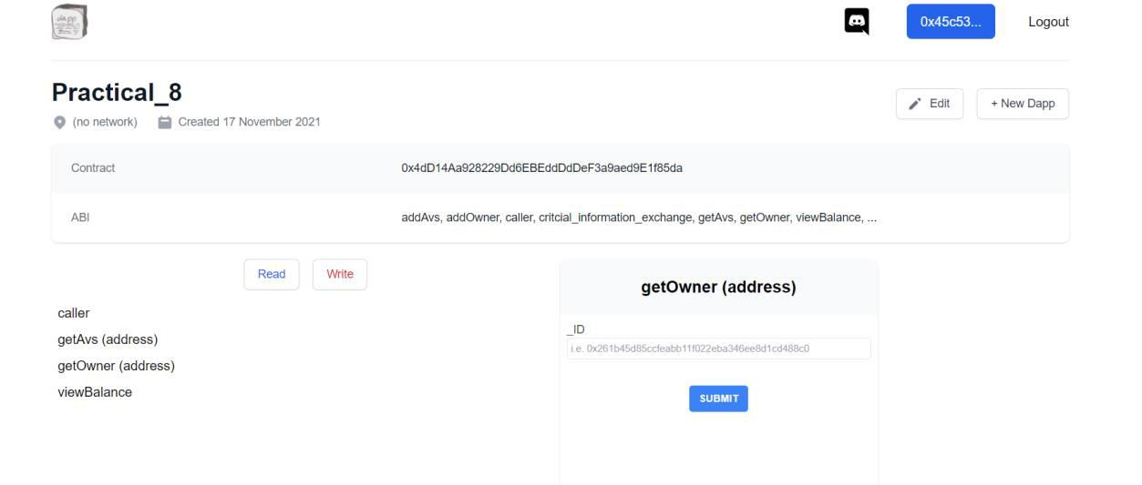

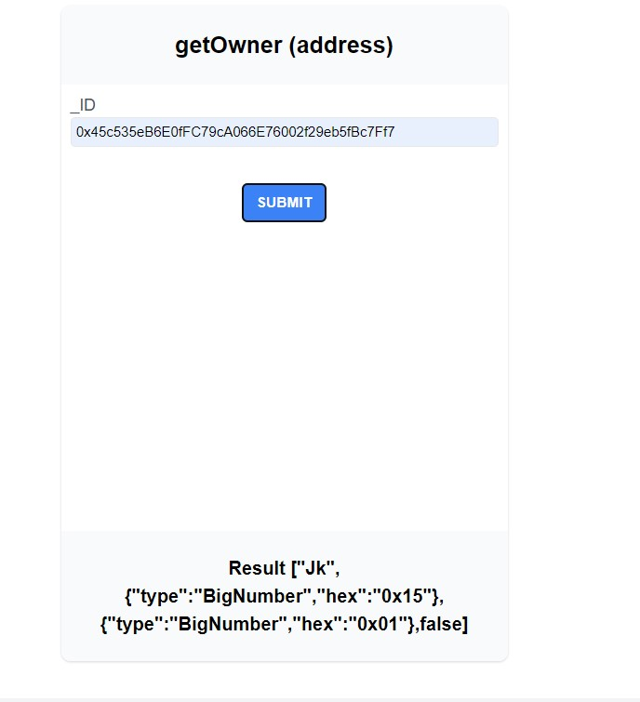

**Conclusion**

After completion of this practical I learnt how to create a Decentralized app using Dapp.