Report
Of
Image Recognition System
Submitted
To
School of Computer Science and Engineering
IILM University, Greater Noida, U.P.
In partial fulfilment of the requirement of degree of
B.Tech CSE

By
Roll Number of Student: 25SCS1003002651
Name of Student: KRISH RANA
Batch: 2025-29

CANDIDATE'S DECLARATION
I, KRISH RANA, do hereby declare that the internship report titled “Image Recognition System” has been completed by me to fulfil the requirement for the award of the degree of Bachelor of Technology in CSE. All the references have been quoted and I have not taken as such any material from any other source. I affirm to you that this report is my own and has not been submitted to any other institute for any degree/diploma requirement and further I shall be solely responsible for any kind of copyright violation in this regard.
Signature
Student Name: KRISH RANA
Roll No.: 25SCS1003002651

ACKNOWLEDGEMENT
I am using this opportunity to express my gratitude to everyone who supported me throughout the Internship Program. I am thankful for their aspiring guidance, invaluably constructive criticism and friendly advice during this work. I am sincerely grateful to them for sharing their truthful and illuminating views on a number of issues related to this work.
I would like to thank Codec Technologies Pvt. Ltd. for providing me the opportunity to undertake this internship, and my project mentors for their continuous support and guidance throughout the development of this project. I also thank the faculty of the School of Computer Science and Engineering, IILM University, for their encouragement.
I express my gratitude to my parents for their blessings.
Signature
Student Name: KRISH RANA
Roll No.: 25SCS1003002651

TABLE OF CONTENTS
Chapter No. | Chapter Name | Page Nos.
 | Cover Page | —
1. | Candidate's Declaration | i
2. | Acknowledgment | ii
3. | Internship Completion Certificate | iii
4. | Project Description  4.1 Introduction  4.2 Organization Profile  4.3 Problem Statement  4.4 Project Objectives  4.5 Scope of the Project  4.6 Technologies and Tools Used  4.7 System Architecture  4.8 Methodology  4.9 Expected Outcomes  4.10 Certificates of completion and other communication mail proof | 1
5. | Bibliography/References | —

INTERNSHIP COMPLETION CERTIFICATE
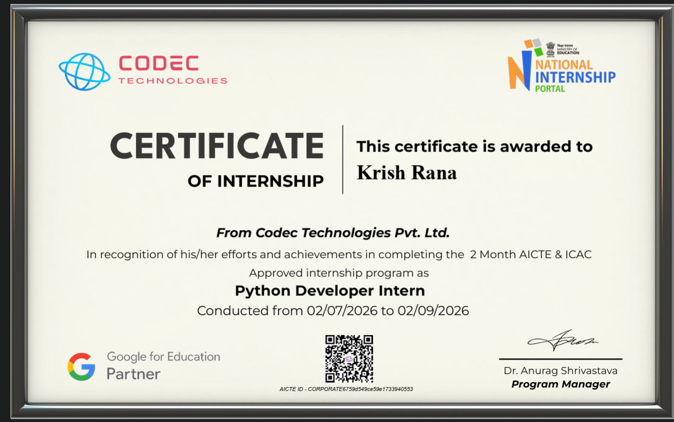

4. Project Description

4.1 Introduction
This internship report documents the design, implementation, and functioning of an Image Recognition System, developed as part of a 2-month internship undertaken as a Python Developer Intern at Codec Technologies Pvt. Ltd. The application is a self-contained, full-stack web application that lets a user upload an image and receive an automatic prediction of what object the image contains, along with a confidence score.
The system is built around a pretrained deep convolutional neural network (MobileNetV2) trained on the ImageNet dataset, combined with OpenCV for image preprocessing and a lightweight Flask backend for serving predictions. Rather than training a classifier from scratch — which requires large labeled datasets and significant compute — the project uses transfer learning in its simplest form: a model already trained on 1,000 general object categories is loaded directly and used for inference. This is the standard, practical approach for an image-classification demo or academic mini-project.

4.2 Organization Profile
Codec Technologies Pvt. Ltd. is a global platform dedicated to empowering learners and connecting diverse talent to create meaningful career opportunities worldwide. Codec Technologies delivers dedicated IT and business consultancy services across 27+ countries, empowering global innovation and strategic growth. The organization is a Google for Education Partner and is ISO 9001:2015 certified, and runs its internship programs through the National Internship Portal under an AICTE-approved corporate ID. The internship was carried out in Pan India, Hybrid mode, under the designation of Python Developer Intern, from 02/07/2026 to 02/09/2026, reporting to the assigned Project Head(s).

4.3 Problem Statement
Manually identifying and categorizing objects within images is slow and does not scale when large volumes of images need to be processed — for example, in inventory management, content moderation, or accessibility tools. Training a custom deep-learning model from scratch for such tasks is impractical for most small teams or academic projects, since it requires large labeled datasets and significant compute time. There is a need for a lightweight, practical system that can classify everyday objects in an uploaded image quickly and accurately, using a pretrained model rather than building one from the ground up, while remaining easy to deploy and run entirely offline after initial setup.

4.4 Project Objectives
- Build a working image-classification web application without training a model from scratch.
- Apply OpenCV for practical image decoding, resizing, and color-space conversion.
- Integrate a pretrained TensorFlow/Keras CNN (MobileNetV2) for real-time inference.
- Cache the downloaded model locally so the app can run fully offline after first use.
- Provide clear, human-readable predictions with confidence percentages and alternatives.
- Log every prediction to SQLite for a simple, queryable history.
- Implement robust validation and error handling across the upload-to-prediction pipeline.

4.5 Scope of the Project
The system accepts JPG/JPEG/PNG image uploads through a responsive, drag-and-drop web interface, validates file type and size on both client and server, and preprocesses the uploaded image with OpenCV to match the CNN's expected input format. It classifies the image using a pretrained MobileNetV2 model (ImageNet, 1000 classes) and returns the top prediction plus two runner-ups, persists every prediction (filename, predicted class, confidence, timestamp) to a SQLite database, and exposes a JSON history endpoint. Invalid files, oversized uploads, and unexpected errors are handled gracefully without crashing the server.

4.6 Technologies and Tools Used
Layer | Technology | Purpose
Backend | Python 3.9–11, Flask 3.0.3 | Web server, routing, request handling
Deep Learning | TensorFlow / Keras 2.16.1 (MobileNetV2) | Pretrained CNN for image classification (ImageNet, 1000 classes)
Image Processing | OpenCV (opencv-python 4.10.0.84) | Decode, resize, color-space conversion of uploaded images
Numerical Computing | NumPy 1.26.4 | Array operations feeding the model
Utilities | Pillow 10.4.0, Werkzeug 3.0.3 | Image handling support; secure filename handling
Database | SQLite (built-in sqlite3) | Local, file-based prediction history logging
Frontend | HTML5, CSS3, Vanilla JavaScript | Drag-and-drop upload UI, live preview, AJAX calls

4.7 System Architecture
The application follows a simple three-tier architecture: a browser-based upload/preview UI, a Flask backend that exposes REST endpoints, and an inference layer combining OpenCV preprocessing with a cached MobileNetV2 model, backed by a SQLite prediction log. The user selects or drags an image into the web UI, which shows a live preview. On submission, the frontend sends the image as multipart/form-data to POST /predict. Flask (app.py) validates the request, saves the file under a UUID-based safe filename, decodes and preprocesses it with OpenCV, and passes it to the cached MobileNetV2 model for inference. The top prediction and confidence are logged to SQLite and returned to the frontend as JSON.
Component flow (textual):
Browser (index.html + script.js) → Flask App (app.py) → OpenCV preprocessing → MobileNetV2 (model/model.h5) → SQLite (predictions.db) → JSON reply back to Browser

4.8 Methodology
The system uses a transfer-learning approach: instead of training a convolutional neural network from scratch, it reuses MobileNetV2, a network already trained on ImageNet, and applies it directly for inference:
- Model loading: on start-up, the app checks for a cached model/model.h5; if absent, MobileNetV2(weights="imagenet") downloads the pretrained weights once and saves a local copy for offline reuse.
- Decode: raw uploaded bytes are decoded into an OpenCV BGR image array using cv2.imdecode().
- Resize: the image is resized to 224×224 pixels, MobileNetV2's expected input size, using cv2.resize().
- Color conversion: the color order is converted from BGR to RGB using cv2.cvtColor(), since OpenCV loads images in BGR by default.
- Batch & normalize: the array is expanded to shape (1, 224, 224, 3) and passed through Keras's preprocess_input() for MobileNetV2-specific normalization.
- Predict & decode: model.predict() outputs a 1,000-way probability vector, and decode_predictions() maps the top-3 probabilities back to human-readable ImageNet labels, which are logged to SQLite (predictions table: id, filename, predicted_class, confidence, created_at).

4.9 Expected Outcomes
- A fully functional, locally-hosted image classifier capable of identifying objects across 1,000 general ImageNet categories.
- Accurate top-1 predictions with confidence percentages, plus two runner-up predictions for additional context.
- A persistent, queryable log of every prediction for review and analytics.
- A responsive, drag-and-drop upload interface that works smoothly on both desktop and mobile browsers.
- A codebase that is easy to extend — a custom-trained model can be substituted with minimal changes to the model-loading and preprocessing sections.
- Hands-on, industry-level experience applying computer vision, deep learning inference, and full-stack web development as part of the internship program.

4.10 Certificates of completion and other communication mail proof
The Internship Offer Letter issued by Codec Technologies Pvt. Ltd. is attached below as proof of the internship engagement.


5. Bibliography/References
1. TensorFlow / Keras Documentation — https://www.tensorflow.org/api_docs
2. OpenCV Documentation — https://docs.opencv.org/
3. Flask Documentation — https://flask.palletsprojects.com/
4. ImageNet / MobileNetV2 — https://keras.io/api/applications/mobilenet/
5. Python 3 Documentation — https://docs.python.org/3/
6. SQLite Documentation — https://www.sqlite.org/docs.html
7. Codec Technologies Pvt. Ltd. — https://www.codectechnologies.in

