A Report
On
Pulse — AI-Powered Sentiment Analyzer for Social Media, Customer Feedback and Product Reviews
Submitted To
School of Computer Science and Engineering
IILM University, Greater Noida, U.P.
In partial fulfilment of the requirement of the degree of
B.Tech CSE

By
Roll Number of Student: 25SCS1003002651
Name of Student: KRISH RANA
Batch: 2025-29

CANDIDATE'S DECLARATION
I, KRISH RANA, do hereby declare that the internship report titled "Pulse — AI-Powered Sentiment Analyzer for Social Media, Customer Feedback and Product Reviews" has been completed by me to fulfil the requirement for the award of the degree of Bachelor of Technology in CSE. All the references have been quoted and I have not taken as such any material from any other source. I affirm that this report is my own and has not been submitted to any other institute for any degree/diploma requirement, and further I shall be solely responsible for any kind of copyright violation in this regard.
Signature: ____________________
Student Name: KRISH RANA
Roll No.: 25SCS1003002651

ACKNOWLEDGEMENT
I am using this opportunity to express my gratitude to everyone who supported me throughout the internship program. I am thankful for their aspiring guidance, invaluably constructive criticism and friendly advice during this work. I am sincerely grateful to Dr. Anurag Shrivastava, Program Manager, Codec Technologies Pvt. Ltd., and the entire project mentoring team for their continuous support, timely feedback and encouragement throughout the two-month internship, which enabled me to design, build and document the “Pulse” sentiment analyzer project successfully.
I would also like to thank the School of Computer Science and Engineering, IILM University, Greater Noida, for providing me the opportunity and platform to undertake this industry internship as part of my B.Tech curriculum, and for their academic guidance throughout the duration of this work.
Finally, I express my heartfelt gratitude to my parents, family and friends for their unwavering support, encouragement and blessings.
Signature: ____________________
Student Name: KRISH RANA
Roll No.: 25SCS1003002651

TABLE OF CONTENTS
Chapter No. | Chapter Name | Page No.
 | Cover Page | —
1. | Candidate's Declaration | i
2. | Acknowledgement | ii
3. | Internship Completion Certificate | iv
4. | Project Description | 1
 | 4.1 Introduction | 1
 | 4.2 Organization Profile | 2
 | 4.3 Problem Statement | 3
 | 4.4 Project Objectives | 4
 | 4.5 Scope of the Project | 5
 | 4.6 Technologies and Tools Used | 6
 | 4.7 System Architecture | 7
 | 4.8 Methodology | 9
 | 4.9 Expected Outcomes | 10
 | 4.10 Certificates of Completion and Communication Proof | 11
5. | Bibliography / References | 13

INTERNSHIP COMPLETION CERTIFICATE
This is to certify that the internship titled below was successfully completed at Codec Technologies Pvt. Ltd. under the AICTE & ICAC approved internship program, in association with the National Internship Portal, Ministry of Education, Government of India. The certificate issued upon successful completion is reproduced below.
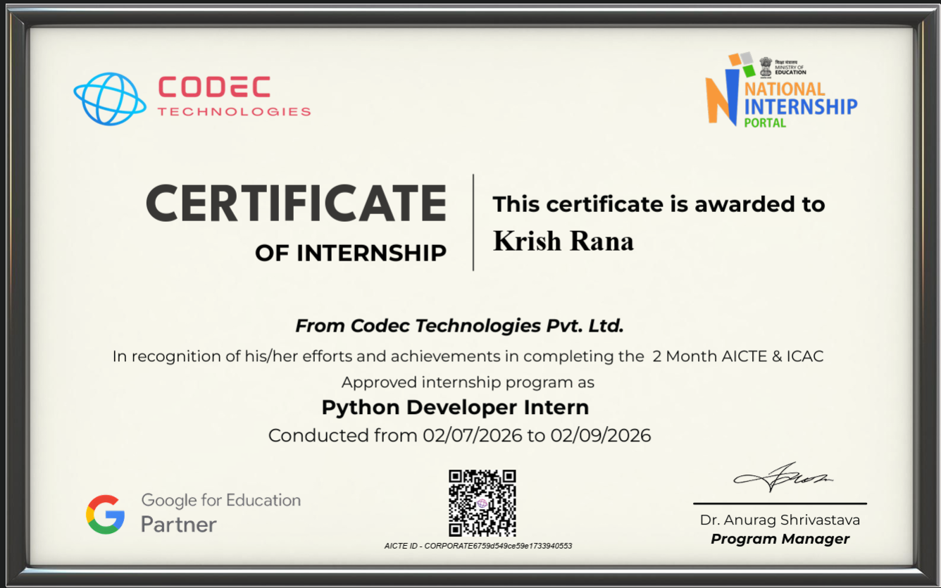
Fig. 3.1 – Certificate of Internship, Codec Technologies Pvt. Ltd.

4. Project Description

4.1 Introduction
Every day, organizations are flooded with unstructured text — product reviews, social media posts, support tickets and customer feedback forms — that carries valuable information about how people feel about a brand, product or service. Manually reading and tagging this volume of text does not scale, which has made automated sentiment analysis one of the most widely applied Natural Language Processing (NLP) techniques in industry today.
As part of a two-month internship as a Python Developer Intern at Codec Technologies Pvt. Ltd., I designed and built “Pulse”, a full-stack AI-powered sentiment analysis web application. Pulse takes free-form text — a single review or a bulk batch of hundreds of entries — and classifies each piece as Positive, Negative or Neutral using a pre-trained Transformer language model, stores the results persistently, and presents them through an interactive analytics dashboard.
This report documents the problem the project addresses, the organization I interned with, the objectives and scope of the work, the technology stack chosen, the system architecture and methodology followed during development, and the outcomes achieved by the end of the internship.

4.2 Organization Profile
Codec Technologies Pvt. Ltd. is a global platform dedicated to empowering learners and connecting diverse talent to meaningful career opportunities worldwide. The organization delivers dedicated IT and business consultancy services across 27+ countries, with a focus on empowering global innovation and strategic growth through hands-on, project-based internship programs.
The internship program undertaken for this project was a 2-Month AICTE & ICAC approved internship, conducted in association with the National Internship Portal (Ministry of Education, Government of India), under the designation of Python Developer Intern. The program was delivered in Pan-India, hybrid mode, with progress reviewed weekly by an assigned project supervisor. Codec Technologies is recognized as a Google for Education Partner and is ISO 9001:2015 certified for its quality management practices.
Organization | Codec Technologies Pvt. Ltd.
Designation | Python Developer Intern
Duration | 02/07/2026 to 02/09/2026 (2 Months)
Mode / Location | Pan India, Hybrid
Reporting To | Assigned Project Head(s)
Program Manager | Dr. Anurag Shrivastava
Certifications | ISO 9001:2015 Certified; Google for Education Partner
Table 4.1 – Internship Profile Summary

4.3 Problem Statement
Businesses increasingly rely on customer reviews, social media mentions and support conversations to gauge public perception, but the volume of this text data makes manual review impractical. Existing solutions are often either too generic to customize and self-host, or require significant machine learning expertise to set up. There is a need for a lightweight, self-contained web application that can:
- Accept a single piece of text or a bulk file (CSV/TXT) of customer feedback.
- Automatically classify each entry as Positive, Negative or Neutral with a measurable confidence score.
- Persist the analyzed results so that trends can be tracked over time.
- Present the aggregated results visually, so that non-technical stakeholders can understand sentiment trends at a glance.
Pulse was conceived and built during the internship specifically to address this gap for small teams and individual analysts who need a fast, self-hosted sentiment analysis tool without depending on a paid third-party API.

4.4 Project Objectives
The key objectives defined for the project were:
- To design and implement a REST API capable of analyzing both single and bulk text inputs for sentiment.
- To integrate a pre-trained Transformer-based NLP model capable of three-class sentiment classification (Positive / Negative / Neutral) rather than a simplistic binary classifier.
- To design a persistent data layer using MongoDB to store every analyzed review along with its confidence scores and metadata.
- To build a responsive, browser-based user interface that supports single-text analysis, bulk file upload, and a visual analytics dashboard.
- To implement robust server-side validation and error handling so that the API degrades gracefully under invalid input or database unavailability.
- To document the system thoroughly, including setup instructions, API reference, and architecture, to the standard expected of a production-ready internal tool.

4.5 Scope of the Project
The scope of Pulse, as built during this internship, covers:
- Single-text sentiment analysis with an instant confidence breakdown across all three sentiment classes.
- Bulk analysis of up to 500 text entries per request, submitted either as a CSV/TXT file upload or as a JSON list.
- Persistent storage of every analyzed review in MongoDB, including the text, predicted sentiment, confidence score, per-class probability distribution, source (single/bulk) and timestamp.
- A paginated, filterable results view and an aggregated analytics dashboard with total-review counts, per-sentiment percentage splits, average confidence per class, and pie/bar chart visualizations.
- A documented REST API (health check, single analyze, bulk analyze, results, dashboard) that can be consumed independently of the bundled web UI.
The following were intentionally kept out of scope for the two-month internship timeframe: multi-language sentiment support, user authentication/multi-tenancy, real-time social media stream ingestion, and fine-tuning a custom model (the project instead uses a strong pre-trained model that is swappable via configuration).

4.6 Technologies and Tools Used
Pulse was built entirely on an open-source stack, chosen to balance developer productivity, model quality and ease of self-hosting:
Layer | Technology / Tool
Programming Language | Python 3.9+
Backend Framework | Flask 3.0, Flask-CORS
NLP / Machine Learning | Hugging Face Transformers, PyTorch — model: cardiffnlp/twitter-roberta-base-sentiment-latest
Database | MongoDB (accessed via PyMongo)
Frontend | HTML5, CSS3, vanilla JavaScript, Chart.js
Configuration | python-dotenv (.env-based configuration)
Version Control | Git
Table 4.2 – Technology Stack Summary
The sentiment model, cardiffnlp/twitter-roberta-base-sentiment-latest, is a RoBERTa model fine-tuned on approximately 124 million tweets. It was selected because it natively outputs three classes (negative, neutral, positive), removing the need for any custom post-processing logic that a binary classifier would otherwise require.

4.7 System Architecture
Pulse follows a classic layered web-application architecture, cleanly separating presentation, application logic, machine-learning inference and data persistence into independent modules, as illustrated in Figure 4.1:
- Presentation Layer — templates/index.html rendered by Flask, styled with static/css/style.css and driven by static/js/app.js, which talks to the backend purely through fetch()-based JSON calls. Three tabs (Analyze, Bulk Upload, Dashboard) share a single-page shell.
- Application Layer — app.py, the Flask entry point that exposes the REST API, performs request validation, uniform JSON error handling (via Flask error handlers) and delegates work to the model and database layers.
- Inference Layer — sentiment_model.py, which lazily loads and caches the Hugging Face pipeline (using functools.lru_cache) so that the ≈500 MB Transformer model is loaded into memory only once per server process, then exposes analyze_text() and analyze_batch() functions.
- Data Access Layer — db.py, which wraps PyMongo to insert single/bulk reviews, fetch paginated and filtered results, and compute dashboard aggregates using MongoDB's aggregation pipeline.
- Persistence — a MongoDB reviews collection, indexed on created_at (descending) and sentiment for efficient querying, storing every analyzed entry.
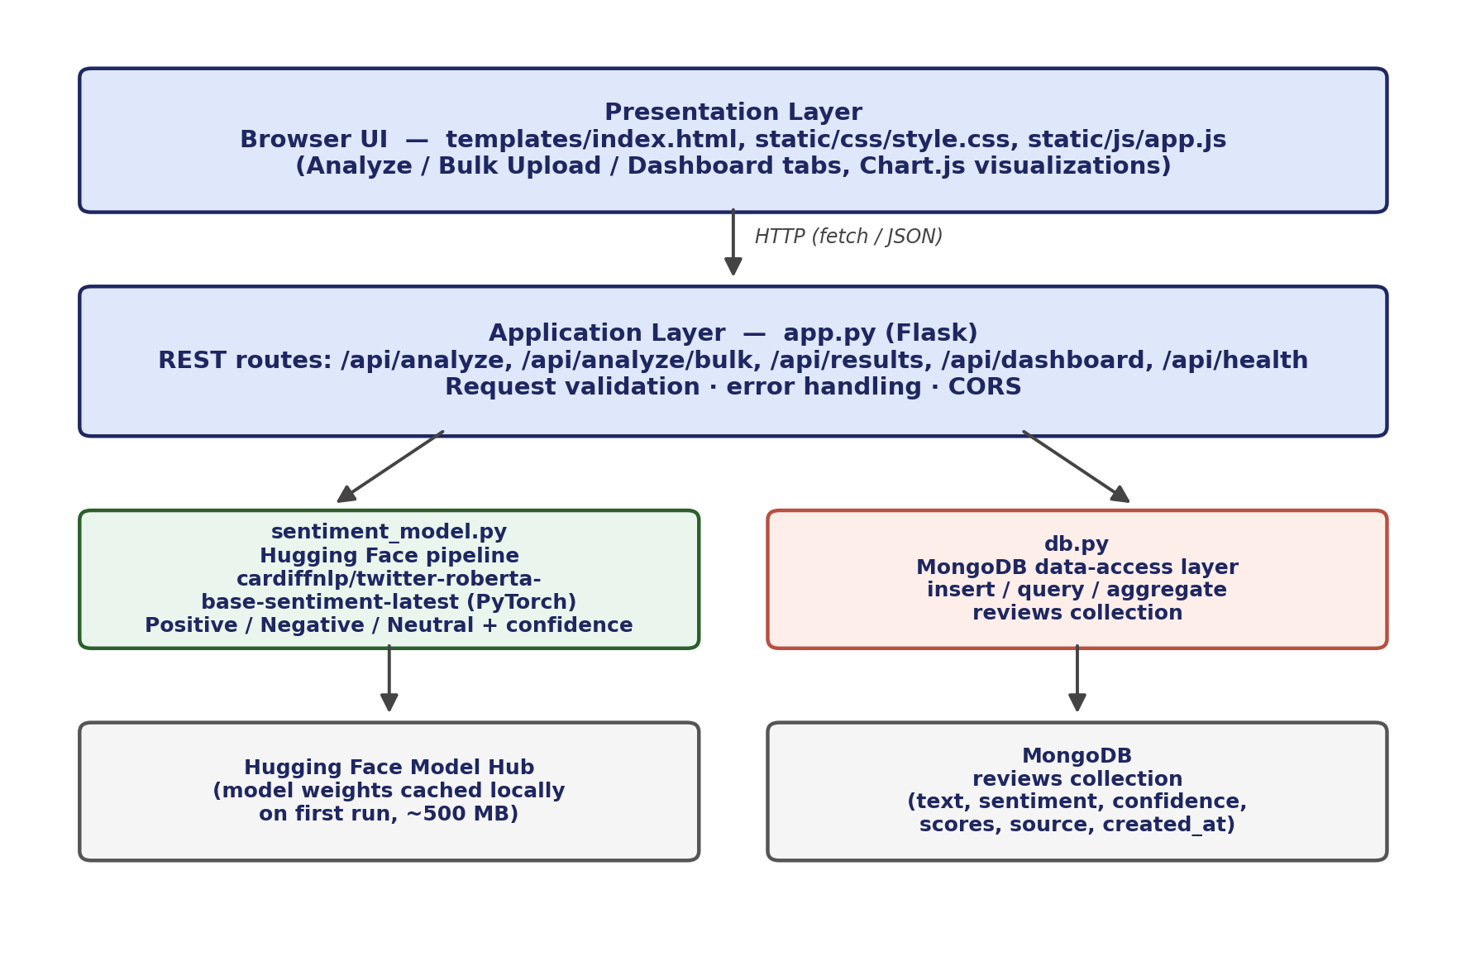
Fig. 4.1 – Layered System Architecture of Pulse
This separation of concerns means the inference logic or the database technology can each be replaced independently — for example, swapping MongoDB for PostgreSQL, or the Transformer model for a different Hugging Face checkpoint — without touching the other layers, which was an explicit design goal for maintainability.

4.8 Methodology
The project was executed using an iterative, milestone-driven methodology suited to the two-month internship timeline, moving from requirement analysis through to a documented, testable deliverable:
Phase | Activity | Key Deliverable
Week 1–2 | Requirement analysis, model research and stack selection | Finalized tech stack; model shortlist evaluated for 3-class output
Week 3–4 | Inference layer and REST API development | sentiment_model.py, app.py with /api/analyze and /api/health
Week 5 | Database schema design and integration | db.py; MongoDB reviews collection with indexes
Week 6 | Bulk upload endpoint and CSV/TXT parsing | /api/analyze/bulk with validation and partial-failure handling
Week 7 | Frontend UI and dashboard with Chart.js | Analyze / Bulk Upload / Dashboard tabs; pie & bar charts
Week 8 | Testing, error handling review, and documentation | README, API reference, this report
Table 4.3 – Development Methodology and Timeline
Throughout each phase, functionality was validated manually against the REST API using sample requests (e.g. curl), and every server-side route was designed defensively: empty or oversized input is rejected before it reaches the model, and database failures are caught so that an analysis result can still be returned to the caller even if persistence temporarily fails.

4.9 Expected Outcomes
By the end of the internship, Pulse achieves the following outcomes:
- A working, end-to-end sentiment analysis pipeline that classifies arbitrary text into Positive, Negative or Neutral with a per-class confidence score in real time.
- A bulk-processing capability that can analyze up to 500 entries from a single CSV/TXT upload or JSON payload in one request, with per-item success/failure reporting.
- A persistent MongoDB-backed history of every analyzed review, queryable by page and sentiment filter through the /api/results endpoint.
- A live analytics dashboard showing total reviews analyzed, sentiment distribution percentages, average confidence per class, and chart-based visual summaries.
- A documented, five-endpoint REST API that can be integrated into other tools independent of the bundled UI.
- Practical, hands-on experience with production-style Python backend development, Transformer-based NLP inference, NoSQL schema design and full-stack integration — directly reinforcing the Python Developer Intern learning outcomes of the internship program.

4.10 Certificates of Completion and Other Communication Mail Proof
This section attaches the official internship offer letter and the certificate of completion issued by Codec Technologies Pvt. Ltd. on successful conclusion of the 2-month AICTE & ICAC approved Python Developer Intern program, verifiable via the QR code and AICTE ID printed on the certificate, and cross-referenced with the National Internship Portal, Ministry of Education, Government of India.
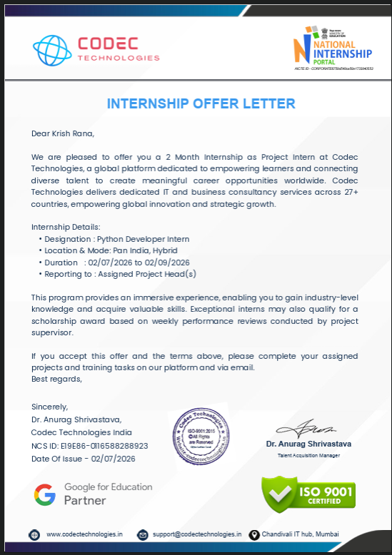
Fig. 4.2 – Internship Offer Letter, Codec Technologies Pvt. Ltd.
Fig. 4.3 – Certificate of Internship Completion, Codec Technologies Pvt. Ltd.

5. Bibliography / References
[1] Barbieri, F., Camacho-Collados, J., Espinosa Anke, L., & Neves, L. (2020). TweetEval: Unified Benchmark and Comparative Evaluation for Tweet Classification. Findings of EMNLP 2020.
[2] Liu, B. (2012). Sentiment Analysis and Opinion Mining. Synthesis Lectures on Human Language Technologies, Morgan & Claypool Publishers.
[3] Liu, Y., Ott, M., Goyal, N., et al. (2019). RoBERTa: A Robustly Optimized BERT Pretraining Approach. arXiv:1907.11692.
[4] Vaswani, A., Shazeer, N., Parmar, N., et al. (2017). Attention Is All You Need. Advances in Neural Information Processing Systems (NeurIPS).
[5] Hugging Face. Transformers Documentation. https://huggingface.co/docs/transformers
[6] Hugging Face. cardiffnlp/twitter-roberta-base-sentiment-latest — Model Card. https://huggingface.co/cardiffnlp/twitter-roberta-base-sentiment-latest
[7] Flask Documentation. Pallets Projects. https://flask.palletsprojects.com/
[8] MongoDB, Inc. PyMongo Driver Documentation. https://pymongo.readthedocs.io/
[9] Chart.js Documentation. https://www.chartjs.org/docs/
[10] Codec Technologies Pvt. Ltd. Internship Offer Letter and Certificate of Internship, Python Developer Intern Program (02/07/2026 – 02/09/2026).

