STEP BY STEP EXPLINATION OF ARCHIECTURE WORKING:

1. Check if the user is Authorize user or not.
2. Generate the authorize token for every valid user.
3. Receives the request from the user.
4. Check the request is generated from authorized user or not.
5. If the request is coming from the valid user then request is receive by the API Gateway and forwards to lambda.
6. Lambda triggers events based on the user request if user generates get request it will fetch the information from the database or if it is put request then it will update the information on database.

SERVICES USED AND ITS EXPLINATION:

1. DYNAMO DB: it is a distributed schemaless nosql distributed storage services, dynamodb you no need to worry about the storage limits it supports horizontal scaling.
2. LAMDA : It is used to run your code without worrying about managing the servers and you can also pay for the time we use.
3. API GATEWAY : It is fully managed API service helps developers to create and manage there APIS.
4. COGNITO : It maintains users login and signup information for web applications and mobile applicatios.

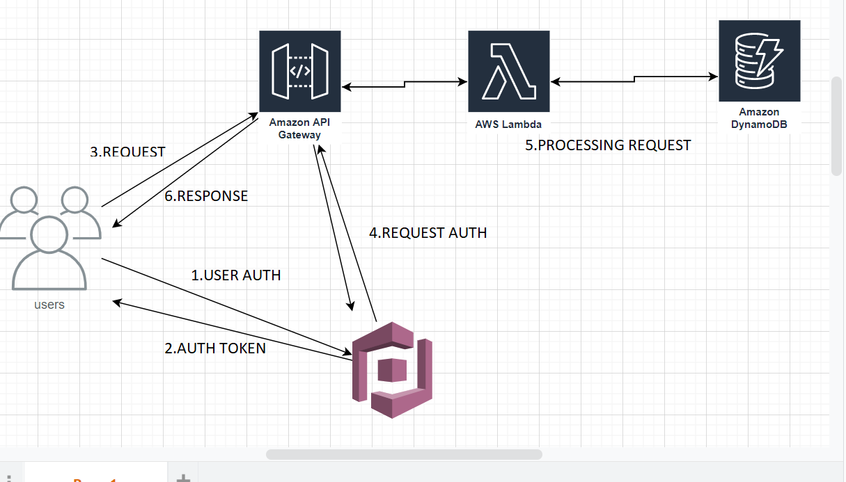

IMPLEMENTAION IN CLOUD:

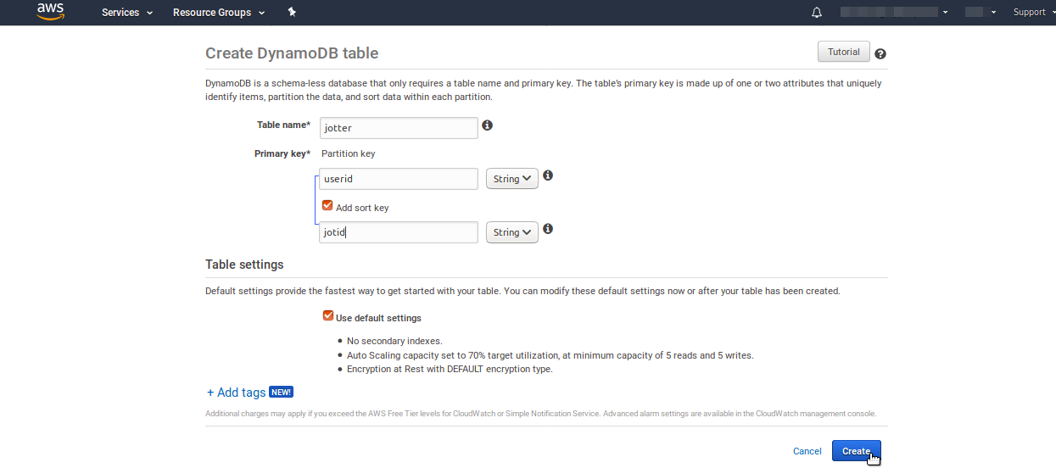

1.CREATING TABLES IN DYNAMO DB

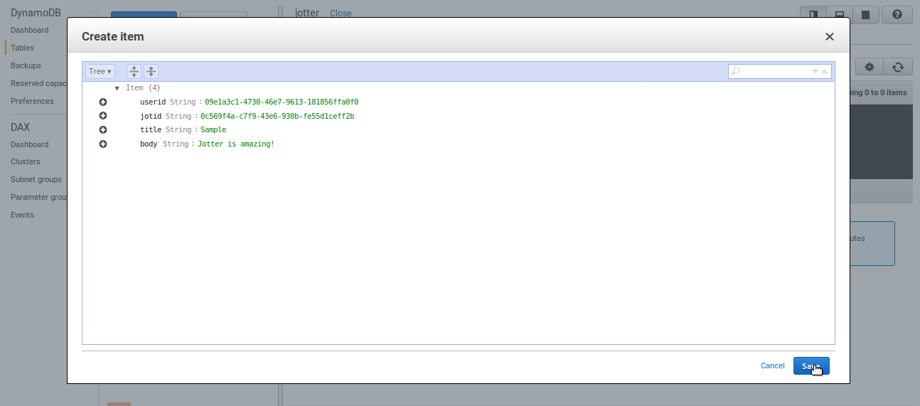

2. ADDING DATA TO DATABASE

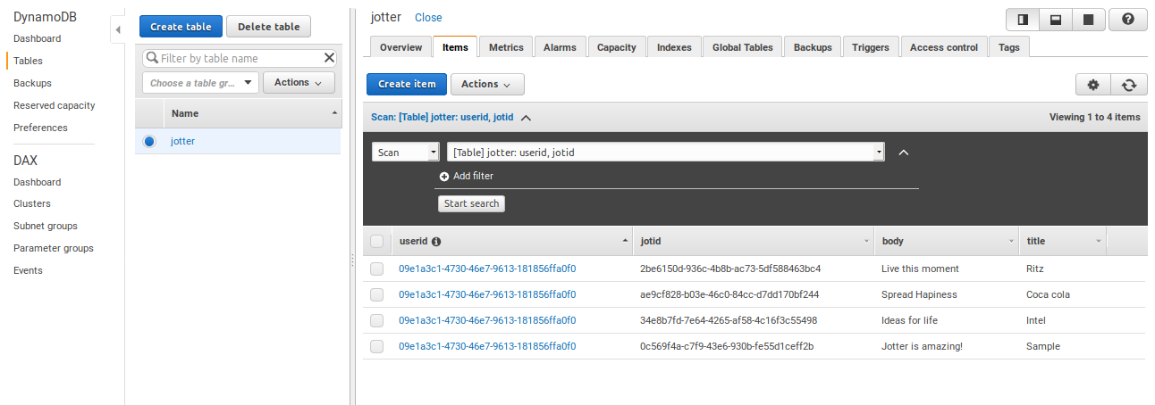

3. TABLES PRESENT IN DYNAMODB

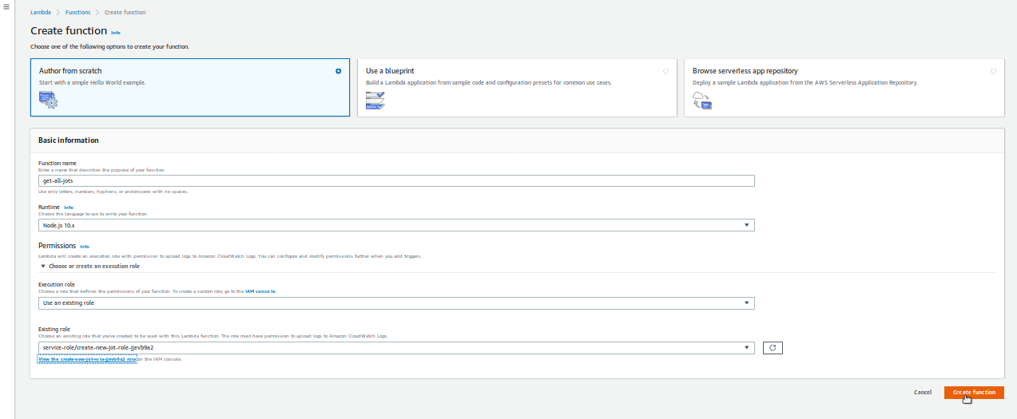

4. CREATING LAMBDA FUNCTIONS

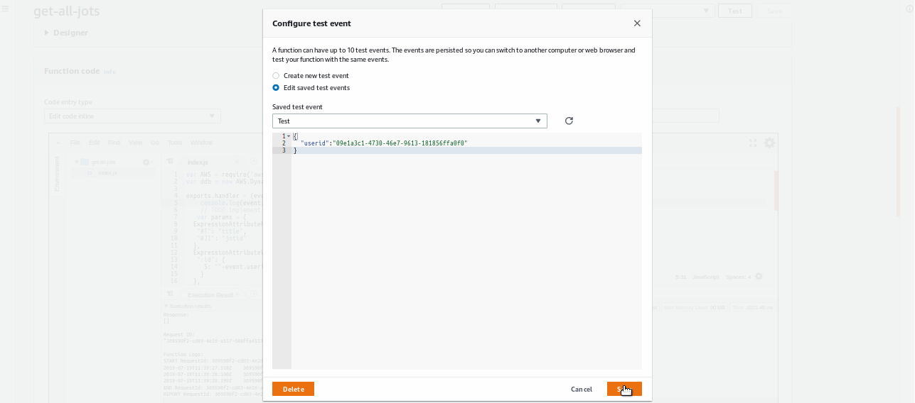

5. TESTING LAMBDA FUNCTIONS BY GIVING DATA

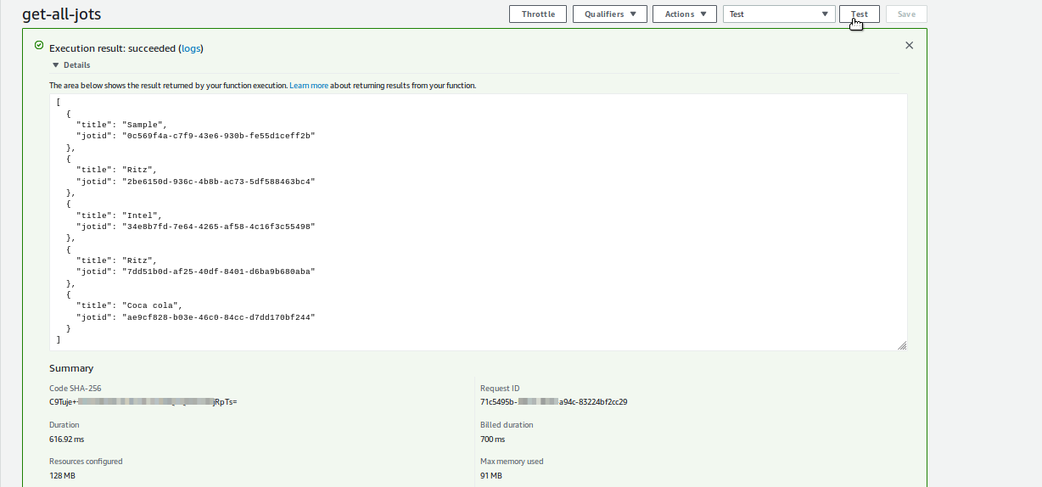

6. RESULTS AFTER TESTING LAMBDA FUNCTIONS

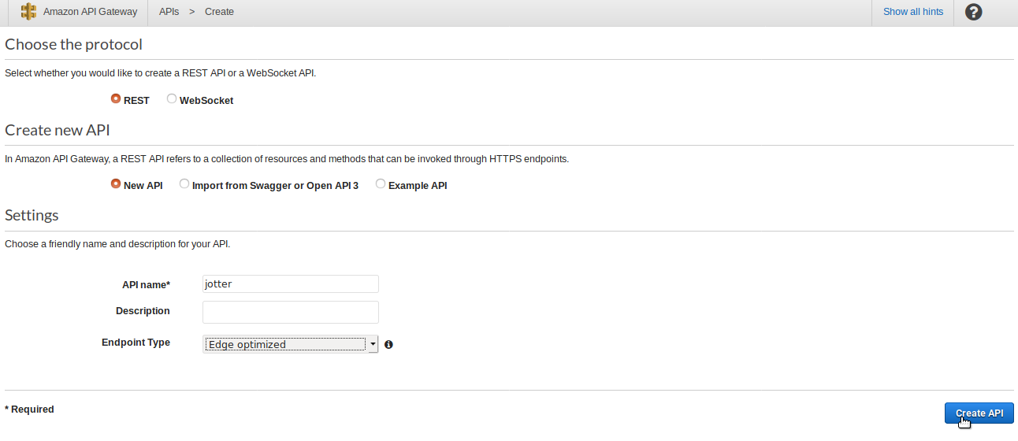

7. API GATEWAY CREATION

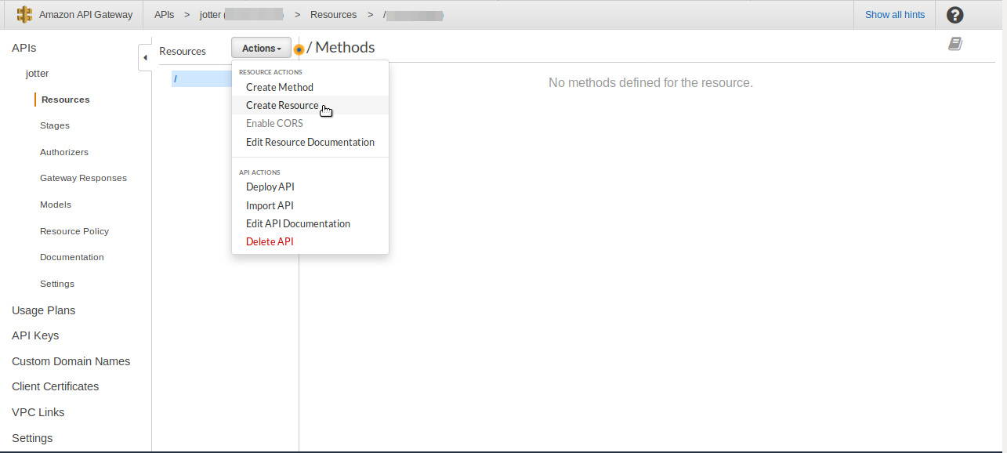

8 PERFORMING REST API CALLS

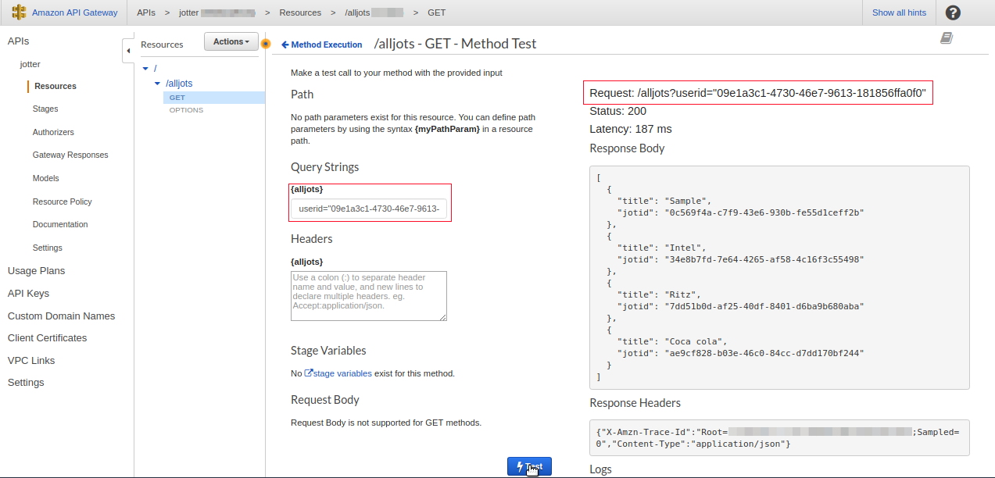

9. RESULT FOR GET METTHOD CALL