Explanation:

The architecture what we implemented is straight forward, whenever user click on [www.nhs.com](http://www.nhs.com) the request re directed to route53 which converts dns names into approiate IP address and forwards request to api gateway. the api gateway triggers get request and rest things taken care by lambada functions.

1. It parses the arguments sent by the frontend via api gateway in json format.
2. It generates the dynamic id creates an entery into amazon rds associated with the id and stores the data in database.
3. Next it will checks for either EC2 is stopped or working if it is stopped then it will spin it up and waits for it to be operational otherwise it moves on.
4. It will execute the scripts on EC2 instance. This process is achived by ssm agents which forward list of commands to execute on this machine.
5. S3 bucket services used to hold all the static information about website.

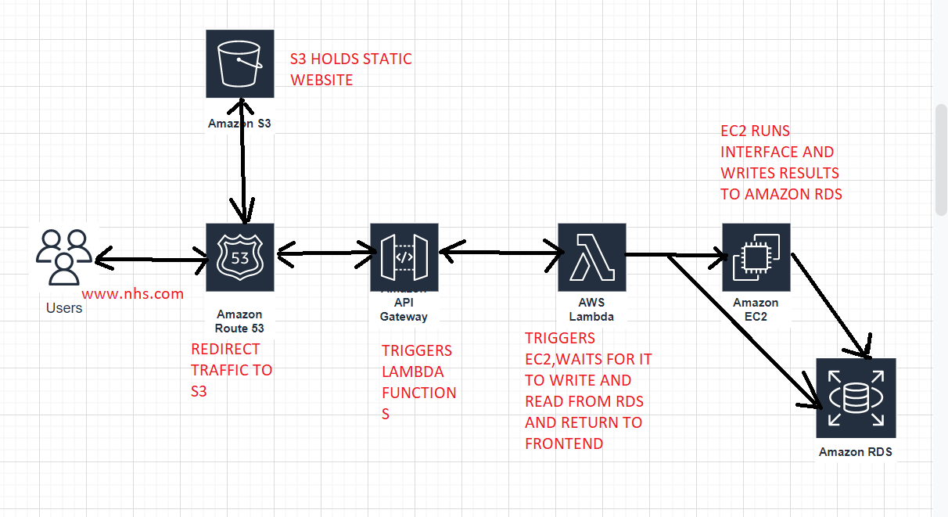

SERVICES USED AND INTRODUCTION ABOUT SERVICES:

1. AMAZON ROUTE 53: It is highly available Domain Namining System (DNS) web service. It is designed in cost effiective way to route end users to applications by transcilating domain names into appropioate ip address.
2. AMAZON API GATEWAY: it acts like as translator between frontend and backend to perform all RESTAPI calls.
3. LAMBDA FUNCTIONS : it is an event driven program it means whatever the event trigger it will respond to that particular event.
4. AMAZON RDS: It is a fully managed relational database servercie managed by the aws.
5. AMAZON S3: it is a bucket service used to hold the objects.