Linux Programming: Assignment-3
NAME-GUJJULA MOHAN KRISHNA REDDY
USN:ENG24CY0109
Roll:50
SEC-CY(C)

Q1) Distinguish between man and whatis commands. Justify with proper example.
- man command
  - Stands for manual. It shows the complete manual page of a command, including description, syntax, options, examples, and related commands.
  - Example: man ls
This will open the manual page for ls, showing all available options like -l, -a, -h etc.
- whatis command
  - Gives only a one-line short description of the command.
Example: whatis ls
Output:
ls (1) - list directory contents
Difference:
man = full manual (detailed explanation).
whatis = short one-line summary.

Q2) Use the tee command to save the output of ls -l into a file while also displaying it.
- The tee command is used when we want to see the output on the screen and save it into a file at the same time.

Example: ls -l | tee output.txt
This will:
- Display the result of ls -l on the terminal.
- Save the same output into a file called output.txt.
If you want to append (add) instead of overwriting:
ls -l | tee -a output.txt

Q3) Explain with an example how the tee command can be used in logging.
The tee command is special in Linux because it can do two things at once:
- It shows the output of a command on the screen (standard output).
- It also saves the same output into a file at the same time.
This makes it very useful for logging purposes, because you don’t lose the live output while still keeping a permanent record of it.

Example:
Suppose you want to check the network connectivity by running a ping command:
ping -c 5 google.com | tee pinglog.txt
- Here, the output of the ping will be printed on the screen so you can watch it live.
- At the same time, the same result will be written into a file called pinglog.txt.
- Later, you can open that file with cat pinglog.txt or any editor to check the details.

Why is tee important for logging?
- It avoids losing important information.
- Useful in debugging scripts, troubleshooting, or auditing system changes.
- Helps when you need both real-time monitoring and saved records.

Q4) List the steps involved in installing Ubuntu 25.04 LTS on Oracle VirtualBox.
Installing Ubuntu inside VirtualBox is basically like setting up a computer inside existing computer.

Step 1: Download Ubuntu ISO
- Go to the official Ubuntu website.
- Download the ISO image of Ubuntu 25.04 LTS (64-bit).
- Save it somewhere you can find easily (like Downloads).

Step 2: Create a New Virtual Machine in VirtualBox
- Open Oracle VirtualBox and click on “New.”
- Give a name → Ubuntu25.04.
- Type = Linux, Version = Ubuntu (64-bit).
- Assign RAM (at least 4GB, better 8GB if system allows).
- Assign CPU cores (2 or more).

Step 3: Create a Virtual Hard Disk
- Choose VDI (VirtualBox Disk Image).
- Storage type → Dynamically allocated.
- Disk size → Minimum 25GB

Step 4: Mount the Ubuntu ISO
- Go to Settings → Storage.
- Under the optical drive, select the Ubuntu ISO you downloaded.
- This makes VirtualBox boot from the ISO as if it were a DVD.

Step 5: Boot the Virtual Machine
- Click Start.
- The VM will boot from the Ubuntu ISO.
- Choose “Install Ubuntu”

Step 6: Installation Wizard
- Select Language and Keyboard layout.
- Choose Normal Installation
- Partitioning: Pick Erase disk and install Ubuntu
- Set up username and password → e.g. saitanveesh.

Step 7: Installation Process
- The installer will copy files and install Ubuntu inside the virtual hard disk you created.
- Once finished, it will ask you to restart.
- Important: When rebooting, remove the ISO from the virtual drive, otherwise it will boot into the installer again.

Step 8: Post-Installation Steps
- Log in with your username and password.
- Update the system:
sudo apt update && sudo apt upgrade

Q5) During Ubuntu OS installation, you face a Kernel Panic Error. How would you troubleshoot it?
A Kernel Panic means the Linux kernel has encountered a critical error and cannot continue safely. During Ubuntu installation in VirtualBox,

Step 1: Verify the ISO file
- Sometimes the downloaded ISO is incomplete or corrupted.
- Check the file’s checksum (SHA256) with the one given on the Ubuntu website.
- If it doesn’t match → re-download the ISO.

Step 2: Recreate Bootable Media
- If installing on real hardware, remake the bootable USB using tools like Rufus (Windows) or dd (Linux).
- If inside VirtualBox, just re-attach the correct ISO image.

Step 3: Adjust VirtualBox Settings
- Make sure virtualization is enabled in BIOS/UEFI (Intel VT-x or AMD-V).
- In VM settings →
  - System → Processor: Allocate at least 2 CPUs.
  - System → Motherboard: Enable I/O APIC.
  - Display: Increase Video Memory to 128MB.

Step 4: Boot with Safe Options
- When the GRUB menu appears, press e to edit boot parameters.
- Add options like:
  - nomodeset → bypass graphics driver issues.
  - acpi=off → disable advanced power features if causing panic.
- Then continue booting with these safe parameters.

Step 5: Try an Older Kernel or Recovery Mode
- Sometimes the newest kernel doesn’t play well with VirtualBox or specific hardware.
- If installer gives the option, select a different kernel or recovery mode.
- If you can reach a shell, view logs using:
dmesg | less

Q6) Write the command to display the system’s hostname. How to change hostname using sysctl command?

1. Displaying the hostname
- The hostname command is used to show the current hostname of the system.
Example:
hostname
Output might look like:
saitanveesh-pc
This is the name by which the machine identifies itself in a network.

2. Changing the hostname using sysctl
- The hostname is controlled by the kernel parameter kernel.hostname.
- You can temporarily change it using the sysctl command:
sudo sysctl kernel.hostname=newname
Example:
sudo sysctl kernel.hostname=ubuntu-server

Important Note:
- This change is temporary. Once you reboot, the hostname will go back to the old one.
- To make it permanent, you must edit the file /etc/hostname and also update /etc/hosts.
sudo hostnamectl set-hostname newname

Q7) Which command is used to show the calendar of the year 1984 with August month?
In Linux, the cal command is used to display a calendar in the terminal.
1. Show a specific month of a year
The syntax is:
cal <month> <year>
For August 1984, the command will be:
cal 8 1984

Example Output (August 1984)
August 1984
Su Mo Tu We Th Fr Sa
1 2 3 4
5 6 7 8 9 10 11
12 13 14 15 16 17 18
19 20 21 22 23 24 25
26 27 28 29 30 31
Here:
- Su Mo Tu We Th Fr Sa = Days of the week (Sunday to Saturday).
- Dates are arranged under each day.

2. Show the whole year 1984
If instead of one month you want the entire year’s calendar:
cal 1984
This will print all 12 months of the year 1984 together.

Q8) Write a command to display system uptime and logged-in users together.
In Linux, there are different commands that give you both uptime and the users who are currently logged in.
1. Using the w command
The simplest way is:
w
This command shows:
- The current time
- How long the system has been up (uptime)
- List of logged-in users with what they are doing
Sample Output:
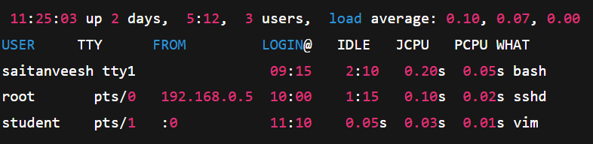
2. Using uptime and who together
You can also combine two commands:
uptime && who
- uptime → shows system uptime, number of users, and load average.
- who → shows list of logged-in users.
Sample Output: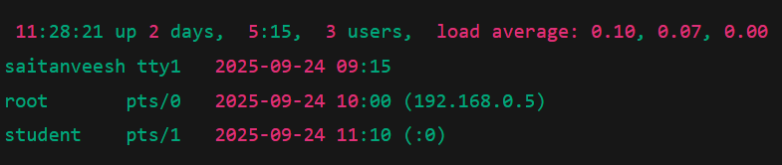

Q9) Use the find command to list all “.c” files in /home/user.
The find command is one of the most powerful tools in Linux for searching files and directories. It scans through directories and lists files that match the conditions you specify.

Syntax:
find <path> -name <pattern>

For this question:
To find all .c files inside /home/user:
find /home/user -name "*.c"
Explanation:
- /home/user → the starting directory where the search begins.
- -name "*.c" → tells find to look for files ending with .c (C language source code files).
- The * (wildcard) means "match any filename ending with .c".

Sample Output (example)
/home/user/project1/main.c
/home/user/project1/utils/helper.c
/home/user/project2/test.c

Final Answer
- Command: find /home/user -name "*.c"
- It will list all C source files in /home/user and its subdirectories.

Q10) How do we change file permissions to allow only the owner to read and write?
In Linux, file permissions are controlled using the chmod command. The requirement here is:
- Owner (user): should have read and write access.
- Group: no access.
- Others: no access.
Command:
chmod 600 filename

Explanation of 600:
- 6 → Owner = read (4) + write (2) = rw-
- 0 → Group = no permission = ---
- 0 → Others = no permission = ---
So the final permission is:
-rw-------

Example Snapshot:

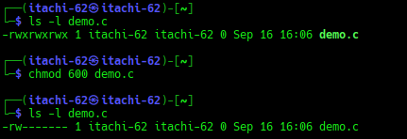

Final Answer
The command chmod 600 filename sets the file so that only the owner can read and write, while group and others have no permissions.

