Linux Programming: Assignment-2
NAME-GUJJULA MOHAN KRISHNA REDDY
USN:ENG24CY0109
Roll:50
SEC-CY(C)
Q1) What does the command pwd, whoami, and hostname display?
- pwd (Print Working Directory):
This command shows the exact path of the directory where we are currently working. For example, if we are inside a folder called Documents under your user account, it will display /home/username/Documents. It helps the user know their present location in the Linux file system.
- whoami:
This command prints the username of the person who is logged in. It is useful when multiple users are working on the same machine or when switching between accounts.
- hostname:
This command displays the name given to the computer (the host) in the network. For example. It helps in identifying the machine especially when it is connected in a network with many other systems.

Q2) Write the command to create a directory named “project” inside the /home/student folder and keep three .txt file into it. Give output snapshot.

Step 1: Create the directory
bash --- mkdir /home/student/project
This makes a new folder called project inside /home/student.
Step 2: Move into that directory
Bash---- cd /home/student/project
Now you are inside the project folder.
Step 3: Create three text files
Bash--- touch file1.txt file2.txt file3.txt
This will create three empty text files in one command.
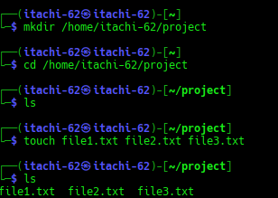

Q3) Explain the difference between absolute path and relative path with proper examples.
- Absolute Path
  - Definition: An absolute path is the complete path of a file or directory starting from the root /.
  - It always begins with / and shows the full location in the file system, no matter where you currently are.
Example:
    - /home/saitanveesh/project/file1.txt
    - Here, it starts from the root / → home → saitanveesh → project → file1.txt.
Use case: Useful when you want to be sure of the exact location of a file, independent of the current working directory.
- Relative Path
  - Definition: A relative path is the location of a file or directory relative to the directory you are currently working in.
  - It does not start with /. Instead, it uses . (current directory) or .. (parent directory).
Example:
    - Suppose your current location is /home/saitanveesh.
    - The relative path to file1.txt inside the project folder will be:
project/file1.txt
    - To go one level up: ../Downloads/file2.txt

Absolute Path | Relative Path
- Always starts with / | - Does not start with /
- Complete location from root | - Location depends on where you are (current directory)
- Works anywhere in the system | - Only works correctly if you are in the expected directory
- Example: /home/saitanveesh/project/file1.txt | - Example: project/file1.txt

Q4) What command will give you the already executed command traces in the terminal. Give output snapshot

In Linux, the command used is:
Bash programming command --------- history
- It shows a numbered list of all the commands that have been executed in the current shell session (and also from previous sessions, depending on settings).
- You can re-run a command directly using !<number> from the history list.
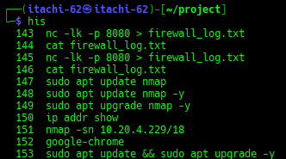

Q5) Compare the working functionality of find and locate command. Which one is faster and why?
ANS--- 1.find command
  - Functionality: Searches for files and directories by walking through the filesystem in real time.
  - It can search by name, type, size, permission, owner, date, etc.
  - Works even if the file was just created a few seconds ago.
  - Example:
  - find /home/saitanveesh -name "file1.txt"
→ This will search the entire /home/saitanveesh directory for file1.txt.
2.locate command
  - Functionality: Searches files by checking a pre-built database (mlocate.db) instead of scanning the disk live.
  - Faster because it does not look at the actual filesystem each time.
  - But if the database is not updated (sudo updatedb), newly created files may not appear.
  - Example:
  - locate file1.txt
→ This will instantly display the path of file1.txt (if it is already recorded in the database).
Q6)Which command is used to modify file permissions in Linux? Give an example.
- The command used is chmod (change mode).
- It allows you to set or change the read (r), write (w), and execute (x) permissions for the owner, group, and others on a file or directory.
Example 1: Using symbolic method
chmod u+x file1.txt
This gives the user (owner) execute permission on file1.txt.
Example 2: Using numeric (octal) method
chmod 755 file1.txt
This sets permissions as:
- 7 → owner = read + write + execute (rwx)
- 5 → group = read + execute (r-x)
- 5 → others = read + execute (r-x)

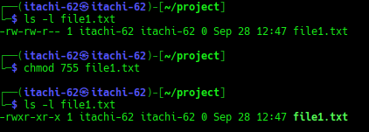

Q7) A file has permissions -rw -r- -r- -. What does this mean ?

In Linux, file permissions are shown in 10 characters. It means like this:
Bash command is -rw-r--r--
- First character (-)
  - Shows the type of file.
  - - = regular file
- Next 3 characters (rw-) → Owner (User) permissions
  - r = read allowed
  - w = write allowed
  - - = no execute permission
- Next 3 characters (r--) → Group permissions
  - r = read allowed
  - -- = no write, no execute
- Last 3 characters (r--) → Others (world) permissions
  - r = read allowed
  - -- = no write, no execute
Q8) Explain the difference between chown and chgrp with an example ?
- chown (Change Owner)
  - Used to change the owner of a file or directory.
Syntax:
chown new_owner filename
Example:
  - sudo chown saitanveesh file1.txt
- chgrp (Change Group)
  - Used to change the group ownership of a file or directory.
Syntax:
chgrp new_group filename
Example:
  - sudo chgrp student file1.txt
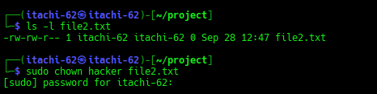

Q9) A file needs to be accessible by multiple users but only writable by the owner. How will you set permissions?

Requirement:
  - Owner → should have read and write access.
  - Group & Others (all users) → should have read-only access.
  - No one except the owner should be able to modify the file.

Using chmod (symbolic method)
Bash command---- chmod 644 filename
- 6 → Owner = read (4) + write (2) = rw-
- 4 → Group = read only = r--
- 4 → Others = read only = r--
final permission will be:
-rw-r--r—
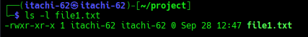

10. How do you check the manual page for any Linux commands?.
- In Linux, almost every command has a manual (man) page that explains what the command does, its syntax, options, and examples.
- To open the manual page, we use the man command followed by the command name.

Syntax:
man <command>
Example:
man ls
now it will open the manual page for the ls command, showing:
- Description of the command
- Usage / syntax
- Available options (like -l, -a, -h)
- Exit status and related commands

