AZURE WEB APPLICATION DEPLOYMENT

Krishnaraj S

ACE11698

These are the steps to deploy Web Application in Azure Web Services:

### **1. Create an Azure Account**

If you don't have an Azure account, sign up for one at [azure.com](https://azure.com/).

### **2. Create a Web App Service**

* Log in to the Azure Portal.
* Click on "Create a resource" and search for "Web App."
* Select "Web App" from the results.

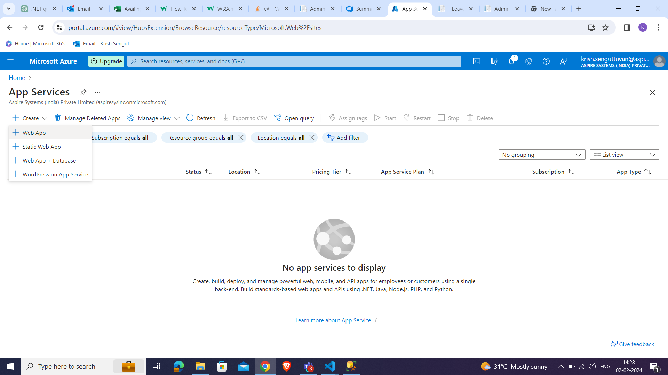

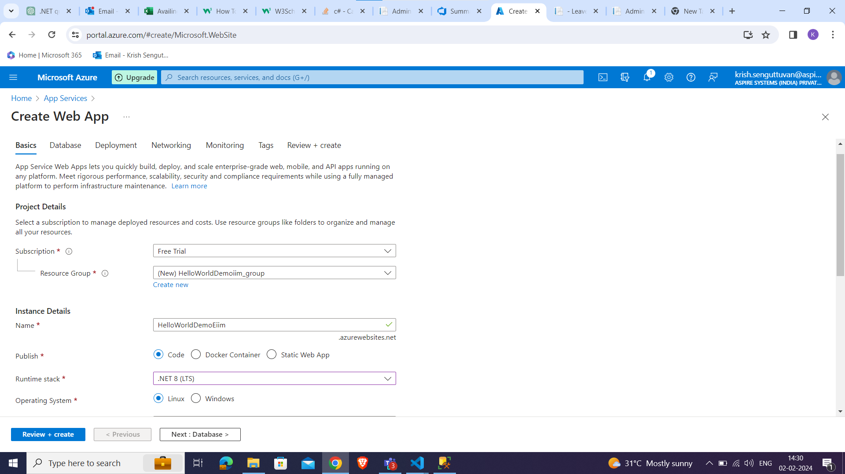

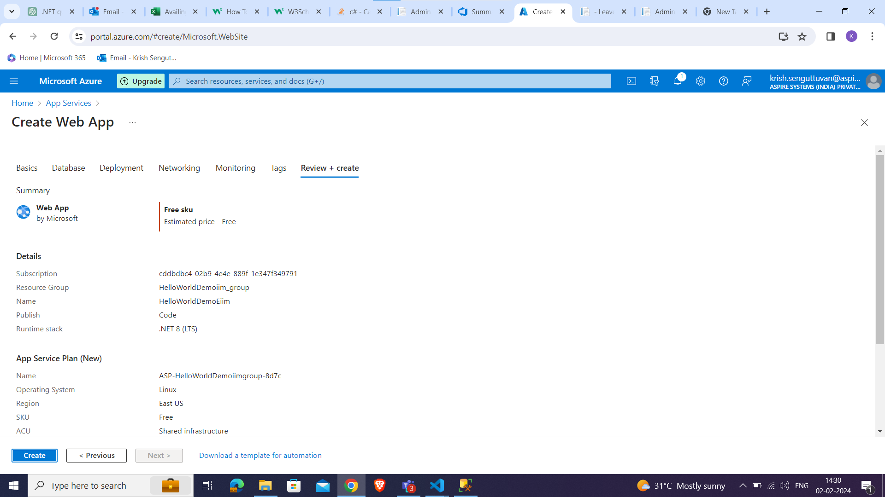

* Fill out the required information such as subscription, resource group, name, and region.
* Click "Review + create," then "Create" to provision the Web App Service.

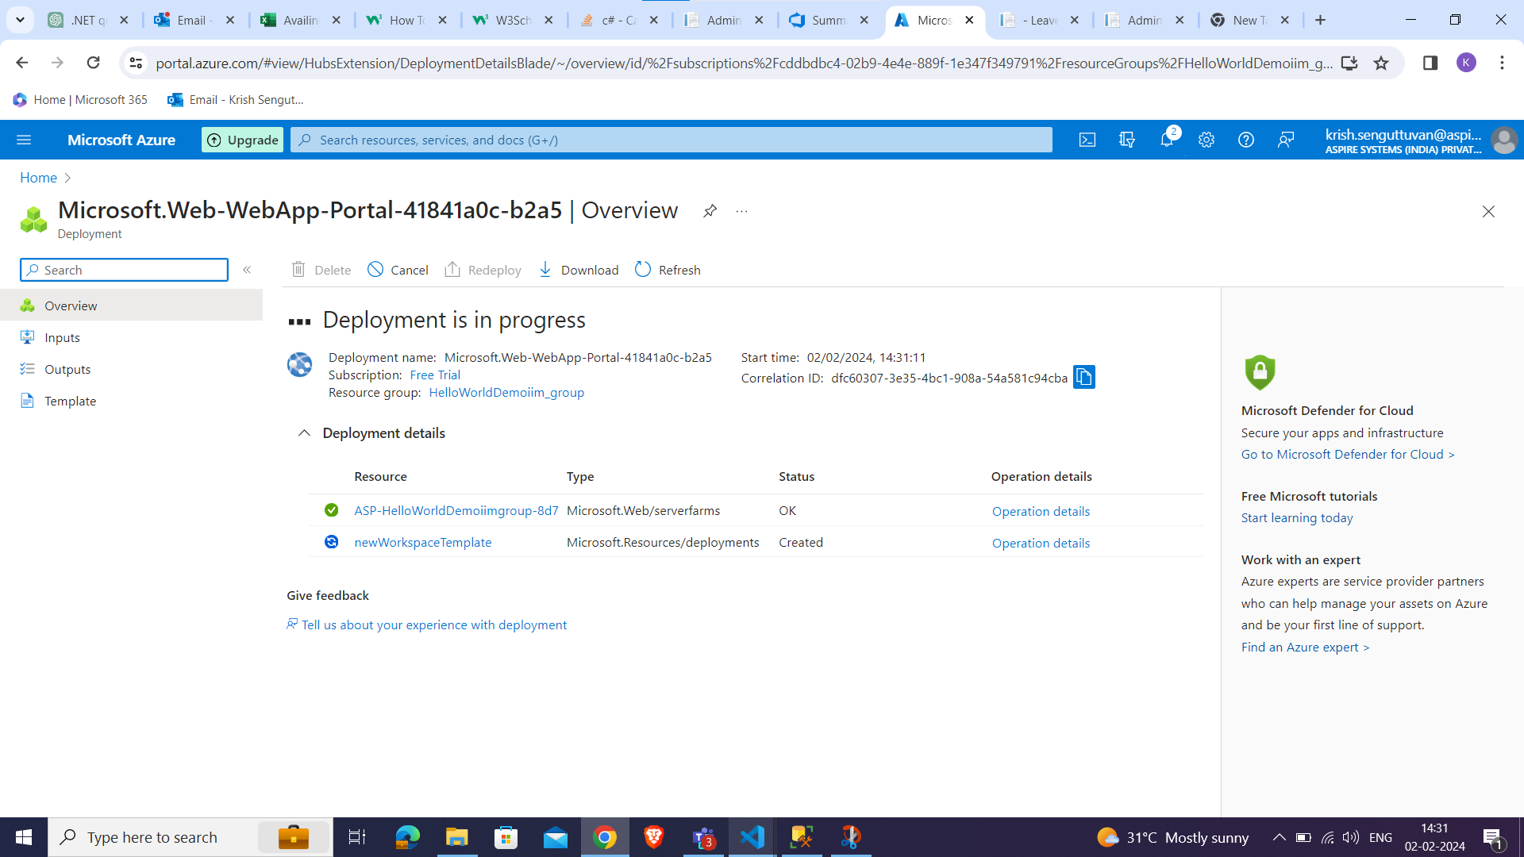

### **3. Set Up Deployment Source**

* Once your Web App is created, navigate to it in the Azure Portal
* Choose your preferred source control option (e.g., GitHub, Azure DevOps, Bitbucket) and connect your repository.
* Configure your deployment options (branch, build settings, etc.) and save.

### **5. Build and Deploy**

* Push your changes to your selected source control repository.
* Monitor the deployment process through the Azure Portal's Deployment Center or by viewing deployment logs.

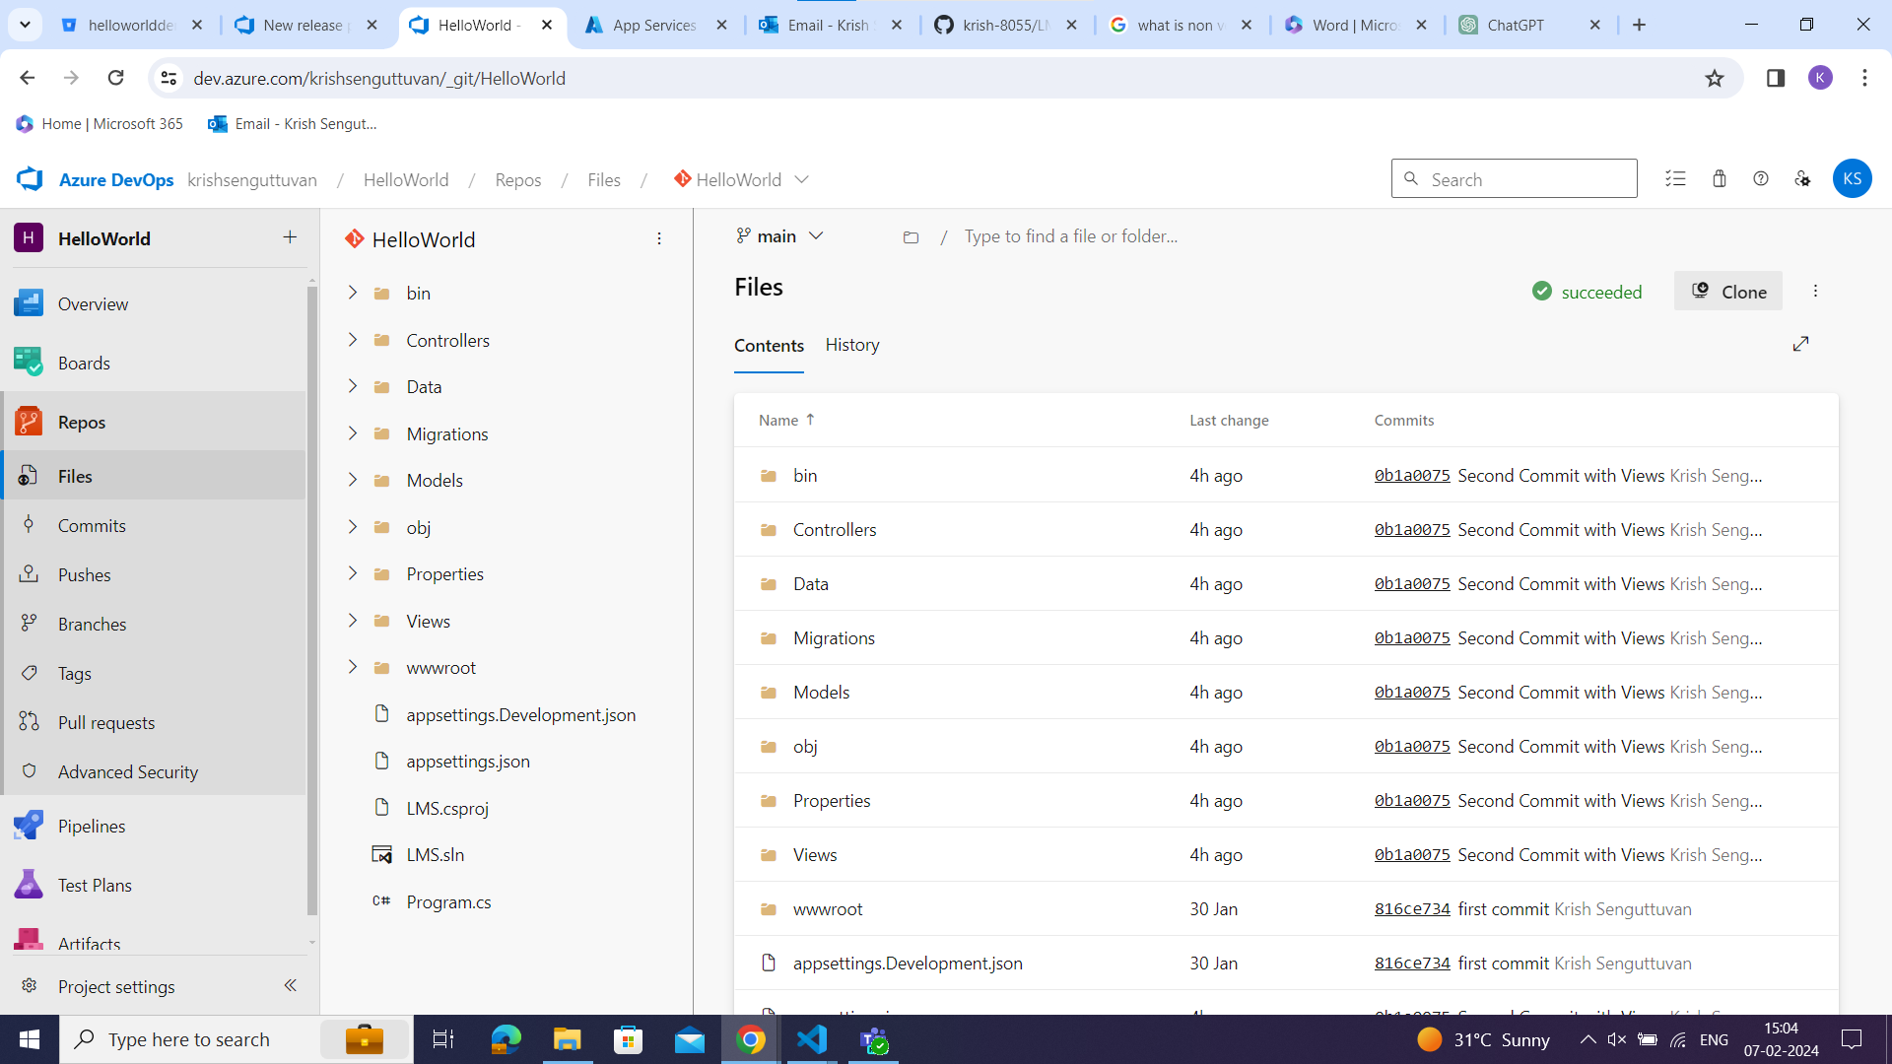

* After the successful execution of pipeline, service connection is setup to our web app services.

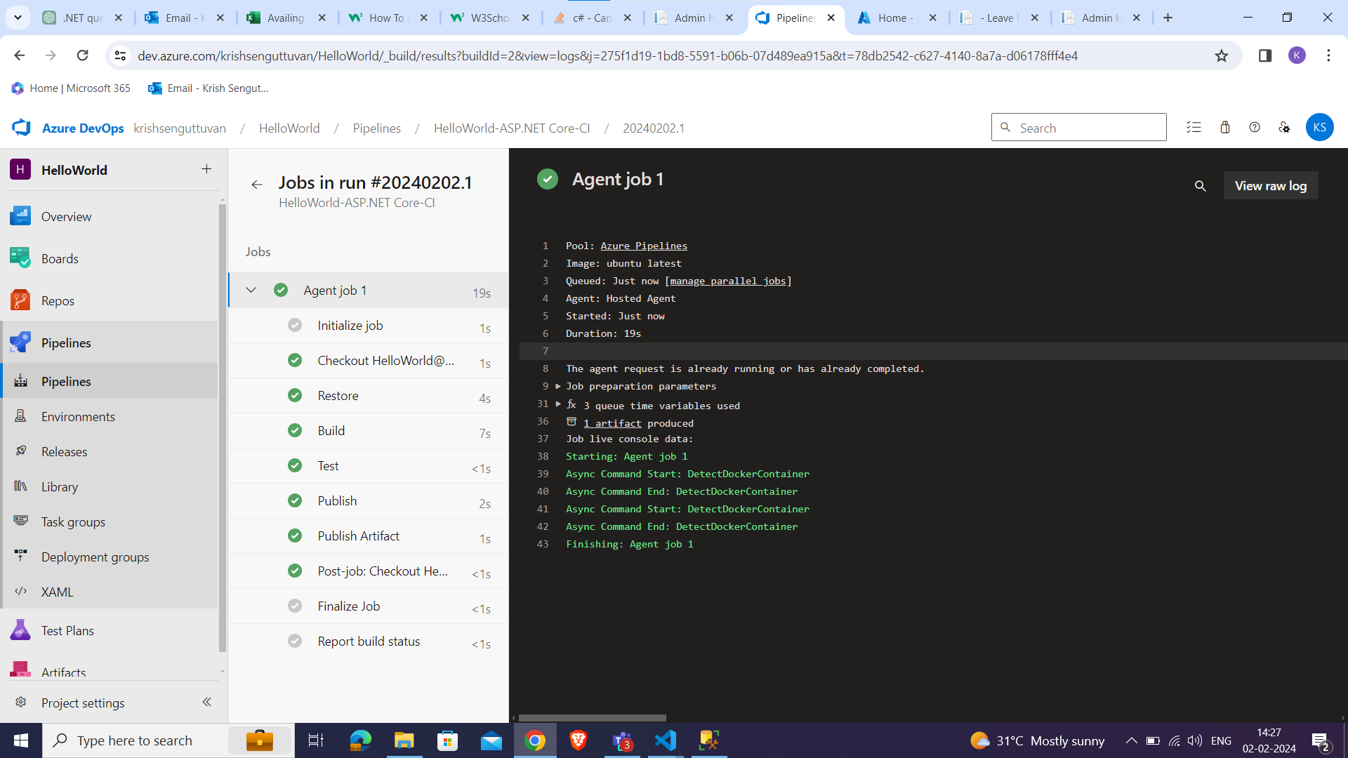

### **5. SERVICE CONNECTION**

* Open your Azure DevOps project.
* Navigate to "Project Settings" from the bottom left corner of the page.
* Choose the type of service connection you want to create. Azure DevOps supports various types, including Azure Resource Manager, Jenkins, GitHub, Docker Registry, etc.
* Select the appropriate service connection type based on your requirements and click "Next."
* Fill in the required information based on the type of service connection you selected.
* Provide subscription ID, subscription name, resource group, and other authentication details.

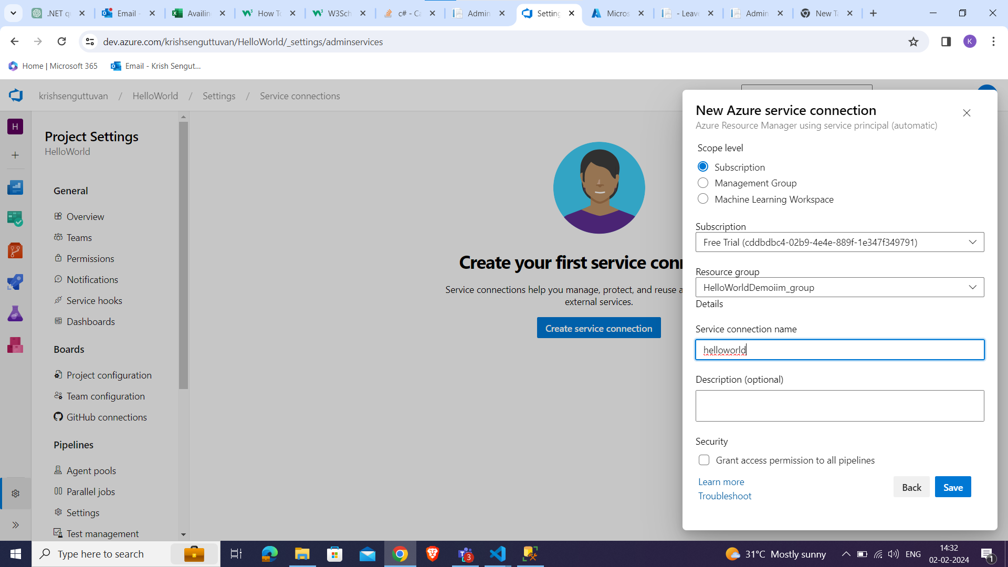

* Once you've provided all the necessary details and authenticated the connection, Azure DevOps will attempt to verify the connection.
* give the service connection a meaningful name.
* Click on "Verify and save" or "Save" to create and save the service connection.

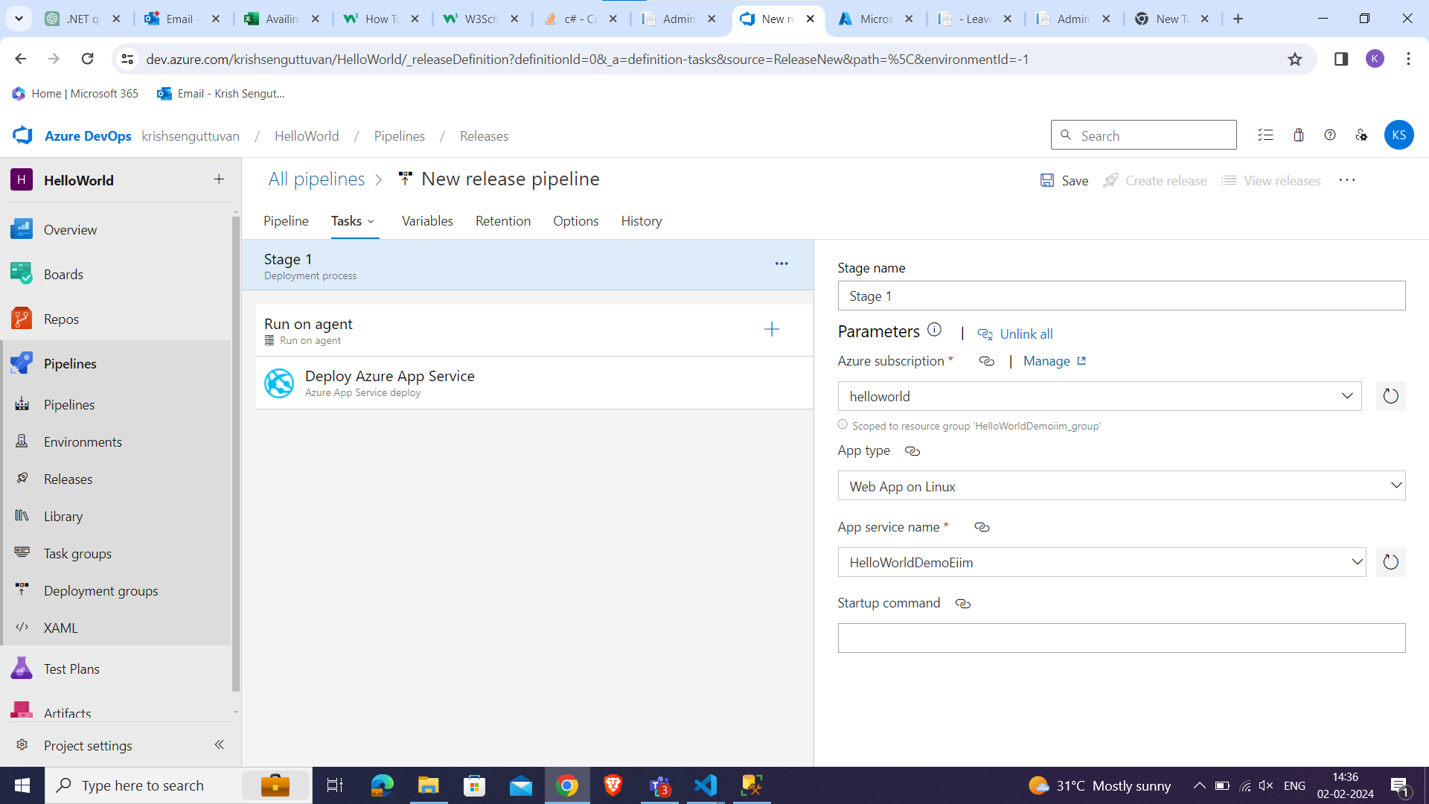

### **6. Use the Service Connection**

* After creating the service connection, you can use it in your pipelines, builds, releases, or other relevant areas within Azure DevOps.
* Look for the "Releases" section within your pipeline configuration and locate the release you want to trigger.
* Click on "Create release" or "Release" to initiate the release process.

### **7. Confirm and Start Release**

* Review the release details to ensure everything is configured correctly.
* Click on "Start" or "Deploy" to initiate the release process.

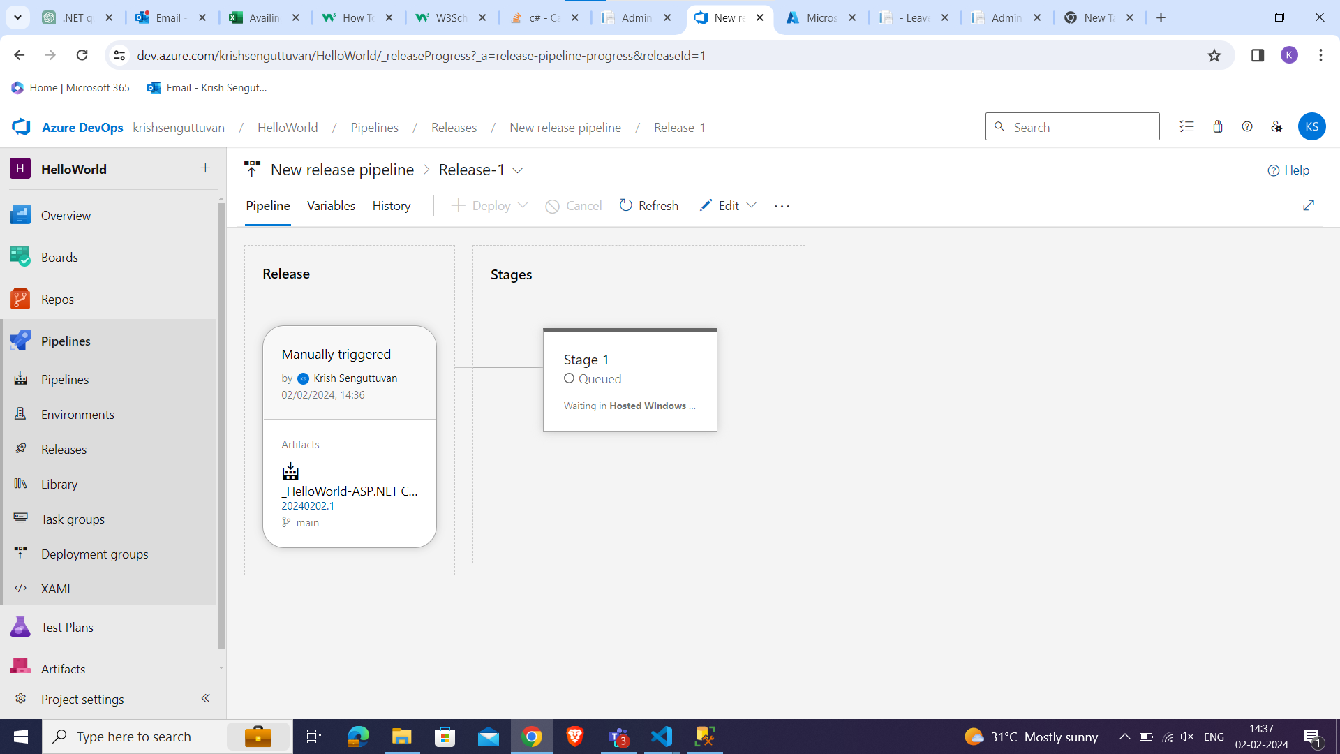

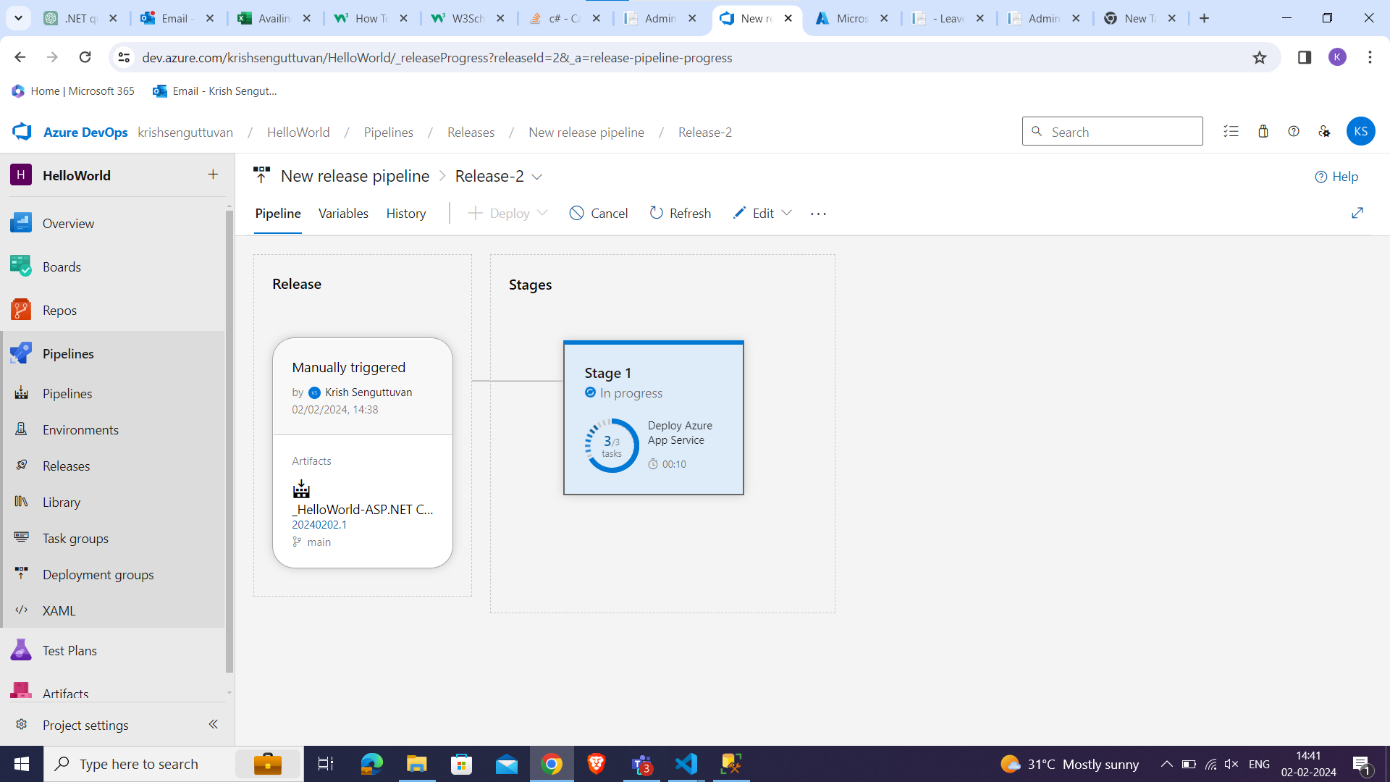

* After the release completes successfully, verify that the application or services have been deployed as expected.

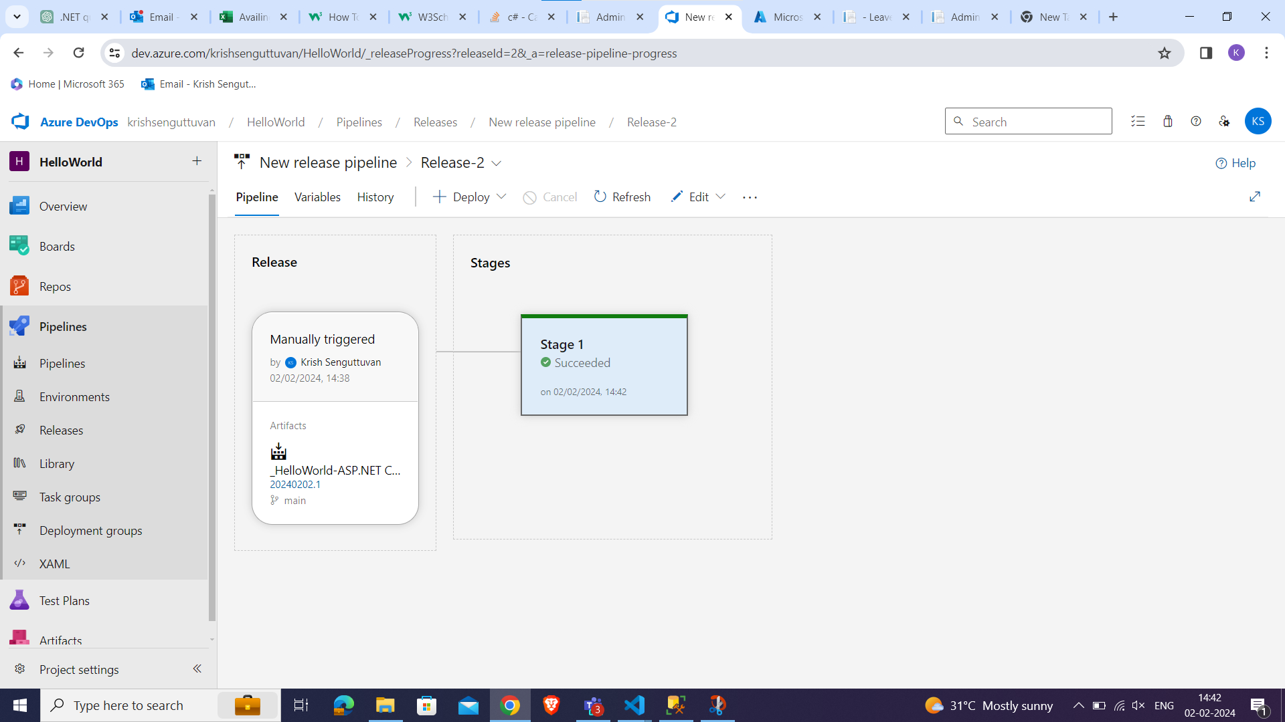

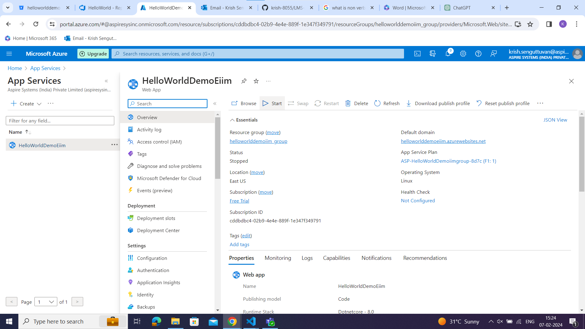

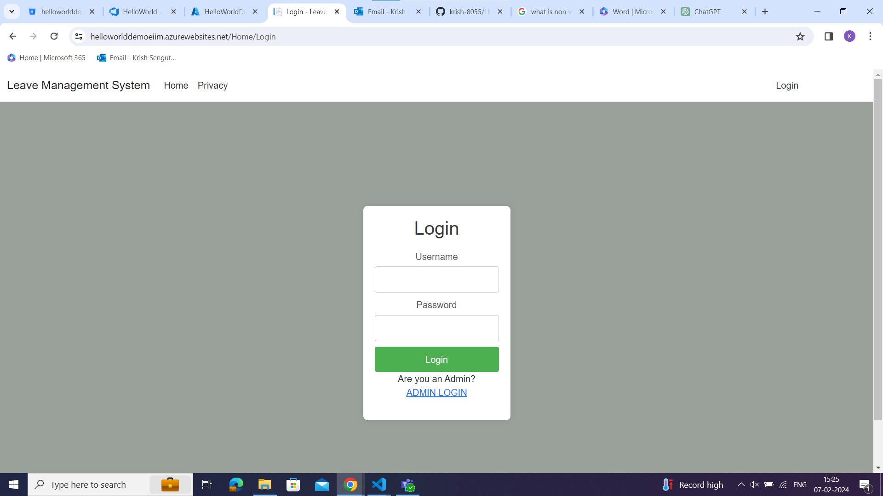

* By following these steps, you can successfully deploy your MVC (.NET) application to Azure Web Services and make it accessible to users over the internet.