WEDRIVER.IO with MOCHA & CHAI

Section 1 – Install and run with Standalone mode

- Install Webdriver.io and Selenium Standalone from NPM using command on terminal using the below command:

npm install –save-dev webdriverio selenium-standalone
(Please install in our project folder)

- Install selenium-standalone by using command:

./node_modules/.bin/selenium-standalone install

- Start the selenium-standalone server by using command:

./node_modules/.bin/selenium-standalone start

- Run our first test using the below commands:

File it as example.js and place it in our project folder.

var webdriverio = require('webdriverio');
var options = { desiredCapabilities: { browserName: 'chrome' } };
var client = webdriverio.remote(options);
client
.init()
.url('https://duckduckgo.com/')
.setValue('#search_form_input_homepage', 'WebdriverIO')
.click('#search_button_homepage')
.getTitle().then(function(title) {
console.log('Title is: ' + title);
// outputs:
// "Title is: WebdriverIO (Software) at DuckDuckGo"
})
.end();

- Run with command: node example.js

This is the example of how to run our script in standalone mode and locally without using any testing framework.

Section 2 – Run with WDIO Test Runner

- Config our wdio using the below command in command line:

.node_module/.bin/wdio or .node_module/.bin/wdio config

Please answer all the questions as shown below except ‘base url’ (last question).
We can initialize it later.

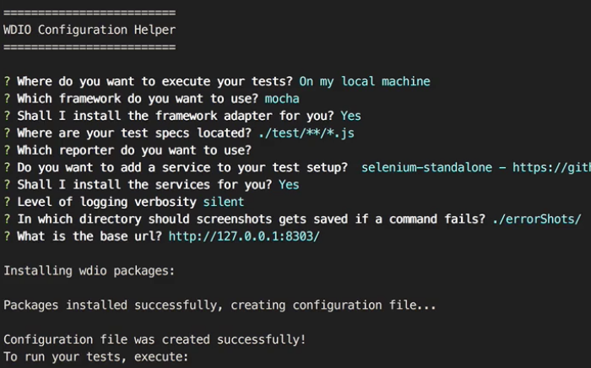

After that our wdio.conf.js file successfully installed in our folder.

- If we need to run our test then using the below command:

./node_modules/.bin/wdio

Section 2.1 – Run test in an Asynchronous way

- Copy the below code in a new file:

Please use the URL (http://www.kevinlamping.com/webdriverio-course-content /webdriverio-course-content) and initialize it in our config.js file in the baseUrl section.

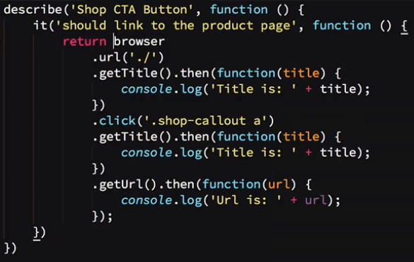

Note:

- `return` the browser object using return keyword, as we're still testing via the asynchronous interface.

- Mocha handles asynchronous testing by accepting a Promise returned from our `it` function callback. Remember, WebdriverIO uses Promises to handle the asynchronous nature of browser testing, and every command on the `browser` object returns a Promise. We simply pass the promise back to Mocha, which will wait for it to resolve before completing the test.

- Please make sure the value of ‘sync’ setting make it as ‘false’ eg.‘sync: false’ in our wdio.conf.js file.

- Run it by ./node_modules/.bin/wdio

TIP: We define (‘./’) in browser.url(‘./’). it will go to whatever is defined in the `baseUrl`. Instead we use without dot (‘/’ ), it would go to the root of the `baseUrl` value.

Section 2.1 – Run test in a Synchronous way

- Copy the below code in a new file:

Please use the URL (http://www.kevinlamping.com/webdriverio-course-content /webdriverio-course-content) and initialize it in our config.js file in the baseUrl section.

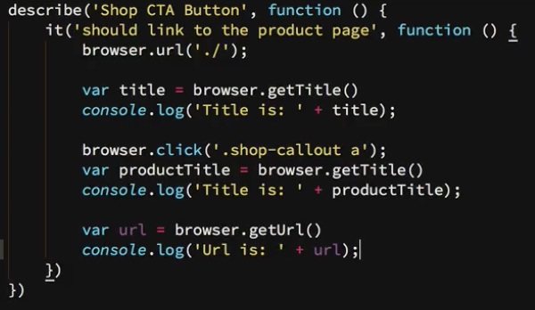

Note:

- We don’t use ‘return’ keyword in the ‘it’ block here as we mentioned before in the asynchronous way.

- Remove all ‘then’ functions and organize our codes as shown above.

- Please make sure the value of ‘sync’ setting make it as ‘false’ eg.‘sync: false’ in our wdio.conf.js file.

- Run it by ./node_modules/.bin/wdio

