pfSense VLAN Segmentation Lab

Role | Network Administrator / Security Engineer
Scope | - Implement VLANs (Virtual LANs) for HR and IT using a single pfSense interface.  - Configure IP addressing and DHCP for both VLANs.  - Apply firewall rules to control inter-VLAN traffic.  - Demonstrate and verify network segmentation using client VMs.
Prerequisits | - VirtualBox environment with:  - pfSense Firewall VM (Main pfSense instance)  - Two client VMs:  - HR-Client (existing client renamed)  - IT-Client (clone of HR-Client)  - Network Configuration:  - pfSense LAN Adapter 3 → hr-net  - pfSense LAN Adapter 4 → it-net  - HR-Client → connected to hr-net  - IT-Client → connected to it-net  - Basic understanding of IP addressing, DHCP, and firewall configuration.

Objective
To create two logically separate VLANs for HR and IT departments using a single network interface on pfSense and configure firewall rules to control inter-network traffic, demonstrating effective network segmentation.

Tasks

1. Creating VLANs in pfSense (HR & IT)
Goal: Define the VLAN tags that pfSense will use to separate traffic.
- Log into your pfSense web interface as the admin user.
- Navigate to Interfaces > Assignments.
- Click on the VLANs tab.
- Click the + Add button to create your first VLAN.
  - Parent Interface: Select your LAN interface (e.g., em1).
  - VLAN Tag: 10 (unique ID for HR network).
  - Description: HR Network.
  - Click Save.
- Click + Add again to create the second VLAN.
  - Parent Interface: Select the same LAN interface (e.g., em1).
  - VLAN Tag: 20 (unique ID for IT network).
  - Description: IT Network.
  - Click Save.
- You have now defined the VLANs, but they don't do anything until they are assigned and configured.

2 . Interface Assignments and Configuration
Goal: Turn the virtual VLANs into usable pfSense interfaces with IP addresses.
- Navigate back to Interfaces > Assignments.
- Under Available network ports, you will now see your two new VLANs.
- Click the + Add button next to VLAN 10 on em1 to create a new interface called OPT1.
- Click the + Add button next to VLAN 20 on em1 to create another new interface called OPT2.
Configure OPT1 (HR Department):
- Click on OPT1.
- Check the box for Enable interface.
- Change the Description to HR.
- Set IPv4 Configuration Type to Static IPv4.
- Under Static IPv4 Configuration, set the IPv4 Address to 192.168.10.1/24.
- Click Save, then Apply Changes.
Configure OPT2 (IT Department):
- Go back to Interfaces > Assignments and click on OPT2.
- Check the box for Enable interface.
- Change the Description to IT.
- Set IPv4 Configuration Type to Static IPv4.
- Set the IPv4 Address to 192.168.20.1/24.
- Click Save, then Apply Changes.

3 . DHCP Setup per VLAN
Goal: Configure pfSense to automatically assign IP addresses to devices on both the HR and IT networks.
- Navigate to Services > DHCP Server.
- You will now see tabs for your new interfaces: HR and IT.
Configure DHCP for HR VLAN:
- Click on the HR tab.
- Check the box for Enable DHCP server on HR interface.
- Set IP Range: 192.168.10.100 to 192.168.10.200.
- Click Save.
Configure DHCP for IT VLAN:
- Click on the IT tab.
- Check the box for Enable DHCP server on IT interface.
- Set IP Range: 192.168.20.100 to 192.168.20.200.
- Click Save.

4 . Firewall Rule Configuration for Inter-VLAN Restrictions
Goal: Implement the core security policy — IT can access the HR network, but HR cannot access the IT network.
- Navigate to Firewall > Rules.
Allow Internet Access:
- Click on the HR tab → + Add.
  - Create a rule that allows traffic from HR net to any destination.
  - Click Save.
- Click on the IT tab → + Add.
  - Create a similar rule allowing traffic from IT net to any destination.
  - Click Save.
Allow IT to Access HR Network:
- While on the IT tab, click + Add.
  - Action: Pass
  - Interface: IT
  - Protocol: any
  - Source: IT net
  - Destination: Single host or alias → HR net
  - Description: Allow IT to access HR network.
  - Click Save, then Apply Changes.
Note: No block rule is needed on the HR interface.
By default, pfSense blocks all inter-interface traffic unless a “Pass” rule is defined.

5 . Testing Segmentation with Ping and Access Attempts
Goal: Verify that your firewall rules are working exactly as intended.
- Start both HR-Client and IT-Client VMs.
- Check IP Addresses:
  - On HR-Client, run ip a — should show IP in 192.168.10.x.
  - On IT-Client, run ip a — should show IP in 192.168.20.x.
- Perform connectivity tests:
  - From HR-Client → ping 8.8.8.8 → Should succeed.
  - From IT-Client → ping 8.8.8.8 → Should succeed.
- Inter-VLAN tests:
  - From IT-Client → ping 192.168.10.100 (HR client) → Should succeed.
  - From HR-Client → ping 192.168.20.100 → Should fail.

Outcome
- Successfully created VLANs (HR: VLAN 10, IT: VLAN 20) on pfSense.
- Each VLAN has its own subnet and DHCP service.
- Both VLANs have internet access.
- IT can access HR, but HR cannot access IT.
- Validated segmentation through ping and access tests.
- Demonstrated secure network isolation and VLAN-based segmentation.

Solution
1. Creating VLANs in pfSense (HR & IT)
Goal: Define the VLAN tags that pfSense will use to separate traffic.
- Log into your pfSense web interface as the admin user.
- Navigate to Interfaces > Assignments.
- Click on the VLANs tab.
- Click the + Add button to create your first VLAN.
  - Parent Interface: Select your LAN interface (e.g., em1). This is the physical port the tagged traffic will travel on.
  - VLAN Tag: 10. This is the unique ID for the HR network.
  - Description: HR Network.
  - Click Save.
- Click + Add again to create the second VLAN.
  - Parent Interface: Select the same LAN interface (e.g., em1).
  - VLAN Tag: 20. The unique ID for the IT network.
  - Description: IT Network.
  - Click Save.
You have now defined the VLANs, but they don't do anything until they are assigned and configured.
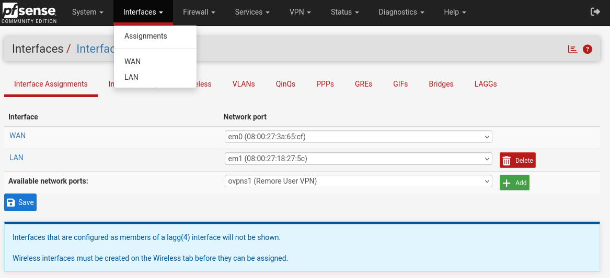
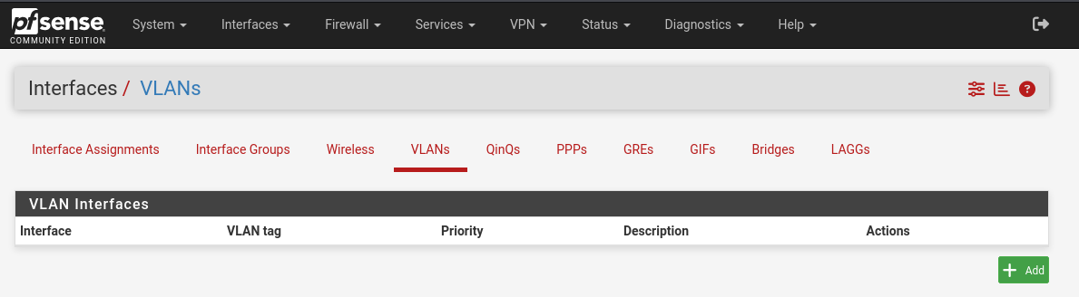
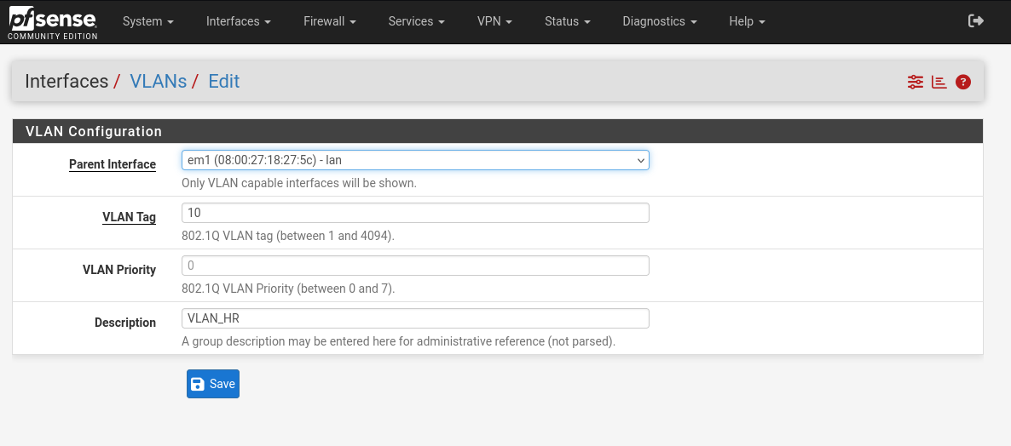
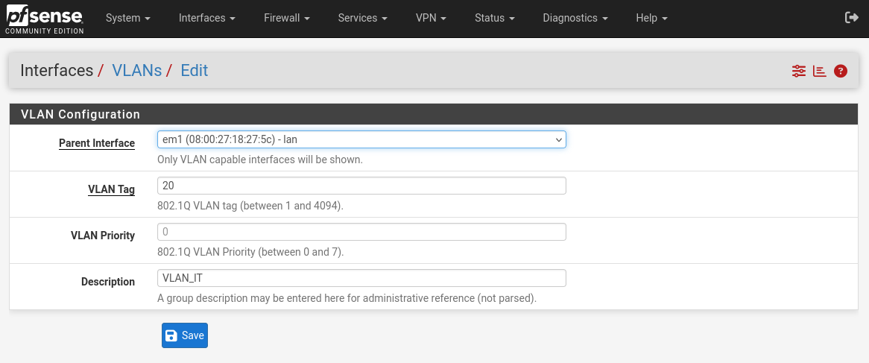
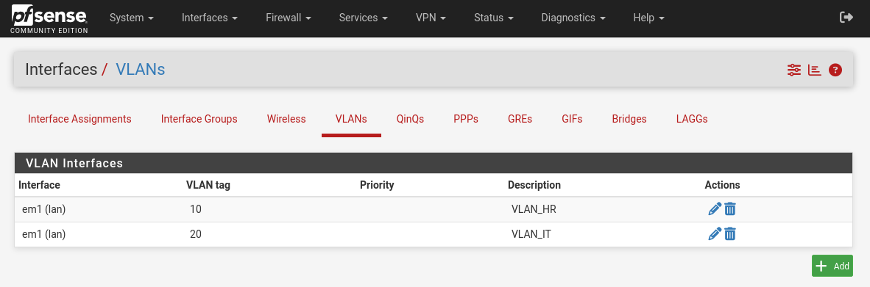

2. Interface Assignments and Configuration
Goal: Turn the virtual VLANs into usable pfSense interfaces with IP addresses.
- Navigate back to Interfaces > Assignments.
- Under Available network ports, you will now see your two new VLANs.
- Click the + Add button next to VLAN 10 on em1 to create a new interface called OPT1.
- Click the + Add button next to VLAN 20 on em1 to create another new interface called OPT2.
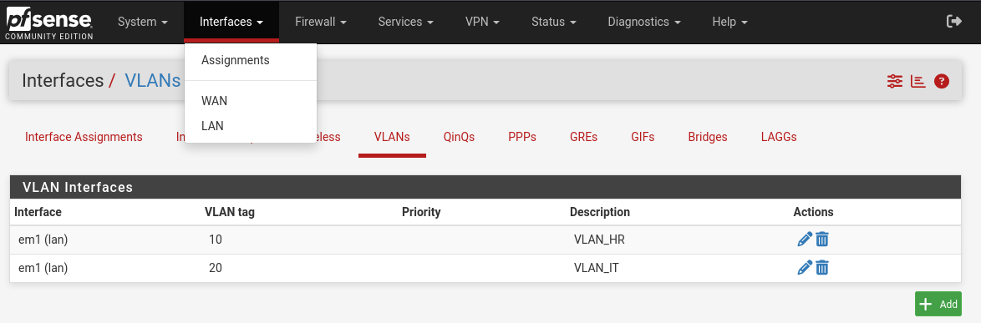
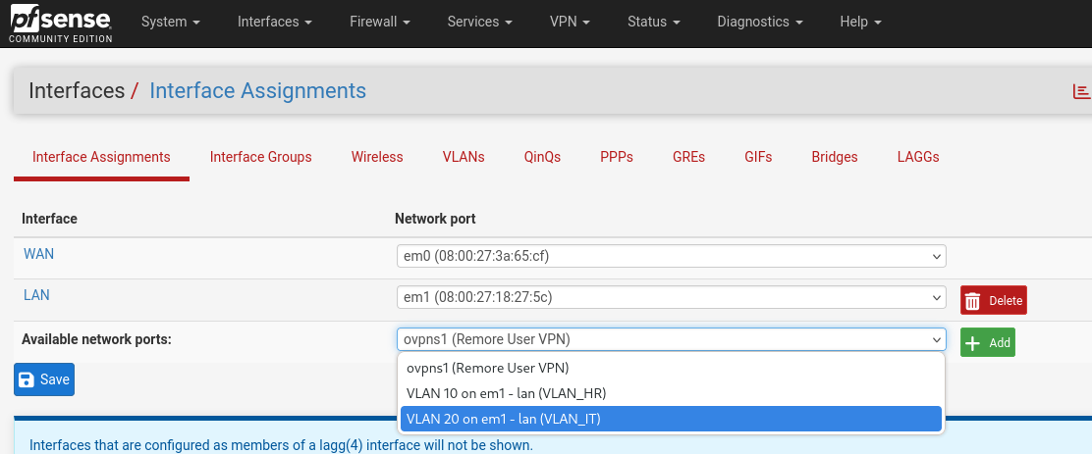

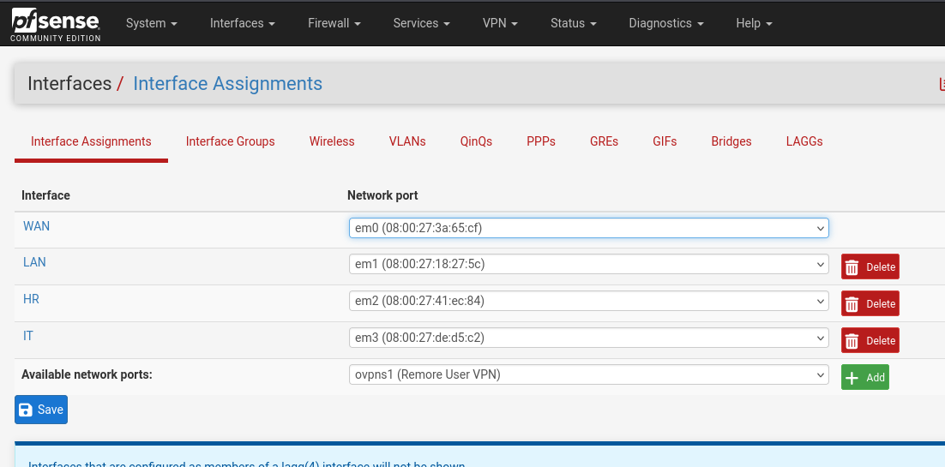

- Now, let's configure OPT1 for the HR department. Click on the OPT1 name.
  - Check the box for Enable interface.
  - Change the Description to HR.
  - Set IPv4 Configuration Type to Static IPv4.
  - Under Static IPv4 Configuration, set the IPv4 Address to 192.168.10.1 and the subnet mask to /24.
  - Click Save, and then Apply Changes.
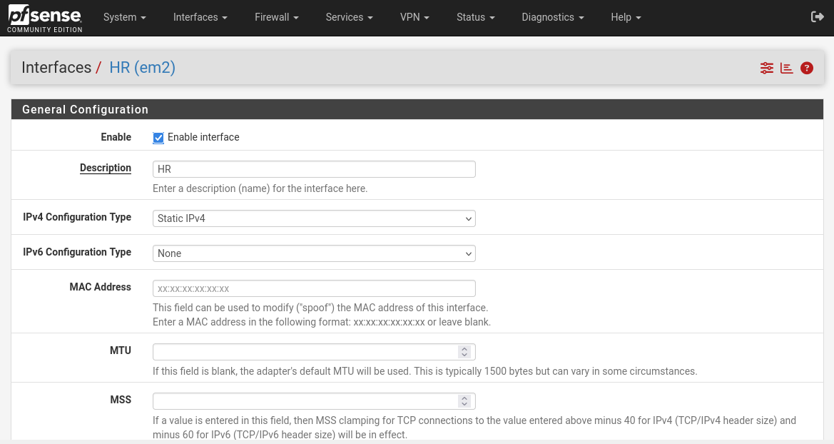
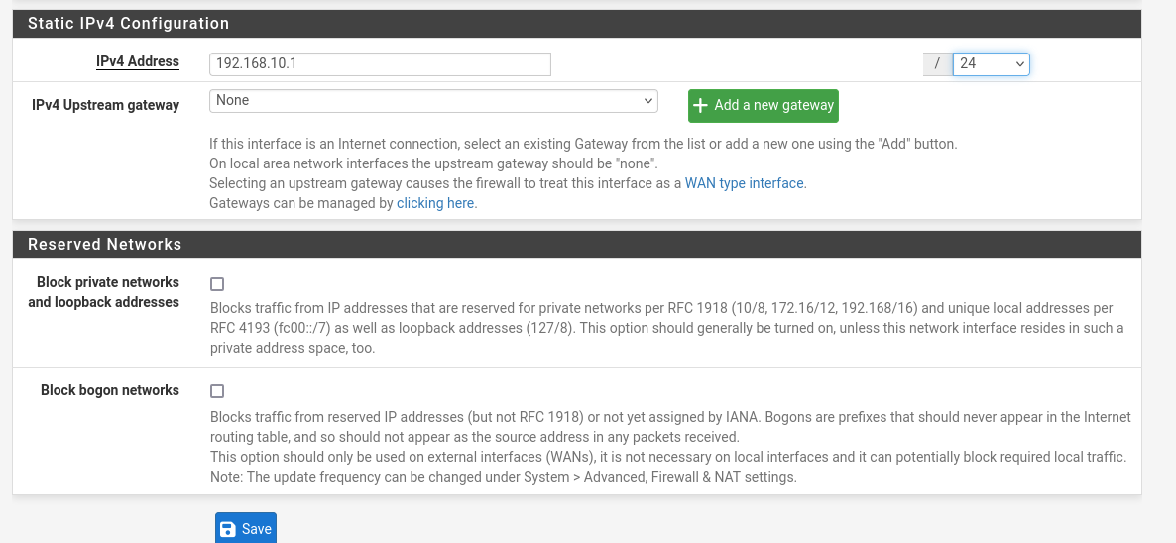
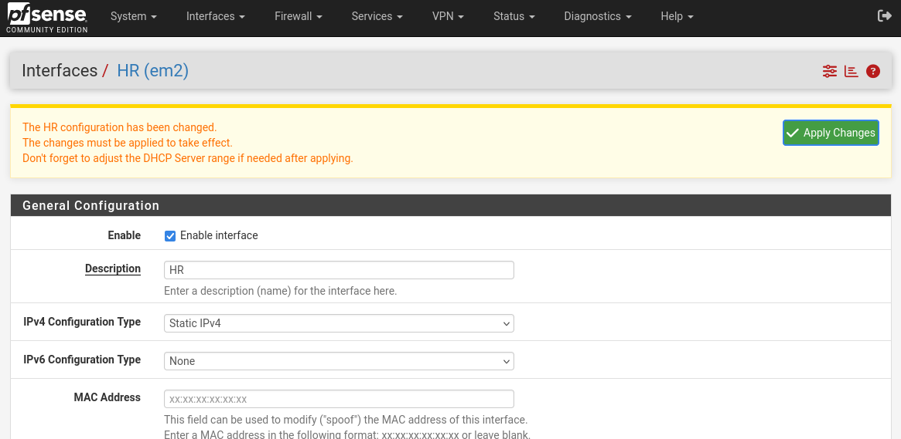
- Next, configure OPT2 for the IT department. Go back to Interfaces > Assignments and click on OPT2.
  - Check the box for Enable interface.
  - Change the Description to IT.
  - Set IPv4 Configuration Type to Static IPv4.
  - Set the IPv4 Address to 192.168.20.1 with a /24 subnet mask.
  - Click Save, and then Apply Changes.
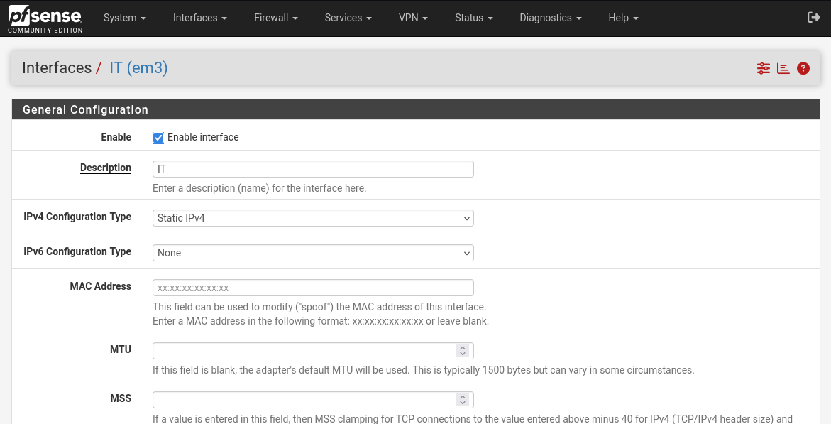
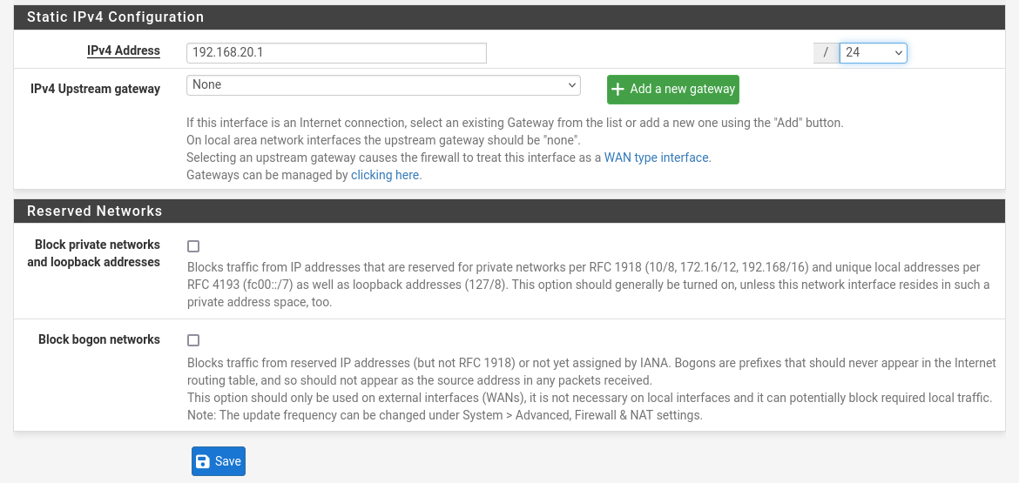
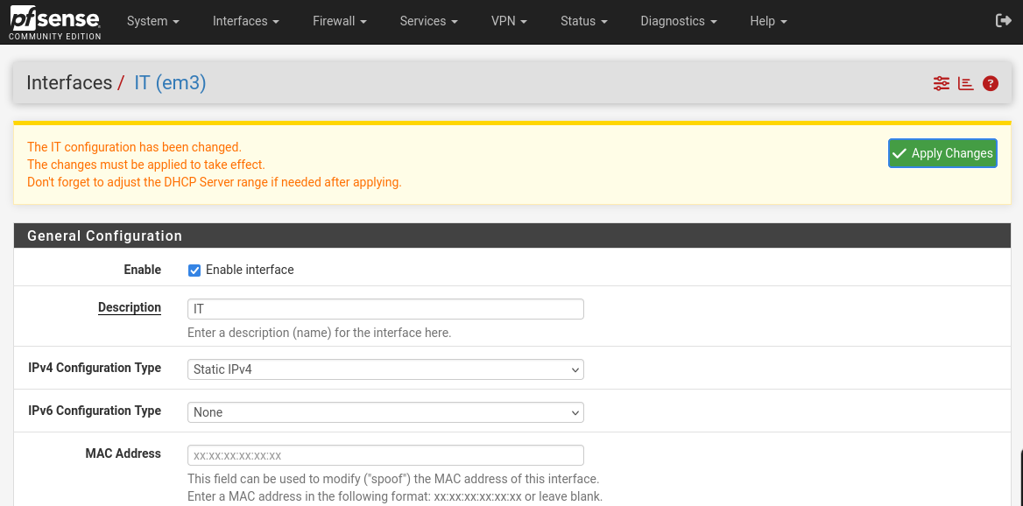

3. DHCP Setup per VLAN
Goal: Configure pfSense to automatically assign IP addresses to devices on both the HR and IT networks.
- Navigate to Services > DHCP Server.
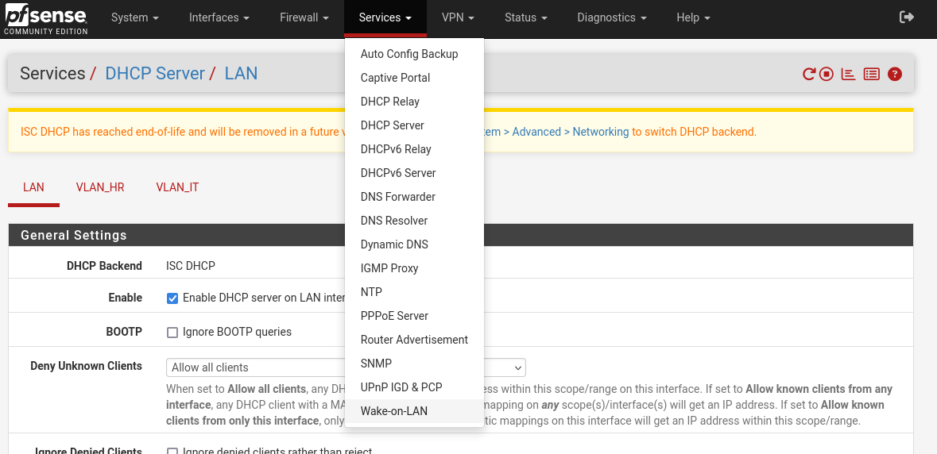
- You will now see tabs for your new interfaces: HR and IT.
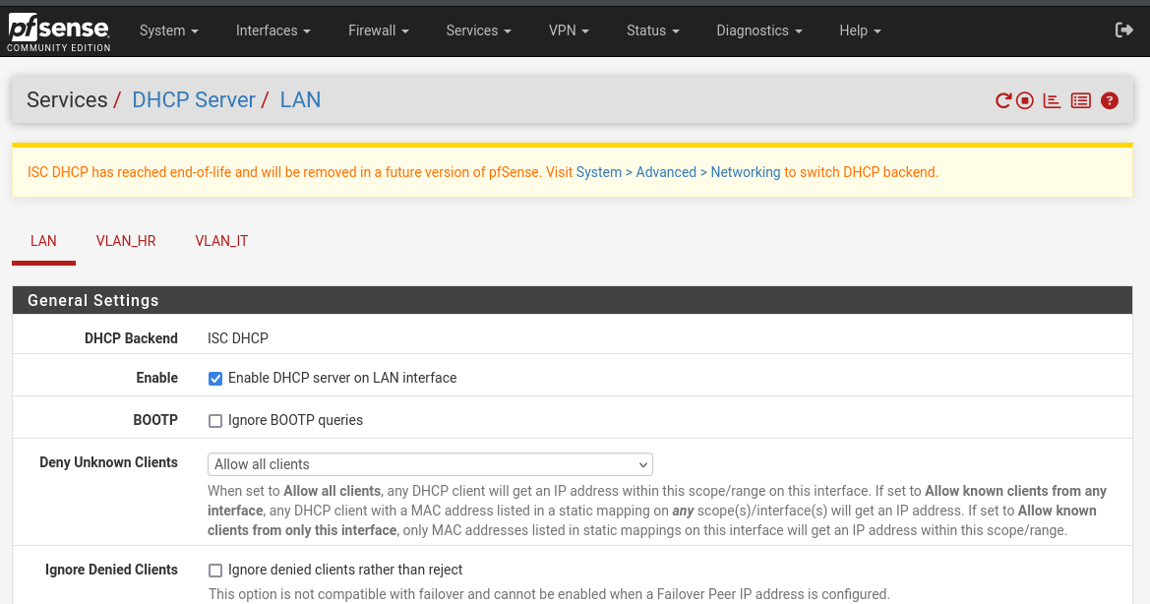
- Click on the HR tab.
  - Check the box for Enable DHCP server on HR interface.
  - Set the Range of IP addresses to issue, for example, from 192.168.10.100 to 192.168.10.200.
  - Click Save.
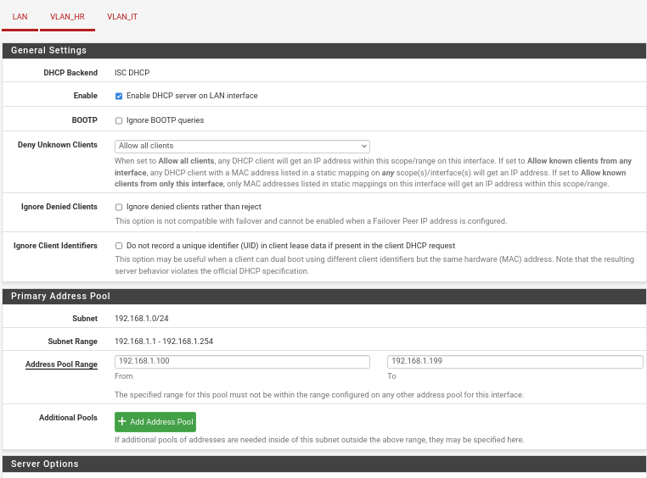
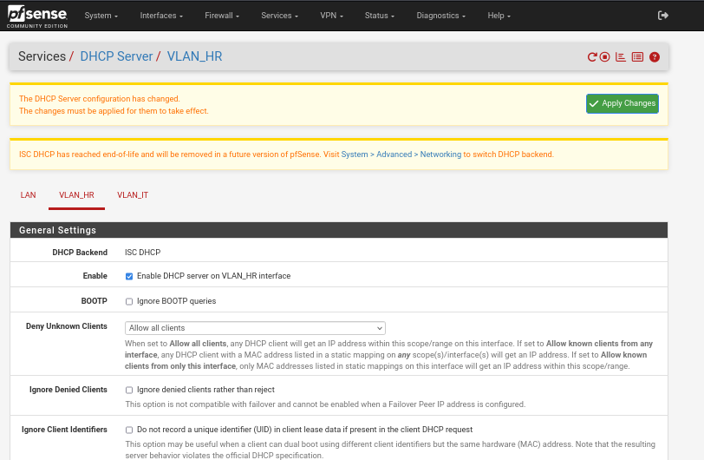
- Now click on the IT tab.
  - Check the box for Enable DHCP server on IT interface.
  - Set the Range from 192.168.20.100 to 192.168.20.200.
  - Click Save.
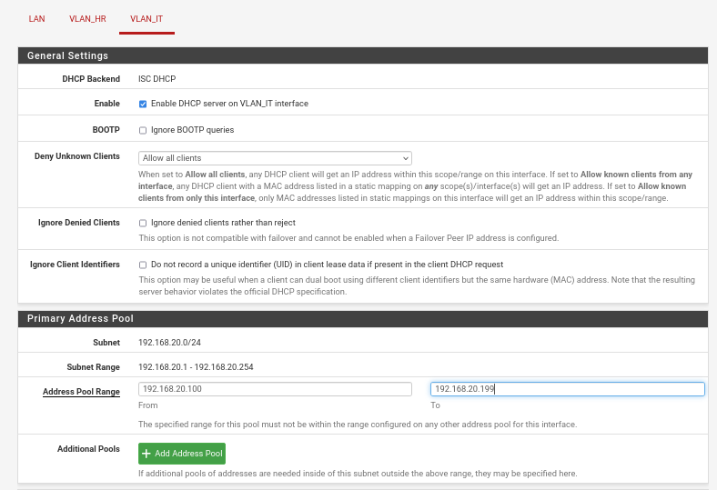

4. Firewall Rule Configuration for Inter-VLAN Restrictions
Goal: Implement the core security policy: IT can access the HR network, but HR cannot access the IT network.
- First, we need to give both networks internet access.
  - Navigate to Firewall > Rules.
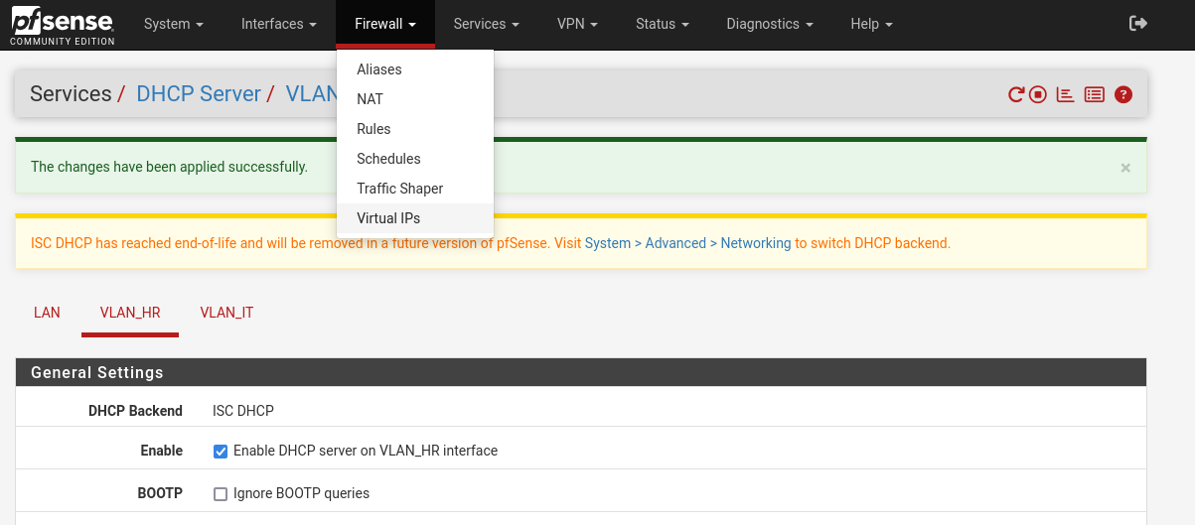
  - Click the HR tab. Click + Add.
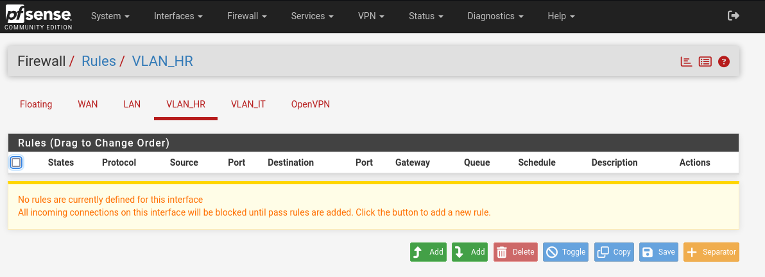
  - Create a rule that allows traffic from HR net to any destination. This is a basic "allow out" rule. Click Save.
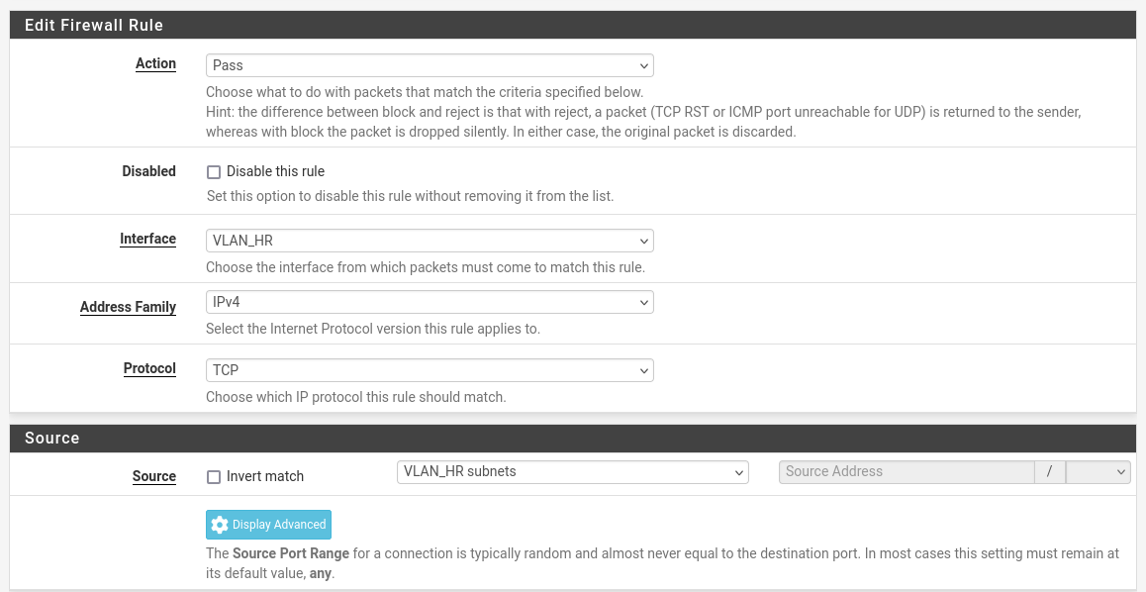
  - Click the IT tab. Click + Add.
  - Create a similar rule allowing traffic from IT net to any destination. Click Save.
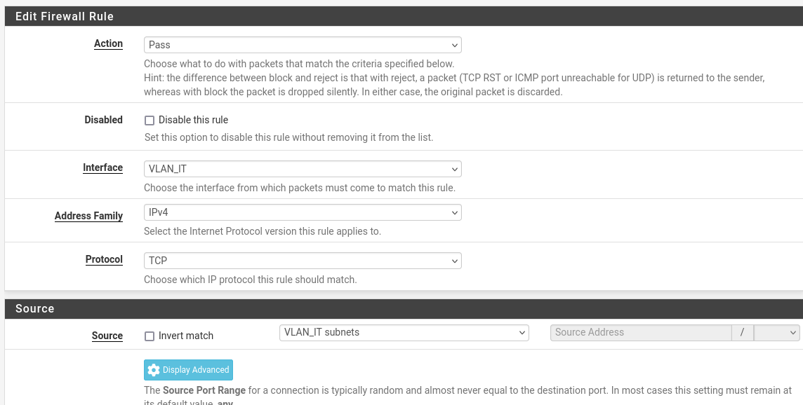
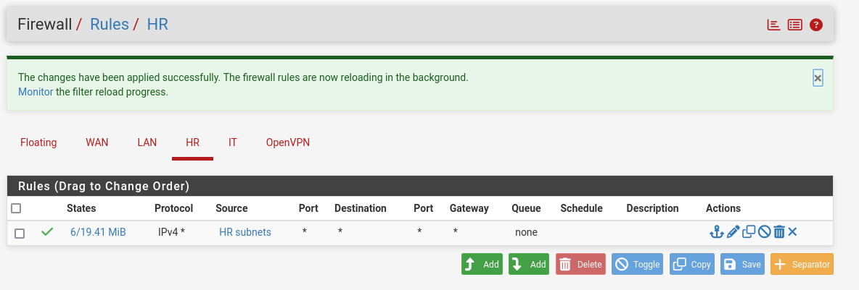
- Now, create the specific inter-VLAN rule.
  - While on the IT tab, click + Add to create a new rule.
  - Action: Pass
  - Interface: IT
  - Protocol: any
  - Source: IT net
  - Destination: Select Single host or alias and type HR net.
  - Description: Allow IT to access HR network.
  - Click Save, then Apply Changes.
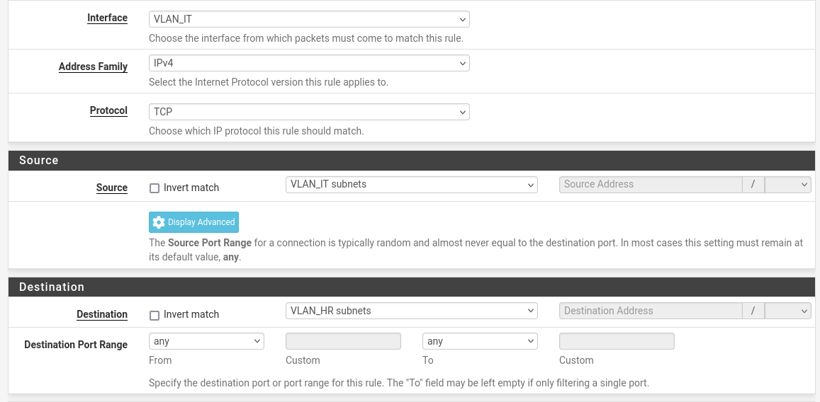
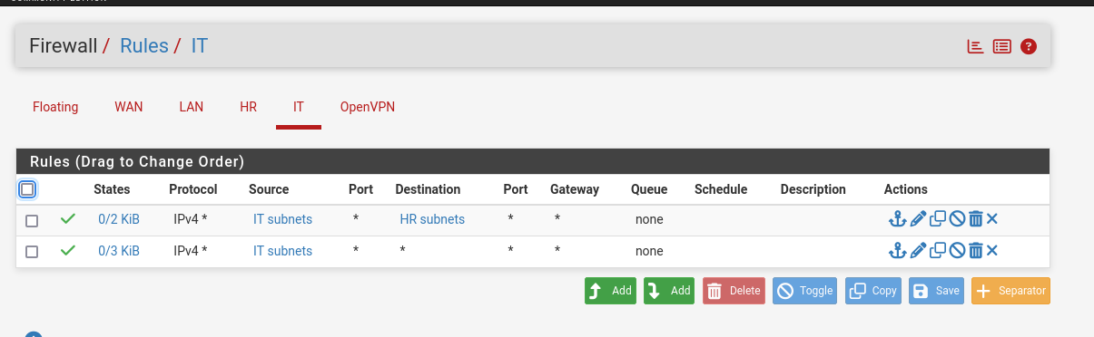
Important: We do NOT need to create a block rule on the HR interface. By default, pfSense blocks all traffic between interfaces unless a "Pass" rule specifically allows it. Since we never created a rule allowing HR to talk to IT, traffic is already blocked.
5. Testing Segmentation with Ping and Access Attempts
Goal: Verify that your firewall rules are working exactly as intended.
- Start both client VMs: Power on HR-Client and IT-Client.
- Check IP Addresses:
  - On HR-Client, open a terminal and type ip a. It should have an IP address in the 192.168.10.x range.
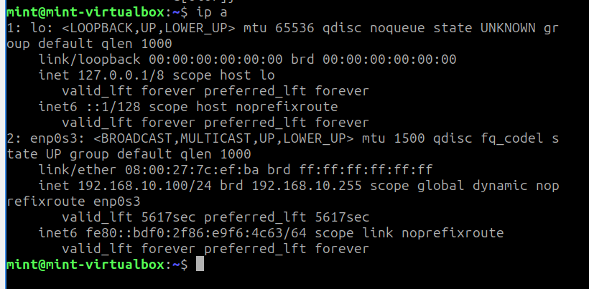
  - On IT-Client, do the same. It should have an IP in the 192.168.20.x range.
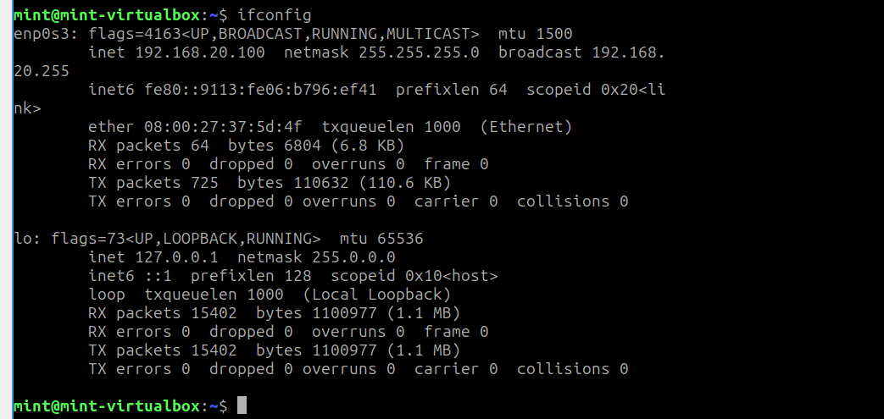
- Perform the Tests from HR-Client:
  - In the terminal, test internet access: ping 8.8.8.8. This should succeed.
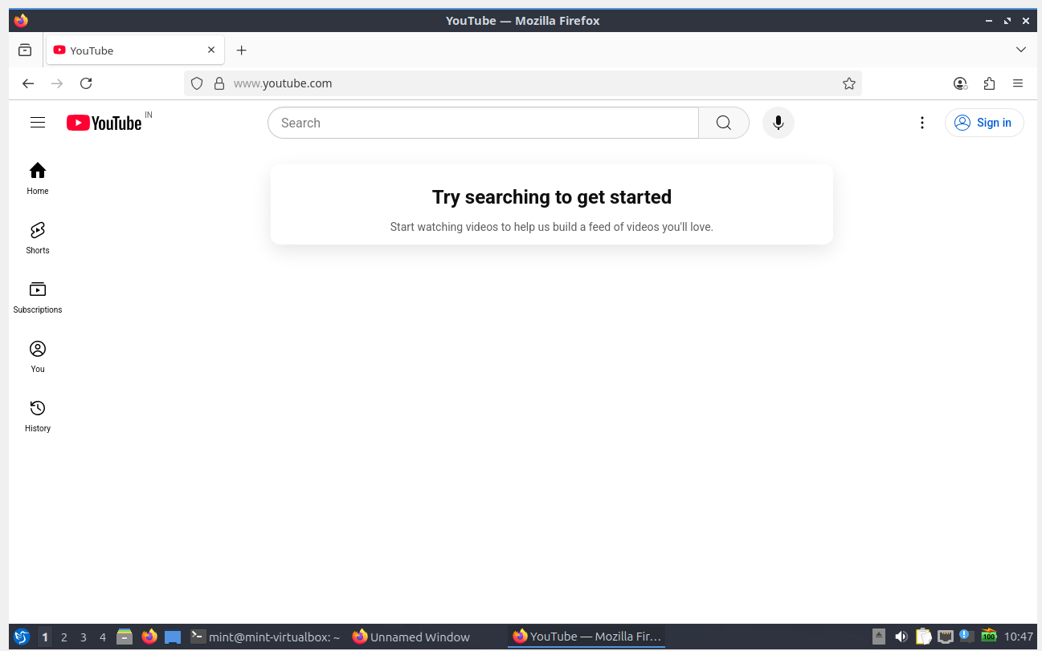
- Perform the Tests from IT-Client:
  - In the terminal, test internet access: ping 8.8.8.8. This should succeed.
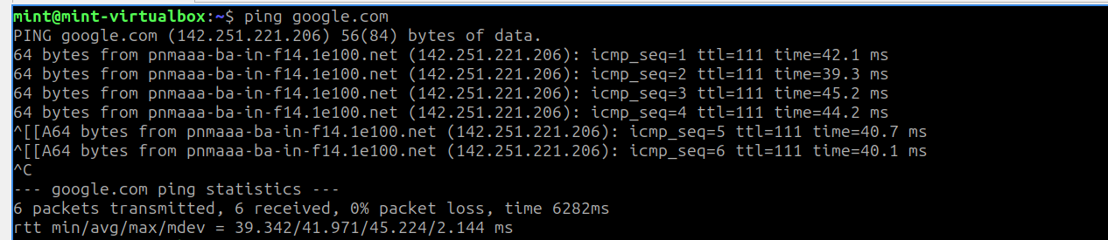
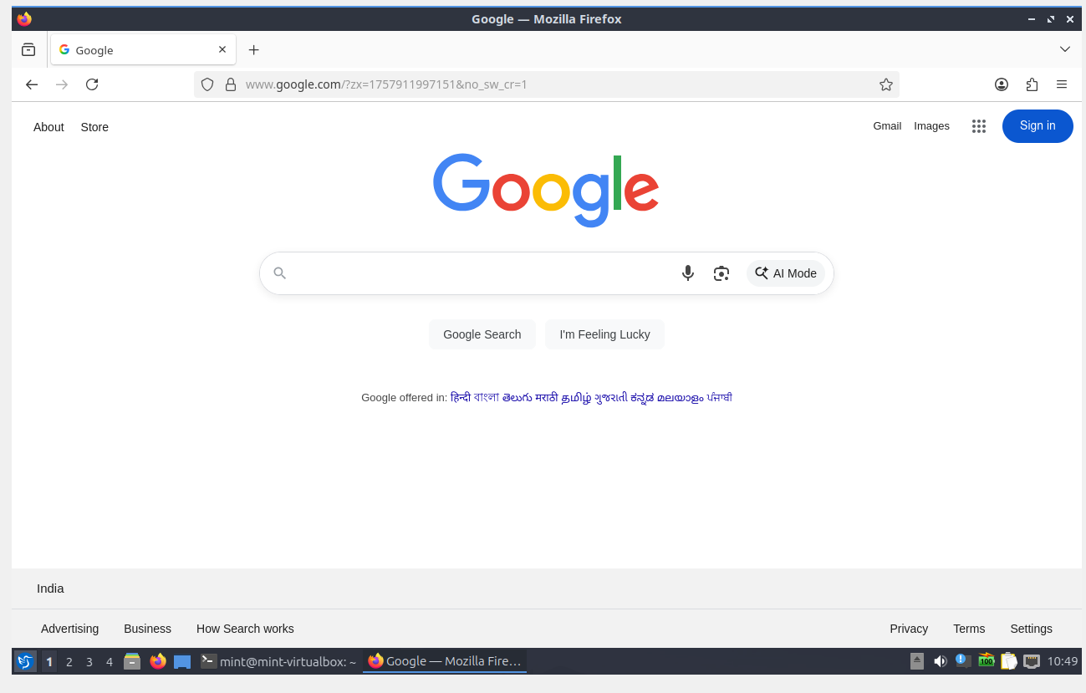
  - Now, attempt to access the HR network: ping 192.168.10.100 (the HR-Client's IP). This should be SUCCEED.
