**Q1. Implement the following basic commands used in LINUX/ UNIX OS**

* ls:



* man: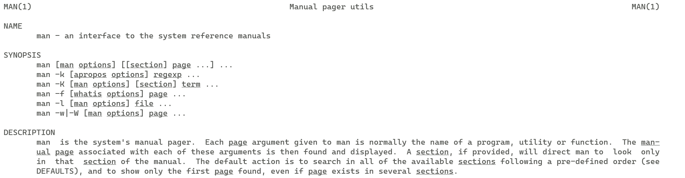
* pwd:

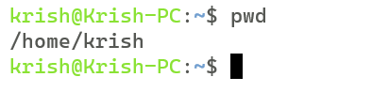

* who:

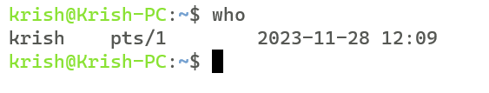

* whoami:

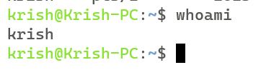

* date:

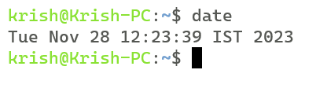

* cal:

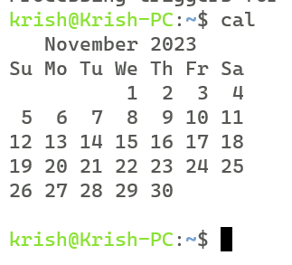

* mkdir:

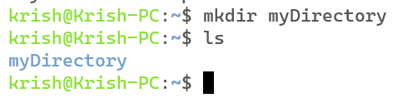

* rm:

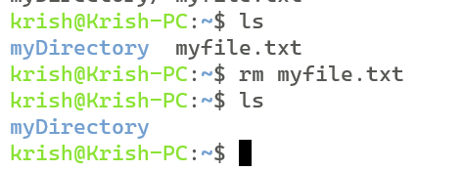

* rmdir:

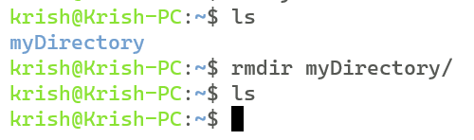

* cat:

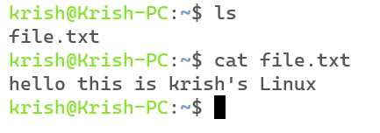

* head:

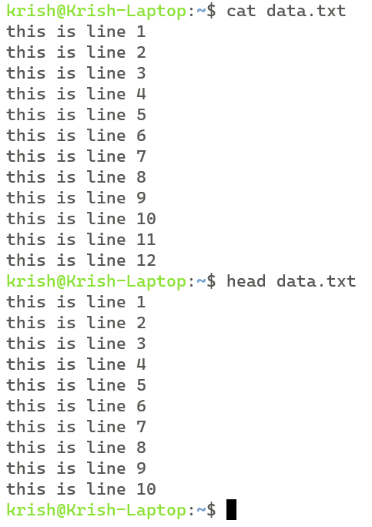

* tail:

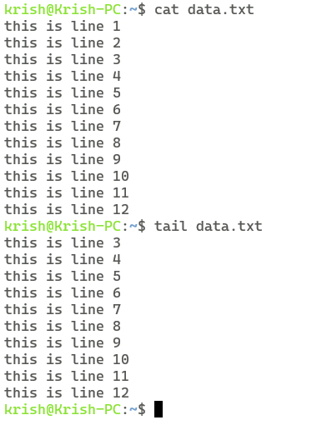

* more:

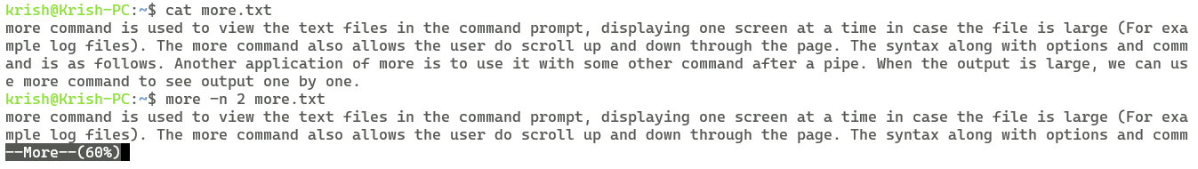

* less:

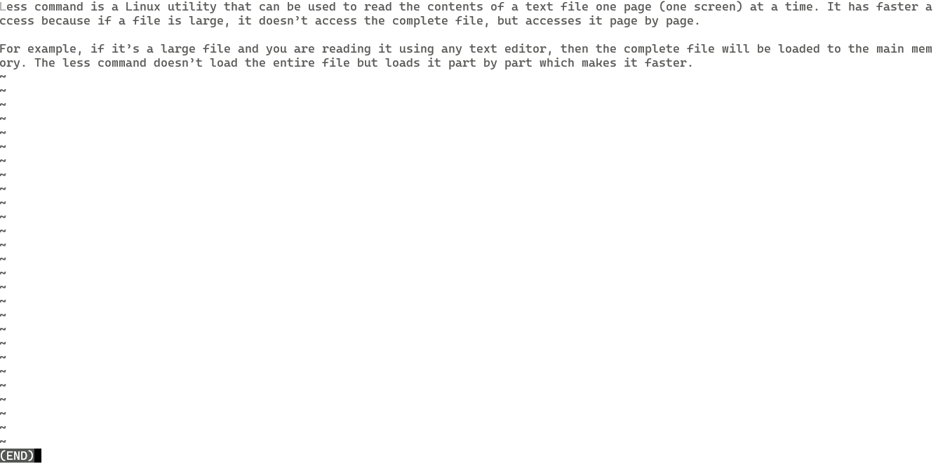

* cp:

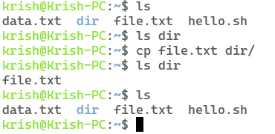

* mv:

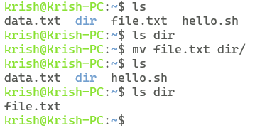

* echo:

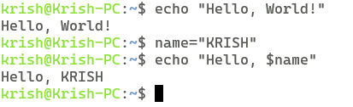

1. **Who is current user:**

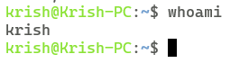

1. **What is current login name:**

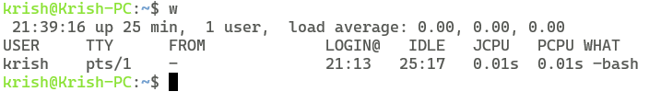

1. **How to take backup of a file:**

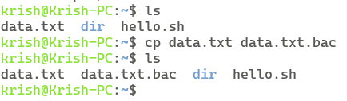

1. **How to create 3 subdirectories in a directory using single line command:**

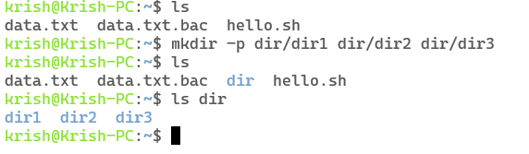

1. **How to remove file of .txt extension:**

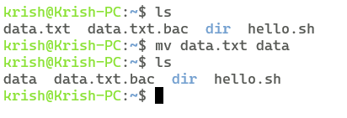

1. **How to remove file of any extension:**

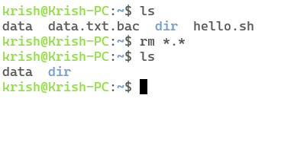

1. **How to remove file starting with “a”:**

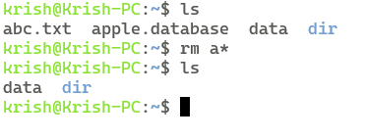

1. **How to remove non empty directory:**

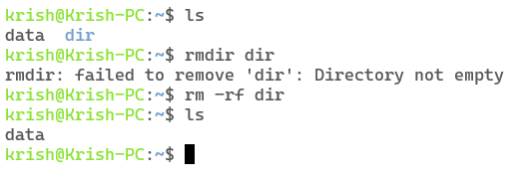

**Q2. Implement the following basic commands used in LINUX/ UNIX OS**

* **Cut:**

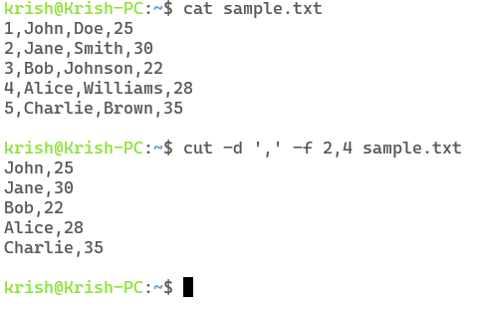

* **Uniq:**

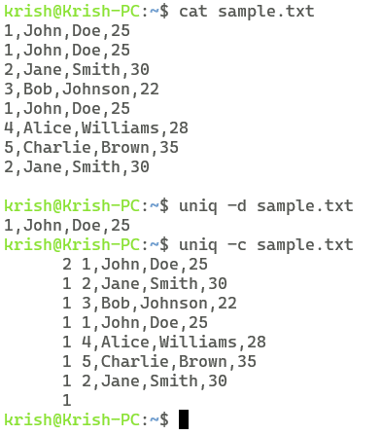

* **Chmod:**

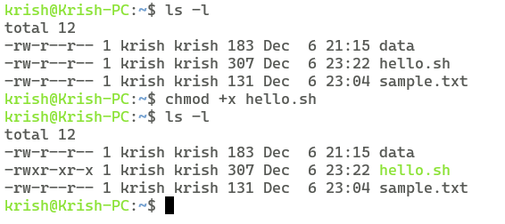

* **Diff:**

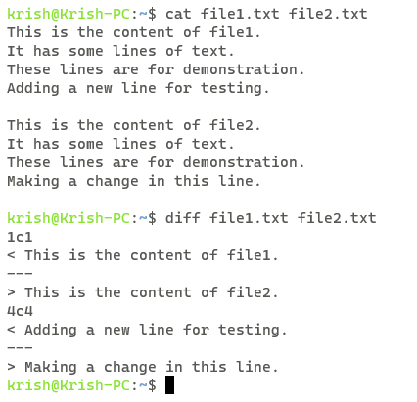

* History:

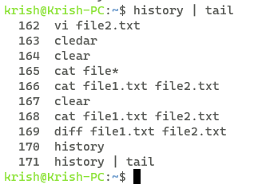

* Last:

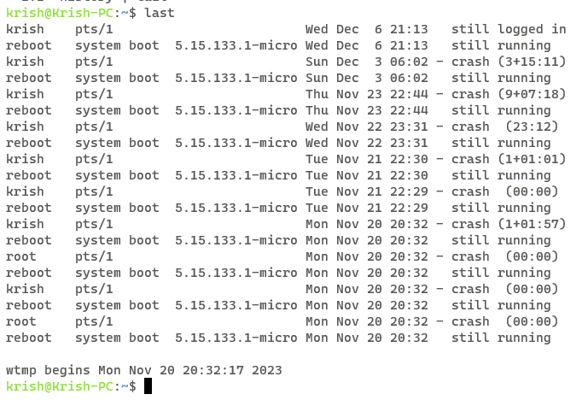

* Sort:

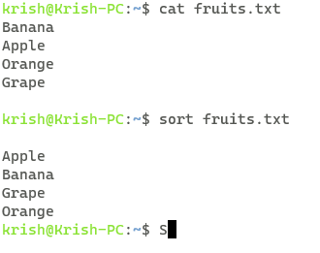

* Sed:

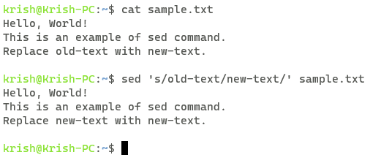

* Grep:

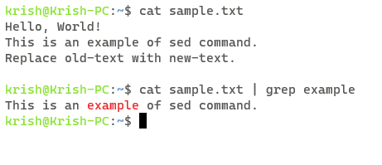

1. Total no of users connected to system currently:

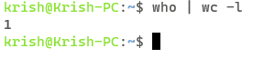

1. Display only current local time of system:

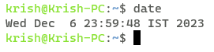

1. Arranging the files of directory on ascending order of their sizes:

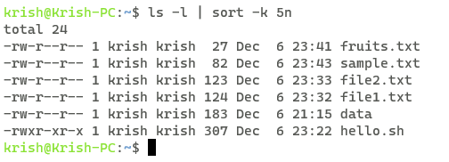

1. Display 5th character of your name:

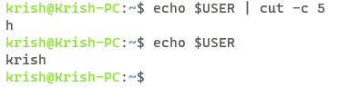

1. Display 7th line of a file:

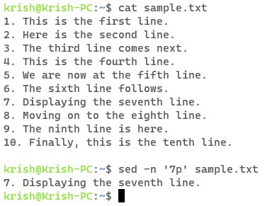

**Q3. Shell scripts that uses simple commands:**

1. Write a shell script to display current date in a particular format, number of users currently login and current month’s calendar.

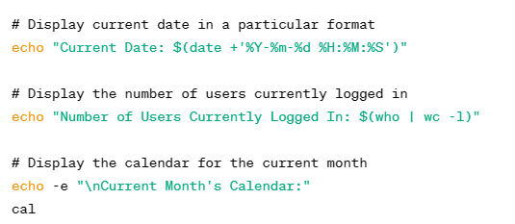

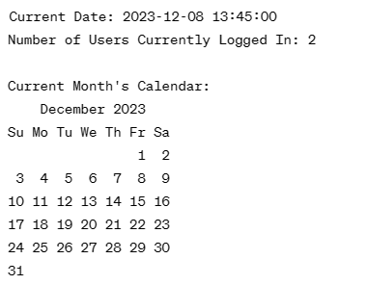

1. Write a shell script to display the process name and its process id.

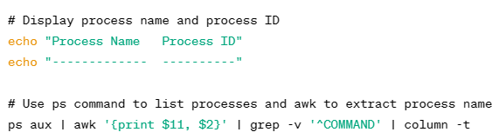

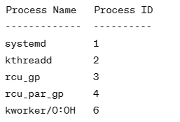

1. Write a shell script to take name as a input and display a greeting message to the user by checking system clock.

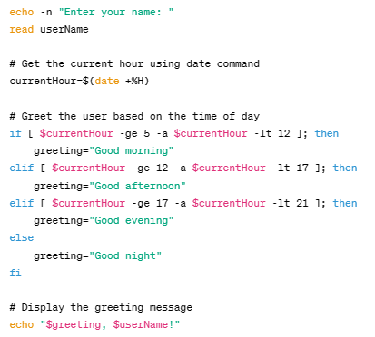



1. Write a shell script to merge the content of 2 files into one file: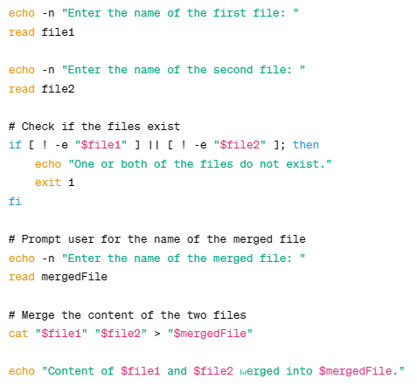

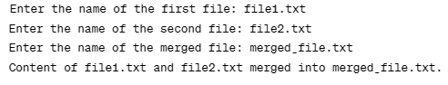

1. Write a shell script to create a tsv file containing name, roll no. and age of 10 students. Then use that tsv file to display only the names of the students in alphabetical order:

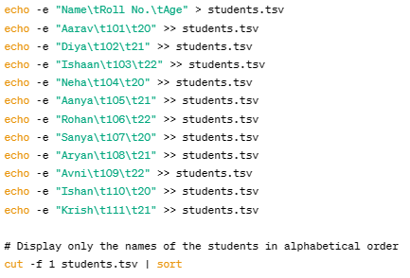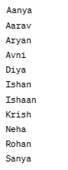

**Q4. Decision based Shell scripts:**

1. Write a shell script that finds whether an entered number is even or odd:

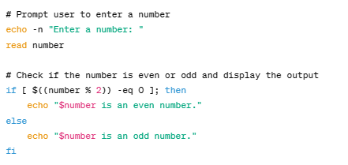



1. Write a shell script to input the name of a file as command line argument and display whether it is a file, a directory or anything else:

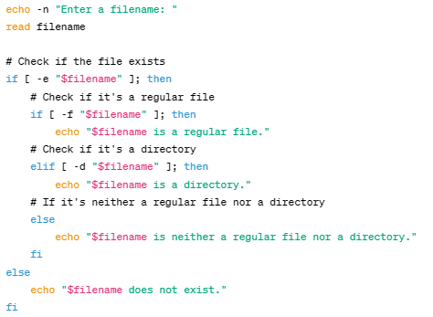



1. Write a shell script to input the marks of a student in 3 subjects and find his grade:

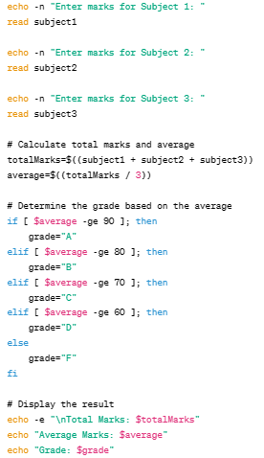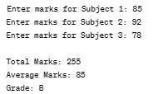

1. Write a Shell script to accept a filename as argument and displays the last modification time if the file exists and a suitable message if it does not:

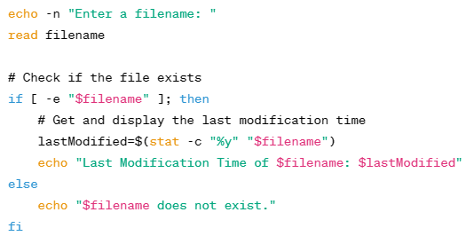 

1. Write the shell script to take file name as input and if the file exists then print the number of lines and also print 10th line of that file:

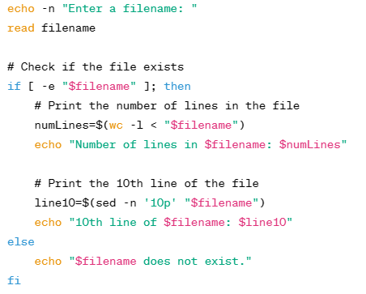

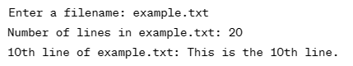

**Q5. Shell scripts related to loops and arrays:**

1. Write a shell script that print multiplication table of a given no:

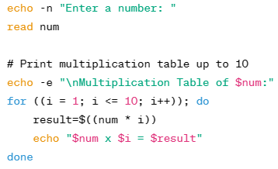 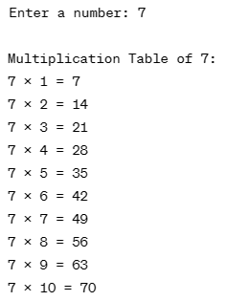

1. Write a shell script to implement a timer:

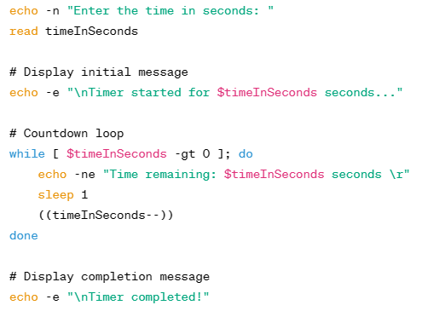 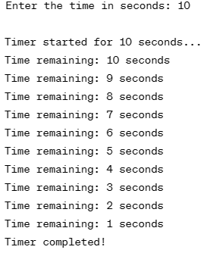

1. Write a shell script that print reverse of a given positive number:

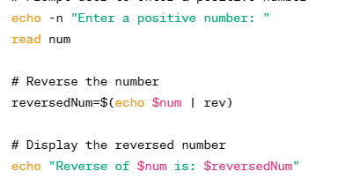

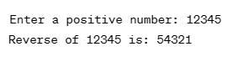

1. Write a shell script that print factorial of a given number:

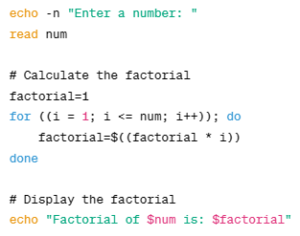



1. Write a shell to demonstrate the working of array. Input 10 integer in array and display maximum, minimum, total sum and average of an array:

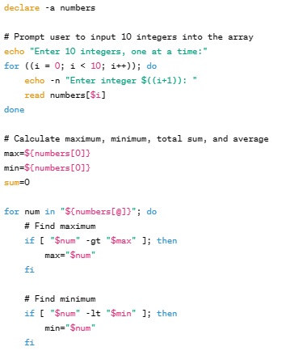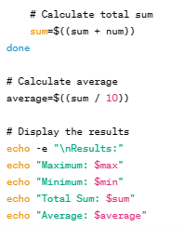

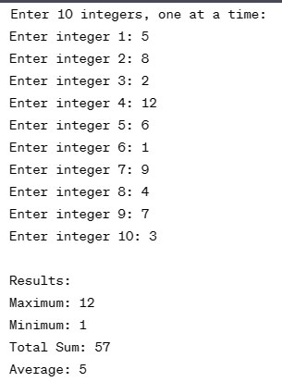

**Q6. Shell scripts related to strings and pipes:**

1. Write a shell script to input two strings from the user and determine whether they are same or not:

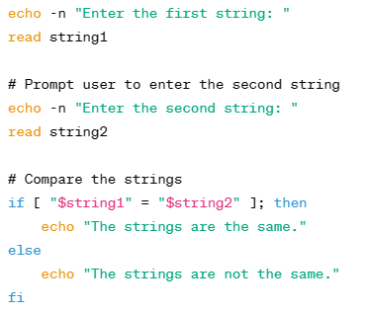

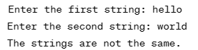

1. Write a shell script to input a string from the user and determine its length:

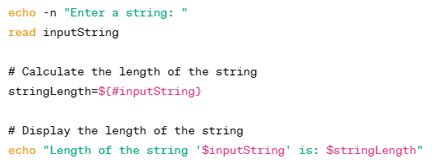

1. Write a shell script to input two strings from the user and find the occurrences of string2 in string 1:

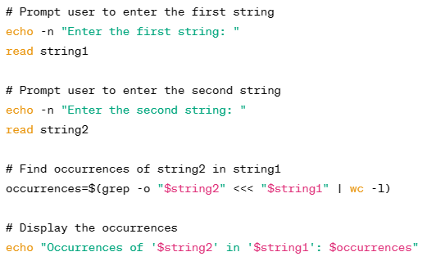

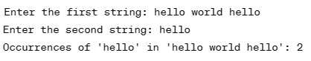

1. Write a shell script to input the name of a file as command line argument and display the number of characters, words and lines in the file:

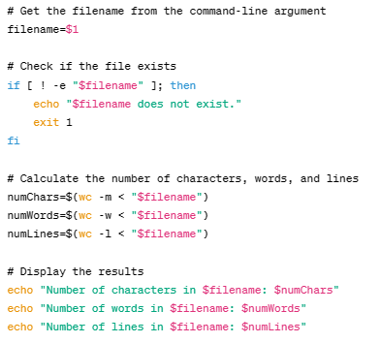



1. Write a shell script to display a list of directories within the current directory and how much space they consume, sorted from the largest to the smallest:

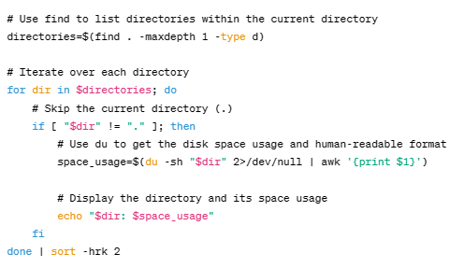

1. Write a short script count txt to count the total number of .txt files in the current directory, and print out this number to screen:

