

Tribhuvan University

Institute of Science and Technology

A Final Year Project Proposal

On

“Medicine Recommendation System”

Submitted to:

Department of Computer Science and Information Technology

Academia International College

Gwarko, Lalitpur, Nepal

In Partial fulfillment of the requirements

For the Bachelors of Science in Computer Science

and Information Technology

Submitted by:

Sharada Luitel (26517/077)

Krish Kumar Shrestha (26493/077)

Under the supervision of

Mr................................

August 2024

**Contents**

Introduction 1

Problem Statement 2

Objectives 2

Scope and Limitation 3

Methodology 4

a. Requirement identification 5

i. Literature Review 5

ii. Requirement Identification 6

b. Feasibility study 6

i. Technical Feasibility 6

ii. Operational Feasibility 7

iii. Economic Feasibility 7

iv. Schedule 7

c. High level design of system 9

i. Designs of diagrams 9

Flowchart 9

ii. Description of algorithm 12

Expected outcome 14

References 15

**List of Figures**

**Figure 1 Time Schedule for Project 6**

**Figure 2 Gantt chart 6**

**Figure 3 Agile Methodology 7**

**Figure 4 flowchart 8**

**Figure 5 Linear SVC 10**

**Figure 6 Non-Linear SVC 10**

# **Introduction**

Healthcare is an essential service that impacts the lives of people worldwide. It is critical to provide the right treatment to patients as fast as possible, and the success of such treatment depends on the accuracy of the medication prescribed. Over the years, the healthcare industry has made significant progress in medical research, diagnostic equipment, and other medical technologies. However, one area that has been overlooked is the personalized medication recommendation, which can improve healthcare outcomes and reduce healthcare costs. [1]

Jay Prakash Gupta [2] and his team proposed medicine recommendation system to predict disease and provide medicine according to the disease . A Medicine Recommendation System is one of the biggest innovations in medication systems. This system also incorporated the best algorithm and data analytics in searching the patient’s symptoms that would enable the system to recommend the disease user maybe suffering from and along with it diets, workouts, medicine best fit for the disease. Through the application of this technology, users would be in a position to be more cautious. In addition, it helps aware the patients before the condition is critical.

In the context of Nepal there are some special challenges for the Nepalese healthcare system especially those that are quite remote and/or rural, lack doctors. Moreover, there is a great divide and differentiation on the healthcare system some areas have advanced hospitals, while others have mere clinics. These factors create a problem in the provision of standard and quality treatment across the country. The deliver of standardized care is already challenging because of the disease type and the patient’s cultural background, economic status, and overall health.

# **Problem Statement**

There are several head-scratching issues that prevails in Nepalese healthcare system that makes it hard in delivering uniform and qualitative treatment and care across the nation. Some of these factors include limited health workforce [3], especially in the rural setting, poor density of qualified doctors, fundamental and emergency drugs, and inadequate medical facilities. They point to the fact that while some urban centers will have well-endowed hospitals, most rural areas will only have clinics that are badly equipped and cannot handle the demand that exists in those areas. These challenges point to the fact that there is need to come up with advanced approaches that include the health-related systems that assist in coming up with the appropriate disease prediction along with suggesting diets, workouts and prescription to give to the patients hence improving the Nepalese patient’s health results as well as preventing individual from suffering different serious health issues.

# **Objectives**

The main purpose of the our system are :

* To create a healthcare system that tries to enhance health of users.
* To improve patient safety by awaring users of what they might be suffering from.
* To elevate overall healthcare quality by suggesting diets and workouts to the users.

# **Scope and Limitation**

**Scope**

The system provides personalized health advice by analyzing symptoms to predict potential diseases and offering suggestions. It delivers customized diet plans aligned with the predicted disease, recommends appropriate workouts to support recovery or management, and advises on precautions to minimize further health risks. Additionally, the system integrates a continuous learning mechanism, ensuring that its recommendations evolve and improve over time based on the latest medical research and data, making it a reliable and up-to-date health management tool.

**Limitation**

The system currently operates with a limited dataset, encompassing only 131 symptoms and 41 diseases, which may constrain its diagnostic capabilities. The effectiveness of the system heavily relies on the quality and availability of patient data, which can vary significantly, leading to potential inaccuracies in regions where data is incomplete or inconsistent. Additionally, the accuracy of the system's output depends on the correct input of symptoms by the user any errors in symptom entry could result in crashing of our system.

# **Methodology**

## Requirement identification

### Literature Review

A literature survey for medicine recommendation system involves conducting a comprehensive review of existing research and academic literature in the field. The survey begins by defining the research objectives and identifying relevant literature sources such as academic databases, research journals, and conference proceedings. Selected papers are then reviewed in detail, focusing on research methodologies, data sources, machine learning algorithms employed, explainability approaches, and evaluation methodologies.

Lisha Kurian [4] conducted significant research on medicine recommendation systems using machine learning algorithms, emphasizing patient-specific factors. Their study utilized machine learning to extract patient data and provide personalized health advice, highlighting the importance of tailoring recommendations to individual patient needs. However, the study's evaluation of algorithmic explainability was limited.

Ms. Silpa and her team [5] developed a system designed for use in medical emergencies, employing a machine learning approach similar to ours. Their system utilized a Random Forest classifier to provide real-time medical assistance, especially during emergencies. Our system, uses a Support Vector Classifier, which was chosen for its effectiveness in handling high-dimensional data and its potential for better performance in our specific context.

A different approach is explored in the literature “Implementing collaborative filtering for medicine recommendation systems”. This technique leverages the collective knowledge and preferences of users to make personalized medication recommendations. Collaborative filtering identifies similarities and patterns among users based on their historical behavior or preferences, which can be particularly useful in personalized healthcare settings [6].

Jianguo Chen and his team [7] proposed a disease diagnosis and treatment system that utilizes data sharing and treatment intelligence. Their work focuses on the integration of data-driven insights to enhance treatment accuracy and efficiency, contributing to the broader field of intelligent healthcare systems.

### Requirement Identification

The requirements can be functional and non-functional.

**Functional Requirements**

* User registration and authentication
* Login option for the registered user
* Search for symptoms
* Get suggestions according to the input

**Non-Functional Requirements**

* Easy to navigate user interface
* Reliable and quick responses
* Work on every device

## Feasibility study

Feasibility analysis is important in arriving at a decision with an objective of establishing whether or not to undertake any projects. It assesses such factors as technical, economic, legal, operational and scheduling in a bid to determine the likely risks and resources. Thus, through the analysis of the cost per benefit, it provides the rationale for the expenditure and ensures that meets the objectives and Standard Operating Procedures and regulations. The foregoing process affords a best practice for planning and makes decisions that are knowledgeable in their execution.

### Technical Feasibility

The technical feasibility to develop a system that aware users about their health using Python, Flask and machine learning is possible. scikit-learn libraries are also used to work and implement the models. Flask offers an elaborate architecture for extensive websites, and gives necessary tools to add and process user information. This duo facilitates the management of data, models incorporation as well as horizontal scalability when deploying a system, and therefore suitable in building a reliable and efficient system.

### Operational Feasibility

An operational feasibility analysis for a system that will be developed by Python, Flask, and including machine learning approaches refers to the identification of possible implementation and management issues. Python and Flask have good documentation and community, they make it easy for us to develop and deploy, which is quite feasible. Flask framework supports the creation of user- friendly applications.

### Economic Feasibility

Every system requires the economic consideration while development and deployment. For our system using Python, Flask, and machine learning Python and Flask do not require licensing fees, making it possible for us to reduce on initial costs of development. Other costs are other operational costs like the deployment costs. However, the installation of Flask is platform independent and the performance of Python is also good thereby controlling these costs.

### Schedule

The process of creating and applying a system can be subdivided into several phases. Project Planning carries on to Project Initiation to set goals and to collect necessities. This is then succeeded by Analysis, to test for technical, operational and economic feasibility. System Design focuses on planning of architecture of the system and the user interfaces. Development is concentrated on constructing the non-visual parts, adding the data analysis with the help of different algorithms, and establishing the product interface. The verification is done through unit, integration and user acceptance tests.

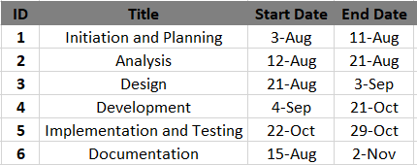

**Figure 1 Time Schedule for Project**

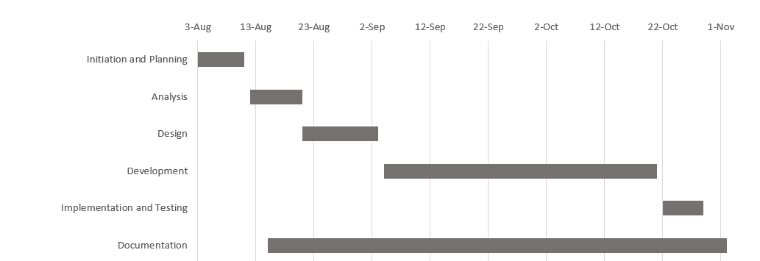

**Figure 2 Gantt chart**

## High level design of system

The project’s development and implementation are guided by the Agile methodology. This approach emphasizes iterative progress, continuous feedback, and flexibility, allowing us to adapt to changing requirements and evolving needs. We break the project into short, manageable sprints, each aimed at delivering specific features or improvements. Regular review sessions are held to assess our progress, incorporate feedback, and adjust priorities as necessary. By integrating Agile practices, we ensure the system evolves effectively, promptly addresses emerging issues, and consistently meets user needs throughout the development lifecycle.

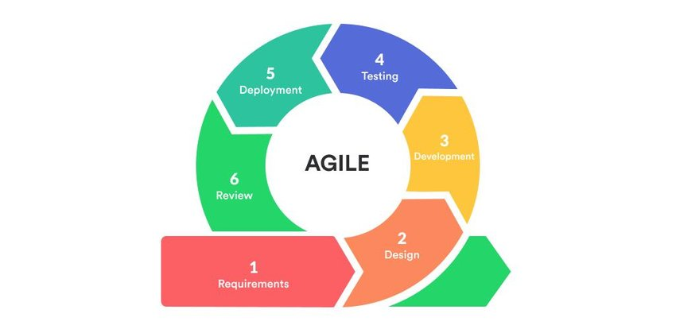

**Figure 3 Agile Methodology**

### Flowchart

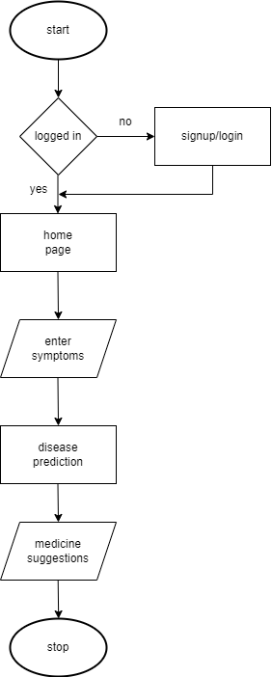

**Figure 4 flowchart**

### Description of algorithm

**Support vector classification**

Support Vector Classification (SVC) is a machine learning algorithm used for binary and multi-class classification tasks. [8] It works by finding the optimal hyperplane that maximizes the margin between different classes in the feature space. SVC is effective in high-dimensional spaces and can be extended to handle non-linear data using kernel functions. For a linear Support Vector Classifier (SVC) [9], the decision boundary is defined by a linear equation. The formula for the decision function f(x) is:

𝑓(𝑥)=𝑤⋅𝑥+𝑏

Where:

w is the weight vector (normal to the hyperplane).

x is the input feature vector.

b is the bias term (also known as the intercept).

⋅ denotes the dot product.

**Decision Rule:**

If f(x)≥0, classify the input as one class (e.g., +1).

If f(x)<0, classify the input as the other class (e.g., -1).

Basic concepts of svc

Support Vectors: These are the data points closest to the decision boundary (hyperplane) and are critical in defining the position of the hyperplane. The classifier is named after these support vectors because they “support” the optimal boundary.

Hyperplane: In an SVC, the goal is to find the optimal hyperplane that separates different classes with the maximum margin. In higher dimensions, this hyperplane becomes a decision boundary.

Margin: The distance between the hyperplane and the nearest data point from either class. SVC aims to maximize this margin.

SVC can be of two types:

Linear svc

When data is linearly separable, the SVC finds a straight line (in 2D), plane (in 3D), or hyperplane (in higher dimensions) that best separates the classes.

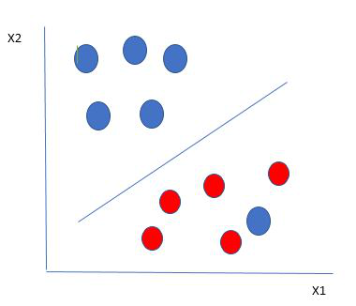

**Figure 5 Linear SVC**

Nonlinear svc

When data is not linearly separable, SVC uses a kernel trick to map the data into a higher-dimensional space where a linear separation is possible.

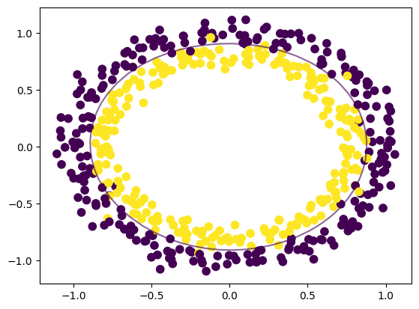

**Figure 6 Non-Linear SVC**

# **Expected outcome**

The expected outcome of the system is to enhance patient’s safety by offering data-driven health analysis along with personalized diet precautions and workout. By analyzing patient symptoms, it provides personalized recommendations resulting overall treatment effectiveness. Additionally, the system enhances patient safety by identifying potential diseases early and offering timely suggestions, thereby reducing the risk of complications. Furthermore, by optimizing medication use through diet and workout and minimizing the need for frequent doctor appointments, the system contributes to significant cost savings for patients, lowering overall healthcare expenses.

# References

|  |  |
| --- | --- |
| [1] | C. K. Suryadevara, "TOWARDS PERSONALIZED HEALTHCARE - AN INTELLIGENT MEDICATION RECOMMENDATION SYSTEM," vol. 5, no. 9, p. 16, 2020. |
| [2] | J. P. Gupta, A. Singh and R. K. Kumar, *A COMPUTER-BASED DISEASE PREDICTION AND MEDICINE RECOMMENDATION SYSTEM USING MACHINE LEARNING APPROACH,* vol. 12, no. 3, p. 11, 2021. |
| [3] | P. R. Shankar, "Attracting and retaining doctors in rural Nepal," 2010. [Online]. Available: https://www.rrh.org.au/journal/article/1420. |
| [4] | E. K. J. J. K. U. J. Mrs. Lisha Kurian, "Disease Prediction and Medicine Recommendation Systems: A Comparative Analysis on learning algorithms," 2023. |
| [5] | Silpa, B Sravani, D Vinay, C Mounika, K Poorvitha, "Drug Recommendation System in Medical Emergencies using Machine Learning," 2023. |
| [6] | D. G. B. Ching-Seh (Mike) Wu, "Medicine Recommendation System Using Collaborative Filtering," 2022. |
| [7] | J. Chena, . K. Li, H. Rong, K. Bilal, N. Yang and K. Li, "A Disease Diagnosis and Treatment Recommendation System," Information Sciences, 2018. |
| [8] | J. W. A. Ben-Hur, "A user's guide to support vector machines," vol. 609, 2020. |
| [9] | "What are support vector machines (SVMs)?," IBM, 2023. [Online]. Available: https://www.ibm.com/topics/support-vector-machine#:~:text=A%20support%20vector%20machine%20(SVM,in%20an%20N%2Ddimensional%20space.. |