Department of Computer Technology

Vision of the Department
To be a well-known centre for pursuing computer education through innovative pedagogy, value-based education and industry collaboration.

Mission of the Department
To establish learning ambience for ushering in computer engineering professionals in core and multidisciplinary area by developing Problem- solving skills through emerging technologies.

Session 2025-2026
Mission: Means to achieve Vision
Vision: Dream of where you want.

Program Educational Objectives of the program (PEO): (broad statements that describe the professional and career accomplishments)
PEO1 | Preparation | P: Preparation | Pep-CL abbreviation  pronounce as Pep-si-lL easy to recall
PEO2 | Core Competence | E: Environment (Learning Environment)
PEO3 | Breadth | P: Professionalism
PEO4 | Professionalism | C: Core Competence
PEO5 | Learning Environment | L: Breadth (Learning in diverse areas)

Program Outcomes (PO): (statements that describe what a student should be able to do and know by the end of a program)

Keywords of POs:
Engineering knowledge, Problem analysis, Design/development of solutions, Conduct Investigations of Complex Problems, Engineering Tool Usage, The Engineer and The World, Ethics, Individual and Collaborative Team work, Communication, Project Management and Finance, Life-Long Learning
PSO Keywords: Cutting edge technologies, Research
“I am an engineer, and I know how to apply engineering knowledge to investigate, analyse and design solutions to complex problems using tools for entire world following all ethics in a collaborative way with proper management skills throughout my life.” to contribute to the development of cutting-edge technologies and Research.

Integrity: I will adhere to the Laboratory Code of Conduct and ethics in its entirety.

Name and Signature of Student and Date

Krishna Mishra
(Signature and Date in Handwritten)

Department of Computer Technology

Vision of the Department
To be a well-known centre for pursuing computer education through innovative pedagogy, value-based education and industry collaboration.

Mission of the Department
To establish learning ambience for ushering in computer engineering professionals in core and multidisciplinary area by developing Problem- solving skills through emerging technologies.

Session | 2024-25 (ODD) | Course Name | Computer vision Lab
Semester | 6 | Course Code | 23ADS1602
Roll No | 42 | Name of Student | Krishna Mishra

Practical Number | 09
Course Outcome | Implement and evaluate modern object detection methods including YOLO and R-CNN
Aim | Implement Facial Expression Recognition.
Theory | Facial Expression Recognition (FER) is a computer vision technique used to automatically identify human emotions from facial images or video frames. It works by detecting facial features such as eyes, eyebrows, nose, and mouth, and analyzing their movements or patterns to classify expressions like happiness, sadness, anger, surprise, fear, and disgust. The system typically involves face detection followed by feature extraction using techniques such as Haar Cascades, Histogram of Oriented Gradients (HOG), or Convolutional Neural Networks (CNNs). Machine learning or deep learning models then classify the extracted features into emotional categories. FER is widely used in human–computer interaction, security systems, healthcare monitoring, and emotion-aware applications, often implemented using libraries like OpenCV, TensorFlow, or PyTorch.
Procedure and Execution | Algorithm:  - Preprocessing: Load the video via OpenCV Video-Capture and convert the initial frame to grayscale to serve as the baseline for pixel intensity comparisons.  - Dense Flow Estimation: The cv2.calcOpticalFlowFarneback function uses polynomial expansion to approximate the movement of every pixel between the previous and current frames.  - Vector Conversion: The resulting flow fields are converted into Polar coordinates (magnitude for speed, angle for direction) using cv2.cartToPolar.  - Motion Visualization:  - A Color Map is applied to the magnitude to create a thermal-style motion overlay.  - Quiver Plotting draws green arrows at regular intervals (defined by step) to represent directional vectors.  - Sequential Update: The current frame is stored as the new "previous" frame, repeating the process for the entire video stream.
Code:-
from deepface import DeepFace
import cv2
import matplotlib.pyplot as plt

uploaded = files.upload()
image_path = list(uploaded.keys())[0]

image_bgr = cv2.imread(image_path)

if image_bgr is None:
print(f"Error: The image at '{image_path}' could not be found.")
else:
img_rgb = cv2.cvtColor(image_bgr, cv2.COLOR_BGR2RGB)
print(f"Successfully loaded '{image_path}' with dimensions {img_rgb.shape}.")

results = DeepFace.analyze(
img_path=img_rgb,
actions=['emotion'],
enforce_detection=False
)

if isinstance(results, dict):
results = [results]

print(f"Detected {len(results)} face(s).")
print(results)

annotated_img = img_rgb.copy()

for face in results:
region = face['region']
x, y, w, h = region['x'], region['y'], region['w'], region['h']
emotion = face['dominant_emotion']

cv2.rectangle(annotated_img, (x, y), (x + w, y + h), (0, 255, 0), 5)
cv2.putText(annotated_img, emotion, (x, y - 10),
cv2.FONT_HERSHEY_SIMPLEX, 1, (0, 255, 0), 2)

plt.figure(figsize=(10,7))
plt.imshow(annotated_img)
plt.title("Facial Expression Detection Results")
plt.axis('off')
plt.show()

Output:
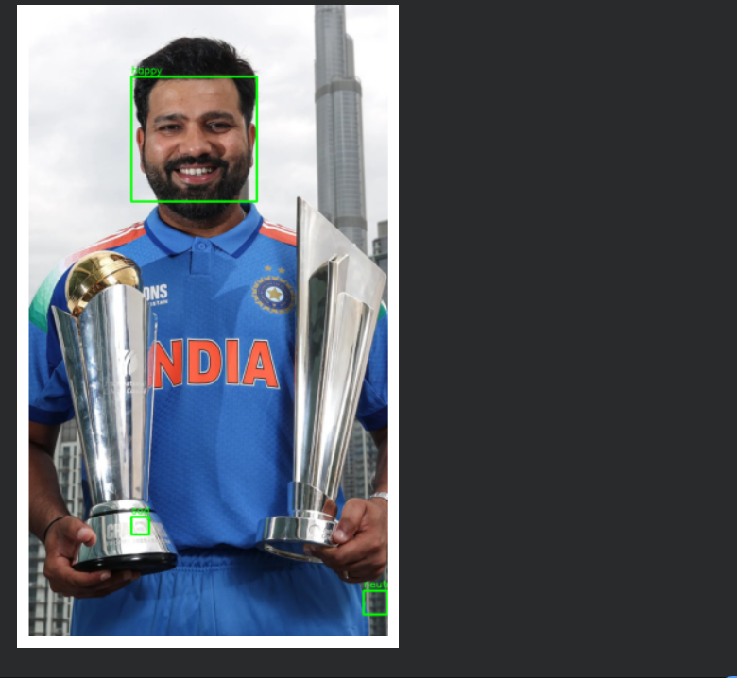
Output Analysis | This algorithm converts frame-to-frame pixel shifts into a mathematical "velocity-map" by calculating the precise speed and direction of every point in motion. It isolates the dynamic "fingerprint" of movement, ignoring static backgrounds and lighting changes to focus purely on the structural flow of the subject. This allows a computer to track and quantify the momentum of an object regardless of its original color, texture, or surface details.
Link of student Github profile where lab assignment has | krish-na45/ComputerVision_Practicals

Department of Computer Technology

Vision of the Department
To be a well-known centre for pursuing computer education through innovative pedagogy, value-based education and industry collaboration.

Mission of the Department
To establish learning ambience for ushering in computer engineering professionals in core and multidisciplinary area by developing Problem- solving skills through emerging technologies.

been uploaded
Conclusion | I have successfully implemented this optical flow technique, achieving the desired motion-tracking output and gaining a clear understanding of how  Dense Optical Flow functions for real-time motion estimation.
Plag Report (Similarity index < 12%) | <= 8 %
Date | 25/02/2026

