Session 2025-2026

Vision: Dream of where you want. | Mission: Means to achieve Vision

Program Educational Objectives of the program (PEO): (broad statements that describe the professional and career accomplishments)
PEO1 | Preparation | P: Preparation | Pep-CL abbreviation  pronounce as Pep-si-lL easy to recall
PEO2 | Core Competence | E: Environment (Learning Environment) | Pep-CL abbreviation  pronounce as Pep-si-lL easy to recall
PEO3 | Breadth | P: Professionalism | Pep-CL abbreviation  pronounce as Pep-si-lL easy to recall
PEO4 | Professionalism | C: Core Competence | Pep-CL abbreviation  pronounce as Pep-si-lL easy to recall
PEO5 | Learning Environment | L: Breadth (Learning in diverse areas) | Pep-CL abbreviation  pronounce as Pep-si-lL easy to recall

Program Outcomes (PO): (statements that describe what a student should be able to do and know by the end of a program)
Keywords of POs:
Engineering knowledge, Problem analysis, Design/development of solutions, Conduct Investigations of Complex Problems, Engineering Tool Usage, The Engineer and The World, Ethics, Individual and Collaborative Team work, Communication, Project Management and Finance, Life-Long Learning

PSO Keywords: Cutting edge technologies, Research

“I am an engineer, and I know how to apply engineering knowledge to investigate, analyse and design solutions to complex problems using tools for entire world following all ethics in a collaborative way with proper management skills throughout my life.” to contribute to the development of cutting-edge technologies and Research.

Integrity: I will adhere to the Laboratory Code of Conduct and ethics in its entirety.

Name and Signature of Student and Date
Krishna Mishra
(Signature and Date in Handwritten)

Session | 2025-26 (EVEN) |  | Course Name | LAB: Sensor Data Analytics
Semester | 6th |  | Course Code | 23ADS1602
Roll No | 42 |  | Name of Student | Krishna Mishra
Practical Number |  | Practical 3
Course Outcome |  | CO1 Apply image enhancement and smoothing  techniques to improve image quality for further  analysis.  CO2 Extract meaningful features from images using  descriptors such as HOG and SIFT.  CO3 Implement and evaluate modern object detection  methods including YOLO and R-CNN  CO4 Analyse and Develop solutions for motion  estimation, object recognition, and facial  expression recognition using classical and learning-  based methods.
Aim |  | Implement Histogram of Oriented Gradient (HOG) for Feature extraction.
Problem Definition |  | To implement Histogram of Oriented Gradients (HOG) for extracting meaningful gradient-based features from images, enabling effective representation for object detection and image classification tasks.
Theory  (100 words) |  | Histogram of Oriented Gradients (HOG) is a feature extraction technique used in computer vision to describe the structural and shape information of an image. It works by computing intensity gradients in both horizontal and vertical directions to capture edge information. These gradients are divided into small regions called cells, where gradient orientations are grouped into histograms. To reduce the effect of illumination variations, neighboring cells are combined into blocks and normalized. The final HOG descriptor is formed by concatenating all normalized histograms, producing a robust feature vector widely used for object detection and image classification.
Procedure and Execution  (100 Words) |  | Algorithm:  1.Read the input image and convert it to grayscale.  2.Apply gradient operators (e.g., Sobel) to compute horizontal and vertical gradients.  3.Calculate gradient magnitude and orientation for each pixel.  4.Divide the image into small cells (e.g., 8×8 pixels).  5.Create orientation histograms for each cell using gradient magnitudes.  6.Group neighboring cells into blocks and normalize the histograms.  Concatenate all normalized block histograms to form the HOG feature vector.
Code:

import cv2
import pandas as pd
import numpy as np
import matplotlib.pyplot as plt
from skimage.feature import hog
from skimage import exposure,data
from skimage.io import imread, imshow
from skimage.transform import resize

#1 . reading image
img = cv2.imread("RohitSharma.jpg")

if img is None:
raise ValueError("Image not found. Check the image path.")

image_rgb = cv2.cvtColor(img, cv2.COLOR_BGR2RGB)
plt.imshow(image_rgb)

# Convert to grayscale

gray = cv2.cvtColor(img, cv2.COLOR_BGR2GRAY)
plt.imshow(gray)

#Apply hog
features, hog_image = hog(
gray,
orientations = 9,
pixels_per_cell = (8,8),
cells_per_block = (2,2),
block_norm = 'L2-Hys',
visualize= True
)

hog_image_rescaled = exposure.rescale_intensity(hog_image, in_range=(0,
10))

plt.figure(figsize=(10, 5))
plt.subplot(1, 2, 1)
plt.title("Original Image")
plt.imshow(image_rgb)
plt.axis("off")
plt.subplot(1, 2, 2)
plt.title("HOG Feature Visualization")
plt.imshow(hog_image_rescaled, cmap='gray')
plt.axis("off")

plt.tight_layout()
plt.show()
# 4. Print Feature Vector Size
print("HOG feature vector length:", len(features))

Output:
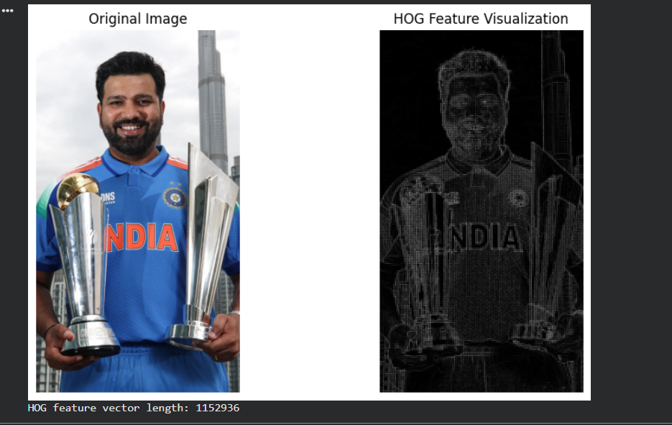
HOG feature vector length: 1152936
Output Analysis |  | The output shows the original image and the HOG feature visualization. The HOG image highlights edges and object boundaries by showing gradient directions and intensities.
Link of student Github profile where lab assignment has been uploaded |  | https://github.com/Krish-na45/Computer-Vision-Practical/blob/main/cv_practical3.py
Conclusion |  | Histogram of Oriented Gradients (HOG) successfully extracts meaningful features from the image by capturing edge and gradient information. It reduces the effect of illumination changes and focuses on object structure. HOG features are widely used in object detection, image classification, and pattern recognition. Therefore, HOG is a powerful and efficient feature extraction technique in computer vision.
Plag Report (Similarity index < 12%) |  | 
Date |  | 19-02-2026

