Session 2025-2026

Vision: Dream of where you want. | Mission: Means to achieve Vision

Program Educational Objectives of the program (PEO): (broad statements that describe the professional and career accomplishments)
PEO1 | Preparation | P: Preparation | Pep-CL abbreviation  pronounce as Pep-si-lL easy to recall
PEO2 | Core Competence | E: Environment (Learning Environment) | Pep-CL abbreviation  pronounce as Pep-si-lL easy to recall
PEO3 | Breadth | P: Professionalism | Pep-CL abbreviation  pronounce as Pep-si-lL easy to recall
PEO4 | Professionalism | C: Core Competence | Pep-CL abbreviation  pronounce as Pep-si-lL easy to recall
PEO5 | Learning Environment | L: Breadth (Learning in diverse areas) | Pep-CL abbreviation  pronounce as Pep-si-lL easy to recall

Program Outcomes (PO): (statements that describe what a student should be able to do and know by the end of a program)
Keywords of POs:
Engineering knowledge, Problem analysis, Design/development of solutions, Conduct Investigations of Complex Problems, Engineering Tool Usage, The Engineer and The World, Ethics, Individual and Collaborative Team work, Communication, Project Management and Finance, Life-Long Learning

PSO Keywords: Cutting edge technologies, Research

“I am an engineer, and I know how to apply engineering knowledge to investigate, analyse and design solutions to complex problems using tools for entire world following all ethics in a collaborative way with proper management skills throughout my life.” to contribute to the development of cutting-edge technologies and Research.

Integrity: I will adhere to the Laboratory Code of Conduct and ethics in its entirety.

Name and Signature of Student and Date
Krishna Mishra

(Signature and Date in Handwritten)

Session | 2025-26 (EVEN) |  | Course Name | LAB: Computer Vision
Semester | 6th |  | Course Code | 23ADS1602
Roll No | 42 |  | Name of Student | Krishna Mishra
Practical Number |  | Practical 2
Course Outcome |  | CO1 Apply image enhancement and smoothing techniques to improve image quality for further  analysis.  CO2 Extract meaningful features from images using descriptors such as HOG and SIFT.  CO3 Implement and evaluate modern object detection methods including YOLO and R-CNN  CO4 Analyse and Develop solutions for motion estimation, object recognition, and facial  expression recognition using classical and learning-based methods.
Aim |  | Write a Program to apply convolution processes on an input image for image smoothing.
Problem Definition |  | To perform image smoothing by applying convolution operations on an input image using MATLAB. The objective is to reduce noise and unwanted details by filtering the image with smoothing kernels such as averaging and Gaussian filters
Theory  (100 words) |  | Image smoothing is a fundamental image enhancement technique used to reduce noise and minor variations in intensity. It is achieved by convolving the input image with a smoothing kernel or mask. Convolution is a mathematical operation where each pixel value is replaced by a weighted sum of its neighboring pixels. Averaging filters reduce random noise but may blur edges, while Gaussian filters provide better smoothing by giving more weight to central pixels. Image smoothing is commonly used as a preprocessing step in image processing tasks such as segmentation, edge detection, and feature extraction.
Procedure and Execution  (100 Words) |  | Algorithm:  1.Read the input image.  2.Convert it to grayscale and double format.  3.Define a smoothing filter kernel.  4.Apply convolution to the image.  5.Display the original and smoothed images.  6.End.
Code:
img = imread('RohitSharma.jpg');
figure; imshow(img);
title('original image');
%smoothing using mean filter
kernel_mean = ones(3,3)/9;
smooth_mean = imfilter(img,kernel_mean,'same');
figure; imshow(uint8(smooth_mean));
title('smooth image using mean ');
%smoothing using gaussian
sigma = 1;
kernel_gaussian = fspecial('gaussian',[3,3],sigma);
smooth_gaussian = imfilter(img,kernel_gaussian,'same');
figure; imshow(uint8(smooth_gaussian));
title('Smoothed image using gaussian');
Output:
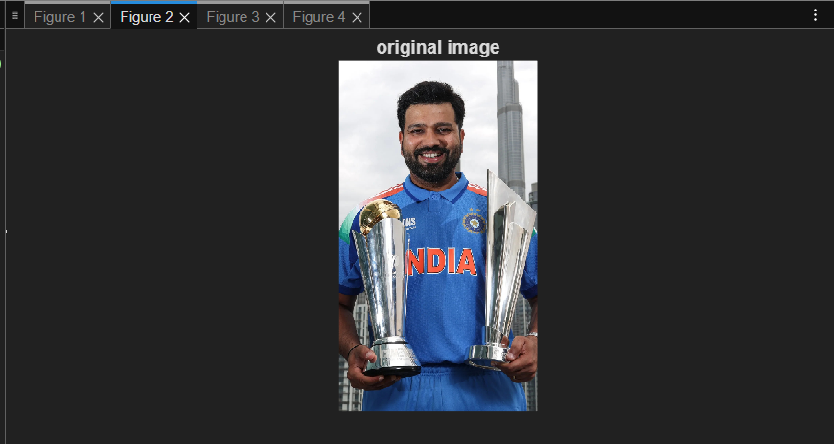
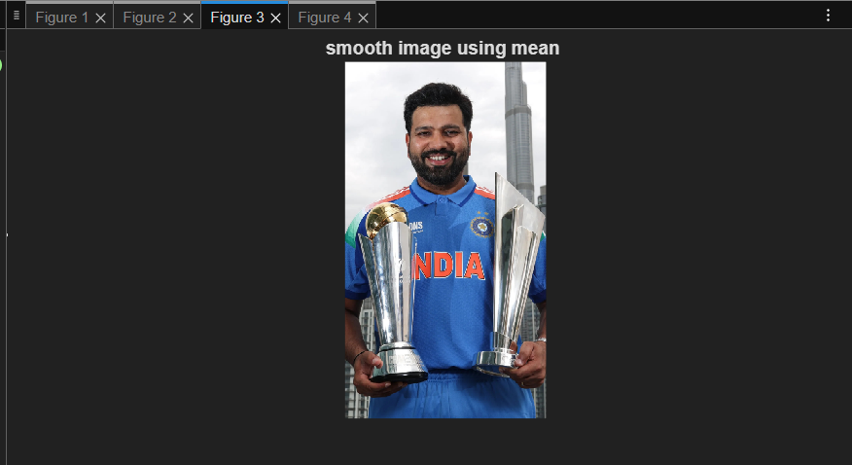
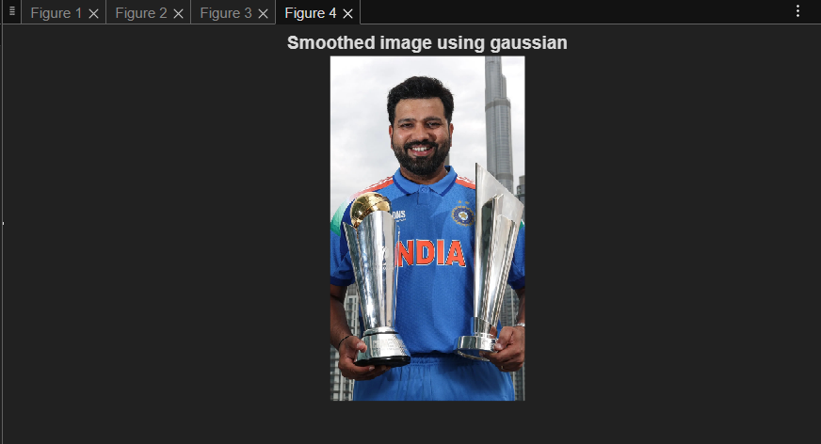
Output Analysis |  | The smoothed image shows reduced noise and intensity variations after applying convolution. Averaging and Gaussian filters produce a blur effect, improving overall image quality. Fine details and sharp edges are slightly softened due to smoothing.
Link of student Github profile where lab assignment has been uploaded |  | krish-na45/ComputerVision_Practicals
Conclusion |  | Convolution-based image smoothing effectively reduces noise and enhances visual quality. It serves as an important preprocessing step for further image processing tasks.
Plag Report (Similarity index < 12%) |  | 
Date |  | 18-01-2026

