Session 2025-2026

Vision: Dream of where you want. | Mission: Means to achieve Vision

Program Educational Objectives of the program (PEO): (broad statements that describe the professional and career accomplishments)
PEO1 | Preparation | P: Preparation | Pep-CL abbreviation  pronounce as Pep-si-lL easy to recall
PEO2 | Core Competence | E: Environment (Learning Environment) | Pep-CL abbreviation  pronounce as Pep-si-lL easy to recall
PEO3 | Breadth | P: Professionalism | Pep-CL abbreviation  pronounce as Pep-si-lL easy to recall
PEO4 | Professionalism | C: Core Competence | Pep-CL abbreviation  pronounce as Pep-si-lL easy to recall
PEO5 | Learning Environment | L: Breadth (Learning in diverse areas) | Pep-CL abbreviation  pronounce as Pep-si-lL easy to recall

Program Outcomes (PO): (statements that describe what a student should be able to do and know by the end of a program)
Keywords of POs:
Engineering knowledge, Problem analysis, Design/development of solutions, Conduct Investigations of Complex Problems, Engineering Tool Usage, The Engineer and The World, Ethics, Individual and Collaborative Team work, Communication, Project Management and Finance, Life-Long Learning

PSO Keywords: Cutting edge technologies, Research

“I am an engineer, and I know how to apply engineering knowledge to investigate, analyse and design solutions to complex problems using tools for entire world following all ethics in a collaborative way with proper management skills throughout my life.” to contribute to the development of cutting-edge technologies and Research.

Integrity: I will adhere to the Laboratory Code of Conduct and ethics in its entirety.

Name and Signature of Student and Date
Krishna Mishra

(Signature and Date in Handwritten)

Session | 2025-26 (EVEN) |  | Course Name | LAB: Computer Vision
Semester | VI |  | Course Code | 23ADS1602
Roll No | 42 |  | Name of Student | Krishna Mishra
Practical Number |  | Practical 1
Course Outcome |  | CO1 Apply image enhancement and smoothing techniques to improve image quality for further  analysis.  CO2 Extract meaningful features from images using descriptors such as HOG and SIFT.  CO3 Implement and evaluate modern object detection methods including YOLO and R-CNN  CO4 Analyse and Develop solutions for motion estimation, object recognition, and facial  expression recognition using classical and learning-based methods.
Aim |  | Implement various grey level transformations for Image Enhancement.
Problem Definition |  | To enhance the visual quality of a digital image by implementing various grey level (intensity) transformations in MATLAB. The objective is to apply point processing techniques such as image negative, logarithmic transformation, power-law (gamma) transformation, contrast stretching, and thresholding, and analyze their effect on image contrast, brightness, and detail visibility. These transformations help improve image interpretation for further image processing and analysis tasks.
Theory  (100 words) |  | Grey level transformations are image enhancement techniques that operate directly on pixel intensity values to improve image appearance. These methods modify the grey levels of an image using mathematical functions. Image negative enhances white details in dark regions. Logarithmic transformation expands dark pixel values, useful for images with large dynamic ranges. Power-law (gamma) transformation controls overall brightness and contrast. Contrast stretching increases the range of intensity values for better visibility. Thresholding separates objects from the background. Such transformations are widely used as preprocessing steps in digital image processing applications.
Procedure and Execution  (100 Words) |  | Algorithm:  1.Start the program.  2.Read the input grayscale image using MATLAB.  3.Convert the image to grayscale if it is in RGB format.  4.Normalize the image intensity values to the range [0, 1].  5.Apply Image Negative transformation:  s = 1 − r  6.Apply Logarithmic transformation:  s = c · log(1 + r)  7.Apply Power-law (Gamma) transformation:  s = c · r^γ  8.Apply Contrast Stretching to expand the intensity range.  9.Apply Thresholding to segment the image based on intensity values.  10.Display and compare the original and enhanced images.  11.Stop the program.
Code:
img = imread('RohitSharma.jpg');
grayImg = rgb2gray(img);

g = im2double(grayImg);
rgbD = im2double(img);

negImg = 1 - g;

c = 1;
logImg = c * log(1 + g);
logImg = mat2gray(logImg);

gamma = 0.5;
powerImg = g .^ gamma;

rmin = min(g(:));
rmax = max(g(:));
stretchImg = (g - rmin) / (rmax - rmin);

figure;
subplot(2,4,1), imshow(rgbD), title('Original RGB')
subplot(2,4,2), imshow(g), title('Grayscale')
subplot(2,4,3), imshow(negImg), title('Negative')
subplot(2,4,4), imshow(logImg), title('Log Transform')
subplot(2,4,5), imshow(powerImg), title('Gamma Transform')
subplot(2,4,6), imshow(stretchImg),title('Contrast Stretched')

Output:

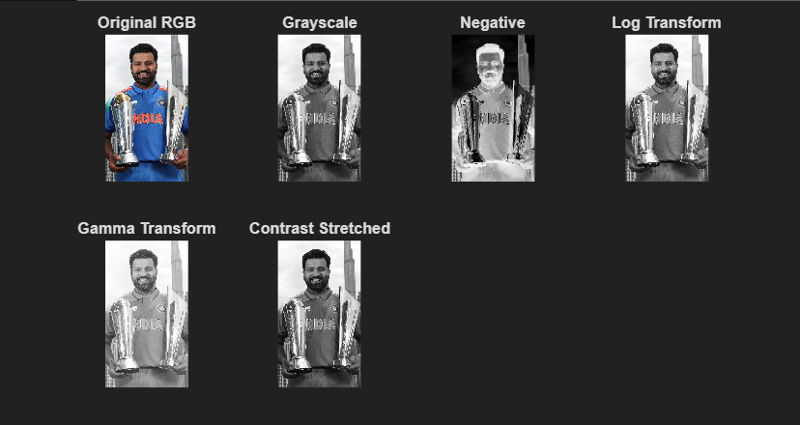
Output Analysis |  | The output images show noticeable improvement in visual quality after applying grey level transformations. The image negative enhances bright details in dark regions. Logarithmic transformation improves visibility of low-intensity areas while compressing higher intensities. Power-law (gamma) transformation effectively controls image brightness and contrast. Contrast stretching expands the dynamic range, making details clearer. Thresholding successfully separates foreground objects from the background. Overall, these transformations enhance image interpretability and prepare the image for further processing tasks.
Link of student Github profile where lab assignment has been uploaded |  | krish-na45/ComputerVision_Practicals
Conclusion |  | Grey level transformations enhance image contrast and brightness, making important details more visible. These simple techniques are effective preprocessing steps for accurate image analysis and interpretation.
Plag Report (Similarity index < 12%) |  | 
Date |  | 18-01-2026

