Session 2025-2026

Vision: Dream of where you want. | Mission: Means to achieve Vision

Program Educational Objectives of the program (PEO): (broad statements that describe the professional and career accomplishments)
PEO1 | Preparation | P: Preparation | Pep-CL abbreviation  pronounce as Pep-si-lL easy to recall
PEO2 | Core Competence | E: Environment (Learning Environment) | Pep-CL abbreviation  pronounce as Pep-si-lL easy to recall
PEO3 | Breadth | P: Professionalism | Pep-CL abbreviation  pronounce as Pep-si-lL easy to recall
PEO4 | Professionalism | C: Core Competence | Pep-CL abbreviation  pronounce as Pep-si-lL easy to recall
PEO5 | Learning Environment | L: Breadth (Learning in diverse areas) | Pep-CL abbreviation  pronounce as Pep-si-lL easy to recall

Program Outcomes (PO): (statements that describe what a student should be able to do and know by the end of a program)
Keywords of POs:
Engineering knowledge, Problem analysis, Design/development of solutions, Conduct Investigations of Complex Problems, Engineering Tool Usage, The Engineer and The World, Ethics, Individual and Collaborative Team work, Communication, Project Management and Finance, Life-Long Learning

PSO Keywords: Cutting edge technologies, Research

“I am an engineer, and I know how to apply engineering knowledge to investigate, analyse and design solutions to complex problems using tools for entire world following all ethics in a collaborative way with proper management skills throughout my life.” to contribute to the development of cutting-edge technologies and Research.

Integrity: I will adhere to the Laboratory Code of Conduct and ethics in its entirety.

Name and Signature of Student and Date
Krishna Mishra
(Signature and Date in Handwritten)

Session | 2025-26 (EVEN) |  | Course Name | LAB: Computer vision
Semester | 6th |  | Course Code | 23ADS1602
Roll No | 12 |  | Name of Student | Nikita Dubey
Practical Number |  | 04
Course Outcome |  | CO1 Apply image enhancement and smoothing techniques to improve image quality for further analysis.  CO2 Extract meaningful features from images using descriptors such as HOG and SIFT.
Aim |  | Write a Program to apply Scale Invariant Feature Transform on input image.
Problem Definition |  | The goal is to detect and extract distinctive feature points from an input image using the Scale Invariant Feature Transform (SIFT) algorithm. These feature points should remain invariant to changes in scale, rotation, illumination, and noise. The detected key points and descriptors help in tasks like image matching, object recognition, and tracking.
Theory  (100 words) |  | Scale Invariant Feature Transform (SIFT) is a feature detection algorithm in computer vision used to identify unique and stable key points in an image. It detects extrema points using Difference of Gaussian across multiple scales and assigns orientations to achieve rotation invariance. For every key point, a 128dimensional descriptor is generated based on gradient information. These descriptors allow matching of similar regions between images. SIFT is robust to scaling, rotation, illumination changes, and noise. It is widely used in object recognition, image stitching, panorama creation, and feature matching applications due to its high accuracy and reliability.
Procedure and Execution  (100 Words) |  | Algorithm:  1.Read the input image in grayscale  2.Initialize SIFT detector using cv2.SIFT_create().  3.Detect key points in the image  4.Compute descriptors for each key point.  5.Draw key points on the image.  6.Display the output image.
Code:
import cv2
import matplotlib.pyplot as plt

# read image

image = cv2.imread('RohitSharma.jpg')
# Display original image

# Convert BGR to RGB
image_rgb = cv2.cvtColor(image, cv2.COLOR_BGR2RGB)

# Display original image
plt.figure(figsize=(6, 6))
plt.imshow(image_rgb)
plt.title("Original Image")
plt.axis("off")
plt.show()

#convert to grayscale
gray = cv2.cvtColor(image,cv2.COLOR_BGR2GRAY)
gray

# Create SIFT object
sift = cv2.SIFT_create()

# Detect keypoints and compute descriptors
keypoints, descriptors = sift.detectAndCompute(gray, None)

# Draw keypoints on the image
sift_image = cv2.drawKeypoints(
image,
keypoints,
None,
flags=cv2.DRAW_MATCHES_FLAGS_DRAW_RICH_KEYPOINTS
)

# Show results
plt.figure(figsize=(8, 6))
plt.imshow(cv2.cvtColor(sift_image, cv2.COLOR_BGR2RGB))
plt.title(f"SIFT Keypoints (Total: {len(keypoints)})")
plt.axis("off")
plt.show()

Output:


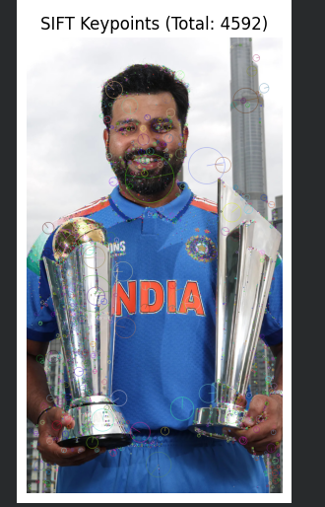
Output Analysis |  | After applying the Scale Invariant Feature Transform (SIFT) algorithm to the input image, multiple key points are detected at important regions such as edges, corners, and textured areas. These key points are displayed as circular markers on the image. The size of each circle represents the scale of the feature, and the orientation indicates the direction of the gradient. The algorithm generates descriptors of size 128 for every key point, which uniquely describe local image features. A higher number of key points indicates richer image details. Thus, SIFT successfully extracts robust and distinctive features invariant to scale, rotation, and illumination changes.
Link of student Github profile where lab assignment has been uploaded |  | krish-na45/ComputerVision_Practicals
Conclusion |  | The SIFT algorithm was successfully implemented to detect scale and rotation invariant key points in the input image. It effectively extracted distinctive features and generated descriptors for matching. The method is robust and reliable for various computer vision applications such as object detection, image matching, and tracking. Hence, SIFT is a powerful feature extraction technique.
Plag Report (Similarity index < 12%) |  | 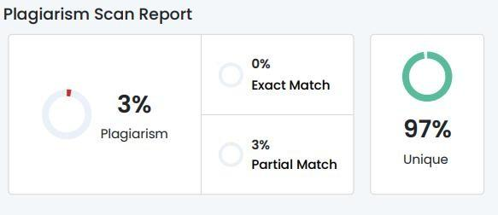
Date |  | 19-02-2026

