Session 2025-2026

Vision: Dream of where you want. | Mission: Means to achieve Vision

Program Educational Objectives of the program (PEO): (broad statements that describe the professional and career accomplishments)
PEO1 | Preparation | P: Preparation | Pep-CL abbreviation  pronounce as Pep-si-lL easy to recall
PEO2 | Core Competence | E: Environment (Learning Environment) | Pep-CL abbreviation  pronounce as Pep-si-lL easy to recall
PEO3 | Breadth | P: Professionalism | Pep-CL abbreviation  pronounce as Pep-si-lL easy to recall
PEO4 | Professionalism | C: Core Competence | Pep-CL abbreviation  pronounce as Pep-si-lL easy to recall
PEO5 | Learning Environment | L: Breadth (Learning in diverse areas) | Pep-CL abbreviation  pronounce as Pep-si-lL easy to recall

Program Outcomes (PO): (statements that describe what a student should be able to do and know by the end of a program)
Keywords of POs:
Engineering knowledge, Problem analysis, Design/development of solutions, Conduct Investigations of Complex Problems, Engineering Tool Usage, The Engineer and The World, Ethics, Individual and Collaborative Team work, Communication, Project Management and Finance, Life-Long Learning

PSO Keywords: Cutting edge technologies, Research

“I am an engineer, and I know how to apply engineering knowledge to investigate, analyse and design solutions to complex problems using tools for entire world following all ethics in a collaborative way with proper management skills throughout my life.” to contribute to the development of cutting-edge technologies and Research.

Integrity: I will adhere to the Laboratory Code of Conduct and ethics in its entirety.

Session | 2025-26 (ODD) |  | Course Name | LAB:Neural Networks and Deep Learning
Semester | 7th |  | Course Code | 23ADS1704
Roll No | 41 |  | Name of Student | Krishna Mishra
Practical Number |  | 03
Course Outcome |  | CO1: Understand the fundamental concepts of deep learning and neural network architectures  CO2: Apply different techniques to develop and optimize deep learning models.  CO3: Analyse the performance of deep learning models using appropriate evaluation techniques.  CO4: Design and implement deep learning solutions for real-world problems using modern tools and  frameworks.
Aim |  | Implement a Feed-Forward Neural Network using google colab for Handwritten Digit Classification.
Theory |  | 1. Theoretical Background  A. Introduction to Neural Networks  Neural networks are a subset of machine learning inspired by the structure and function of the human brain. They are composed of interconnected nodes (neurons) organized in layers. Each neuron processes input, and passes its output to other neurons. The 'learning' in a neural network involves adjusting the weights (strength of connections) and biases associated with these connections to minimize the difference between predicted and actual outputs.  B. Feed Forward Neural Network (FFNN)  An FFNN is the simplest type of artificial neural network where connections between nodes do not form a cycle. Information moves in only one direction—forward—from the input layer, through any hidden layers, and to the output layer. There are no loops or feedback connections.  C. Key Components of an FFNN  Input Layer: Receives the raw data (features). For image classification, this layer typically takes the pixel values of an image.  Hidden Layers: One or more layers between the input and output layers. These layers perform complex computations, extracting features and patterns from the input data. The number of neurons and hidden layers can vary depending on the complexity of the problem.  Output Layer: Produces the final prediction. The number of neurons in this layer corresponds to the number of classes for classification tasks or the predicted value for regression tasks.  Neurons (Nodes): Basic computational units that receive inputs, apply weights, sum them up, add a bias, and then pass the result through an activation function.  Weights and Biases: Parameters that the network learns during training. Weights determine the strength of the connection between neurons, and biases shift the activation function output.  Activation Functions: Introduce non-linearity into the network, enabling it to learn complex patterns. Without them, a neural network would only be able to learn linear relationships. Common activation functions include:  ReLU (Rectified Linear Unit): f(x) = max(0, x). It outputs the input directly if it's positive, otherwise, it outputs zero. ReLU helps in faster training and mitigating the vanishing gradient problem.  Softmax: Applied in the output layer for multi-class classification. It converts a vector of arbitrary real values into a probability distribution, where each value is between 0 and 1, and all values sum up to 1. The formula for softmax for the i-th element z_i in a vector z is: softmax(z_i) = exp(z_i) / sum(exp(z_j) for all j). The output of softmax can be interpreted as the probability of the input belonging to a particular class.  D. Loss Function  For multi-class classification with one-hot encoded labels, Categorical Cross-Entropy is commonly used. It measures the performance of a classification model whose output is a probability value between 0 and 1. The goal is to minimize this loss, indicating that the predicted probabilities align closely with the true labels.  E. Optimizer  An optimizer is an algorithm used to change the attributes of the neural network, such as weights and learning rate, in order to reduce the losses. Adam (Adaptive Moment Estimation) is a popular optimization algorithm that combines the advantages of two other extensions of stochastic gradient descent: Adaptive Gradient Algorithm (AdaGrad) and Root Mean Square Propagation (RMSProp).
Procedure and Execution |  | Algorithm: Load Dataset: Load the MNIST handwritten digit dataset, which consists of 60,000 training images and 10,000 test images, each of size 28x28 pixels.  Data Preprocessing:  Normalization: Scale the pixel values of the images from the original range of 0-255 to 0-1. This is done by converting the image data type to float32 and dividing by 255.0. Normalization helps stabilize and speed up the training process.  One-Hot Encoding: Convert the integer labels (0-9) into a one-hot encoded format. For instance, the digit '5' would be represented as [0, 0, 0, 0, 0, 1, 0, 0, 0, 0]. This is required for using the categorical_crossentropy loss function.  Model Definition (FFNN Architecture):  Initialize a Sequential Keras model.  Add a Flatten layer as the input layer to transform the 28x28 2D image arrays into a 1D vector of 784 pixels.  Add two Dense hidden layers with relu activation functions. The first hidden layer has 128 neurons, and the second has 64 neurons. These layers learn hierarchical features from the input.  Add a Dense output layer with 10 neurons (one for each digit class) and a softmax activation function to produce probability distributions over the 10 classes.  Model Compilation:  Configure the model for training using model.compile().  Specify the optimizer as 'adam'.  Set the loss function to 'categorical_crossentropy'.  Define metrics=['accuracy'] to monitor the classification accuracy during training and evaluation.  Model Training:  Train the model using model.fit(), passing the preprocessed training data (X_train, y_train).  Set the epochs to 10, meaning the model will iterate over the entire training dataset 10 times.  Specify a batch_size of 32, which is the number of samples processed before the model's weights are updated.  Use validation_split=0.1 to reserve 10% of the training data for validation during training, allowing for monitoring of the model's performance on unseen data and detection of overfitting.  Model Evaluation:  Evaluate the trained model's performance on the unseen test dataset (X_test, y_test) using model.evaluate().  Report the test loss and test accuracy.  Visualize Predictions:  Use the trained model to make predictions on a subset of the X_test data.  Compare these predictions with the actual y_test labels.  Employ matplotlib.pyplot to display the actual images, their true labels, and the model's predicted labels. Color-code the titles (e.g., green for correct, red for incorrect) for easy visual interpretation
Code:
import tensorflow as tf
from tensorflow.keras.datasets import mnist
from tensorflow.keras.models import Sequential
from tensorflow.keras.layers import Dense, Flatten
from tensorflow.keras.utils import to_categorical
import matplotlib.pyplot as plt
import numpy as np

(X_train_raw, y_train_raw), (X_test_raw, y_test_raw) = mnist.load_data()

print(f"Training data shape: {X_train_raw.shape}")
print(f"Training labels shape: {y_train_raw.shape}")
print(f"Test data shape: {X_test_raw.shape}")
print(f"Test labels shape: {y_test_raw.shape}")

X_train = X_train_raw.astype('float32') / 255.0
X_test = X_test_raw.astype('float32') / 255.0

y_train = to_categorical(y_train_raw, 10)
y_test = to_categorical(y_test_raw, 10)

print(f"Normalized training data shape: {X_train.shape}")
print(f"One-hot encoded training labels shape: {y_train.shape}")

model = Sequential([
Flatten(input_shape=(28, 28)), # Input layer: Flattens the 28x28 images into a 1D vector of 784 pixels
Dense(128, activation='relu'), # First hidden layer with 128 neurons and ReLU activation
Dense(64, activation='relu'), # Second hidden layer with 64 neurons and ReLU activation
Dense(10, activation='softmax') # Output layer with 10 neurons (for 10 classes) and Softmax activation
])

model.compile(
optimizer='adam',
loss='categorical_crossentropy',
metrics=['accuracy']
)

model.summary()

history = model.fit(
X_train,
y_train,
epochs=10, # Number of times the model will go through the entire training dataset
batch_size=32, # Number of samples per gradient update
validation_split=0.1 # Use 10% of training data for validation during training
)

loss, accuracy = model.evaluate(X_test, y_test, verbose=0)

print(f"\nTest Loss: {loss:.4f}")
print(f"Test Accuracy: {accuracy:.4f}")

# Get the model's predictions on the test set
predictions = model.predict(X_test)

# Convert one-hot encoded y_test back to original labels for comparison
y_test_labels = np.argmax(y_test, axis=1)

# Select a few images to display
num_images_to_display = 10

plt.figure(figsize=(15, 6))
for i in range(num_images_to_display):
# Display the image
plt.subplot(2, 5, i + 1) # 2 rows, 5 columns
plt.imshow(X_test_raw[i], cmap='gray')

# Get actual and predicted labels
actual_label = y_test_labels[i]
predicted_label = np.argmax(predictions[i])

# Set title based on prediction correctness
color = 'green' if predicted_label == actual_label else 'red'
plt.title(f'Actual: {actual_label}\nPred: {predicted_label}', color=color)
plt.axis('off')

plt.tight_layout()
plt.show()
Output:
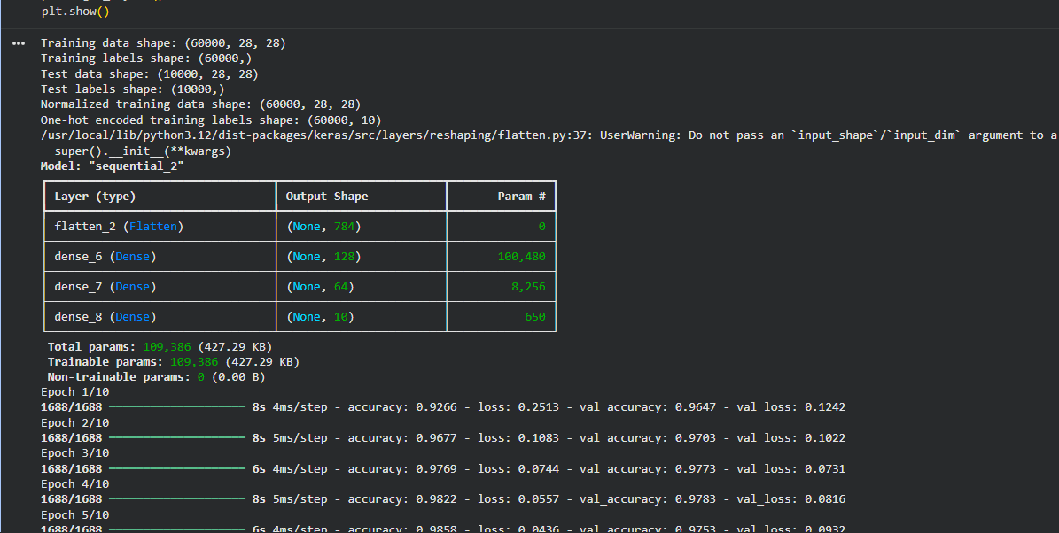

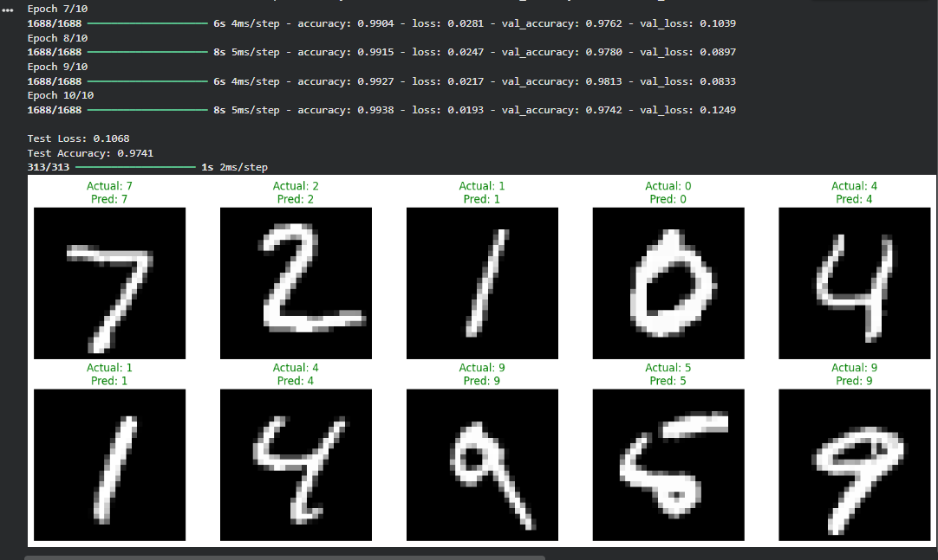

Output Analysis |  | The Feed Forward Neural Network achieved a strong test accuracy of approximately 97.41% on the MNIST dataset. The visual inspection of sample predictions showed that the model correctly identified all the displayed handwritten digits.
Link of student Github profile where lab assignment has been uploaded |  | https://github.com/krish-na45/Neural-Network-Deep-Learning-Practicals
Conclusion |  | This practical successfully implemented a Feed Forward Neural Network (FFNN) for handwritten digit classification using the MNIST dataset. The process involved:  Data Preparation: Loading the MNIST dataset, normalizing the pixel values of the images (scaling them from 0-255 to 0-1), and one-hot encoding the labels to prepare them for the neural network.  Model Architecture: Designing an FFNN using Keras's Sequential API. This model consisted of:  A Flatten layer to convert the 2D image data into a 1D vector.  Two Dense hidden layers with 128 and 64 neurons respectively, both utilizing the ReLU activation function to introduce non-linearity.  A Dense output layer with 10 neurons (corresponding to the 10 digit classes) and a Softmax activation function to output probability distributions.  Training and Evaluation: The model was compiled with the Adam optimizer and categorical cross-entropy loss function, and then trained for 10 epochs. Post-training, the model was evaluated on an unseen test set.
Plag Report (Similarity index < 12%) |  | 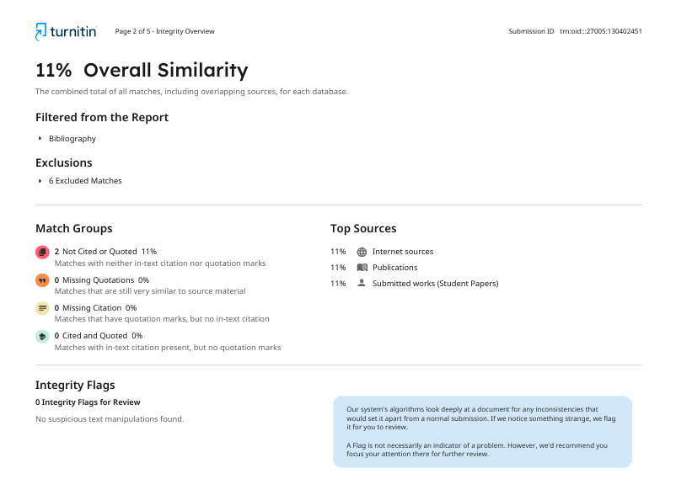
Date |  | 21/07/2026

