research, and industry collaboration, to become successful professionals contributing for the betterment of society. Mission of the Department To nurture computer engineering professionals by offering:
- Dynamic learning environment that encourages problem-solving using emerging technology
- National Education Policy aligned evidence-based technical education, fostering innovation, research, and industry–institute collaboration • Holistic, ethical and sustainable development for lifelong success.

Session 2025-2026

Vision: Dream of where you want. | Mission: Means to achieve Vision

Program Educational Objectives of the program (PEO): (broad statements that describe the professional and career accomplishments)
PEO1 | Preparation | P: Preparation | Pep-CL abbreviation pronounce as Pep-si-lL easy to recall
PEO2 | Core Competence | E: Environment  (Learning Environment)
PEO3 | Breadth | P: Professionalism
PEO4 | Professionalism | C: Core Competence
PEO5 | Learning  Environment | L: Breadth (Learning in diverse areas)

Program Outcomes (PO): (statements that describe what a student should be able to do and know by the end of a program)
Keywords of POs:
Engineering knowledge, Problem analysis, Design/development of solutions, Conduct Investigations of Complex Problems, Engineering Tool Usage, The Engineer and The World, Ethics, Individual and Collaborative Team work, Communication, Project Management and Finance, Life-Long Learning

PSO Keywords: Cutting edge technologies, Research

“I am an engineer, and I know how to apply engineering knowledge to investigate, analyse and design solutions to complex problems using tools for entire world following all ethics in a collaborative way with proper management skills throughout my life.” to contribute to the development of cutting-edge technologies and Research.

Integrity: I will adhere to the Laboratory Code of Conduct and ethics in its entirety.

research, and industry collaboration, to become successful professionals contributing for the betterment of society. Mission of the Department To nurture computer engineering professionals by offering:
- Dynamic learning environment that encourages problem-solving using emerging technology
- National Education Policy aligned evidence-based technical education, fostering innovation, research, and industry–institute collaboration • Holistic, ethical and sustainable development for lifelong success.

Session | 2025-26 (EVEN) | Course Name | LAB: Sensor Data Analytics
Semester | 6th | Course Code | 23ADS1626
Roll No | 42 | Name of Student | Krishna Mishra

Practical Number | 1
Course Outcome | CO1: Apply data preprocessing, cleaning, normalization, and visualization techniques on sensor datasets.  CO2: Build and evaluate regression and classification models using machine learning algorithms.  CO3: Analyze unlabeled data using clustering and dimensionality reduction techniques.  CO4: Design, train, and evaluate deep learning models for image, text, and real-world applications.
Aim | To perform data cleaning, handling missing values, normalization, and visualization on a real-world dataset.
Problem Definition | The objective is to load a sensor-based dataset (Weather Data), identify and treat inconsistencies such as missing values and outliers, and apply normalization to ensure features contribute equally to analysis. Finally, the data must be visualized to understand distributions and relationships.
Theory  (100 words) | - Data Cleaning  Data cleaning is the process of removing or correcting inaccurate, incomplete, or inconsistent data to improve data quality.  - Missing Values  Missing values occur due to:  - Data entry errors  - Sensor failure
research, and industry collaboration, to become successful professionals contributing for the betterment of society. Mission of the Department To nurture computer engineering professionals by offering:
- Dynamic learning environment that encourages problem-solving using emerging technology
- National Education Policy aligned evidence-based technical education, fostering innovation, research, and industry–institute collaboration • Holistic, ethical and sustainable development for lifelong success.

3. Incomplete records
Handling methods:
- Remove rows/columns
- Replace with mean/median/mode
- Outliers
Outliers are extreme values that differ significantly from other observations.
Detection method:
  - Interquartile Range (IQR)
- Normalization
Normalization scales numeric data to a common range so that all features contribute equally.
Common technique:
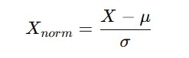
- Data Visualization
Visualization helps in:
  - Understanding data distribution
  - Detecting patterns and anomalies

research, and industry collaboration, to become successful professionals contributing for the betterment of society. Mission of the Department To nurture computer engineering professionals by offering:
- Dynamic learning environment that encourages problem-solving using emerging technology
- National Education Policy aligned evidence-based technical education, fostering innovation, research, and industry–institute collaboration • Holistic, ethical and sustainable development for lifelong success.

Procedure and Execution  (100 Words) | Algorithm:  - Import required libraries  - Load CSV dataset  - Display dataset information  - Identify missing values  - Handle missing values  - Detect and remove outliers  - Perform normalization  - Calculate descriptive statistics  - Visualize data using plots
Code:
import pandas as pd import numpy as np import matplotlib.pyplot as plt import seaborn as sns

data = pd.read_csv("weather.csv") print("First 5 rows of dataset:") print(data.head())

print("\nDataset Info:") print(data.info())

print("\nMissing values in each column:") print(data.isnull().sum())

num_cols = data.select_dtypes(include=np.number).columns data[num_cols] = data[num_cols].fillna(data[num_cols].mean())

cat_cols = data.select_dtypes(include='object').columns for col in cat_cols:
data[col].fillna(data[col].mode()[0], inplace=True)

print("\nMissing values after handling:") print(data.isnull().sum())

Mission of the Department To nurture computer engineering professionals by offering:
- Dynamic learning environment that encourages problem-solving using emerging technology
- National Education Policy aligned evidence-based technical education, fostering innovation, research, and industry–institute collaboration • Holistic, ethical and sustainable development for lifelong success.

print("\nDescriptive Statistics:") print(data.describe())

Q1 = data[num_cols].quantile(0.25)
Q3 = data[num_cols].quantile(0.75)
IQR = Q3 - Q1

data_clean = data[~((data[num_cols] < (Q1 - 1.5 * IQR)) |
(data[num_cols] > (Q3 + 1.5 * IQR))).any(axis=1)]

print("\nDataset shape after outlier removal:") print(data_clean.shape)

data_norm = data_clean.copy()
data_norm[num_cols] = (data_clean[num_cols] -
data_clean[num_cols].mean()) / data_clean[num_cols].std()

data_norm[num_cols].hist(figsize=(12, 10)) plt.suptitle("Histogram of Normalized Weather Features") plt.show()

plt.figure(figsize=(12, 6)) sns.boxplot(data=data_norm[num_cols])
plt.xticks(rotation=90) plt.title("Boxplot of Normalized Weather Data") plt.show()

plt.figure(figsize=(8, 6)) sns.scatterplot(x=data_norm["MinTemp"], y=data_norm["MaxTemp"]) plt.title("Scatter Plot: MinTemp vs MaxTemp") plt.xlabel("MinTemp (Normalized)") plt.ylabel("MaxTemp (Normalized)") plt.show()

research, and industry collaboration, to become successful professionals contributing for the betterment of society. Mission of the Department To nurture computer engineering professionals by offering:
- Dynamic learning environment that encourages problem-solving using emerging technology
- National Education Policy aligned evidence-based technical education, fostering innovation, research, and industry–institute collaboration • Holistic, ethical and sustainable development for lifelong success.

Output:
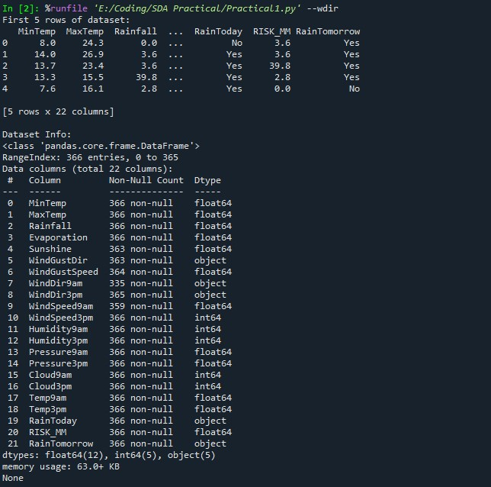
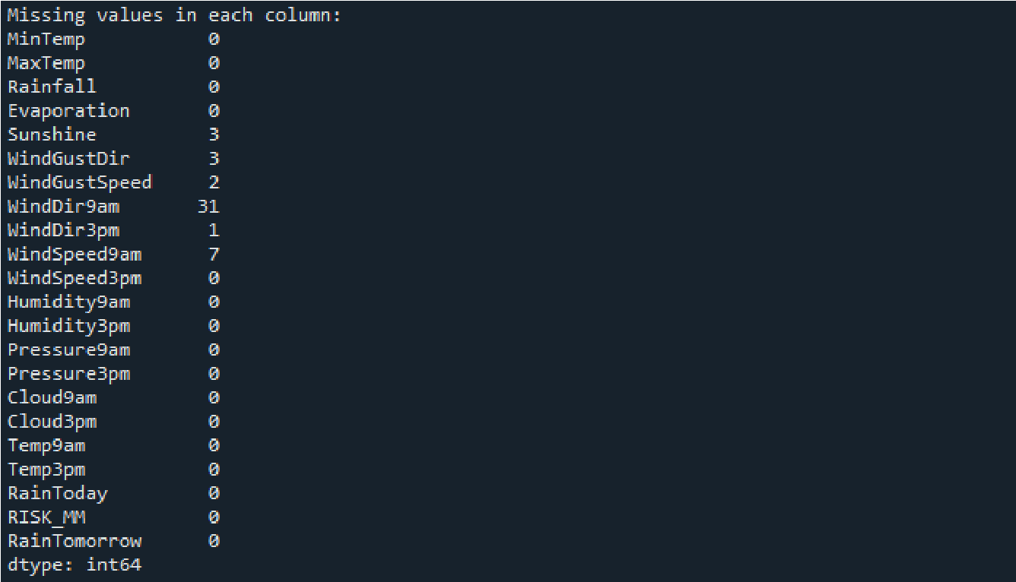
Mission of the Department To nurture computer engineering professionals by offering:
- Dynamic learning environment that encourages problem-solving using emerging technology
- National Education Policy aligned evidence-based technical education, fostering innovation, research, and industry–institute collaboration • Holistic, ethical and sustainable development for lifelong success.

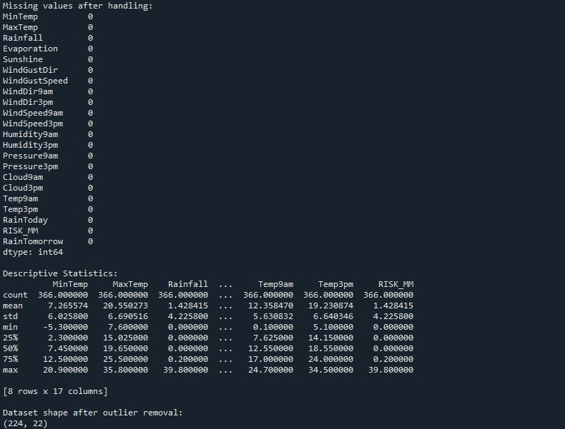

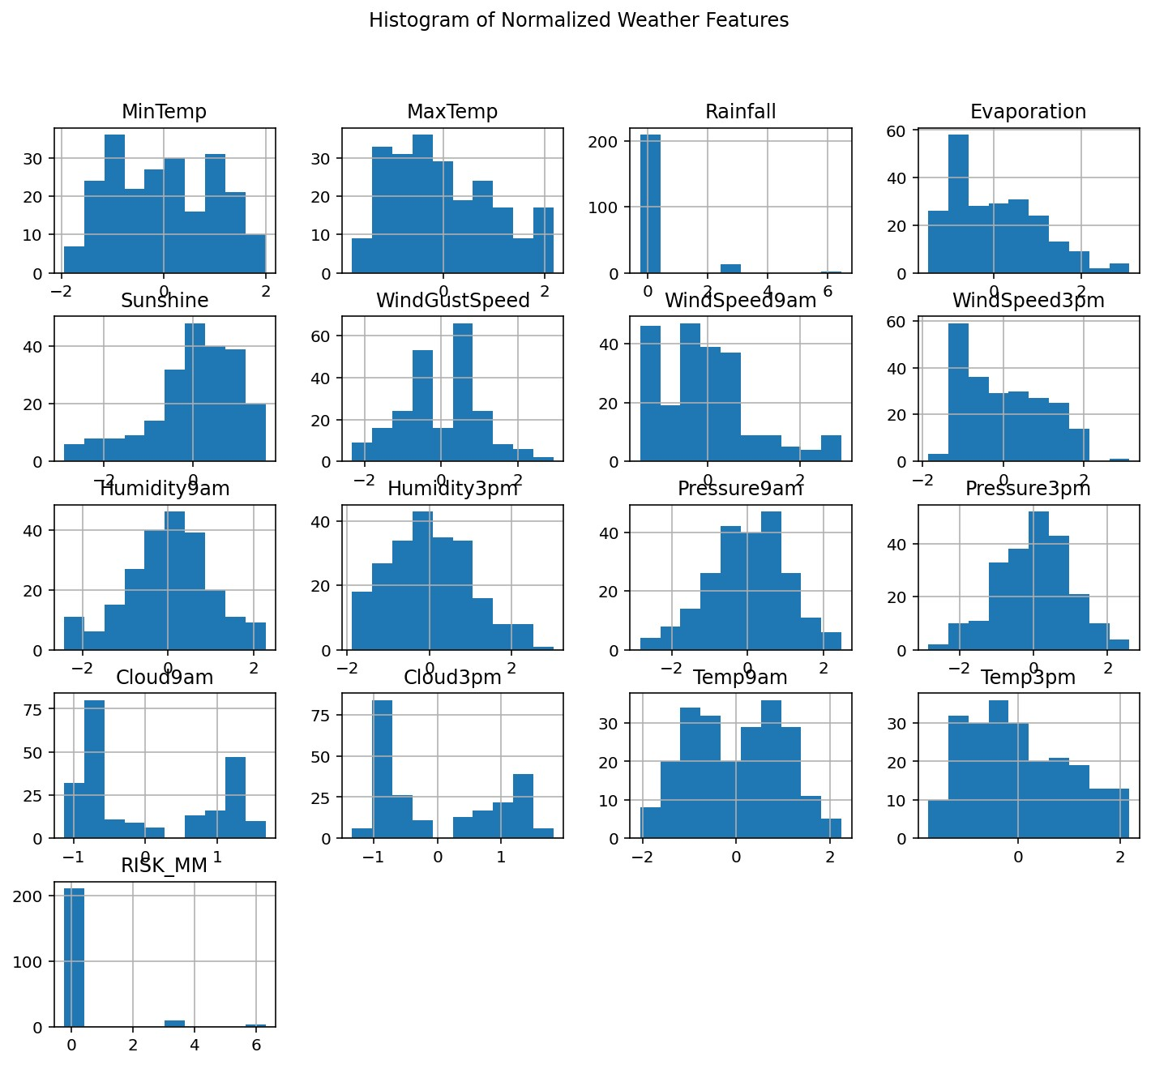

Mission of the Department To nurture computer engineering professionals by offering:
- Dynamic learning environment that encourages problem-solving using emerging technology
- National Education Policy aligned evidence-based technical education, fostering innovation, research, and industry–institute collaboration • Holistic, ethical and sustainable development for lifelong success.

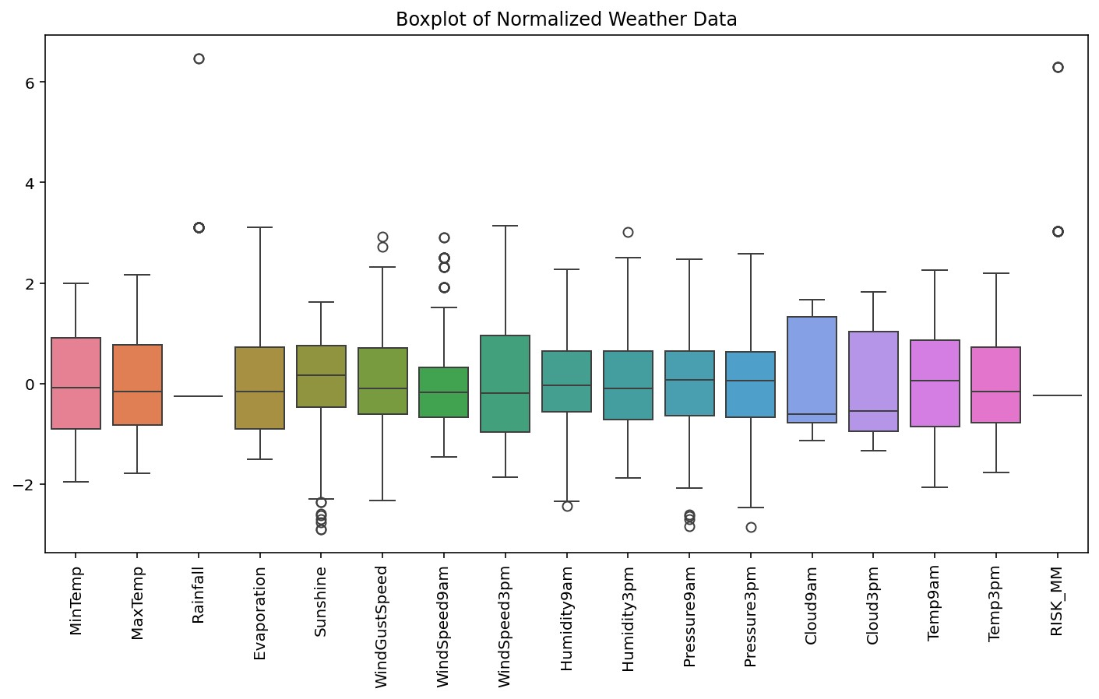

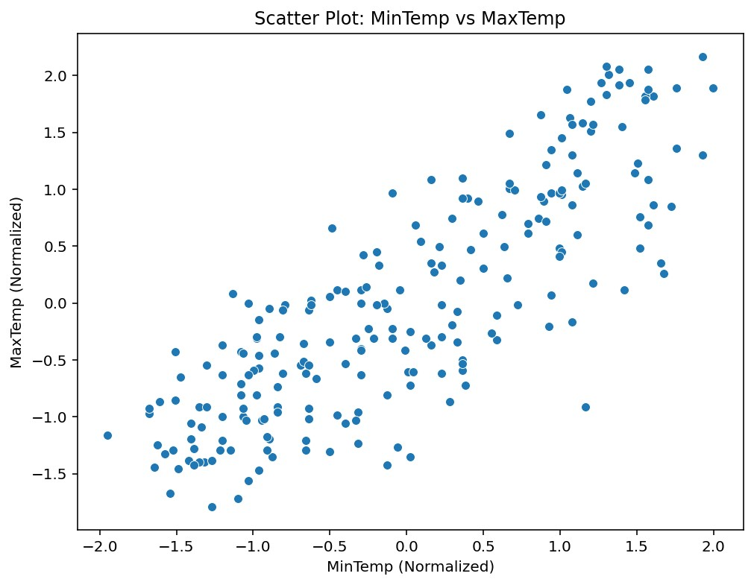

Mission of the Department To nurture computer engineering professionals by offering:
- Dynamic learning environment that encourages problem-solving using emerging technology
- National Education Policy aligned evidence-based technical education, fostering innovation, research, and industry–institute collaboration • Holistic, ethical and sustainable development for lifelong success.

Output Analysis | The output displays a cleaned dataset where null entries in columns like Sunshine and WindDir9am were successfully handled. The removal of outliers via the IQR method reduced the dataset from 366 entries to 224 entries, ensuring more robust analysis by eliminating extreme noise.  - Histogram: Shows the distribution of weather features post-normalization, centered around zero.  - Boxplot: Visualizes the spread and confirms the reduction of extreme outliers across features like WindSpeed9am and Pressure9am.  - Scatter Plot: Specifically illustrates a strong positive correlation between MinTemp and MaxTemp.
Link of student Github profile where lab assignment has been uploaded | krish-na45/SDA_Practicals
Conclusion | Data preprocessing is a crucial step in data science. Clean and normalized data improves the performance of machine learning models and ensures accurate analysis.
Plag Report  (Similarity index <  12%) | 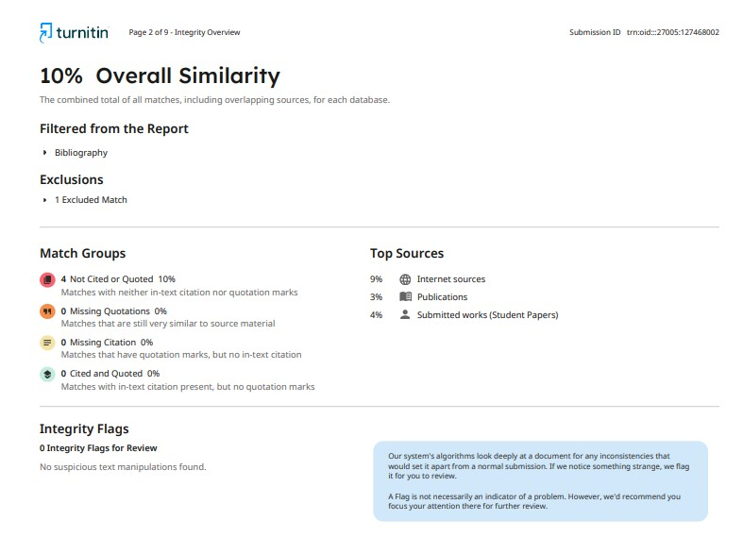
Date | 12/01/2026
(An Autonomous Institution affiliated to Rashtrasant Tukadoji Maharaj Nagpur University)
Hingna Road, Wanadongri, Nagpur - 441 110
NAAC A++
Ph.: 07104-237919, 234623, 329249, 329250 Fax: 07104-232376, Website: www.ycce.edu Department of Artificial Intelligence and Data Science

Vision of the Department
To be a preferred hub for nurturing computer engineering aspirants through innovative, ethical, value-based technical education, impactful research, and industry collaboration, to become successful professionals contributing for the betterment of society. Mission of the Department To nurture computer engineering professionals by offering:
- Dynamic learning environment that encourages problem-solving using emerging technology
- National Education Policy aligned evidence-based technical education, fostering innovation, research, and industry–institute collaboration • Holistic, ethical and sustainable development for lifelong success.

