Mission of the Department To nurture computer engineering professionals by offering:
- Dynamic learning environment that encourages problem-solving using emerging technology
- National Education Policy aligned evidence-based technical education, fostering innovation, research, and industry–institute collaboration • Holistic, ethical and sustainable development for lifelong success.

Session 2025-2026

Vision: Dream of where you want. | Mission: Means to achieve Vision

Program Educational Objectives of the program (PEO): (broad statements that describe the professional and career accomplishments)
PEO1 | Preparation | P: Preparation | Pep-CL abbreviation pronounce as Pep-si-lL easy to recall
PEO2 | Core Competence | E: Environment  (Learning Environment)
PEO3 | Breadth | P: Professionalism
PEO4 | Professionalism | C: Core Competence
PEO5 | Learning  Environment | L: Breadth (Learning in diverse areas)

Program Outcomes (PO): (statements that describe what a student should be able to do and know by the end of a program)
Keywords of POs:
Engineering knowledge, Problem analysis, Design/development of solutions, Conduct Investigations of Complex Problems, Engineering Tool Usage, The Engineer and The World, Ethics, Individual and Collaborative Team work, Communication, Project Management and Finance, Life-Long Learning

PSO Keywords: Cutting edge technologies, Research

“I am an engineer, and I know how to apply engineering knowledge to investigate, analyse and design solutions to complex problems using tools for entire world following all ethics in a collaborative way with proper management skills throughout my life.” to contribute to the development of cutting-edge technologies and Research.

Integrity: I will adhere to the Laboratory Code of Conduct and ethics in its entirety.

Mission of the Department To nurture computer engineering professionals by offering:
- Dynamic learning environment that encourages problem-solving using emerging technology
- National Education Policy aligned evidence-based technical education, fostering innovation, research, and industry–institute collaboration • Holistic, ethical and sustainable development for lifelong success.

Session | 2025-26 (EVEN) | Course Name | LAB: Sensor Data Analytics
Semester | 6th | Course Code | 23ADS1626
Roll No | 42 | Name of Student | Krishna Mishra

Practical Number | 2
Course Outcome | CO1: Apply data preprocessing, cleaning, normalization, and visualization techniques on sensor datasets.  CO2: Build and evaluate regression and classification models using machine learning algorithms.  CO3: Analyze unlabeled data using clustering and dimensionality reduction techniques.  CO4: Design, train, and evaluate deep learning models for image, text, and real-world applications.
Aim | To build regression models and analyze prediction performance.
Problem Definition | To implement supervised learning techniques using Linear Regression and Logistic Regression for predicting continuous and categorical outcomes respectively from a given weather dataset, and to evaluate the performance of the models using suitable evaluation metrics such as Mean Squared Error (MSE), accuracy score, and confusion matrix.
Theory  (100 words) | Supervised Learning  Supervised learning is a machine learning approach where the model is trained using labeled data, i.e., input data along with correct output.  Linear Regression
Mission of the Department To nurture computer engineering professionals by offering:
- Dynamic learning environment that encourages problem-solving using emerging technology
- National Education Policy aligned evidence-based technical education, fostering innovation, research, and industry–institute collaboration • Holistic, ethical and sustainable development for lifelong success.

Linear Regression is used to predict a continuous output by finding the best-fit straight line between input and output variables.
Mathematical model:
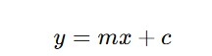
Where:
- = predicted output
- 𝑦𝑥𝑚𝑐= input feature
- = slope
- = intercept
Evaluation Metric:
- Mean Squared Error (MSE)

Logistic Regression
Logistic Regression is used for classification problems where the output is categorical (0 or 1).
It uses the Sigmoid function:
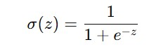
Evaluation Metrics:
- Accuracy
- Confusion Matrix
Mission of the Department To nurture computer engineering professionals by offering:
- Dynamic learning environment that encourages problem-solving using emerging technology
- National Education Policy aligned evidence-based technical education, fostering innovation, research, and industry–institute collaboration • Holistic, ethical and sustainable development for lifelong success.

Procedure and Execution  (100 Words) | Algorithm:  Linear Regression  - Import required libraries  - Load dataset  - Split dataset into training and testing sets  - Train Linear Regression model  - Predict output  - Calculate Mean Squared Error  Logistic Regression  - Load classification dataset  - Split dataset  - Train Logistic Regression model  - Predict class labels  - Evaluate accuracy and confusion matrix
Code: import pandas as pd
import matplotlib.pyplot as plt from sklearn.model_selection import train_test_split from sklearn.linear_model import LinearRegression, LogisticRegression
from sklearn.metrics import mean_squared_error, accuracy_score, confusion_matrix from sklearn.preprocessing import LabelEncoder

df = pd.read_csv('weather.csv')

print("Linear Regression: Predicting MaxTemp")

X_lin = df[['MinTemp']].values
y_lin = df['MaxTemp'].values

X_train_l, X_test_l, y_train_l, y_test_l = train_test_split(X_lin, y_lin, test_size=0.2, random_state=42)

Mission of the Department To nurture computer engineering professionals by offering:
- Dynamic learning environment that encourages problem-solving using emerging technology
- National Education Policy aligned evidence-based technical education, fostering innovation, research, and industry–institute collaboration • Holistic, ethical and sustainable development for lifelong success.

lr_model = LinearRegression()
lr_model.fit(X_train_l, y_train_l)

y_pred_l = lr_model.predict(X_test_l) print(f"Mean Squared Error: {mean_squared_error(y_test_l, y_pred_l):.2f}\n")

plt.scatter(X_test_l, y_test_l, color='blue', label='Actual') plt.plot(X_test_l, y_pred_l, color='red', linewidth=2, label='Regression Line') plt.xlabel("Min Temperature") plt.ylabel("Max Temperature") plt.title("MinTemp vs MaxTemp") plt.legend()
plt.show()

print("Logistic Regression: Predicting Rain Tomorrow")

le = LabelEncoder() df['RainToday'] = le.fit_transform(df['RainToday'].astype(str)) df['RainTomorrow'] = le.fit_transform(df['RainTomorrow'].astype(str))

features = ['MinTemp', 'MaxTemp', 'Rainfall', 'Humidity9am',
'Humidity3pm']
X_log = df[features].fillna(0)
y_log = df['RainTomorrow']

X_train_log, X_test_log, y_train_log, y_test_log =
train_test_split(X_log, y_log, test_size=0.2, random_state=42)

log_model = LogisticRegression(max_iter=1000) log_model.fit(X_train_log, y_train_log)

y_pred_log = log_model.predict(X_test_log)

print(f"Accuracy: {accuracy_score(y_test_log, y_pred_log):.2f}") print("Confusion Matrix:") print(confusion_matrix(y_test_log, y_pred_log))

Mission of the Department To nurture computer engineering professionals by offering:
- Dynamic learning environment that encourages problem-solving using emerging technology
- National Education Policy aligned evidence-based technical education, fostering innovation, research, and industry–institute collaboration • Holistic, ethical and sustainable development for lifelong success.

Output:
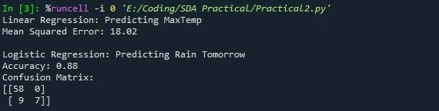

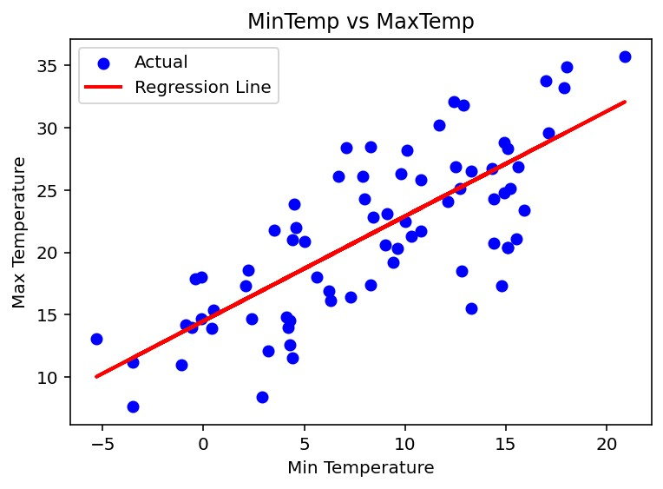
Output Analysis | The Linear Regression model predicts the maximum temperature using minimum temperature with a Mean Squared Error of 18.02, indicating a reasonably good prediction performance. The regression line closely follows the trend of actual data points, showing a positive linear relationship.  The Logistic Regression model achieved an accuracy of 88%, demonstrating strong classification capability in predicting rainfall. The confusion matrix shows a high number of correct predictions with minimal misclassification, confirming the effectiveness of the model. Overall, both regression models perform efficiently for prediction and classification tasks.

Vision of the Department
To be a preferred hub for nurturing computer engineering aspirants through innovative, ethical, value-based technical education, impactful research, and industry collaboration, to become successful professionals contributing for the betterment of society. Mission of the Department To nurture computer engineering professionals by offering:
- Dynamic learning environment that encourages problem-solving using emerging technology
- National Education Policy aligned evidence-based technical education, fostering innovation, research, and industry–institute collaboration • Holistic, ethical and sustainable development for lifelong success.

Link of student Github profile where lab assignment has been uploaded | krish-na45/SDA_Practicals
Conclusion | Regression models are powerful supervised learning techniques. Linear Regression is suitable for numeric prediction, while Logistic Regression is effective for binary classification problems.
Plag Report  (Similarity index <  12%) | 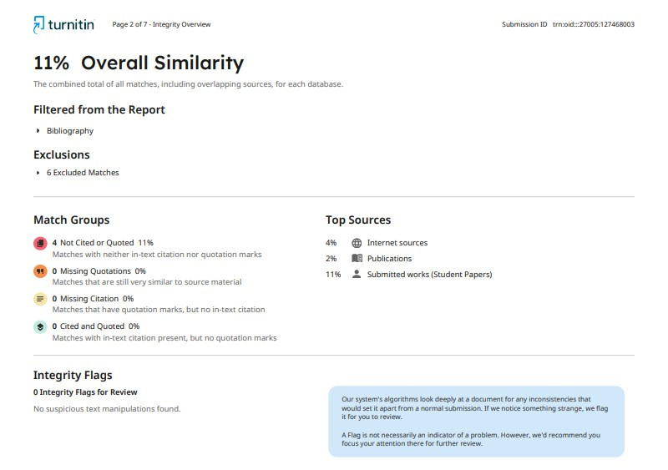
Date | 02/02/2026

