research, and industry collaboration, to become successful professionals contributing for the betterment of society. Mission of the Department To nurture computer engineering professionals by offering:
- Dynamic learning environment that encourages problem-solving using emerging technology
- National Education Policy aligned evidence-based technical education, fostering innovation, research, and industry–institute collaboration • Holistic, ethical and sustainable development for lifelong success.

Session 2025-2026

Vision: Dream of where you want. | Mission: Means to achieve Vision

Program Educational Objectives of the program (PEO): (broad statements that describe the professional and career accomplishments)
PEO1 | Preparation | P: Preparation | Pep-CL abbreviation pronounce as Pep-si-lL easy to recall
PEO2 | Core Competence | E: Environment  (Learning Environment)
PEO3 | Breadth | P: Professionalism
PEO4 | Professionalism | C: Core Competence
PEO5 | Learning  Environment | L: Breadth (Learning in diverse areas)

Program Outcomes (PO): (statements that describe what a student should be able to do and know by the end of a program)
Keywords of POs:
Engineering knowledge, Problem analysis, Design/development of solutions, Conduct Investigations of Complex Problems, Engineering Tool Usage, The Engineer and The World, Ethics, Individual and Collaborative Team work, Communication, Project Management and Finance, Life-Long Learning

PSO Keywords: Cutting edge technologies, Research

“I am an engineer, and I know how to apply engineering knowledge to investigate, analyse and design solutions to complex problems using tools for entire world following all ethics in a collaborative way with proper management skills throughout my life.” to contribute to the development of cutting-edge technologies and Research.

Integrity: I will adhere to the Laboratory Code of Conduct and ethics in its entirety.

Mission of the Department To nurture computer engineering professionals by offering:
- Dynamic learning environment that encourages problem-solving using emerging technology
- National Education Policy aligned evidence-based technical education, fostering innovation, research, and industry–institute collaboration • Holistic, ethical and sustainable development for lifelong success.

Session | 2025-26 (EVEN) | Course Name | LAB: Sensor Data Analytics
Semester | 6th | Course Code | 23ADS1626
Roll No | 42 | Name of Student | Krishna Mishra

Practical Number | 3
Course Outcome | CO1: Apply data preprocessing, cleaning, normalization, and visualization techniques on sensor datasets.  CO2: Build and evaluate regression and classification models using machine learning algorithms.  CO3: Analyze unlabeled data using clustering and dimensionality reduction techniques.  CO4: Design, train, and evaluate deep learning models for image, text, and real-world applications.
Aim | To implement Decision Tree and Random Forest classification models and to compare their accuracy and overfitting behavior.
Problem Definition | To design and implement Decision Tree and Random Forest classifiers on a weather dataset to predict rainfall and to compare their performance in terms of training accuracy, testing accuracy, and overfitting using accuracy gap analysis.
Theory  (100 words) | Decision Tree  A Decision Tree is a supervised learning algorithm that makes decisions by splitting data based on feature values. It consists of:  - Root Node – top decision  - Internal Nodes – decision rules  - Leaf Nodes – final output (class)  Advantages:  - Easy to understand and interpret
research, and industry collaboration, to become successful professionals contributing for the betterment of society. Mission of the Department To nurture computer engineering professionals by offering:
- Dynamic learning environment that encourages problem-solving using emerging technology
- National Education Policy aligned evidence-based technical education, fostering innovation, research, and industry–institute collaboration • Holistic, ethical and sustainable development for lifelong success.

- Works well with non-linear data
Disadvantage:
- Easily overfits training data

Random Forest
A Random Forest is an ensemble learning technique that builds multiple decision trees and combines their outputs.
Key idea:
“Many weak learners together form a strong learner.”
Advantages:
- Reduces overfitting
- Higher accuracy
- More robust than a single decision tree

Overfitting
Overfitting occurs when a model:
- Performs very well on training data
- Performs poorly on unseen (test) data
Random Forest reduces overfitting by averaging results of many trees.

Mission of the Department To nurture computer engineering professionals by offering:
- Dynamic learning environment that encourages problem-solving using emerging technology
- National Education Policy aligned evidence-based technical education, fostering innovation, research, and industry–institute collaboration • Holistic, ethical and sustainable development for lifelong success.

Procedure and Execution  (100 Words) | Algorithm:  Decision Tree  - Import required libraries  - Load dataset  - Split data into training and testing sets  - Train Decision Tree classifier  - Predict output  - Calculate accuracy  Random Forest  - Train Random Forest classifier  - Predict output  - Calculate accuracy  - Compare with Decision Tree
Code:

import pandas as pd from sklearn.model_selection import train_test_split from sklearn.tree import DecisionTreeClassifier from sklearn.ensemble import RandomForestClassifier from sklearn.metrics import accuracy_score from sklearn.preprocessing import LabelEncoder

df = pd.read_csv('weather.csv')

le = LabelEncoder() df['RainTomorrow'] = le.fit_transform(df['RainTomorrow'].astype(str))

features = ['MinTemp', 'MaxTemp', 'Rainfall', 'Humidity9am',
'Humidity3pm']
X = df[features].fillna(0)
y = df['RainTomorrow']

Mission of the Department To nurture computer engineering professionals by offering:
- Dynamic learning environment that encourages problem-solving using emerging technology
- National Education Policy aligned evidence-based technical education, fostering innovation, research, and industry–institute collaboration • Holistic, ethical and sustainable development for lifelong success.

X_train, X_test, y_train, y_test = train_test_split(X, y, test_size=0.2, random_state=42)

dt = DecisionTreeClassifier(random_state=42) dt.fit(X_train, y_train)

dt_train_acc = accuracy_score(y_train, dt.predict(X_train)) dt_test_acc = accuracy_score(y_test, dt.predict(X_test))

print(f"Decision Tree - Training Accuracy: {dt_train_acc:.2f}") print(f"Decision Tree - Testing Accuracy: {dt_test_acc:.2f}")

rf = RandomForestClassifier(n_estimators=100, random_state=42)
rf.fit(X_train, y_train)

rf_train_acc = accuracy_score(y_train, rf.predict(X_train)) rf_test_acc = accuracy_score(y_test, rf.predict(X_test))

print(f"\nRandom Forest - Training Accuracy: {rf_train_acc:.2f}") print(f"Random Forest - Testing Accuracy: {rf_test_acc:.2f}")

print("\nModel Comparison") print(f"Accuracy Gap (DT): {dt_train_acc - dt_test_acc:.4f}") print(f"Accuracy Gap (RF): {rf_train_acc - rf_test_acc:.4f}")

Output:
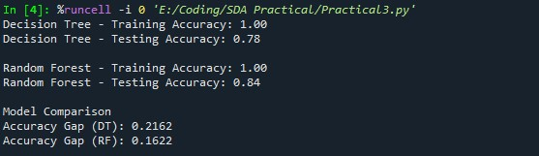
Mission of the Department To nurture computer engineering professionals by offering:
- Dynamic learning environment that encourages problem-solving using emerging technology
- National Education Policy aligned evidence-based technical education, fostering innovation, research, and industry–institute collaboration • Holistic, ethical and sustainable development for lifelong success.

Output Analysis | The Decision Tree model achieved 100% training accuracy, indicating perfect learning of training data, but its testing accuracy of 78% shows overfitting. The large accuracy gap of 0.2162 confirms this behavior.  The Random Forest model also achieved 100% training accuracy, but showed a higher testing accuracy of 84% and a smaller accuracy gap of 0.1622, indicating better generalization and reduced overfitting. Therefore, Random Forest performs better than Decision Tree for rainfall classification.
Link of student Github profile where lab assignment has been uploaded | krish-na45/SDA_Practicals
Conclusion | Tree-based models are powerful for classification tasks. Decision Trees are easy to interpret, while Random Forest provides better generalization and performance using ensemble learning.
Plag Report  (Similarity index <  12%) | 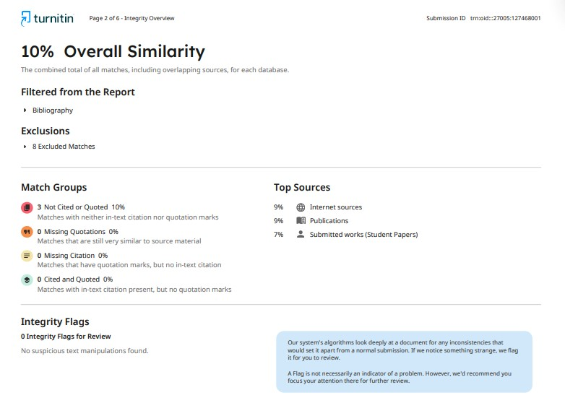
Date | 02/02/2026

