Department of Artificial Intelligence and Data Science

Vision of the Department
To be a preferred hub for nurturing computer engineering aspirants through innovative, ethical, value-based technical education, impactful research, and industry collaboration, to become successful professionals contributing for the betterment of society.

Mission of the Department
To nurture computer engineering professionals by offering:
- Dynamic learning environment that encourages problem-solving using emerging technology
- National Education Policy aligned evidence-based technical education, fostering innovation, research, and industry–institute collaboration
- Holistic, ethical and sustainable development for lifelong success.

Session 2025-2026

Vision: Dream of where you want. | Mission: Means to achieve Vision

Program Educational Objectives of the program (PEO): (broad statements that describe the professional and career accomplishments)
PEO1 | Preparation | P: Preparation | Pep-CL abbreviation pronounce as Pep-si-lL easy to recall
PEO2 | Core Competence | E: Environment (Learning Environment)
PEO3 | Breadth | P: Professionalism
PEO4 | Professionalism | C: Core Competence
PEO5 | Learning Environment | L: Breadth (Learning in diverse areas)

Program Outcomes (PO): (statements that describe what a student should be able to do and know by the end of a program)
Keywords of POs:
Engineering knowledge, Problem analysis, Design/development of solutions, Conduct Investigations of Complex Problems, Engineering Tool Usage, The Engineer and The World, Ethics, Individual and Collaborative Team work, Communication, Project Management and Finance, Life-Long Learning
PSO Keywords: Cutting edge technologies, Research
“I am an engineer, and I know how to apply engineering knowledge to investigate, analyse and design solutions to complex problems using tools for entire world following all ethics in a collaborative way with proper management skills throughout my life.” to contribute to the development of cutting-edge technologies and Research.

Integrity: I will adhere to the Laboratory Code of Conduct and ethics in its entirety.

Department of Artificial Intelligence and Data Science

Vision of the Department
To be a preferred hub for nurturing computer engineering aspirants through innovative, ethical, value-based technical education, impactful research, and industry collaboration, to become successful professionals contributing for the betterment of society.

Mission of the Department
To nurture computer engineering professionals by offering:
- Dynamic learning environment that encourages problem-solving using emerging technology
- National Education Policy aligned evidence-based technical education, fostering innovation, research, and industry–institute collaboration
- Holistic, ethical and sustainable development for lifelong success.

Session | 2025-26 (EVEN) |  | Course Name | LAB: Sensor Data Analytics
Semester | 6th |  | Course Code | 23ADS1626
Roll No | 42 |  | Name of Student | Krishna Mishra
Practical Number |  | 5
Course Outcome |  | CO1: Apply data preprocessing, cleaning, normalization, and visualization techniques on sensor datasets.  CO2: Build and evaluate regression and classification models using machine learning algorithms.  CO3: Analyze unlabeled data using clustering and dimensionality reduction techniques.  CO4: Design, train, and evaluate deep learning models for image, text, and real-world applications.
Aim |  | To implement K-Means and Hierarchical Clustering algorithms to discover hidden patterns in unlabeled data and to analyze clusters using suitable methods.
Problem Definition |  | The objective of this experiment is to understand unsupervised learning by implementing K-Means clustering on unlabeled data. The optimal number of clusters is determined using the Elbow Method. Further, Hierarchical clustering is performed and the resulting dendrograms are analyzed to study the cluster structure and hidden patterns in the data.
Theory  - words) |  | - Unsupervised Learning  Unsupervised learning is a type of machine learning where no labeled output is provided.  The goal is to identify hidden structures or patterns in data.  - K-Means Clustering  K-Means groups data into K clusters by minimizing the distance between data points and  their cluster centroids.  - Working steps:  1. Choose K  2. Initialize centroids  3. Assign data points to nearest centroid  4. Update centroids  5. Repeat until convergence

Department of Artificial Intelligence and Data Science

Vision of the Department
To be a preferred hub for nurturing computer engineering aspirants through innovative, ethical, value-based technical education, impactful research, and industry collaboration, to become successful professionals contributing for the betterment of society.

Mission of the Department
To nurture computer engineering professionals by offering:
- Dynamic learning environment that encourages problem-solving using emerging technology
- National Education Policy aligned evidence-based technical education, fostering innovation, research, and industry–institute collaboration
- Holistic, ethical and sustainable development for lifelong success.

Elbow Method

The Elbow Method is used to find the optimal number of clusters (K) by plotting Within-Cluster Sum of Squares (WCSS) against K.

“The point where the curve bends like an elbow is the optimal K.”

Hierarchical Clustering

Hierarchical clustering builds a tree-like structure of clusters.
Types:

- Agglomerative (bottom-up)
- Divisive (top-down)

Dendrogram visually represents the hierarchy of clusters.

Department of Artificial Intelligence and Data Science

Vision of the Department
To be a preferred hub for nurturing computer engineering aspirants through innovative, ethical, value-based technical education, impactful research, and industry collaboration, to become successful professionals contributing for the betterment of society.

Mission of the Department
To nurture computer engineering professionals by offering:
- Dynamic learning environment that encourages problem-solving using emerging technology
- National Education Policy aligned evidence-based technical education, fostering innovation, research, and industry–institute collaboration
- Holistic, ethical and sustainable development for lifelong success.

Procedure and Execution  (100 Words) | Algorithm:  - K-Means Clustering  1. Load dataset  2. Normalize data  3. Apply K-Means clustering  4. Assign cluster labels  5. Visualize clusters  - Hierarchical Clustering  1. Compute distance matrix  2. Apply agglomerative clustering  3. Plot dendrogram  4. Form clusters
Code:
import numpy as np
import matplotlib.pyplot as plt
from sklearn.datasets import load_iris
from sklearn.cluster import KMeans, AgglomerativeClustering
from sklearn.preprocessing import StandardScaler
from scipy.cluster.hierarchy import dendrogram, linkage

data = load_iris()
X = data.data

scaler = StandardScaler()
X_scaled = scaler.fit_transform(X)

wcss = []
for k in range(1, 11):
kmeans = KMeans(n_clusters=k, random_state=42)
kmeans.fit(X_scaled)
wcss.append(kmeans.inertia_)

plt.plot(range(1, 11), wcss, marker='o')
plt.xlabel("Number of Clusters (K)")
plt.ylabel("WCSS")
plt.title("Elbow Method for K-Means")
plt.show()

kmeans = KMeans(n_clusters=3, random_state=42)
kmeans_clusters = kmeans.fit_predict(X_scaled)

plt.scatter(X_scaled[:, 0], X_scaled[:, 1], c=kmeans_clusters, cmap='viridis')
plt.xlabel("Feature 1")
plt.ylabel("Feature 2")
plt.title("K-Means Clustering")
plt.show()

linked = linkage(X_scaled, method='ward')

plt.figure(figsize=(10, 7))
dendrogram(linked)
plt.title("Hierarchical Clustering Dendrogram")
plt.xlabel("Data Points")
plt.ylabel("Distance")
plt.show()

hc = AgglomerativeClustering(n_clusters=3)
hc_clusters = hc.fit_predict(X_scaled)

plt.scatter(X_scaled[:, 0], X_scaled[:, 1], c=hc_clusters, cmap='rainbow')
plt.xlabel("Feature 1")
plt.ylabel("Feature 2")
plt.title("Hierarchical Clustering")
plt.show()

Department of Artificial Intelligence and Data Science

Vision of the Department
To be a preferred hub for nurturing computer engineering aspirants through innovative, ethical, value-based technical education, impactful research, and industry collaboration, to become successful professionals contributing for the betterment of society.

Mission of the Department
To nurture computer engineering professionals by offering:
- Dynamic learning environment that encourages problem-solving using emerging technology
- National Education Policy aligned evidence-based technical education, fostering innovation, research, and industry–institute collaboration
- Holistic, ethical and sustainable development for lifelong success.

Output:

- Elbow curve showing optimal K

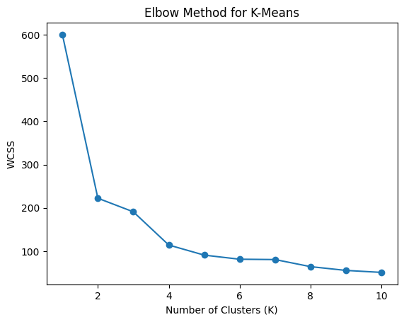

- Clustered scatter plot from K-Means

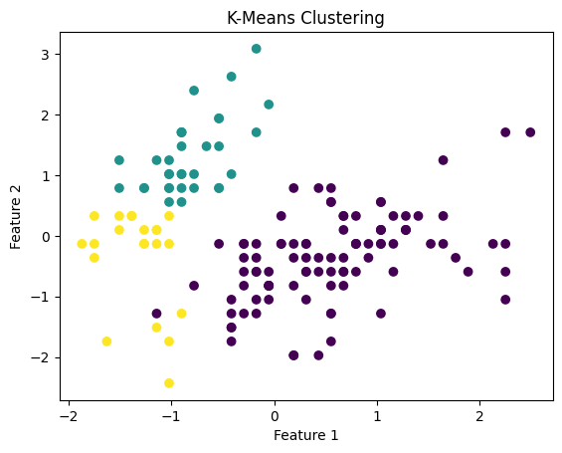

- Dendrogram showing hierarchical structure

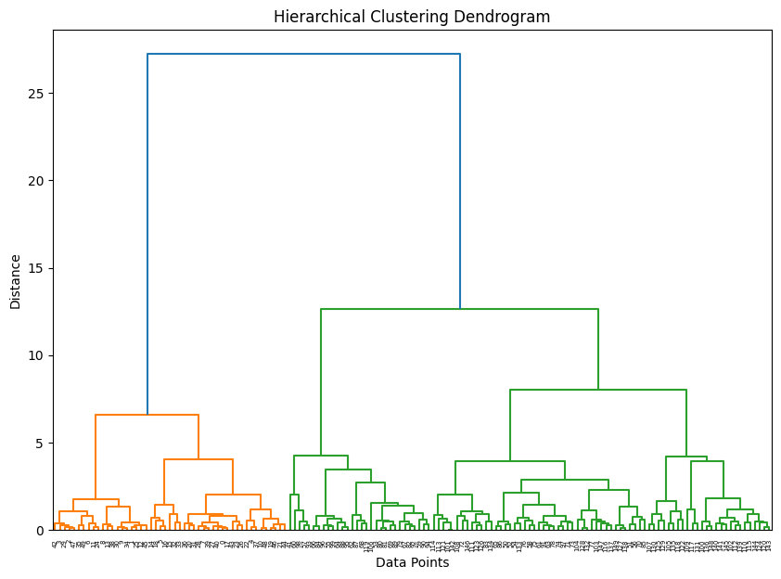

- Cluster labels for hierarchical clustering

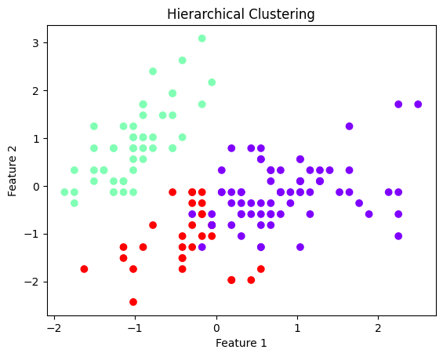

Department of Artificial Intelligence and Data Science

Vision of the Department
To be a preferred hub for nurturing computer engineering aspirants through innovative, ethical, value-based technical education, impactful research, and industry collaboration, to become successful professionals contributing for the betterment of society.

Mission of the Department
To nurture computer engineering professionals by offering:
- Dynamic learning environment that encourages problem-solving using emerging technology
- National Education Policy aligned evidence-based technical education, fostering innovation, research, and industry–institute collaboration
- Holistic, ethical and sustainable development for lifelong success.

Output Analysis | - Elbow Method (K-Means):  The elbow curve shows a sharp decrease in WCSS up to K = 3, indicating the optimal number of clusters.  - K-Means Clustering Output:  The scatter plot shows three compact and well-separated clusters representing similar data points.  - Hierarchical Clustering Dendrogram:  The dendrogram forms three major clusters when cut at an appropriate distance.  - Hierarchical Clustering Output:  The final plot shows three clearly separated clusters similar to K-Means results.
Link of student Github profile where lab assignment has been uploaded | krish-na45/SDA_Practicals
Conclusion | Unsupervised learning techniques help discover hidden patterns in unlabeled data. K-Means is efficient for large datasets, while Hierarchical clustering provides better interpretability through dendrograms.
Plag Report (Similarity index < 12%) | 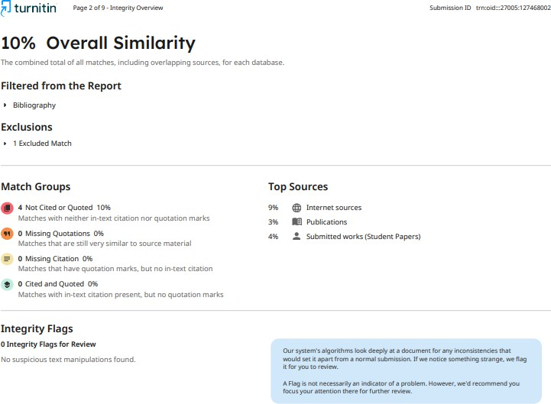
Date | 12/01/2026

