Department of Artificial Intelligence and Data Science

Vision of the Department
To be a preferred hub for nurturing computer engineering aspirants through innovative, ethical, value-based technical education, impactful research, and industry collaboration, to become successful professionals contributing for the betterment of society.

Mission of the Department
To nurture computer engineering professionals by offering:
- Dynamic learning environment that encourages problem-solving using emerging technology
- National Education Policy aligned evidence-based technical education, fostering innovation, research, and industry–institute collaboration
- Holistic, ethical and sustainable development for lifelong success.

Session 2025-2026

Vision: Dream of where you want. | Mission: Means to achieve Vision

Program Educational Objectives of the program (PEO): (broad statements that describe the professional and career accomplishments)
PEO1 | Preparation | P: Preparation | Pep-CL abbreviation pronounce as Pep-si-lL easy to recall
PEO2 | Core Competence | E: Environment (Learning Environment)
PEO3 | Breadth | P: Professionalism
PEO4 | Professionalism | C: Core Competence
PEO5 | Learning Environment | L: Breadth (Learning in diverse areas)

Program Outcomes (PO): (statements that describe what a student should be able to do and know by the end of a program)
Keywords of POs:
Engineering knowledge, Problem analysis, Design/development of solutions, Conduct Investigations of Complex Problems, Engineering Tool Usage, The Engineer and The World, Ethics, Individual and Collaborative Team work, Communication, Project Management and Finance, Life-Long Learning
PSO Keywords: Cutting edge technologies, Research
“I am an engineer, and I know how to apply engineering knowledge to investigate, analyse and design solutions to complex problems using tools for entire world following all ethics in a collaborative way with proper management skills throughout my life.” to contribute to the development of cutting-edge technologies and Research.

Integrity: I will adhere to the Laboratory Code of Conduct and ethics in its entirety.

Department of Artificial Intelligence and Data Science

Vision of the Department
To be a preferred hub for nurturing computer engineering aspirants through innovative, ethical, value-based technical education, impactful research, and industry collaboration, to become successful professionals contributing for the betterment of society.

Mission of the Department
To nurture computer engineering professionals by offering:
- Dynamic learning environment that encourages problem-solving using emerging technology
- National Education Policy aligned evidence-based technical education, fostering innovation, research, and industry–institute collaboration
- Holistic, ethical and sustainable development for lifelong success.

Session | 2025-26 (EVEN) |  | Course Name | LAB: Sensor Data Analytics
Semester | 6th |  | Course Code | 23ADS1626
Roll No | 42 |  | Name of Student | Krishna Mishra
Practical Number |  | 7
Course Outcome |  | CO1: Apply data preprocessing, cleaning, normalization, and visualization techniques on sensor datasets.  CO2: Build and evaluate regression and classification models using machine learning algorithms.  CO3: Analyze unlabeled data using clustering and dimensionality reduction techniques.  CO4: Design, train, and evaluate deep learning models for image, text, and real-world applications.
Aim |  | To apply Principal Component Analysis (PCA) for reducing feature dimensions while preserving maximum variance and to visualize the reduced dimensions.
Problem Definition |  | The objective of this experiment is to apply Principal Component Analysis (PCA) to reduce high-dimensional data into lower dimensions while retaining maximum information. The explained variance ratio is analyzed to understand how much data variability is preserved, and the reduced data is visualized to study the structure and distribution after dimensionality reduction.
Theory  - words) |  | - Introduction  Principal Component Analysis (PCA) is an unsupervised dimensionality reduction technique used to reduce the number of features in a dataset while preserving maximum information.  - Need for PCA  High-dimensional data increases computation time and complexity. PCA helps in:  - Reducing dimensionality  - Removing redundant features  - Improving visualization and performance  - Working Principle  PCA transforms the original correlated features into a new set of uncorrelated variables called principal components.  - The first principal component captures maximum variance.  - Each subsequent component captures the remaining variance.  - Explained Variance Ratio  The explained variance ratio indicates the amount of variance preserved by each principal component.  Higher variance means better information retention.  - Advantages of PCA  - Reduces data size  - Removes noise and redundancy  - Improves visualization  - Speeds up machine learning models

Department of Artificial Intelligence and Data Science

Vision of the Department
To be a preferred hub for nurturing computer engineering aspirants through innovative, ethical, value-based technical education, impactful research, and industry collaboration, to become successful professionals contributing for the betterment of society.

Mission of the Department
To nurture computer engineering professionals by offering:
- Dynamic learning environment that encourages problem-solving using emerging technology
- National Education Policy aligned evidence-based technical education, fostering innovation, research, and industry–institute collaboration
- Holistic, ethical and sustainable development for lifelong success.

Procedure and Execution  (100 Words) | Algorithm:  - Load the dataset.  - Standardize the data to have mean 0 and variance 1.  - Compute the covariance matrix.  - Calculate eigenvalues and eigenvectors.  - Select top eigenvectors based on highest eigenvalues.
Code:

import numpy as np
import matplotlib.pyplot as plt
from sklearn.datasets import load_iris
from sklearn.preprocessing import StandardScaler
from sklearn.decomposition import PCA

data = load_iris()
X = data.data
y = data.target

scaler = StandardScaler()
X_scaled = scaler.fit_transform(X)

pca = PCA(n_components=2)
X_pca = pca.fit_transform(X_scaled)

print("Explained Variance Ratio:", pca.explained_variance_ratio_)
print("Total Variance Preserved:", sum(pca.explained_variance_ratio_))

plt.figure(figsize=(8, 6))
plt.scatter(X_pca[:, 0], X_pca[:, 1], c=y, cmap='viridis')
plt.xlabel("Principal Component 1")
plt.ylabel("Principal Component 2")
plt.title("PCA - Dimensionality Reduction")
plt.colorbar(label="Class Label")
plt.show()

Department of Artificial Intelligence and Data Science

Vision of the Department
To be a preferred hub for nurturing computer engineering aspirants through innovative, ethical, value-based technical education, impactful research, and industry collaboration, to become successful professionals contributing for the betterment of society.

Mission of the Department
To nurture computer engineering professionals by offering:
- Dynamic learning environment that encourages problem-solving using emerging technology
- National Education Policy aligned evidence-based technical education, fostering innovation, research, and industry–institute collaboration
- Holistic, ethical and sustainable development for lifelong success.

Output:

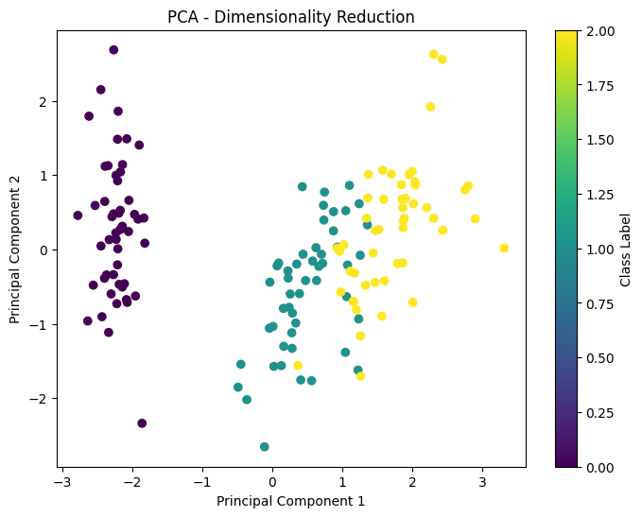

Department of Artificial Intelligence and Data Science

Vision of the Department
To be a preferred hub for nurturing computer engineering aspirants through innovative, ethical, value-based technical education, impactful research, and industry collaboration, to become successful professionals contributing for the betterment of society.

Mission of the Department
To nurture computer engineering professionals by offering:
- Dynamic learning environment that encourages problem-solving using emerging technology
- National Education Policy aligned evidence-based technical education, fostering innovation, research, and industry–institute collaboration
- Holistic, ethical and sustainable development for lifelong success.

Output Analysis | 1. Explained Variance Ratio:  The output shows that the first two principal components capture most of the data variance. This indicates that important information from the original features is retained after dimensionality reduction.  2. Total Variance Preserved:  The total variance preserved is approximately 95%, which means very little information is lost while reducing the dimensions from four to two.  3. Dimensionality Reduction Result:  The dataset is successfully reduced to two dimensions, making it easier to analyse and visualize without affecting the overall data structure.
Link of student Github profile where lab assignment has been uploaded | krish-na45/SDA_Practicals
Conclusion | PCA is an effective dimensionality reduction technique that removes redundancy and preserves important information. It simplifies data visualization and improves computational  efficiency for machine learning models.
Plag Report (Similarity index < 12%) | 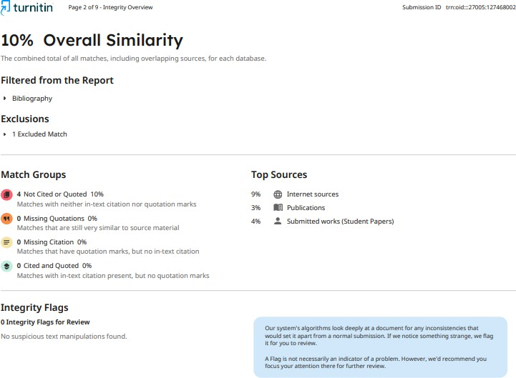
Date | 12/01/2026

