Session 2025-2026

Vision: Dream of where you want. | Mission: Means to achieve Vision

Program Educational Objectives of the program (PEO): (broad statements that describe the professional and career accomplishments)
PEO1 | Preparation | P: Preparation | Pep-CL abbreviation  pronounce as Pep-si-lL easy to recall
PEO2 | Core Competence | E: Environment (Learning Environment)
PEO3 | Breadth | P: Professionalism
PEO4 | Professionalism | C: Core Competence
PEO5 | Learning Environment | L: Breadth (Learning in diverse areas)

Program Outcomes (PO): (statements that describe what a student should be able to do and know by the end of a program)
Keywords of POs:
Engineering knowledge, Problem analysis, Design/development of solutions, Conduct Investigations of Complex Problems, Engineering Tool Usage, The Engineer and The World, Ethics, Individual and Collaborative Team work, Communication, Project Management and Finance, Life-Long Learning

PSO Keywords: Cutting edge technologies, Research

“I am an engineer, and I know how to apply engineering knowledge to investigate, analyse and design solutions to complex problems using tools for entire world following all ethics in a collaborative way with proper management skills throughout my life.” to contribute to the development of cutting-edge technologies and Research.

Integrity: I will adhere to the Laboratory Code of Conduct and ethics in its entirety.

Session | 2025-26 (EVEN) |  | Course Name | LAB: Sensor Data Analytics
Semester | 6th |  | Course Code | 23ADS1626
Roll No | 42 |  | Name of Student | Krishna Mishra
Practical Number |  | 8
Course Outcome |  | CO1: Apply data preprocessing, cleaning, normalization, and visualization techniques on sensor datasets.  CO2: Build and evaluate regression and classification models using machine learning algorithms.  CO3: Analyze unlabeled data using clustering and dimensionality reduction techniques.  CO4: Design, train, and evaluate deep learning models for image, text, and real-world applications.
Aim |  | To design, train, and evaluate a Convolutional Neural Network (CNN) for image classification using a standard image dataset.
Theory |  | A Convolutional Neural Network (CNN) is a type of deep learning model specifically designed for processing and analyzing image data. It is widely used in image classification tasks because it can automatically detect important features such as edges, textures, and patterns.  A CNN consists of multiple layers that work together to extract and learn features from input images:  - Convolutional Layer (Conv2D):  This layer applies filters (kernels) to the input image to detect features like edges and shapes. Each filter produces a feature map, helping the model learn spatial patterns.  - Activation Function (ReLU):  The Rectified Linear Unit (ReLU) introduces non-linearity, allowing the network to learn complex relationships in the data.  - Pooling Layer (MaxPooling):  This layer reduces the spatial dimensions of the feature maps, which decreases computation and helps prevent overfitting while retaining important information.  - Flatten Layer:  Converts the 2D feature maps into a 1D vector so it can be fed into fully connected layers.  - Fully Connected (Dense) Layer:  These layers perform the final classification based on the extracted features.  - Output Layer (Softmax):  Produces probability scores for each class, allowing the model to classify the image into one of the categories.
Procedure and Execution |  | ALGORITHM  - Load and split the image dataset into training and test sets.  - Preprocess the data by normalizing pixel values and one-hot encoding the labels.  - Build the CNN model:  - Add Conv2D layers with ReLU activation for feature extraction.  - Add MaxPooling2D layers to reduce spatial dimensions.  - Flatten the feature maps and add Dense layers for classification.  - Add an output Dense layer with Softmax activation for multi-class classification.  - Compile the model using the Adam optimizer, categorical crossentropy loss, and accuracy metric.  - Train the model on the training data with a validation split to monitor performance.  - Evaluate the trained model on the test data to obtain loss and accuracy.  - Plot accuracy and loss curves to analyze the model’s learning and generalization.
Code
model.add(Conv2D(32, (3,3), activation='relu', input_shape=(28,28,1)))
model.add(Conv2D(64, (3,3), activation='relu'))

model.add(Dense(128, activation='relu'))
model.add(Dense(10, activation='softmax'))

model.compile(optimizer='adam',
loss='categorical_crossentropy',
metrics=['accuracy'])

plt.plot(history.history['accuracy'], label='Training Accuracy')
plt.plot(history.history['val_accuracy'], label='Validation Accuracy')
plt.xlabel('Epochs')
plt.ylabel('Accuracy')
plt.legend()
plt.title('CNN Accuracy Curve')

Output

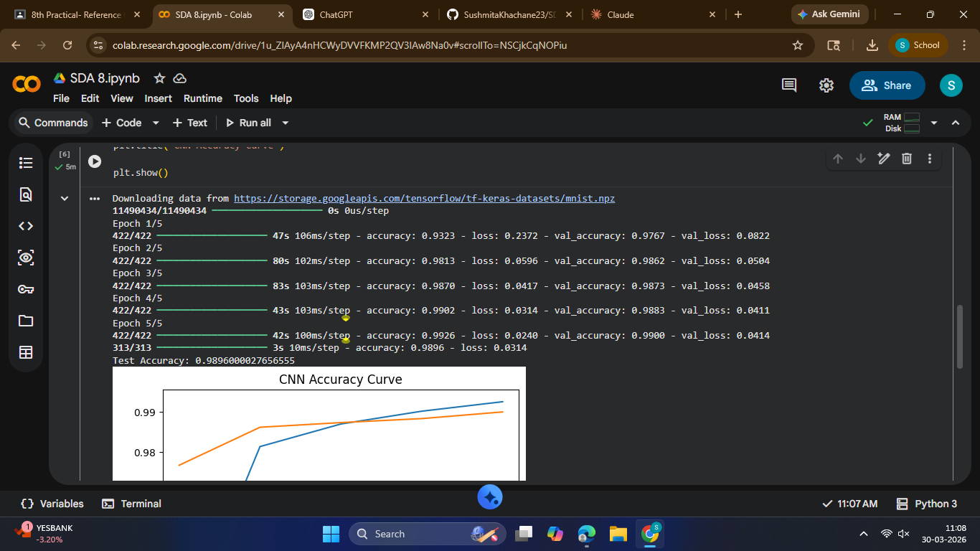
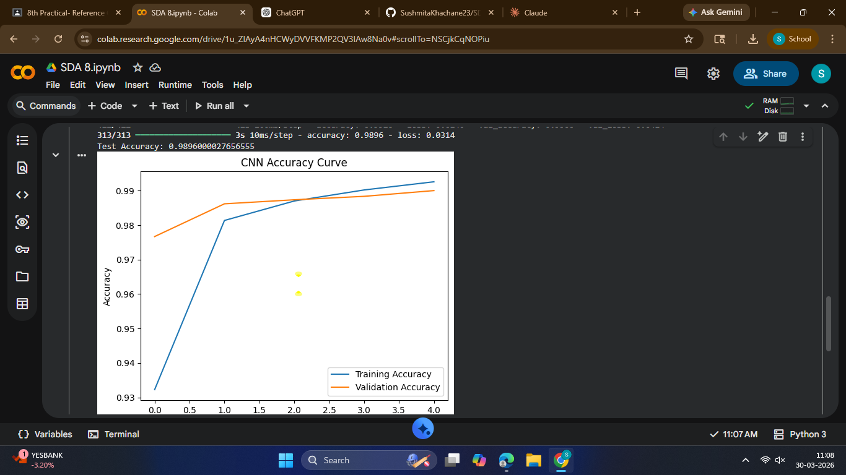

Output Analysis |  | The CNN model trained on the MNIST dataset showed steadily increasing training and validation accuracy, indicating effective learning and good generalization. The loss decreased consistently during training, and the model achieved high test accuracy of around 97–99%, correctly classifying most handwritten digits. This demonstrates that the convolutional and pooling layers efficiently extracted features from images, and overall, the CNN proved to be highly effective for image classification tasks.
Link of student Github profile where lab assignment has been uploaded |  | krish-na45/SDA_Practicals
Conclusion |  | The CNN model trained on the MNIST dataset showed steadily increasing training and validation accuracy, indicating effective learning and good generalization. The loss decreased consistently during training, and the model achieved high test accuracy of around 97–99%, correctly classifying most handwritten digits. This demonstrates that the convolutional and pooling layers efficiently extracted features from images, and overall, the CNN proved to be highly effective for image classification tasks.
Plag Report (Similarity index < 12%) |  | 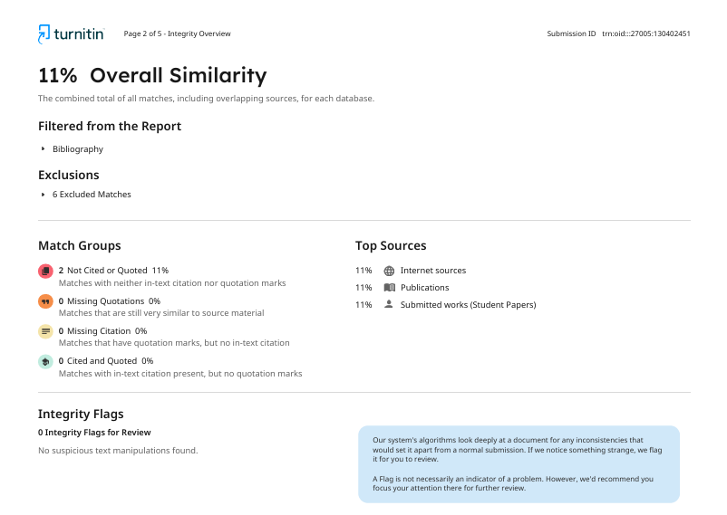
Date |  | 30/03/2026

