Session 2025-2026

Vision: Dream of where you want. | Mission: Means to achieve Vision

Program Educational Objectives of the program (PEO): (broad statements that describe the professional and career accomplishments)
PEO1 | Preparation | P: Preparation | Pep-CL abbreviation  pronounce as Pep-si-lL easy to recall
PEO2 | Core Competence | E: Environment (Learning Environment)
PEO3 | Breadth | P: Professionalism
PEO4 | Professionalism | C: Core Competence
PEO5 | Learning Environment | L: Breadth (Learning in diverse areas)

Program Outcomes (PO): (statements that describe what a student should be able to do and know by the end of a program)
Keywords of POs:
Engineering knowledge, Problem analysis, Design/development of solutions, Conduct Investigations of Complex Problems, Engineering Tool Usage, The Engineer and The World, Ethics, Individual and Collaborative Team work, Communication, Project Management and Finance, Life-Long Learning

PSO Keywords: Cutting edge technologies, Research

“I am an engineer, and I know how to apply engineering knowledge to investigate, analyse and design solutions to complex problems using tools for entire world following all ethics in a collaborative way with proper management skills throughout my life.” to contribute to the development of cutting-edge technologies and Research.

Integrity: I will adhere to the Laboratory Code of Conduct and ethics in its entirety.

Session | 2025-26 (EVEN) |  | Course Name | LAB: Sensor Data Analytics
Semester | 6th |  | Course Code | 23ADS1626
Roll No | 42 |  | Name of Student | Krishna Mishra
Practical Number |  | 8
Course Outcome |  | CO1: Apply data preprocessing, cleaning, normalization, and visualization techniques on sensor datasets.  CO2: Build and evaluate regression and classification models using machine learning algorithms.  CO3: Analyze unlabeled data using clustering and dimensionality reduction techniques.  CO4: Design, train, and evaluate deep learning models for image, text, and real-world applications.
Aim |  | To perform basic NLP tasks on textual data.
Theory |  | SMS Spam Detection is a text classification task in which messages are categorized as spam (unwanted, promotional, or malicious messages) or ham (legitimate messages). Machine learning models, such as the Naive Bayes classifier, are widely used for this task due to their simplicity and effectiveness with textual data.  Text data cannot be directly used by machine learning algorithms, so it is first transformed into numerical features. One common method is TF-IDF (Term Frequency-Inverse Document Frequency) vectorization, which assigns weights to words based on their frequency in a message relative to the entire dataset. Stopwords (common words like “the”, “is”, “and”) are removed to improve performance.  The Multinomial Naive Bayes classifier works well for discrete data like word counts or TF-IDF scores. It uses Bayes’ theorem to estimate the probability that a message belongs to a particular class (spam or ham) based on the features.
Procedure and Execution |  | ALGORITHM  - Load the dataset containing SMS messages and their labels (spam or ham).  - Preprocess the data by converting labels to binary form (ham = 0, spam = 1).  - Remove stopwords from the messages to reduce noise.  - Transform the text data into numerical features using TF-IDF vectorization.  - Split the dataset into training and test sets.  - Train a Multinomial Naive Bayes classifier on the training data.  - Predict the labels for the test set.  - Evaluate the model using accuracy and a confusion matrix.  - Analyze results to understand model performance.
Code
# Import required libraries
import numpy as np
import matplotlib.pyplot as plt
from tensorflow.keras.datasets import mnist
from tensorflow.keras.models import Sequential
from tensorflow.keras.layers import Conv2D, MaxPooling2D, Flatten, Dense
from tensorflow.keras.utils import to_categorical

# Load MNIST dataset
(X_train, y_train), (X_test, y_test) = mnist.load_data()

# Reshape and normalize data
X_train = X_train.reshape(-1, 28, 28, 1) / 255.0
X_test = X_test.reshape(-1, 28, 28, 1) / 255.0

# One-hot encode output labels
y_train = to_categorical(y_train)
y_test = to_categorical(y_test)

# Build CNN model
model = Sequential()

model.add(Conv2D(32, (3,3), activation='relu', input_shape=(28,28,1)))
model.add(MaxPooling2D((2,2)))

model.add(Conv2D(64, (3,3), activation='relu'))
model.add(MaxPooling2D((2,2)))

model.add(Flatten())

model.add(Dense(128, activation='relu'))
model.add(Dense(10, activation='softmax'))

# Compile model
model.compile(optimizer='adam',
loss='categorical_crossentropy',
metrics=['accuracy'])

# Train model
history = model.fit(X_train, y_train,
epochs=5,
batch_size=128,
validation_split=0.1)

# Evaluate model
test_loss, test_accuracy = model.evaluate(X_test, y_test)
print("Test Accuracy:", test_accuracy)

# Plot accuracy curve
plt.plot(history.history['accuracy'], label='Training Accuracy')
plt.plot(history.history['val_accuracy'], label='Validation Accuracy')
plt.xlabel('Epochs')
plt.ylabel('Accuracy')
plt.legend()
plt.title('CNN Accuracy Curve')
plt.show()

Output

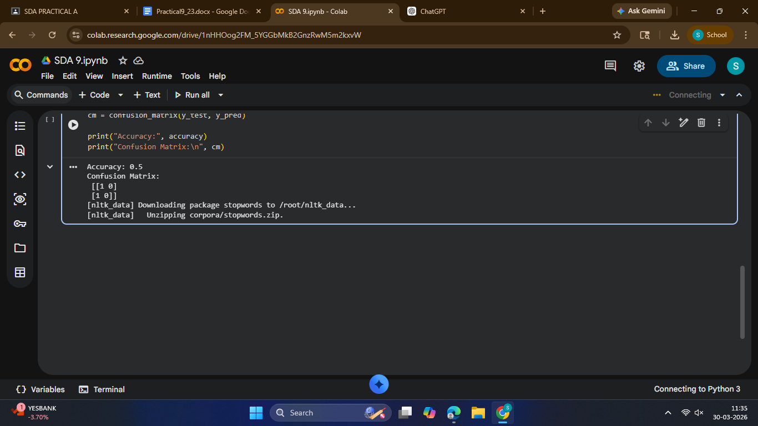
Output Analysis |  | After training and testing the model, the classifier predicted the labels of unseen messages. The accuracy indicates the proportion of correctly classified messages, while the confusion matrix shows the number of true positives (correctly detected spam), true negatives (correctly detected ham), false positives (ham classified as spam), and false negatives (spam classified as ham).
Link of student Github profile where lab assignment has been uploaded |  | krish-na45/SDA_Practicals
Conclusion |  | The practical demonstrates that SMS spam detection can be effectively implemented using TF-IDF vectorization and a Multinomial Naive Bayes classifier. Despite its simplicity, Naive Bayes performs well on text classification tasks by leveraging the statistical relationships between words and message labels. This approach highlights the importance of text preprocessing, feature extraction, and careful model evaluation in building reliable spam detection systems.
Plag Report (Similarity index < 12%) |  | 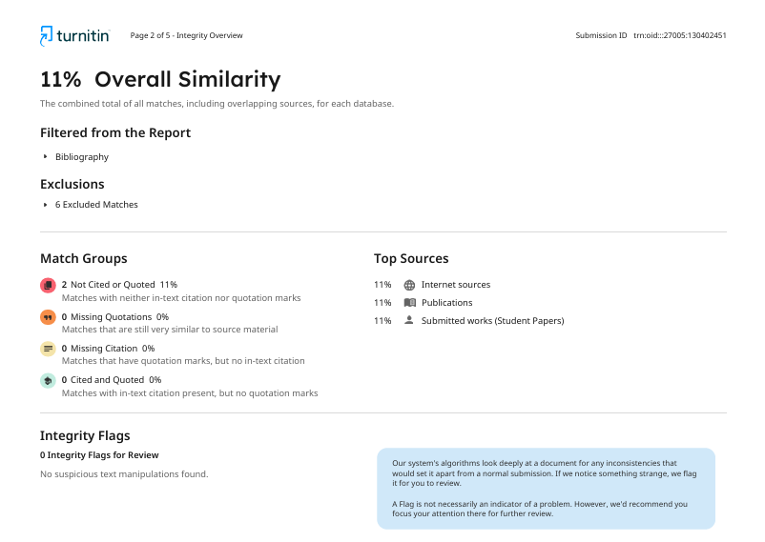
Date |  | 30/03/2026

