To

The Chief Warden

Good Host Spaces Pvt. Ltd. Manipal University Jaipur

Date: – 4th September, 2024

Subject: - Request for Desk Setup for TechnoVision 2.0

Respected Sir,

I am writing to you on behalf of the IEEE Robotics and Automation Society to request your kind permission. This request is made in light of the preparations required for our upcoming event, **TechnoVision 2.0**, an ideathon scheduled to be held on the **14th and 15th of September**.

During this period, our team will be engaged in various preparatory activities, including crafting, operational work, and planning, all of which are crucial to the successful execution of the event. We  **seek permission to set up a promotional desk in the hostel premises (in front of China Town) from 8th September to 13th September from 4pm to 10pm .** This desk will be used to promote TechnoVision 2.0, providing information and registration assistance to participants.

We and would ask you to kindly grant us permission for the following:-

1. 2 tables and 4 chairs(arranged on our own)
2. Decorations and LEDs.
3. Connecting wires and connection from the electric poles with the help of an electrician.
4. Music and sound within the volume limits.
5. Speaker from GHS office. (arranged on our own)

**Location**:   
 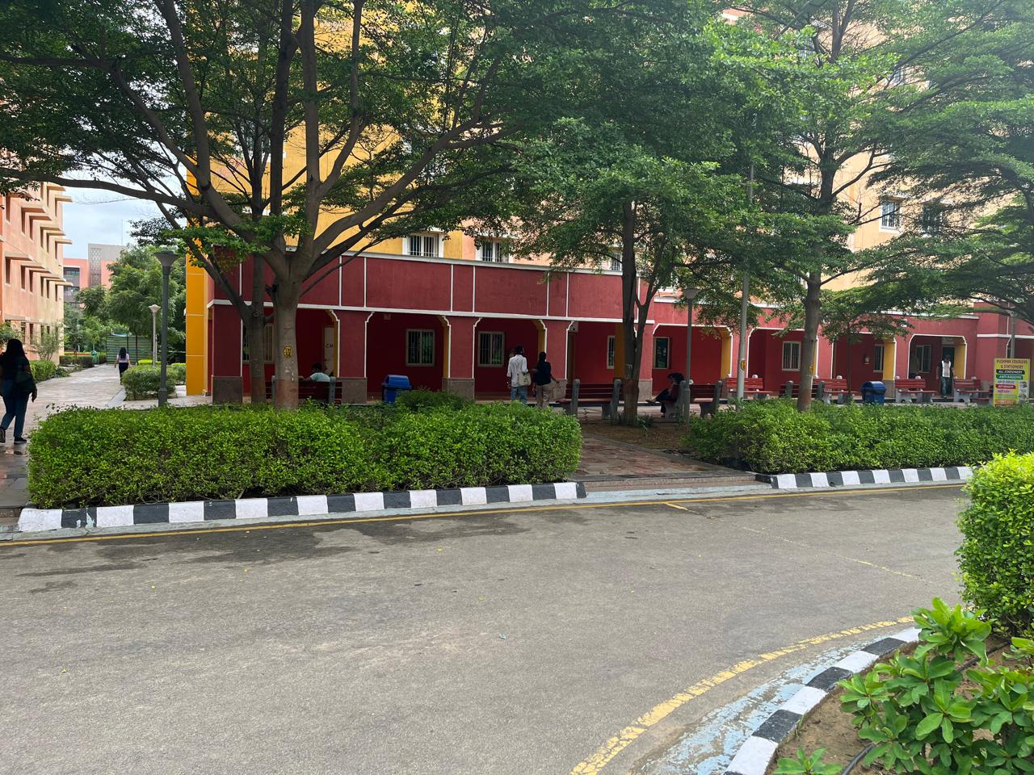

We shall take full responsibility and not cause any damage to hostel property. We would be grateful if you could grant us the permission for aforementioned.

Thanking you

**Team IEEE RAS**