

Digital Assignment – 1

ITE1005 - Advanced JAVA Programming

Slot – G2 + TG2
Faculty- Prof. Priya V

Submitted By:

Registration No.- 16BIT0453
Name- Krishna Kumar Mahto

Question:

I) Write a class named Car that has the following fields (attributes):
year (an int which holds the car's year)
model (a String with holds the car's model)
make (a String which holds the make of the car)
speed (an int which holds the car's initial speed)
The Car class should have the following constructors and other methods:
Constructor - Accepts the car's year, model, make, and speed as arguments.
Default Constructor - Does not accept any input parameters, and uses data type defaults.
Accessors (getters) for the object's attributes and Modifiers (setters).
Methods:
1. accelerate - each time it is called, it should add a random number between 5 and 30, to the
speed field
2. brake - each time it is called, it should subtract a random number between 5 and 30, to the
speed field

II) Write a Driver class, the DrivingSimulation class, which does the following:
✓ Prompt the user for the year, model, make, and initial speed of car #1.
✓ Create a Car object #1 using the default constructor. Then use the setters to initialize
it's values.
✓ Prompt the user for the year, model, make, and initial speed of car #2.
✓ Create a Car object #2 using the non-default constructor.
✓ Display the information for each car.
✓ Display an announcement that a race is about to begin between the 2 cars. Use your
creativity regarding all messages displayed.
✓ Create a loop that will simulate racing around a track 5 times.
o Within the loop, call the accelerate for each of the car objects, and after each
call, use the accessor method to display the current speed of the car
o Within the loop, call the brake for each of the car objects, and after each call,
use the accessor method to display the current speed of the car
o Within the loop, compare the speed for each car, and store the fastest speed for
each car (hint: use 2 local variables in the driver to hold the fastest speed of
each car. Compare current speed to fastest speed, at each loop iteration)
✓ At the end of the loop, display the fastest speed that each car reached. Make a
conclusion about which car achieved the fastest speed, and report on it.

Answer:

Description:

The ‘Car’ class was compiled as a package which was then inherited by the ‘Race’ class after importing it into ‘Race.java’.

UML Diagram for the Classes:
(used an online tool for drawing the UML)

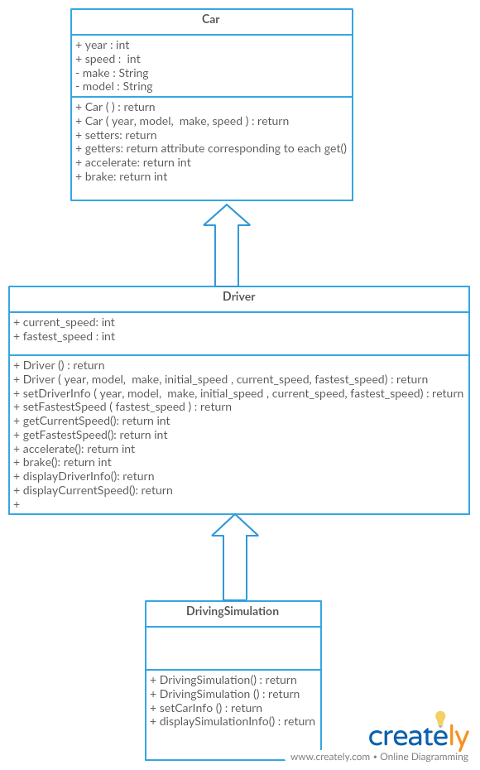
JAVA codes and Outputs:

Car.java

package Car;
import java.util.Random;

// Class declaration
public class Car {
int year;
String model;
String make;
int speed;
private Random accelerator = new Random();
// Default constructor
public Car() {
this.year = 0;
this.model = "";
this.make = "";
this.speed = 0;
}

// Parameterised constructor
public Car(int year, String model, String make, int speed) {
this.year = year;
this.model = model;
this.make = make;
this.speed = speed;
}

// Setters
public void setYear(int year) {
this.year = year;
}

public void setModel(String model) {
this.model = model;
}

public void setMake(String make) {
this.make = make;
}

public void setSpeed(int speed) {
this.speed = speed;
}

// Getters
public int getYear() {
return this.year;
}

public String getModel(String model) {
return this.model;
}

public String getMake(String make) {
return this.make;
}

public int getSpeed(int speed) {
return this.speed;
}

// Accelerate
public int accelerate() {
this.speed += accelerator.nextInt(25) + 5;
return this.speed;
}

// Brake
public int brake() {
this.speed -= accelerator.nextInt(25) - 5;
return this.speed;
}

public void displayCarInfo() {
System.out.println("Year: " + this.year);
System.out.println("Initial speed: " + this.speed);
System.out.println("Model: " + this.model);
System.out.println("Make: " + this.make);
}
}

Race.java

import java.util.Scanner;
import java.util.Random;
import Car.Car;

class Driver extends Car{
private int current_speed, fastest_speed;

public Driver() {
super();
this.current_speed = this.fastest_speed = 0;
}

public Driver(int year, int initial_speed, String model, String make, int current_speed, int fastest_speed) {
super(year, model, make, initial_speed);
this.current_speed = current_speed;
this.fastest_speed = fastest_speed;
}

public void setDriverInfo(int year, int initial_speed, String model, String make, int current_speed, int fastest_speed) {
super.setYear(year);
super.setModel(model);
super.setMake(make);
super.setSpeed(initial_speed);
this.current_speed = current_speed;
this.fastest_speed = fastest_speed;
}

public void setFastestSpeed(int fastest_speed) {
this.fastest_speed = fastest_speed;
}

public int getCurrentSpeed() {
return this.current_speed;
}

public int getFastestSpeed() {
return this.fastest_speed;
}

public int accelerate() {
this.current_speed = super.accelerate();
return this.current_speed;
}

public int brake() {
this.current_speed = super.brake();
return this.current_speed;
}

public void displayDriverInfo() {
super.displayCarInfo();
}

public void displayCurrentSpeed() {
System.out.println("Current speed: " + this.current_speed);
}

public void displayFastestSpeed() {
System.out.println("Fastest speed: " + this.fastest_speed);
}
}

class DrivingSimulation extends Driver {
public DrivingSimulation() {
super();
}

public DrivingSimulation(int year, int initial_speed, String model, String make) {
super(year, initial_speed, model, make, initial_speed, initial_speed);
}

public void setCarInfo(int year, int initial_speed, String model, String make) {
super.setDriverInfo(year, initial_speed, model, make, initial_speed, initial_speed);
}

public void displaySimulationInfo() {
super.displayDriverInfo();
}
}

public class Race {
public static void main(String args[]) {

int year, initial_speed;
String model, make;

Scanner keyboard = new Scanner(System.in);

System.out.println("Car 1 Info: ");
System.out.println("-----------");
System.out.println();
System.out.print("Year: ");
year = keyboard.nextInt();
keyboard.nextLine();
System.out.print("Initial speed: ");
initial_speed = keyboard.nextInt();
keyboard.nextLine();
System.out.print("Model: ");
model = keyboard.nextLine();
System.out.print("Make: ");
make = keyboard.nextLine();
System.out.println();

DrivingSimulation car1 = new DrivingSimulation();
car1.setCarInfo(year, initial_speed, model, make);

System.out.println("Car 2 Info: ");
System.out.println("-----------");
System.out.println();
System.out.print("Year: ");
year = keyboard.nextInt();
keyboard.nextLine();
System.out.print("Initial speed: ");
initial_speed = keyboard.nextInt();
keyboard.nextLine();
System.out.print("Model: ");
model = keyboard.nextLine();
System.out.print("Make: ");
make = keyboard.nextLine();
System.out.println();

DrivingSimulation car2 = new DrivingSimulation(year, initial_speed, model, make);

Random carOperator = new Random();

int oneLoopRunInterval = 2;
int carDistance1 = 0;
int carDistance2 = 0;

int beforeAcceleration, afterAcceleration;
System.out.println("---------------------------------------");
for(int i = 0; i<5; i++) {
if( i > 0) {
carDistance1 += car1.getCurrentSpeed() * oneLoopRunInterval;
carDistance2 += car2.getCurrentSpeed() * oneLoopRunInterval;
}
switch(carOperator.nextInt(4)) {
case 0:
beforeAcceleration = car1.getCurrentSpeed();
afterAcceleration = car1.accelerate();
if(car1.getCurrentSpeed() > car1.getFastestSpeed())
car1.setFastestSpeed(car1.getCurrentSpeed());
System.out.println("Car 1 accelerated by " + (afterAcceleration - beforeAcceleration) + ".");
break;
case 1:
beforeAcceleration = car2.getCurrentSpeed();
afterAcceleration = car2.accelerate();
if(car2.getCurrentSpeed() > car2.getFastestSpeed())
car2.setFastestSpeed(car2.getCurrentSpeed());
System.out.println("Car 2 accelerated by " + (afterAcceleration - beforeAcceleration) + ".");
break;
case 2:
beforeAcceleration = car1.getCurrentSpeed();
afterAcceleration = car1.brake();
System.out.println("Car 1 decelerates by " + Math.abs(afterAcceleration - beforeAcceleration) + ".");
break;
case 3:
beforeAcceleration = car2.getCurrentSpeed();
afterAcceleration = car2.brake();
System.out.println("Car 2 decelerates by " + Math.abs(afterAcceleration - beforeAcceleration) + ".");
break;
}
}
System.out.println();
System.out.println("----------------Results----------------");
System.out.println();
if(carDistance1 > carDistance2)
System.out.print("*** Car 1 won! ***");
else
System.out.println("*** Car 2 won! ***");

System.out.println();
System.out.println("Distance travelled by Car 1: " + carDistance1);
System.out.println("Distance travelled by Car 2: " + carDistance2);
System.out.println();
System.out.println("Fastest Speed attained by Car 1: " + car1.getFastestSpeed());
System.out.println("Fastest Speed attained by Car 2: " + car2.getFastestSpeed());
}
}

Output:

