EXAM MANAGEMENT SYSTEM (EMS)
Automated Exam Scheduling, Seating Allocation and Invigilation Duty Assignment
Design Lab: Use Case, Data Flow, Sequence and State Transition Diagrams
Prepared by
Harsh Vardhan | 240467
Himank Swami | 240474
Ishan Batra | 240485
Koushik Araveti | 240512
Krish Sharma | 240514
Software Engineering | BML Munjal University | September 2026

Contents
Introduction
1. Use Case Diagram
2. Data Flow Diagram (DFD)
3. Sequence Diagram
4. State Transition Diagram

Introduction
Every semester the examination cell must produce three things before exams can begin: an exam schedule, a seating allocation for every student, and an invigilation duty roster for teachers. The Exam Management System (EMS) automates all three using a solver pipeline: papers to days, days to sessions, seating, and duties.
This document presents the four design diagrams for EMS required by the design lab. They are based on our Software Requirements Specification (SRS v0.1). The feature codes C1 to C10 and module numbers M1 to M9 used below refer to the SRS.

1. Use Case Diagram

1.1 Actors
The system has six actors. Examination Cell Staff is the primary actor who operates the system; the others supply data or receive its outputs.
Actor | Description
Examination Cell Staff | Primary user. Uploads input data, runs the solver, reviews results and handles overrides.
System Administrator | Maintains reference data, such as the mapping from course codes to papers.
Examination Controller / HoD | Reviews fairness evidence and approves the final exam plan.
Teachers & Invigilators | Receive their personal invigilation duty roster.
Invigilator on Duty | A teacher supervising an exam room. Uses the seating chart and attendance sheet during the exam.
Students | Receive their personal exam timetable and seat allocation.

1.2 Use Cases
Actor | Use cases
Examination Cell Staff | Ingest & Validate Data; Run Pre-Solve Feasibility Check; Generate Exam Schedule; Allocate Seating; Assign Invigilation Duties; View Infeasibility Diagnosis; Pin Manual Override & Re-solve; Generate Reports
System Administrator | Map Course Codes to Papers
Examination Controller / HoD | Review Fairness Evidence; Approve Exam Plan
Teachers & Invigilators | View Duty Roster
Invigilator on Duty | Use Seating Chart & Attendance Sheet
Students | View Personal Timetable & Seat

1.3 Use Case Diagram
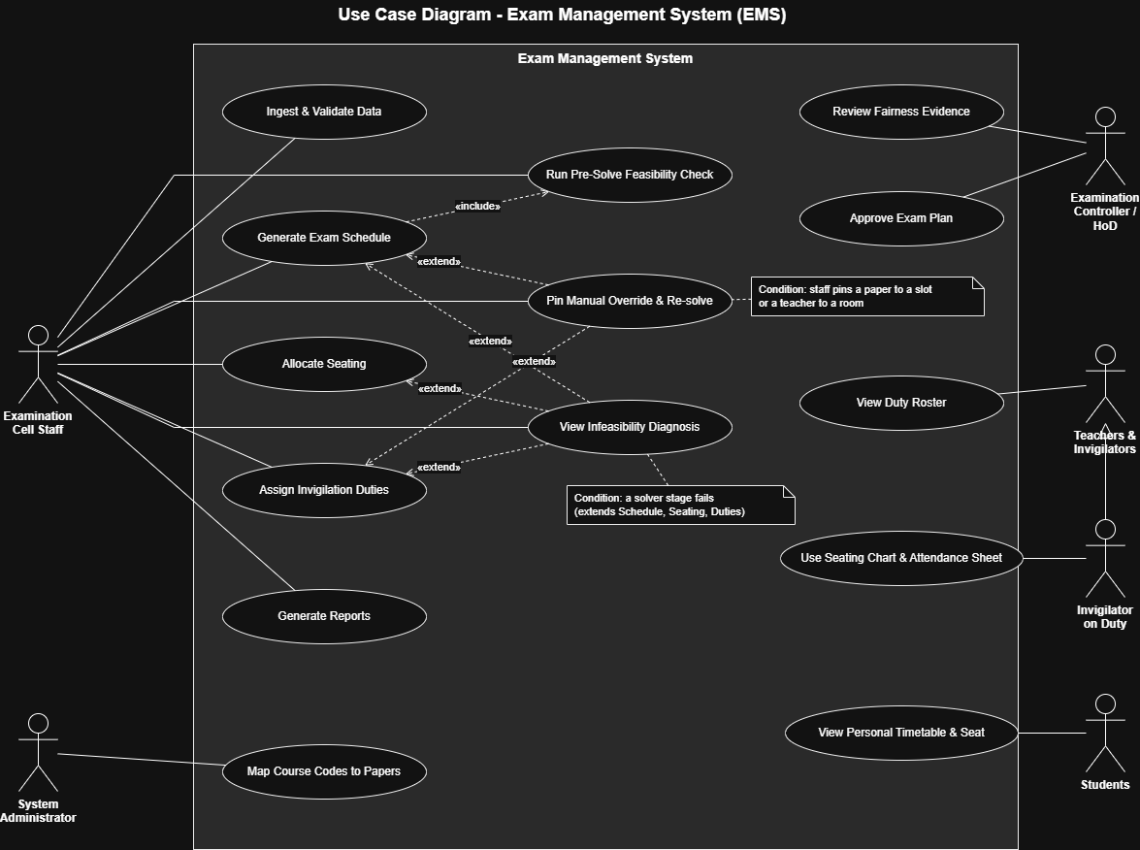
Figure 1: Use Case Diagram of the Exam Management System
Each actor is connected by a plain line to the use cases it takes part in. The diagram also shows the following relationships:
- «include»: Generate Exam Schedule always includes Run Pre-Solve Feasibility Check. The system checks that there are enough seats and invigilators before it tries to build a schedule.
- «extend»: View Infeasibility Diagnosis extends Generate Exam Schedule, Allocate Seating and Assign Invigilation Duties. It only happens when one of these stages fails, and it tells staff which rule failed.
- «extend»: Pin Manual Override & Re-solve extends Generate Exam Schedule and Assign Invigilation Duties. It only happens when staff fix a paper to a slot or a teacher to a room and run the solver again.
- Generalization: Invigilator on Duty is a specialised kind of Teachers & Invigilators, so it inherits their use cases.

2. Data Flow Diagram (DFD)

2.1 Processes, Data Stores, External Entities and Data Flows
External entities: Examination Cell Staff, System Administrator, Examination Controller / HoD, Teachers / Invigilators, and Students.
Processes:
Process | Purpose
P1 Validate & Ingest Data | Checks the input files and reference data, and stores the validated data.
P2 Map Course Codes to Papers | Maps the different course codes used for the same paper to one canonical paper ID.
P3 Build Conflict Graph | Links papers that share at least one student, and records which teacher taught which class.
P4 Generate Exam Schedule | Assigns every paper to a day and session, keeping at least two days between a student's exams.
P5 Allocate Seating | Gives every student a room and seat so that no two neighbours write the same paper.
P6 Assign Invigilation Duties | Assigns two invigilators to every open room, never with a class they taught.
P7 Check Feasibility / Diagnose Infeasibility | Checks capacity before solving and explains why no valid plan exists when solving fails.
P8 Manage Manual Overrides | Stores assignments pinned by staff and runs the solver stages again around them.
P9 Generate Reports | Produces the timetables, duty rosters, seating charts and summaries.

Data stores:
Data store | Contents
D1 Reference Data | Students, teachers, papers, rooms, registrations and teaching assignments
D2 Paper Mapping Table | Course code to canonical paper ID
D3 Conflict Graph & Exclusion Relation | Which papers share students, and which teachers taught which classes
D4 Exam Schedule | The date and session of every paper
D5 Seating Allocation | The room and seat of every student for every paper
D6 Duty Roster | The room and slot of every invigilation duty
D7 Pinned Overrides | Assignments fixed by staff: a paper to a slot, or a teacher to a room

The main data flows are shown on the diagrams below: input files and reference data coming in, intermediate results passed between processes and stored in D1 to D7, and reports going out to each user.

2.2 Context Diagram (Level 0 DFD)
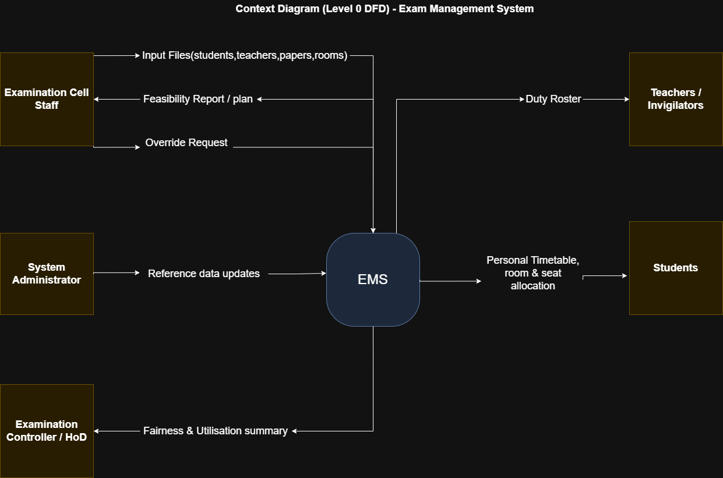
Figure 2: Context Diagram (Level 0 DFD)
The context diagram shows the whole EMS as a single process and the data it exchanges with the five external entities:
External entity | Data into EMS | Data out of EMS
Examination Cell Staff | Input files (students, teachers, papers, rooms); override requests | Feasibility report / plan
System Administrator | Reference data updates | -
Teachers / Invigilators | - | Duty roster
Students | - | Personal timetable, room & seat allocation
Examination Controller / HoD | - | Fairness & utilisation summary

2.3 Level 1 DFD
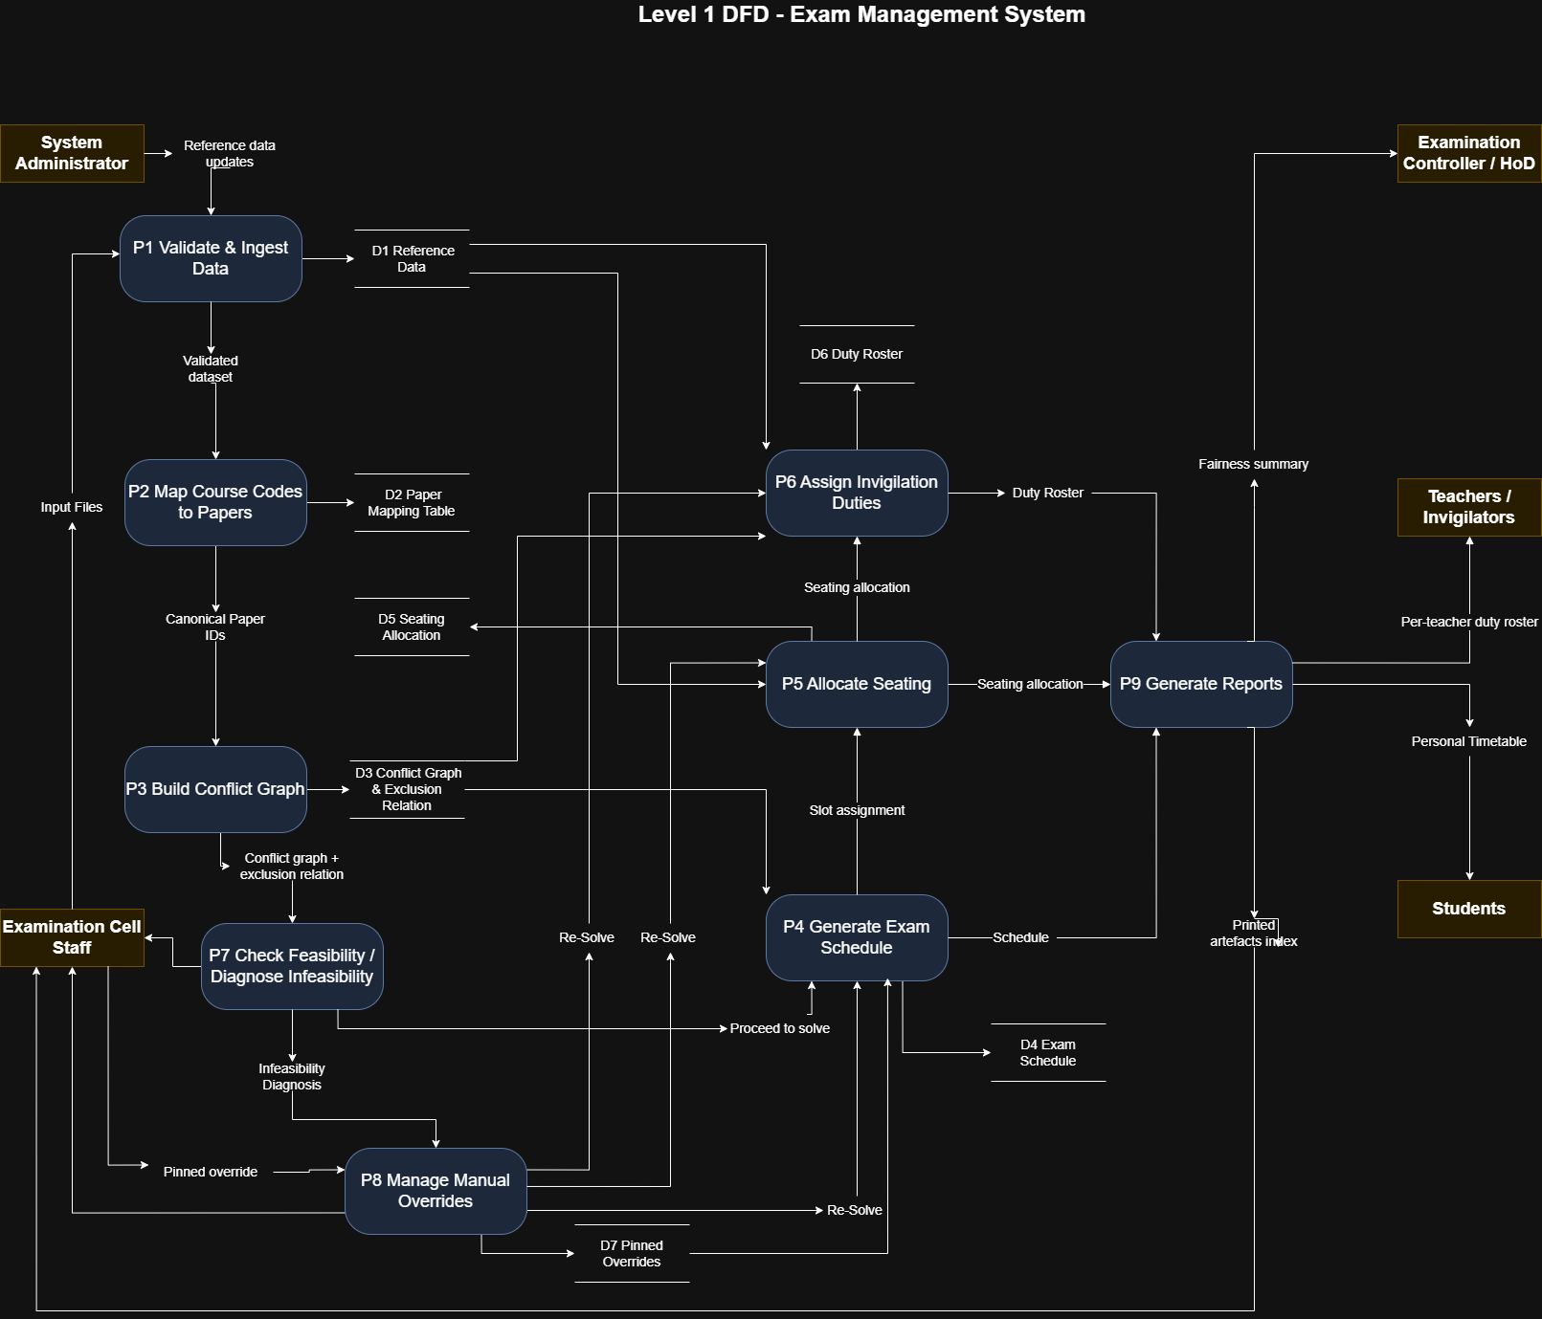
Figure 3: Level 1 DFD
The Level 1 DFD breaks EMS into nine processes. The data moves through them as follows:
- Examination Cell Staff send the input files to P1, and the System Administrator sends reference data updates. P1 validates them, saves them in D1 and passes the validated dataset to P2.
- P2 maps course codes to canonical paper IDs, saves the mapping in D2 and passes the paper IDs to P3.
- P3 builds the conflict graph and exclusion relation, saves them in D3 and passes them to P7.
- P7 checks feasibility and reports to staff. If the data is feasible, P4 proceeds to solve; if not, the infeasibility diagnosis goes to P8.
- P4 generates the exam schedule using the conflict graph from D3 and the pins from D7. It saves the schedule in D4 and sends the slot assignment to P5 and the schedule to P9.
- P5 allocates seats using room and student data from D1, saves the result in D5 and sends the seating allocation to P6 and P9.
- P6 assigns invigilators using teacher data from D1 and the exclusion relation from D3, saves the roster in D6 and sends it to P9.
- Staff can send a pinned override to P8. P8 saves it in D7 and triggers a re-solve of P4, P5 and P6.
- P9 generates the reports: a fairness summary for the HoD, a per-teacher duty roster for teachers, a personal timetable for students and a printed artefacts index for staff.

3. Sequence Diagram

3.1 Selected Use Case
We selected Generate Exam Schedule (C4). It is the core use case of the system, and it involves one «include» (the feasibility check) and two «extend» relationships (diagnosis and manual override), so the sequence diagram can show all of them.

3.2 Objects Involved
Object | Role in this use case
Examination Cell Staff (actor) | Starts schedule generation and receives the results
:EMS Controller | Coordinates the other components
:Conflict Analysis (M3) | Provides the conflict graph
:Feasibility & Diagnostics (M7) | Checks capacity and explains failures
:Override Manager (M8) | Stores and returns pinned assignments
:Scheduling Engine (M4) | Assigns papers to days and sessions

3.3 Sequence Diagram
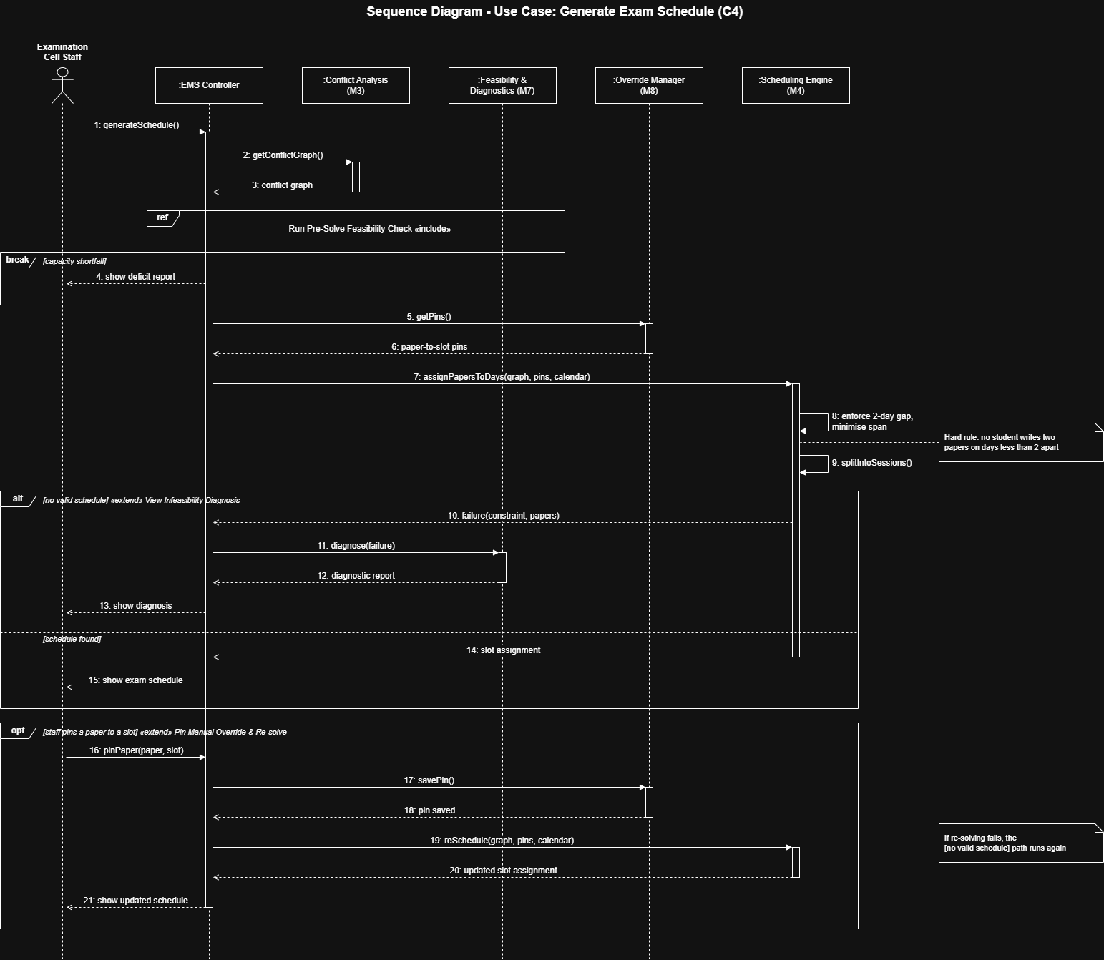
Figure 4: Sequence Diagram for Generate Exam Schedule
The messages happen in this order:
- Staff request a schedule (message 1). The controller gets the conflict graph from Conflict Analysis (messages 2 and 3).
- The ref frame runs the Pre-Solve Feasibility Check, which is the included use case.
- break [capacity shortfall]: if there are not enough seats or invigilators, staff are shown the deficit report and the use case ends (message 4).
- The controller gets existing pins from the Override Manager (messages 5 and 6) and asks the Scheduling Engine to assign papers to days (message 7).
- The Scheduling Engine enforces the two-day gap rule while keeping the exam period short, then splits each day into morning and evening sessions (messages 8 and 9).
- alt: if no valid schedule exists, the failure is sent to Feasibility & Diagnostics and staff are shown the diagnosis (messages 10 to 13). Otherwise the slot assignment is returned and staff are shown the schedule (messages 14 and 15).
- opt: staff may pin a paper to a slot. The pin is saved and the schedule is regenerated around it (messages 16 to 21).
Notation: solid arrows are calls, dashed arrows are replies, and the thin rectangles are activation bars showing when an object is working. The text in square brackets is the condition for each fragment.

4. State Transition Diagram

4.1 Selected Object
We selected the Exam Plan: the complete schedule, seating allocation and duty roster for one exam period. Its behaviour depends on its state. For example, it cannot be seated before it is scheduled, and it cannot be approved before its reports are generated.

4.2 States
State | Meaning
Not Generated | The data has been validated and mapped, but nothing has been solved yet
Feasibility Checked | There are enough seats and invigilators
Scheduled | Every paper has a date and session
Seated | Every student has a room and seat
Duties Assigned | Every open room has two invigilators
Reported | All reports and printed outputs have been generated
Approved (Locked) | The HoD has approved and published the plan; no further changes
Infeasible: Capacity | Not enough seats or invigilators
Infeasible: Schedule | No valid set of exam days exists
Infeasible: Seating | Not enough seats to separate students writing the same paper
Infeasible: Duties | The invigilation rules cannot all be satisfied

4.3 Events and Transitions
Each transition is written as event [condition] / action.
From state | Event [condition] / action | To state
Start | dataset validated and mapped | Not Generated
Not Generated | feasibility check [capacity sufficient] | Feasibility Checked
Not Generated | feasibility check [shortfall] / report deficit | Infeasible: Capacity
Infeasible: Capacity | rooms or teachers added | Not Generated
Feasibility Checked | generate schedule [2-day gap met] | Scheduled
Feasibility Checked | generate schedule [no valid days] / diagnose | Infeasible: Schedule
Infeasible: Schedule | pin paper to slot / re-solve | Feasibility Checked
Scheduled | allocate seats [no adjacent same paper] | Seated
Scheduled | allocate seats [not enough seats] / diagnose | Infeasible: Seating
Infeasible: Seating | pin paper to another slot / re-solve | Feasibility Checked
Seated | assign duties [exclusion & coverage met] | Duties Assigned
Seated | assign duties [rules unsatisfiable] / diagnose | Infeasible: Duties
Infeasible: Duties | pin teacher to room / re-solve | Seated
Duties Assigned | staff pins teacher to room / re-solve | Seated
Duties Assigned | staff pins paper to slot / re-solve | Feasibility Checked
Duties Assigned | generate reports | Reported
Reported | HoD requests changes | Duties Assigned
Reported | HoD approves / publish plan | Approved (Locked)
Approved (Locked) | exam period ends | End

4.4 State Transition Diagram
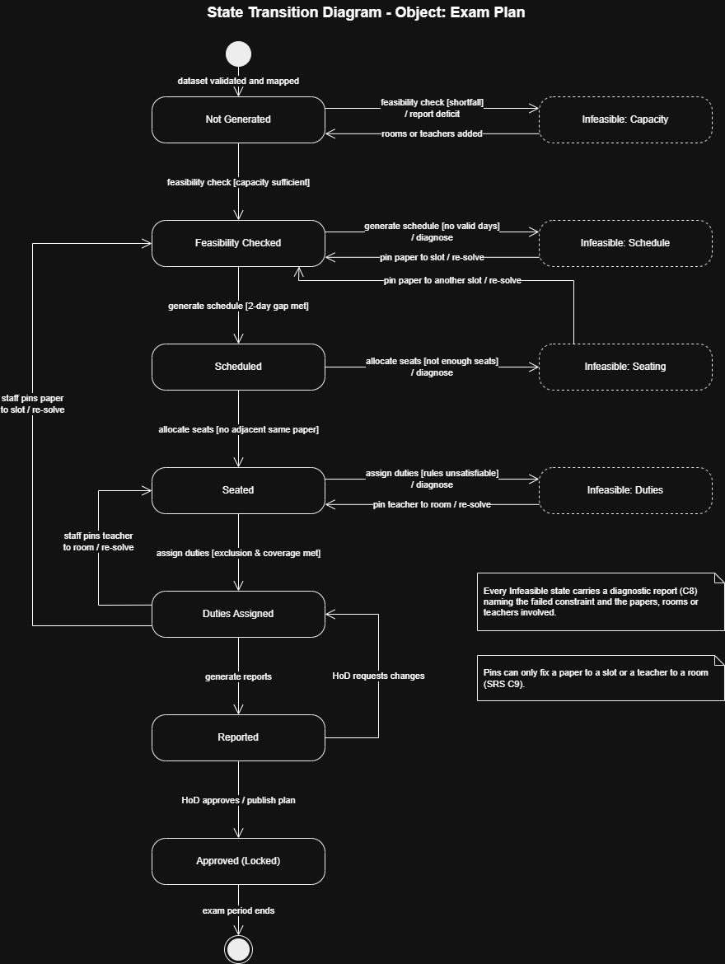
Figure 5: State Transition Diagram for the Exam Plan
The main path runs down the centre, from Not Generated to Approved (Locked). The four Infeasible states on the right are reached when a stage fails, and each one produces a diagnostic report. From an Infeasible state, staff can pin an assignment and re-solve to return to the main path. Staff can also make changes to a complete plan, and the HoD can send a reported plan back for changes before approving it.
Note: Claude (Anthropic) was used to help draft and refine these diagrams and explanations, as disclosed in our Phase 0 Project Plan and SRS.

