System Architecture Design
Authority-Level Disaster Response Coordination System (NDRCS)
This document presents the system architecture of the finished NDRCS prototype. It explains how the citizen interface, control room dashboard, rescue team interface, public monitoring view, backend services, database, and external services work together.
Implementation note: live updates in the current prototype are handled using periodic polling (approximately every 5 seconds) rather than WebSocket-based real-time streaming.
1. Architecture Diagram
The figure below shows the high-level architecture of the deployed academic prototype. It separates the presentation layer, application layer, data layer, and external service dependencies.
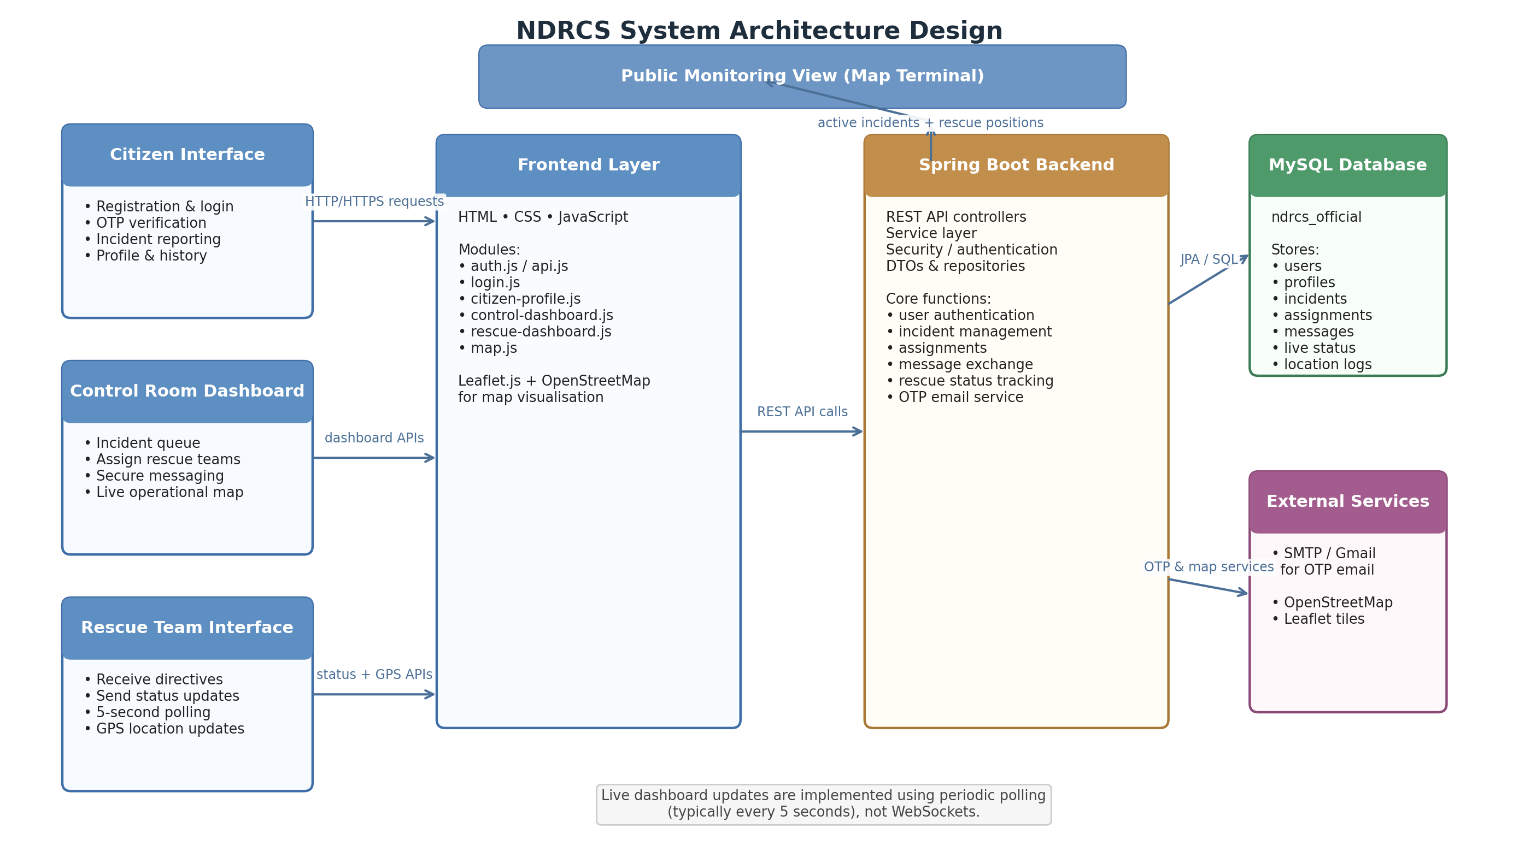
Figure 1. NDRCS system architecture
2. Architectural Explanation
Presentation Layer: The presentation layer consists of four user-facing views: the citizen interface, the control room dashboard, the rescue team dashboard, and the public monitoring map terminal. These interfaces are developed using HTML, CSS, and JavaScript. Leaflet.js with OpenStreetMap is used for map rendering and operational visualisation.
Citizen Interface: Citizens can register, verify their email using OTP, log in, report an incident, and view their profile and previous reports. Citizen users provide incident location details manually during reporting; the current prototype does not continuously track the live location of citizens.
Control Room Dashboard: The control room dashboard acts as the central monitoring and coordination interface. Control room personnel can review incident queues, inspect map markers, assign rescue teams, exchange secure operational messages, and observe rescue team movement through periodically refreshed location data.
Rescue Team Interface: The rescue team interface is used by field units. It supports receiving directives, sending status messages such as message received, dispatched, backup required, and completed, and pushing location updates from the rescue unit. In the implemented prototype, the interface refreshes operational data through polling rather than full duplex live sockets.
Application Layer: The backend is implemented using Java Spring Boot. It exposes REST APIs for authentication, incident creation, incident assignment, status updates, message exchange, OTP verification, and rescue team location handling. The service and repository layers manage business logic and persistence.
Data Layer: The MySQL database stores users, profiles, incidents, citizen reports, email verification records, incident assignments, secure messages, message actions, rescue team live status, and rescue team location logs. This supports both current operational state and historical tracking.
External Services: The project integrates with SMTP email service for OTP delivery and uses Leaflet/OpenStreetMap for map tiles and spatial visualisation. These external services support email verification and map-based situational awareness but are outside the core backend logic.
3. Data and Control Flow Summary
Flow | Source / Trigger | System Response
Citizen reporting flow | Citizen submits disaster report | Backend stores incident and report records; control room sees it on dashboard
Assignment flow | Control room assigns a rescue team | Assignment is stored; rescue team dashboard fetches assigned incident and instructions
Messaging flow | Control room or rescue team sends message | Message is stored in database and shown in the receiver inbox
Tracking flow | Rescue team updates GPS/status | Live status table is updated and location logs are recorded
Monitoring flow | Dashboards poll backend every few seconds | Updated incidents, statuses, and map markers are reloaded
4. Design Characteristics of the Implemented Prototype
- Role-based modular architecture separating citizen, control room, rescue, and monitoring views.
- Spring Boot layered backend using controllers, services, DTOs, repositories, and entity classes.
- Database-backed coordination and periodic polling for operational synchronisation.
- Public monitoring view is read-oriented and does not expose administrative controls.
- Architecture supports future enhancement toward WebSockets, mobile apps, and route optimisation.
5. Current Technical Limitations
- Real-time communication is simulated through repeated polling intervals and not through WebSockets.
- System accuracy depends on internet connectivity, browser geolocation permission, and external map tile availability.
- Citizen-side live tracking is not implemented; incident coordinates are provided through report submission rather than continuous movement monitoring.
- The current prototype is suitable for academic demonstration and controlled testing, not full production-scale disaster infrastructure.

