Data Flow Diagram (DFD) Design
Authority-Level Disaster Response Coordination System (NDRCS)
This document presents the Data Flow Diagram (DFD) design for the finished NDRCS prototype. The DFD explains how information moves between external users, system processes, and internal data stores. The diagrams reflect the actual implemented workflow of the project, including citizen reporting, control room monitoring, rescue team tracking, periodic polling-based updates, and public map monitoring.
Design Note | This prototype uses REST APIs and periodic polling (about every 5 seconds in live dashboard views) rather than WebSocket-based real-time streaming.

1. DFD Level 0 (Context Diagram)
The Level 0 DFD shows the NDRCS platform as a single central process. It identifies the main external entities—Citizen, Control Room Administrator, Rescue Team Member, and Public Monitoring User—and highlights the major high-level data exchanges between them and the system.
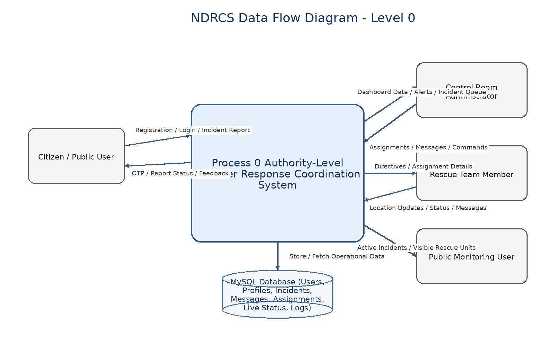
Figure 1. DFD Level 0 - Overall system context of NDRCS
Citizen / Public User: submits registration details, login credentials, OTP verification data, and disaster reports with location information.
Control Room Administrator: receives dashboard information and sends assignment decisions, instructions, and operational commands.
Rescue Team Member: receives directives from the control room and sends location updates, acknowledgements, and mission status messages.
Public Monitoring User: views filtered active incident and visible rescue team information through the public map terminal.
2. DFD Level 1 (Detailed Process Decomposition)
The Level 1 DFD expands the central NDRCS process into smaller functional processes that match the completed project modules. It also identifies the major data stores used by the system, namely user data, incident data, assignments, messages, and tracking logs.
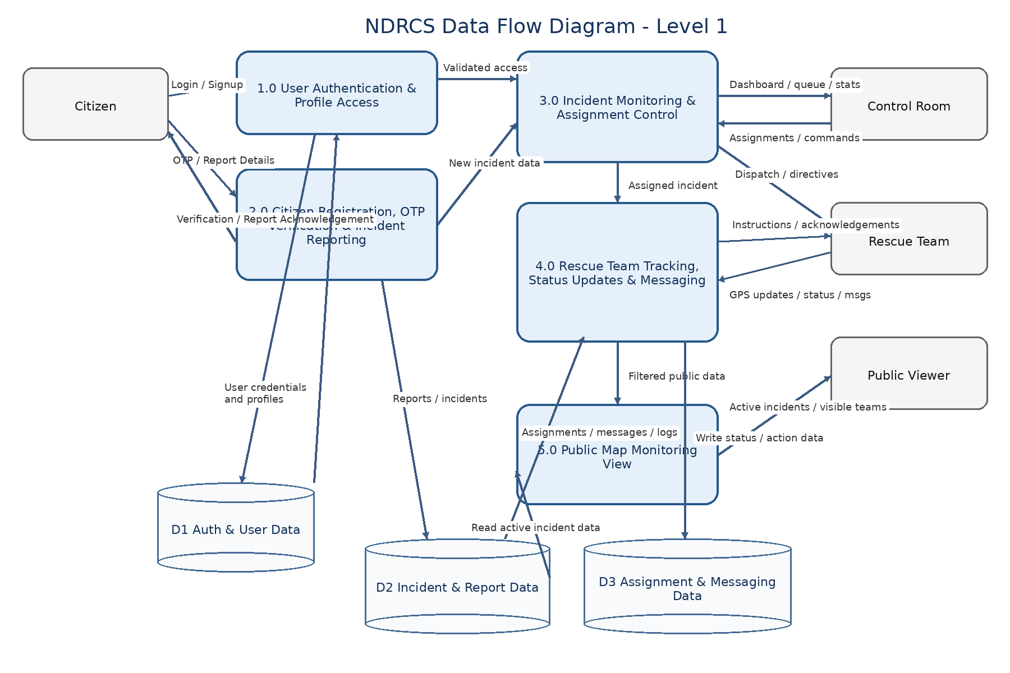
Figure 2. DFD Level 1 - Detailed internal data flow of NDRCS
3. Process Explanation
Process | Purpose | Main Inputs / Outputs
1.0 User Authentication & Profile Access | Validates users and gives role-based access to dashboards and profile data. | Inputs: login details. Outputs: authenticated session, profile access.
2.0 Citizen Registration, OTP Verification & Incident Reporting | Registers citizens, verifies email using OTP, and records disaster reports. | Inputs: registration form, OTP, incident details. Outputs: verified user record, incident report, acknowledgement.
3.0 Incident Monitoring & Assignment Control | Displays incidents to authorities and allows control room staff to assign rescue teams. | Inputs: new incidents, admin actions. Outputs: incident queue, assignment records, dispatch commands.
4.0 Rescue Team Tracking, Status Updates & Messaging | Handles rescue team location updates, mission status, and message exchange with control room. | Inputs: GPS/status updates, team messages, admin directives. Outputs: live status, logs, acknowledgements.
5.0 Public Map Monitoring View | Publishes a filtered map view showing active incidents and visible rescue team information. | Inputs: active incident and live team data. Outputs: public monitoring map.

4. Data Stores Used in the DFD
D1 Auth & User Data: Stores authentication information and linked user profiles such as citizens, control room staff, and rescue teams.
D2 Incident & Report Data: Stores disaster incidents and citizen-submitted report records.
D3 Assignment & Messaging Data: Stores incident assignments, live rescue status, location logs, messages, and message actions.
5. Interpretation of the Finished Project
The DFD confirms that the NDRCS prototype is centered around authority-level coordination. Citizens act as reporting users, while control room administrators and rescue teams interact with operational dashboards.
Incident information originates mainly from citizen report submissions. After validation and storage, the same incident data becomes visible in the control room dashboard, where rescue teams can be assigned for response operations.
The rescue team interface continuously sends periodic updates through polling-based API interaction rather than true socket-based streaming. These updates are stored in live status and location log records, then reflected back on the control room and public monitoring views.
Messaging is treated as a separate operational stream linked to incidents when required. This supports acknowledgement, instruction transmission, and basic communication history between control room users and rescue personnel.
The public map terminal uses filtered operational data. It is intended for monitoring visibility of active incidents and allowed rescue team presence, rather than exposing full internal control room functionality.
6. Current Implementation Limitations
• The prototype uses periodic polling instead of WebSocket-based continuous real-time communication.
• Citizen live GPS tracking is not implemented; citizen-side reporting relies on user-provided location details.
• The system depends on internet connectivity and map service availability for dashboard updates and visualization.
• The DFD reflects a prototype-level operational design and not a fully integrated government-grade disaster response network.

