NDRCS Simplified ER Diagram and Explanation
National Disaster Response Coordination System
Academic project documentation

1. Overview
This document presents the database-oriented entity relationship view of the NDRCS project. The diagram summarizes the main entities used in the implemented system, their key attributes, and the logical relationships that support authentication, disaster reporting, assignment, live rescue tracking, and messaging.

2. ER / Schema Diagram
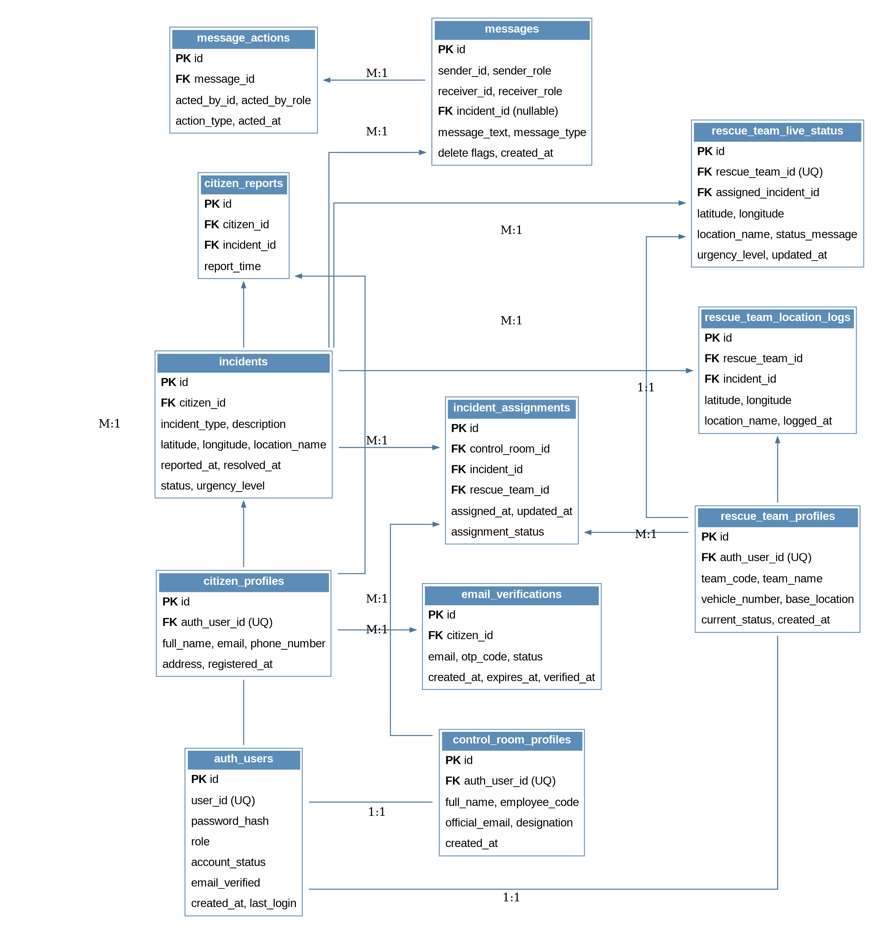
Figure 1. Simplified ER / relational schema view of the NDRCS database.

3. Diagram Explanation

3.1 Core user structure
- The table auth_users acts as the central authentication entity. It stores login identity, role, password hash, account status, email verification flag, and audit timestamps.
- The profile tables citizen_profiles, control_room_profiles, and rescue_team_profiles extend auth_users for the three main user classes of the system.
- This structure separates login credentials from role-specific profile information, which makes the design cleaner and easier to maintain.

3.2 Citizen-side reporting flow
- citizen_profiles is linked to incidents and citizen_reports, showing that registered citizens can create disaster reports and those reports are converted into tracked incidents.
- incidents stores the disaster type, description, coordinates, location name, timestamps, current status, and urgency level.
- citizen_reports provides a reporting history link between the citizen and the generated incident record.

3.3 Control room coordination
- control_room_profiles represents authorized administrative users who supervise operations from the control room dashboard.
- incident_assignments connects incidents, control room profiles, and rescue teams. This table records when a rescue team is assigned to a specific disaster event and how the assignment status changes during operation.
- This design supports the practical coordination workflow implemented in the project: monitor incident, assign team, update status, and mark completion.

3.4 Rescue tracking and field response
- rescue_team_profiles stores identity and operational information for each rescue team, such as team code, vehicle number, base location, and current status.
- rescue_team_live_status stores the most recent tracked position and assigned incident reference for a rescue team. This table supports the live operational view shown on the control room and rescue dashboards.
- rescue_team_location_logs stores historical location points, which provides a basic movement log and accountability trail.
- The implemented prototype updates live location data through periodic polling and refresh logic rather than WebSocket-based continuous streaming.

3.5 Messaging and acknowledgement flow
- messages stores operational communication exchanged between control room staff and rescue teams.
- message_actions stores follow-up actions such as acknowledgement or clearance, making the communication trail easier to review.
- This separation between messages and message_actions helps preserve the original message while recording what happened after the message was received.

3.6 Email verification support
- email_verifications stores OTP-based verification information for citizen registration.
- This table supports the project feature in which citizens verify their email before fully using the reporting system.

4. Key Design Interpretation
- The schema reflects a role-based disaster coordination system with clear separation between authentication, profiles, incident handling, communication, and live tracking.
- The database design is modular and suitable for academic demonstration of multi-user emergency coordination workflows.
- The design supports the completed prototype features: citizen registration and reporting, control room monitoring, rescue team assignment, periodic live tracking, status updates, and public map monitoring.

5. Current Project Notes
- The prototype uses periodic polling and refresh cycles for updates instead of WebSocket communication.
- Citizen location is not continuously tracked in the current implementation; citizens provide incident location details manually during reporting.
- The design is intended for prototype and academic demonstration use, not direct deployment for official disaster operations without further hardening, scaling, and field validation.

