NDRCS Database Schema Diagram
National Disaster Response Coordination System
Schema summary based on the final implemented MySQL database
This document presents the final database schema of the Authority-Level Disaster Response Coordination System (NDRCS).
The diagram is derived from the completed project database and shows the implemented tables, primary keys, foreign keys, and major operational relationships used by the application.
What the diagram shows
Identity model | A shared authentication table supports three user classes: citizen, control room, and rescue team.
Operational hub | The incidents table connects reporting, assignment, communication, and tracking workflows.
Tracking approach | The system stores current rescue visibility in live-status form and also maintains historical location logs.
The next page contains the full schema diagram.

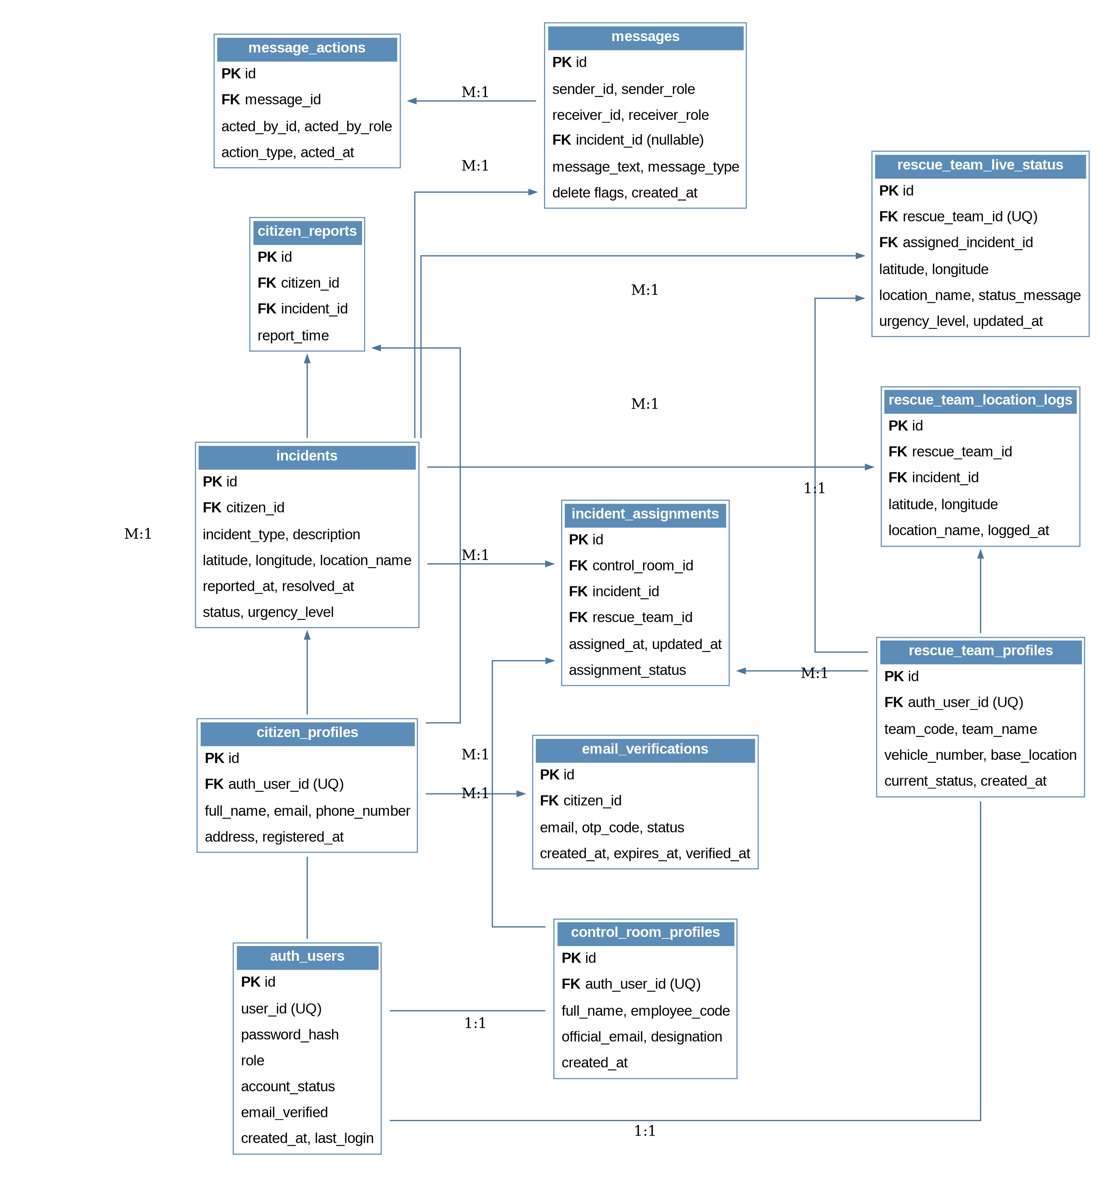
Diagram Explanation
Authentication foundation  The auth_users table stores login identity and account state. citizen_profiles, control_room_profiles, and rescue_team_profiles extend it through one-to-one profile mappings.  Citizen-side reporting flow  citizen_profiles captures public user details. A citizen may submit multiple incidents, and citizen_reports keeps the report linkage between the user and the created incident.  Incident hub  incidents acts as the operational center of the schema and stores disaster type, description, coordinates, timestamps, status, and urgency level. | Authority coordination  incident_assignments connects control room personnel, incidents, and rescue teams, making dispatch activity traceable in the database.  Communication tracking  messages stores operational communication, while message_actions logs acknowledgement, clear, and similar actions performed on each message.  Live tracking design  rescue_team_live_status stores the latest visible team position, whereas rescue_team_location_logs preserves periodic historical location updates for audit and review.

Key Observations
- One base authentication structure supports all three major application roles.
- The incidents table acts as the central hub and connects reporting, assignments, communication, and live rescue tracking.
- The schema supports both current-state visibility and historical logging through rescue_team_live_status and rescue_team_location_logs.
- The finished prototype uses database-backed state updates with periodic polling rather than WebSocket-based live streaming.

