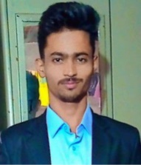**NAME :** BHOKARE KRUSHNA BHARAT

**E-MAIL :** [kbhokare448@gmail.com](mailto:kbhokare448@gmail.com)

**MOBILE NO :** 9156842659

**PORTFOLIO :**

**OBJECTIVES:**

Leading my technical skills to the development and willing to work with new technologies.

**EDUCATION:**

**Rajarshi shau mahavidyalaya latur**

BSC Computer Science currently in 2nd year (CGPA: 8.43)

Graduate in the year (2024)

**EXPERIENCE:**

**Infobite technology:** Web development and designing (01-12-2022) to (03-01-2023)

**College Ranker:** Frontend development (05-07-2022) to (06-07-2022)

**PROJECTS:**

**_______________________________________________________________________________________________**

**SKILLS: (**C, C++, JAVA) (HTML, CSS, JAVASCRIPT, PHP, MYSQL)

**HANDS ON:** JAVA PROGRAMMING

_______________________________________________________________________________________________

**PERSONAL DETAILS:**

NAME : BHOKARE KRUSHNA BHARAT

MARRIED : NO

NATION : INDIAN

LANGUAGE: ENGLISH, HINDI, MARATHI.