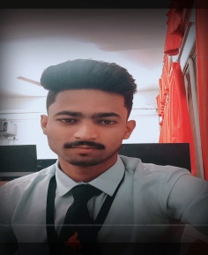**NAME :** BHOKARE KRUSHNA BHARAT

**E-MAIL :** [**kbhokare448@gmail.com**](mailto:kbhokare448@gmail.com)

**MOBILE NO :** 9156842659

**PORTFOLIO :** [**https://krish152.github.io/krish.github.io-/**](https://krish152.github.io/krish.github.io-/)

**OBJECTIVES:**

Leading my technical skills to the development and passionate to work with new technologies where i can work and learn new things .Willing to work as a good team player.

**EDUCATION:**

**Rajarshi shau mahavidyalaya Latur.**

BSC Computer Science currently in 3nd year (CGPA: 8.30)

Graduate in the year (2024)

**EXPERIENCE:**

**Infobite Technology :** Web Development and Designing (01-12-2022) to (03-01-2023)

**College Ranker :** Web Development (04-07-2022) to (05-08-2022)

**_______________________________________________________________________________________**

**PROJECTS:**

**Tourism project (Tourist) :** [**https://krish152.github.io/tour.github.io/**](https://krish152.github.io/tour.github.io/)

**Temperature Converter :** [**https://krish152.github.io/TempConverter.github.io/**](https://krish152.github.io/TempConverter.github.io/)

**_______________________________________________________________________________________**

**SKILLS:** (HTML, CSS, JAVASCRIPT,PHP, MYSQL) (C, C++, C#) (JAVA) (MS-OFFICE)

**PERSONAL DETAILS :**

**NAME :** BHOKARE KRUSHNA BHARAT

**DOB :** 15-11-2001

**MARRIED :** UNMARRIED

**LANGUAGES :** ENGLISH HINDI MARATHI

**_______________________________________________________________________________________**