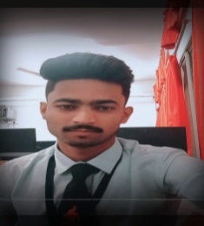**NAME :** BHOKARE KRUSHNA BHARAT

**EMAIL ID :** [**kbhokare448@gmail.com**](mailto:kbhokare448@gmail.com)

**MOBILE NO :** 9156842659

**PORTFOLIO :** [**https://krish152.github.io/krish.github.io-/**](https://krish152.github.io/krish.github.io-/)

**__________________________________________________________________________________**

**CAREER OBJECTIVES :**

Obtain a responsible position in an organization with the best capabilities, skills and knowledge.

___________________________________________________________________________

**WORK EXPERIENCE :**

* Web Developer at BasektHunt Pvt Ltd (June-2023 to August-2023)
* Web Development and Designing From InfoByte Technologies (Dec-2022)
* Web Development Form College Ranker (July-2022)

___________________________________________________________________________

**ACADEMIC QUALIFICATIONS :**

* **BSc Computer Science from Rajarshi Shau Mahavidyalay, Latur**

**Currently in final year (CGPA : 8.22) Graduate in (2024)**

* HSC 12th from Mahatma Basweshwar College, Latur (64.48%)
* SSC 10th from Shri Shivaji High School, Latur (89.00%)

________________________________________________________________

**TECHNICAL SKILLS :**

* **Programming languages :** C++ AND JAVA
* **Web technologies** : HTML, CSS, JAVASCRIPT, PHP
* **Database :** Oracle, MySQL, SQL (Language)
* **Tools :** Visual Studio, phpMyAdmin, Eclipse IDE

________________________________________________________________