1. We have 6 questions in a div and when a user answers question, a progress bar adjusts according to the percentage of the amount of inputs that were filled in and there will be 2 or 3 screens, no submit buttons are there, next screen will slide on fill or select last input.
2. Progress bar should be dynamic, if we will add new input box then progress bar should be adjusts according to number of input fields.
3. 2 text input and progress bar will increase after enter 3 or more character.
4. 2 select boxes and progress bar will increase on select.
5. 2 radio buttons and progress bar will increase on select radio buttons.

Dropdown/Select box design should be custom as shown in fig.

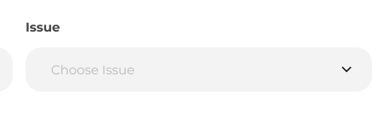

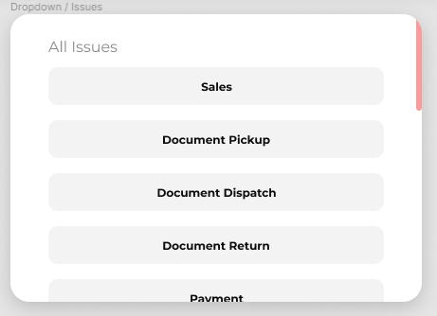

Progress bar design-

