Question 1:

Find out the mail servers of the following domain

* Ibm.com

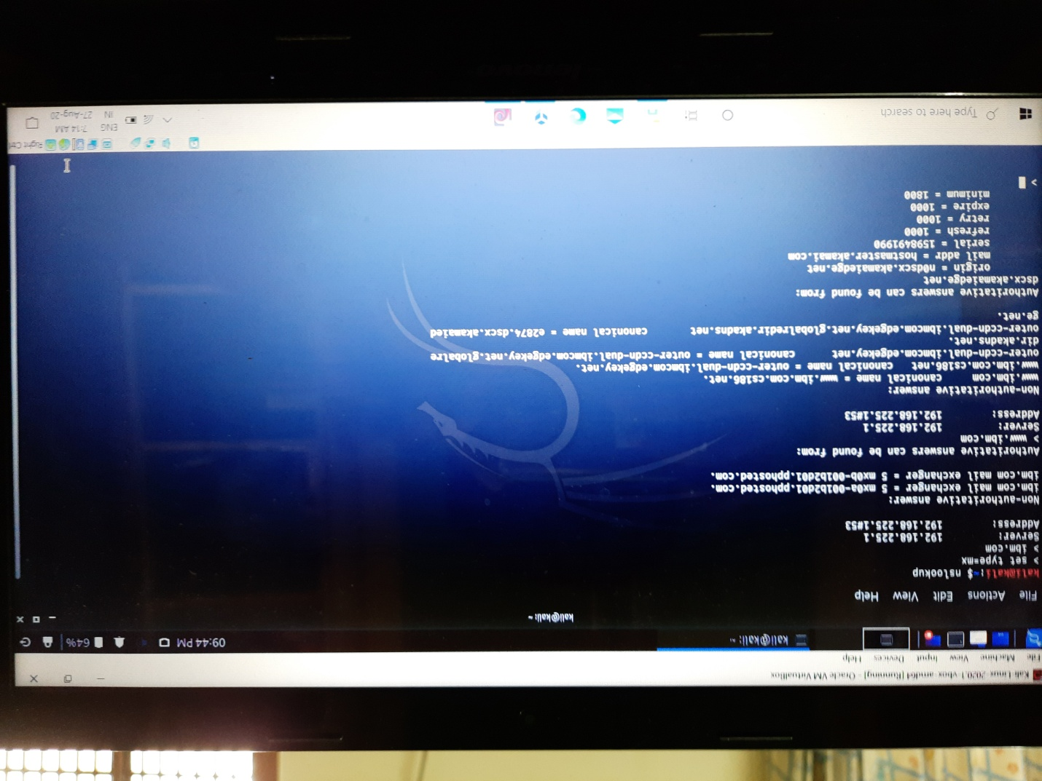

* Wipro.com

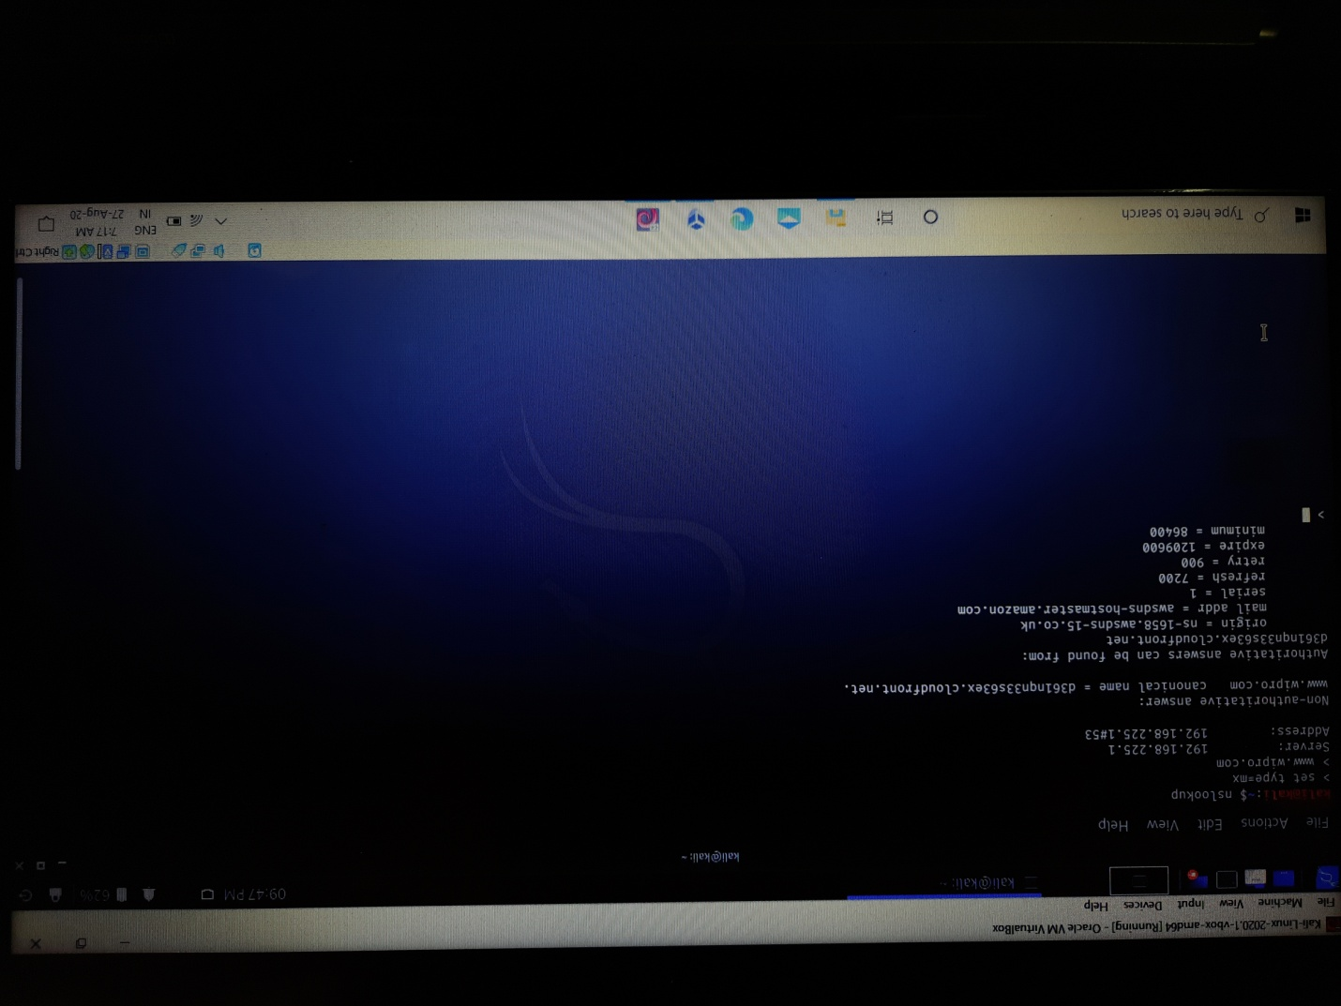

Question 2:

Find the locations, where these email servers are hosted

* [mail@ibm.com](mailto:mail@ibm.com)

Country :United States

City:Sunnyvale

* [mail@wipro.com](mailto:mail@wipro.com)

Country:Singapore

City:Singapore

Question 3:

Scan and find out port numbers open 203.163.246.23

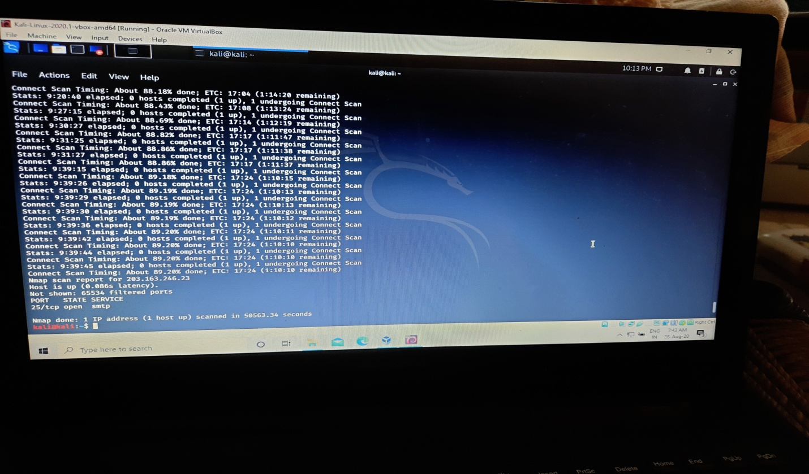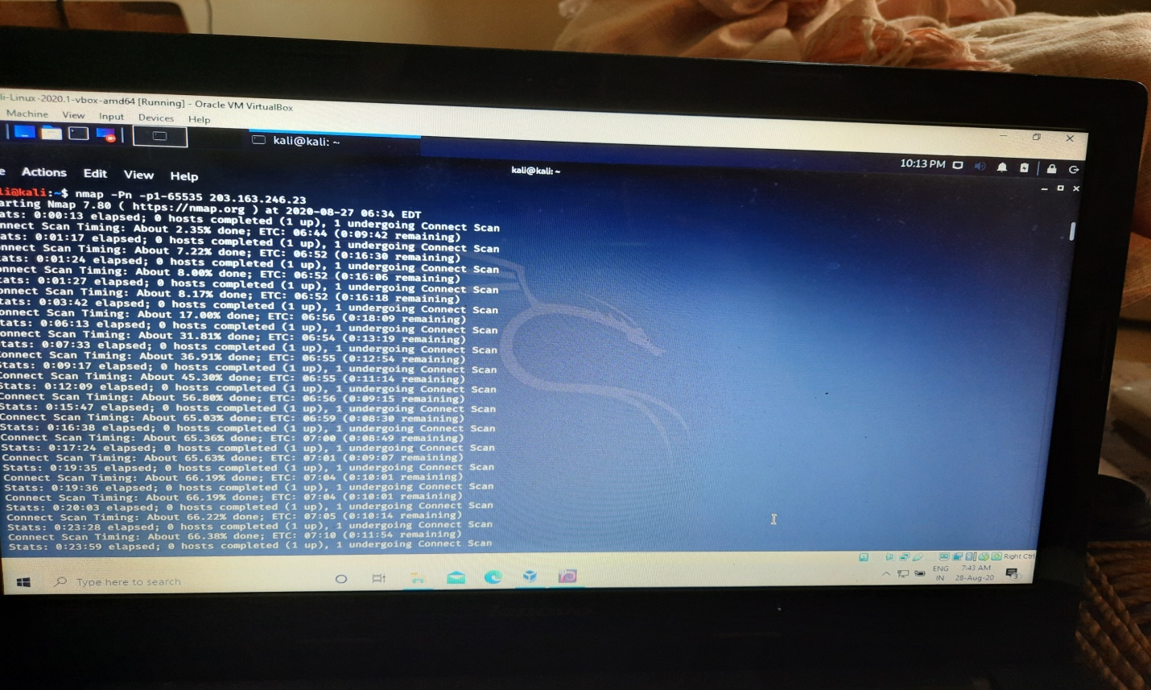

Question 4:

Install nessus in a VM and scan your laptop/desktop for cve

Was not able to download it sir.