BUILDING AGENTIC AI APPLICATION CHALLENGE · NOVEMBER 2026

Agentic AI Technical Brief
What the CatchUp AI agent decides, what it can touch, and how we know

The short version
The model decides what to look at. Code decides anything that has to be correct. The student decides anything that changes their week.

What the model decides
- Which of seven tools to call, in what order, with what arguments (up to 8 turns, 90 seconds).
- What to search for in the student's notes, and which retrieved pages to cite.
- Which study items to propose in a draft plan, and which route to suggest.
- When to ask a clarifying question instead of answering.

The seven tools
Tool | What it gives the agent | Can it change data?
get_study_preferences | Time zone, free minutes per weekday, start time | No
list_assignments | Deadlines, estimates, status (titles flagged if they contain instructions) | No
search_course_material | Page-cited passages from the student's own PDFs, or NO_EVIDENCE | No
get_learning_progress | Blocks completed and remaining in the active plan | No
get_student_memory | Notes the student confirmed for the copilot | No
suggest_memory | Proposes one note; unused until the student keeps it | Suggestion only
draft_recovery_plan | Asks the deterministic planner for a route plus up to 6 cited study items | Creates a PENDING draft only

How retrieval stays grounded
- Search runs only over that student's course, under database row-level security.
- Abstains (NO_EVIDENCE) when nothing passes the evidence threshold.
- Passages that try to instruct the AI are flagged and can't back a fact or a study item.
- Each fact is checked against its cited page before display; unsupported facts are removed.

How the plan is calculated
The agent never computes time. draft_recovery_plan hands the work to a deterministic planner that schedules into real free time and reports any shortfall in minutes. The result is stored as a PENDING draft that expires after six hours.

How the student approves
The approval screen lists every block to be added, kept or cancelled. Approval is a locked, idempotent database transaction bound to that exact draft: stale, expired or infeasible drafts are refused, and ten parallel approvals produce exactly one plan.

Errors and unsafe operations
Situation | What happens | Evidence
Invalid tool arguments | Rejected by the schema; the tool never runs | eval B1
Malformed model output | Run marked failed; any draft expired | eval B2
Second draft in one run | Denied | eval B3
Malicious document | Passage flagged; injected 'facts' removed; no draft | eval B4, unit tests
Another student's course id | Tool denied; nothing leaked | eval X2
Model provider failure | Clear error; nothing saved | scenario S4 (runs with the live key)
Cost spike or abuse | Kill switch, daily token budget, one run at a time, per-student quotas | integration tests

Evidence
Evidence | Result (4 Nov 2026) | Source
Automated tests | 103 unit · 99 integration · 65 end-to-end (production build), all passing; CI on every push | BUILD_STATUS.md, GitHub Actions
Agent evaluation (38 cases) | 30 passed · 0 failed · 8 skipped: the skipped cases need the live model and are not counted as passes | evals/REPORT.md
RAG evaluation (18 questions) | Recall@3 90.9% · Precision@3 0.75 · MRR 0.909 · correct abstention 4/4 · 0 cross-user passages · deleted documents return nothing | RAG_QUALITY_REPORT.md
Claim-to-citation check | Precision 0.938, recall 1.0 on 24 labelled claims (one known miss: an antonym) | evals/rag/claims.json
Security | No open Critical or High findings; one real prompt-injection weakness found by the eval and fixed | SECURITY_AUDIT.md, AI_SECURITY_RED_TEAM_REPORT.md
Live performance | Dashboard full load 0.63 s (was 5.0 s); server responses 0.3–0.6 s per page | BUILD_STATUS.md
Live model run | Not yet run: the Gemini key is being connected; results will be added from the live evaluation | LIVE_AGENT_EVALUATION_REPORT.md
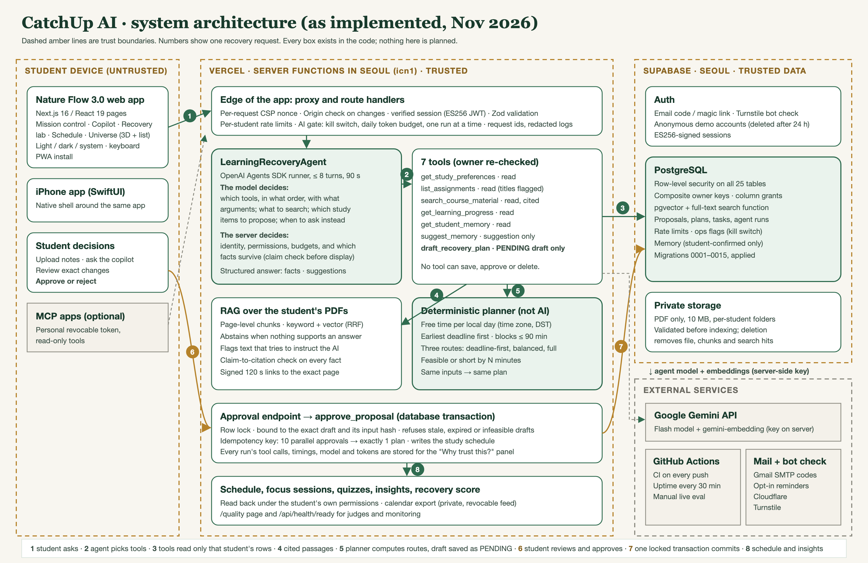
Architecture with trust boundaries.

What is not proven yet
Tool-selection accuracy and answer quality with the live model. The 8 tool-selection cases and the four demo scenarios record real traces (tools, timings, tokens, estimated cost) as soon as the key is connected. Until then they are reported as skipped, never as passed.

