BUILDING AGENTIC AI APPLICATION CHALLENGE · NOVEMBER 2026

Final Project Report
CatchUp AI · Nature Flow 3.0 · an agentic study-recovery copilot · Krishna Mathur

1. Executive summary
CatchUp AI helps a student who has fallen behind get back on track. It reads the student's own lecture notes, deadlines and free time. An AI agent decides which tools to use, explains what was missed with page citations, and drafts a recovery plan. A deterministic planner checks whether the plan really fits before each deadline, and nothing is saved until the student approves it.
The app is live at https://catchupai-chi.vercel.app with a one-click demo on synthetic data, and the code is public at https://github.com/krish2105/CatchupAI-Agentic-AI. 274 automated tests pass and run on every change, and the agent has been evaluated with a live Gemini model: it plans multi-step tool use, cites the pages it used, resists a malicious document and fails safely.

2. Project description
The product covers the whole recovery journey: catch up on a missed lecture, ask questions grounded in the notes, compare three realistic recovery routes, approve one, follow the schedule with focus sessions and quizzes, and watch a recovery score and a growing 'forest' show progress. A public quality page shows tests, evaluation results, CI status and live health.

3. Problem statement
Missing one lecture rarely stays small. A student is ill for two days or a work shift runs late, and suddenly there's a topic they never understood, an assignment due on Friday, and no clear idea how much time they really have. Generic chatbots answer confidently but without any link to what the lecturer taught, and planners schedule work without checking whether it fits.

4. Proposed solution
- Learn what you missed: a catch-up pack with a summary, key terms and check questions, each linked to its page.
- Ask about it: an agent answers from the student's pages and cites them, or says it can't verify the answer.
- See whether it fits: a planning engine compares deadlines with real free time and offers three routes, with any shortfall in minutes.
- Stay in control: the agent only drafts; the student sees the exact changes and approves once.
- Keep going: schedule, focus sessions, quizzes, a recovery score and optional reminders.

5. Target audience
University and college students who have fallen behind, especially those balancing work or family. Secondary users are instructors and learning-support staff who want students to recover from their own course material.

6. Key differentiators
Typical AI study tool | CatchUp AI
Chatbot guesses a timetable | A deterministic planner computes availability per local day and reports any shortfall in minutes
Answers from general knowledge | Answers cite the student's own pages, or say they can't be verified
AI changes your data | The agent only drafts; approval is a separate locked transaction
'The AI did things' | Every tool call is recorded and shown, with model, time and tokens

7. Agentic AI architecture
One agent, LearningRecoveryAgent, built with the OpenAI Agents SDK and running Google Gemini (OpenAI models are also supported). For each request the model chooses which of seven tools to call, in what order and with what arguments, for up to eight turns. The server controls identity, permissions and budgets, and removes any cited fact that its page does not support.
Tool | What it gives the agent | Can it change data?
get_study_preferences | Time zone, free minutes per weekday, start time | No
list_assignments | Deadlines, estimates, status (titles flagged if they contain instructions) | No
search_course_material | Page-cited passages from the student's own PDFs, or NO_EVIDENCE | No
get_learning_progress | Blocks completed and remaining in the active plan | No
get_student_memory | Notes the student confirmed for the copilot | No
suggest_memory | Proposes one note; unused until the student keeps it | Suggestion only
draft_recovery_plan | Asks the deterministic planner for a route plus up to 6 cited study items | Creates a PENDING draft only
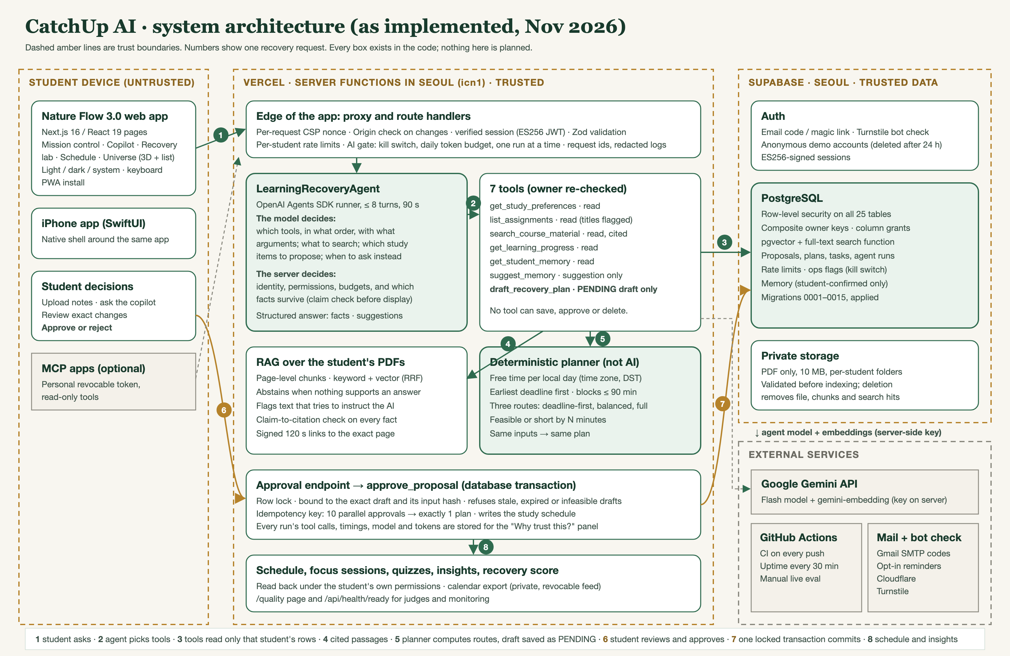
Figure 1. System architecture as implemented, with trust boundaries and one recovery request (1–8).

8. Backend architecture
- Next.js 16 route handlers on Vercel, running in Seoul next to the database (pages load in 0.3–0.6 s).
- Supabase: PostgreSQL with row-level security on all 25 tables, private PDF storage, pgvector and full-text search, email sign-in with a bot check.
- Per-request content security policy, Origin checks, input validation, per-student rate limits, an AI kill switch and a daily token budget.
- Structured, redacted logs with request ids; a readiness endpoint; an uptime check every 30 minutes.

9. RAG and citation grounding
Documents are split by page. Search combines keyword ranking with vector similarity, scoped to the student and course, and abstains when nothing passes the evidence threshold. Text that tries to instruct the AI is flagged and can't support an answer. Before an answer is shown, each fact is checked against its cited page: quotes must match, numbers must appear, and most of the claim's words must be present with no negation flipped.

10. Recovery planning algorithm
The planner turns weekly availability into study windows in the student's time zone (daylight-saving safe), then schedules work earliest-deadline-first in blocks of 90 minutes or less. It produces three nested routes (deadline-first, balanced, full recovery) and reports each one as feasible or short by a number of minutes. The same inputs always give the same plan; the model never does this arithmetic.

11. Security and human approval
Approval is a database function that locks the draft, checks it hasn't expired or gone stale (inputs changed), refuses infeasible routes and commits exactly once: ten parallel approvals produce one plan. No AI tool can save, approve or delete. Two-student tests confirm one student can never read or change another's data.

12. Technology stack
Layer | Technology
Interface | Next.js 16, React 19, TypeScript, React Three Fiber (3D universe with a list fallback), installable web app, SwiftUI iPhone shell
Backend | Next.js route handlers on Vercel (Seoul), Zod validation
Data | Supabase PostgreSQL, row-level security, pgvector, private storage
AI | OpenAI Agents SDK; Google Gemini Flash and gemini-embedding (OpenAI also supported)
Quality | Vitest, Playwright, axe accessibility checks, GitHub Actions CI

13. Quality assurance and evaluation
Evidence | Result (4 Nov 2026) | Source
Automated tests | 110 unit · 99 integration · 65 end-to-end (production build), all passing; CI on every push | BUILD_STATUS.md, GitHub Actions
Agent evaluation (38 cases) | With the live model (gemini-3.6-flash): 33 passed · 1 failed (Google timed out) · 4 not yet run (daily free quota) | evals/REPORT.md
RAG evaluation (18 questions) | With live Gemini embeddings: Recall@3 100% · MRR 0.939 · multi-page 3/3 · correct abstention 4/4 · 0 cross-user passages · deleted documents return nothing | RAG_QUALITY_REPORT.md
Claim-to-citation check | Precision 0.938, recall 1.0 on 24 labelled claims (one known miss: an antonym) | evals/rag/claims.json
Security | No open Critical or High findings; one real prompt-injection weakness found by the eval and fixed | SECURITY_AUDIT.md, AI_SECURITY_RED_TEAM_REPORT.md
Live performance | Dashboard full load 0.63 s (was 5.0 s); server responses 0.3–0.6 s per page | BUILD_STATUS.md
Live agent traces | Missed lecture: 5 model-chosen tools → feasible draft left pending in 10.7 s, facts cited to pp. 2–3; malicious document resisted; provider failure handled safely | docs/evidence/agent-traces

14. Application screens
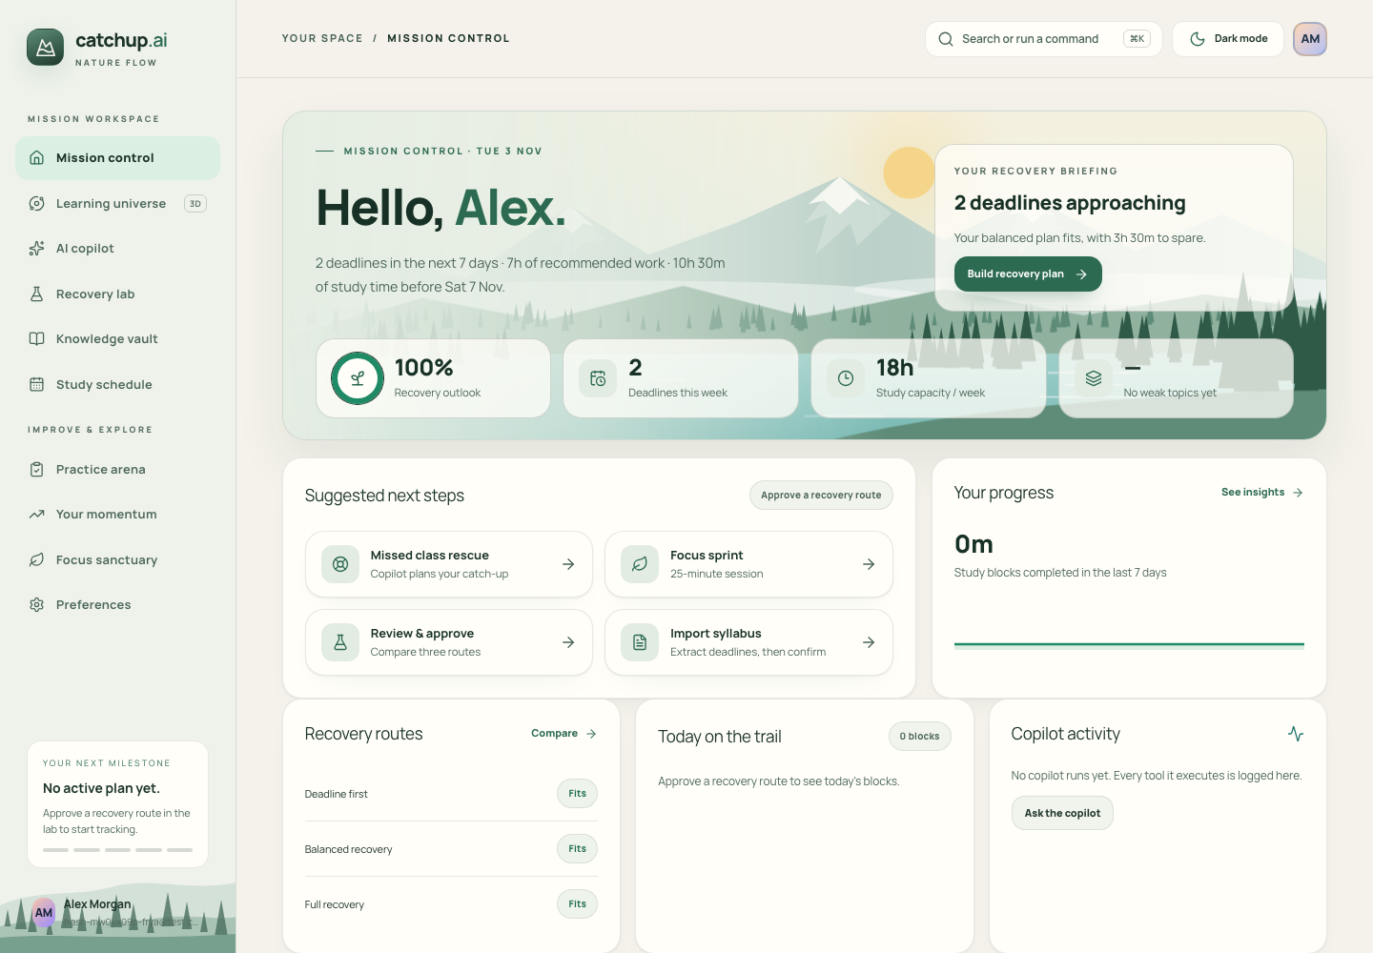
Mission control: the week's deadlines, free time and a briefing built from the student's data.
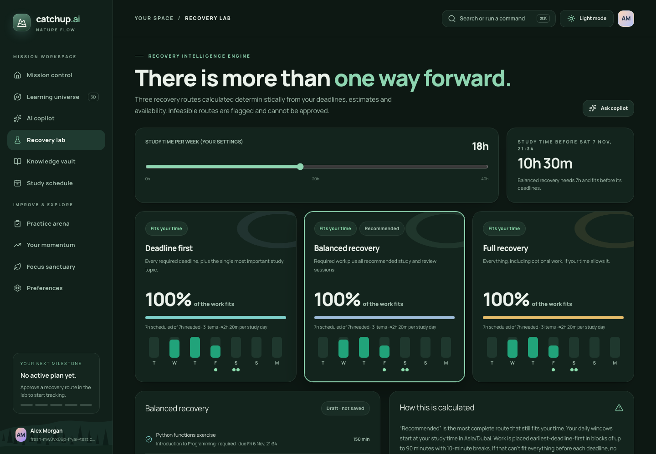
Recovery lab: three routes with day-by-day timelines; routes that don't fit can't be approved.
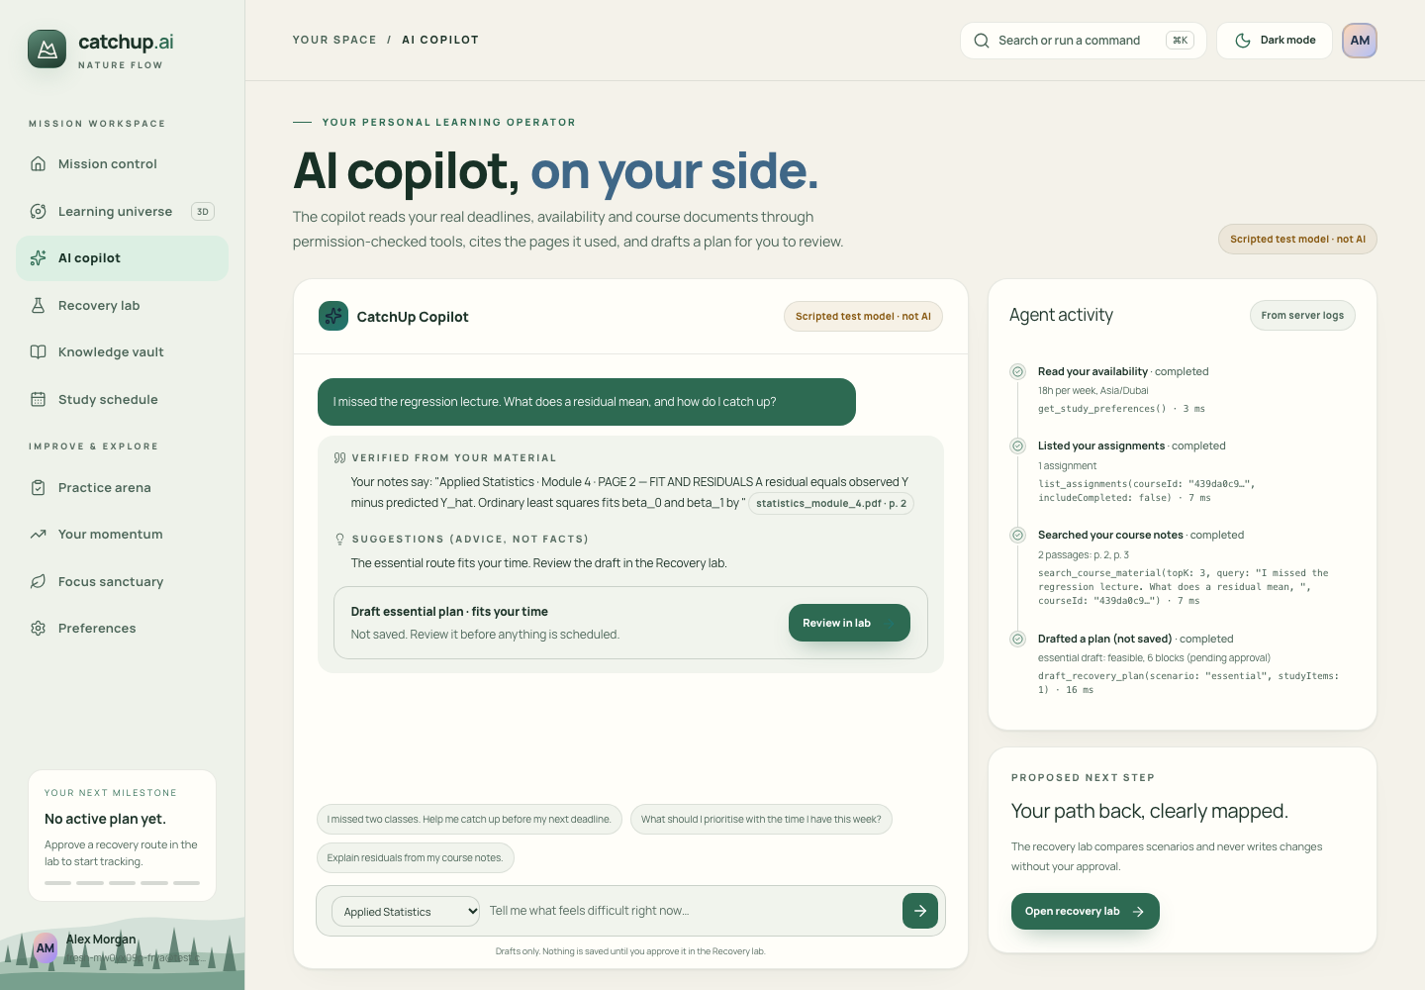
Copilot: the tool timeline and page citations. This screenshot uses the labelled scripted test model; the live model (gemini-3.6-flash) produces the same timeline in production.

15. Real-world applicability
Recovering from a missed lecture is a common, stressful moment that study apps and AI tutors handle separately. CatchUp AI connects them and keeps the student in control, which matters for trust and for academic integrity. The same pattern (grounded answers, deterministic planning, approval before change) fits learning-management systems and student-support teams.

16. Known limitations
- The free Gemini tier allows 20 requests a day per model and answers take 10–90 s when Google is busy; 4 live evaluation cases are still to run.
- The evaluation sets are small and synthetic: good for regression checks, not a benchmark.
- Text-based PDFs only (no OCR), up to 10 MB and 50 pages.
- Usability pilot with student volunteers not yet run.

17. Future SaaS roadmap (planned, not built)
- Free and student plans with per-plan AI quotas; billing only after customer validation.
- LMS integrations (Moodle, Canvas) and an instructor view of where students struggle.
- Push reminders and a home-screen widget in the iPhone app.
Links: live app https://catchupai-chi.vercel.app · quality page https://catchupai-chi.vercel.app/quality · code https://github.com/krish2105/CatchupAI-Agentic-AI

