AI-POWERED AUTOMATED EMAIL AGENT
Automated Response System Using Anthropic Claude AI, FastAPI, and FastMCP
—————————————————————————————————————————————————————————————————
INTERNSHIP PROJECT REPORT
Candidate Name: | Kishan Vadsola
Email Address: | vadsolakishan1310@gmail.com
Project Role: | Software Engineering Intern
Host Organization: | [Internship Company Name]
Project Supervisor: | [Company Supervisor's Name / 'Sir']
Submission Date: | June 22, 2026

1. Executive Summary
In the modern corporate workspace, email is the primary engine of communication. However, sorting through high volumes of customer, internal, and promotional messages daily, drafting contextually accurate replies, and maintaining synchronization leads to severe operational inefficiencies. The objective of this internship project is to build a secure, intelligent, and autonomous workspace ecosystem. The resulting application, 'AI Email Agent', combines Large Language Model intelligence with protocol-driven tool architectures to automatically sync, scan, filter, and draft emails.
The application consists of three integrated subsystems:
1. A robust FastAPI server running concurrent background worker loops that manage Gmail API checks, sync inbox metadata, and cache records in a local database.
2. An Anthropic Claude-powered Auto-Reply Engine that uses contextual prompts to reply dynamically according to chosen tones, or safely skip system notifications.
3. An HTML5 dashboard frontend incorporating live connection states, telemetry charts, background thread diagnostics, and logs.
Additionally, an integration layer using the Model Context Protocol (MCP) exports email operations as tools, making it compatible with agent hosts like Claude Desktop. The project successfully automates repetitive inbox tasks while preventing reply loop issues.
★ Project Scope: The AI Email Agent is fully functional, utilizing a secure local SQLite cache, Google OAuth2 credentials, and Claude-3.5-Sonnet to provide safe email replies.

2. System Architecture & Components
The application is structured into a modular system to ensure isolation of concerns, reliable state updates, and data integrity. The backend handles synchronization protocols and database caches, while the frontend dashboard serves up-to-date visualization panels.
2.1 Technical Stack
- Backend Server: FastAPI (Python): High-performance, async-capable framework used to serve REST APIs and manage application lifespans.
- Server runner: Uvicorn: ASGI web server for running the FastAPI application.
- Data Store: SQLite: Local SQL database used to log sync intervals, configuration settings, inbox records, and auto-reply history.
- Integrations: Google Gmail API (OAuth 2.0): Authenticates using secure consent, downloads inbox messages, and writes replies.
- AI Brain: Anthropic Claude API: Powers the AI engine that drafts personalized, tone-based email replies.
- MCP Protocol: FastMCP: Protocol framework used to create standard MCP endpoints and register tools for Claude Desktop Client.
- Frontend: Vanilla CSS & JavaScript: Styled dashboard featuring glassmorphism elements, stats telemetry, and detailed previews.
2.2 Module Architecture Diagram
The interaction workflow between the client, local server, databases, Google services, and Anthropic APIs is illustrated below:
┌────────────────────────────────────────────────────────┐
│ Frontend Dashboard │
│ (HTML5 / JavaScript / Vanilla CSS) │
└───────────┬─────────────────────────────▲──────────────┘
│ REST Requests │ SSE / Long-poll updates
▼ │
┌─────────────────────────────────────────┴──────────────┐
│ FastAPI Backend Server │
│ - Endpoints: /api/emails, /api/settings, etc. │
│ - Background Async Task (Auto-Reply Engine Loop) │
└─────┬──────────────┬─────────────┬─────────────┬───────┘
│ Read/Write │ OAuth │ API Call │ Tool Calls
▼ ▼ ▼ ▼
┌──────────┐ ┌───────────┐ ┌───────────┐ ┌───────────┐
│ SQLite │ │ Gmail API │ │ Claude AI │ │ MCP │
│ Database │ │ (Google) │ │ (Anthropic│ │ Server │
└──────────┘ └───────────┘ └───────────┘ └───────────┘

3. System Features & Implementation Details
The project was designed and engineered to include multiple advanced features that ensure automated email execution is both user-friendly and highly robust. Below are details of the main features implemented:
3.1 Intelligent Auto-Reply Loop with Label Prevention
Autonomous reply engines are vulnerable to infinite-loop scenarios (where two auto-reply bots continuously reply to one another). To counter this, the AI Email Agent integrates loop prevention safeguards. When the background worker thread processes an unread email, it downloads the details, sends them to Claude, drafts the reply, and sends the response. Crucially, the engine then applies a custom Gmail label ('auto-replied') to the message thread. During subsequent scan checks, the system queries Gmail for messages that match the criteria 'is:unread' but specifically excludes threads tagged with the 'auto-replied' label. This blocks duplicate response executions.
3.2 Smart Email Filtering & Filtering Rules
An AI reply should only be generated for active, personal, or corporate inquiries. Automatically responding to newsletters, commercial flyers, or machine notifications results in spam. The AI Email Agent implements strict skipping guidelines:
- Header Filtering: Skipping system addresses like no-reply@, noreply@, support@, alert@, news@, notifications@.
- AI Content Check: Claude checks the mail subject and body text to identify marketing newsletters, sign-up updates, or receipts.
- Safety Defaults: Replies are disabled if the sender is empty, matches automated system templates, or has a mailing list unsubscribe header.
3.3 Multi-Tone Writing Configurations
Depending on the context of the email address, different tones are required. The auto-reply system supports tone configurations: (1) Professional tone for commercial clients, (2) Friendly tone for colleagues and personal contacts, and (3) Casual tone for everyday operations. Tone settings can be parsed via the environment variables or toggled in database preferences.
3.4 HTML5 Live Dashboard UI
A gorgeous glassmorphism dashboard allows the user to supervise the background tasks. It includes: visual cards for unread count, captured count, and replies sent; a live toggle to turn the background runner ON/OFF; active queue monitoring showing what the worker is doing; two distinct tab views for mail records and generated AI drafts; search bars to filter logs; and detailed modal popups that render draft previews.
3.5 Model Context Protocol (MCP) Server Integration
The project includes an MCP server implementation using FastMCP. This wraps the underlying Gmail services into unified tools: list_unread_emails, get_email_details, reply_to_email, search_emails, and auto_reply_all. When hooked into an MCP host (such as the Claude Desktop app), it allows desktop LLM interfaces to use these tools dynamically, creating a decentralized personal agent ecosystem.

4. Database Schema & Storage Design
To minimize memory footprint while maintaining persistent data logs across server reboots, a local SQLite database structure was designed. It contains three main tables: settings, email_logs, and inbox_emails.
4.1 SQLite Database Schema Details
Table Name | Column Name | Data Type | Constraints | Description
settings | key | TEXT | PRIMARY KEY | Unique configuration keyword (e.g. is_auto_reply_on)
settings | value | TEXT |  | Assigned configuration setting value
email_logs | id | INTEGER | PRIMARY KEY AUTOINCREMENT | Unique internal transaction ID
email_logs | message_id | TEXT | UNIQUE | Gmail API unique string identifier
email_logs | sender | TEXT |  | Email address of the sender replied to
email_logs | subject | TEXT |  | Subject line of the email thread
email_logs | reply_body | TEXT |  | The AI draft body sent as response
email_logs | timestamp | TEXT |  | ISO 8601 string representing transaction time
inbox_emails | id | INTEGER | PRIMARY KEY AUTOINCREMENT | Unique sync counter ID
inbox_emails | message_id | TEXT | UNIQUE | Gmail API message ID used to prevent duplicate entry
inbox_emails | sender | TEXT |  | Sender email address
inbox_emails | sender_name | TEXT |  | Human readable name of the sender
inbox_emails | subject | TEXT |  | Subject line of the inbox message
inbox_emails | snippet | TEXT |  | Truncated snippet text preview
inbox_emails | date | TEXT |  | Origin date header of the email
inbox_emails | captured_at | TEXT |  | Local database capture timestamp
inbox_emails | is_replied | INTEGER | DEFAULT 0 | Flag indicator (1 = Auto-replied, 0 = Outstanding)

4.2 Sync & Log Workflow
Every 30 seconds, the background loop executes a synchronization block. It scrapes the user's unread folders, and commits each new message entry to the `inbox_emails` table. If the auto-reply engine toggle is active, it runs the response engine. Upon a successful response API call to Gmail, the agent writes a log to the `email_logs` table and updates the status flag `is_replied = 1` in the `inbox_emails` table. The frontend polls these SQLite tables to serve up-to-date metrics.

5. REST API Documentation
The backend exposes REST API endpoints, allowing the dashboard frontend or outer integrations to manage the email engine. All routes are prefixed with '/api'.
HTTP Method | Endpoint Route | Description | Parameters | Response Schema
GET | /api/health | Service status check | None | {"status": "ok", "service": "on/off"}
GET | /api/emails/unread | Retrieve unread emails | None | List of pending unread emails
GET | /api/emails/{id} | Fetch email details | id (path parameter) | Email subject, body, snippet
POST | /api/emails/{id}/reply | Trigger manual AI reply | id (path), body (json optional) | {"status": "replied", "body": "..."}
POST | /api/emails/auto-reply | Trigger full auto-reply scan | None | {"status": "completed", "processed": N}
GET | /api/emails/search | Search email logs | q (query string search) | List of matching database rows
POST | /api/settings/toggle | Toggle auto-reply engine | is_on (boolean body) | {"status": "success", "is_on": boolean}

6. Working Implementation Screenshots
This section features screenshots captured from the live application showing the frontend web control dashboard, the AI response history logs, and the email metadata modal popup interface.
6.1 Main Dashboard & Inbox View
The primary view displays the system status, email counters, and the live control toggle. Under the 'Mail Inbox' tab, users can inspect all captured inbox emails sorted in reverse chronological order.
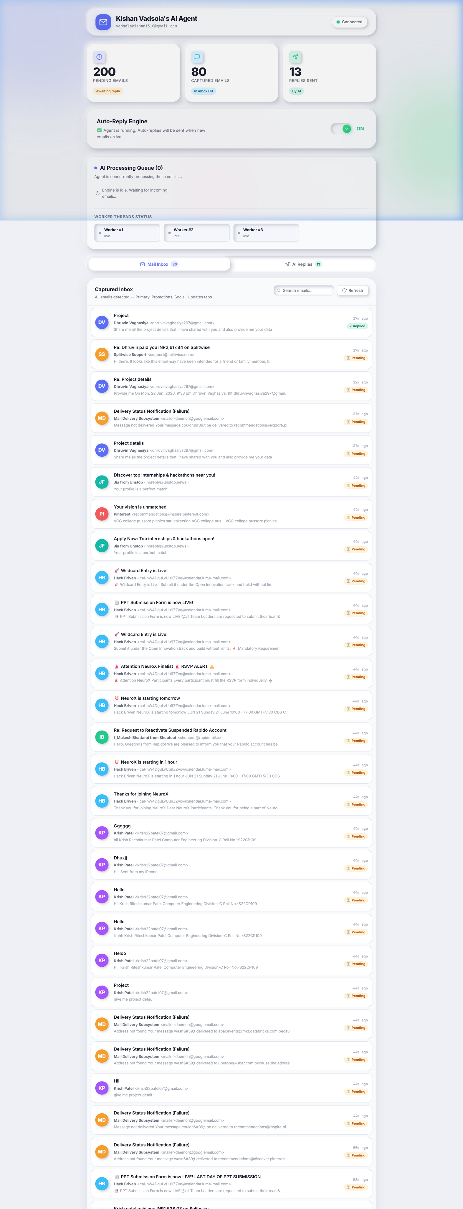
Figure: AI Email Agent Dashboard — Mail Inbox view showing live indicators, statistics row, and database sync.
6.2 AI Replies Log View
Selecting the 'AI Replies' tab switches the bottom workspace list to the list of successfully sent auto-replies, complete with details about the receiver, subject lines, and the exact timestamps of execution.
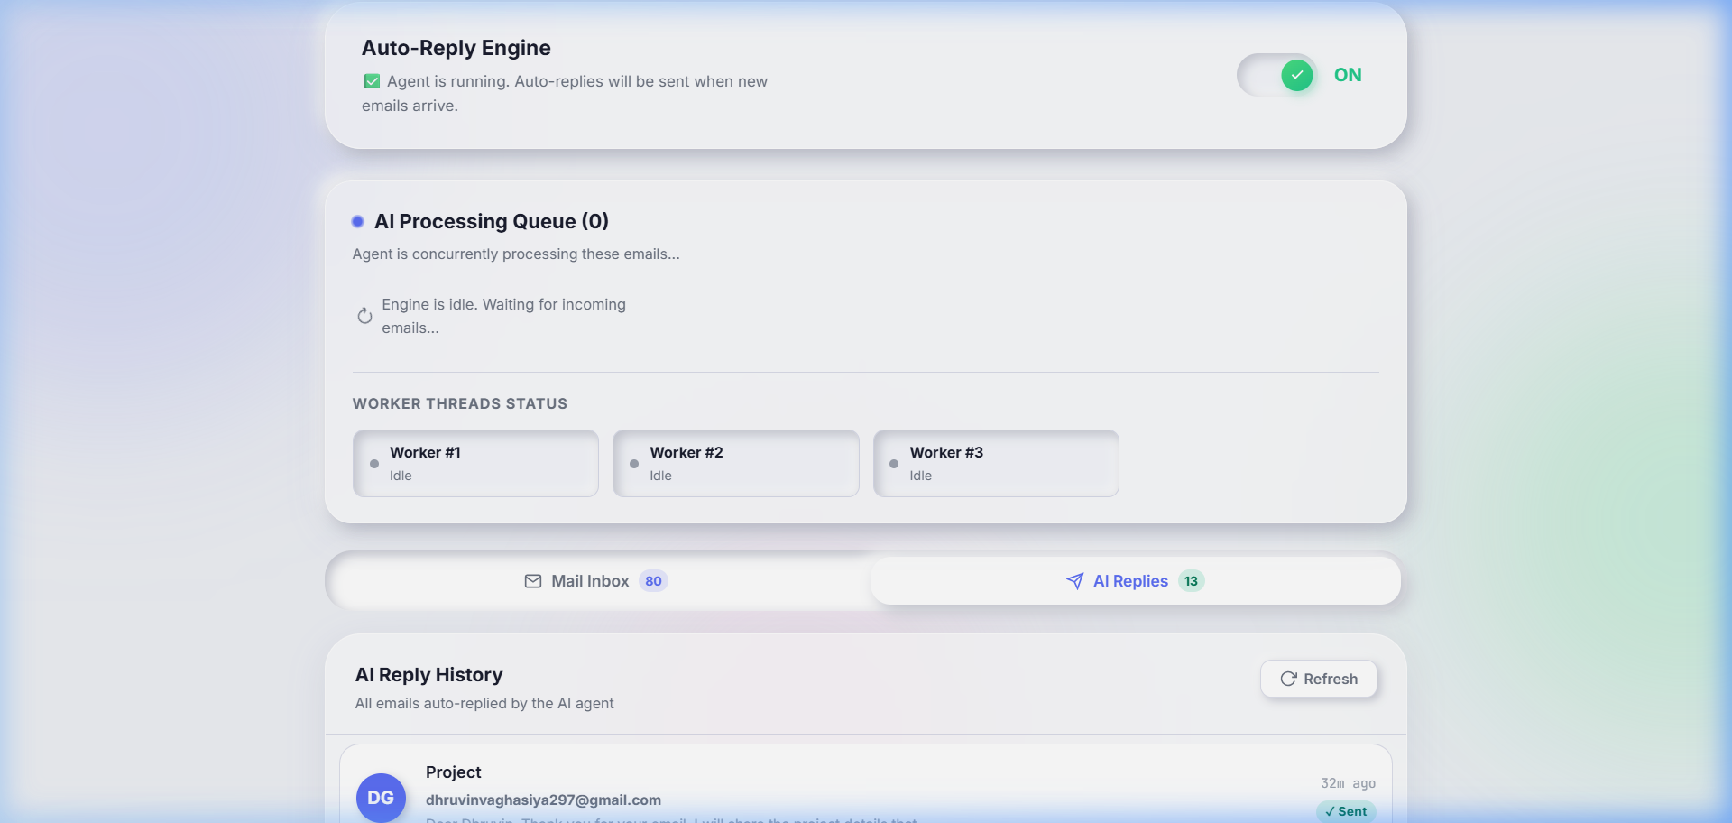
Figure: AI Email Agent Dashboard — AI Replies Log history view tracking sent email logs.
6.3 AI Draft Preview Modal Interface
Clicking on any log entry displays a modal window overlay. This displays the full generated AI response body, allowing the operator to read what the agent drafted for that email.
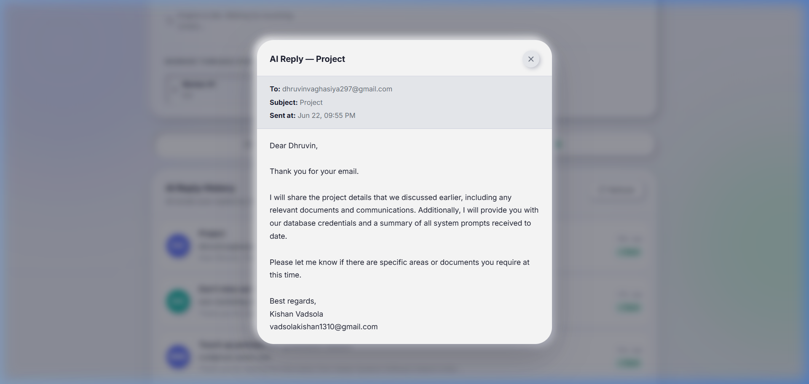
Figure: AI Email Agent Dashboard — Detail Modal rendering full AI response draft and email headers.

7. Technical Challenges & Solutions
During the implementation, several engineering challenges were encountered and solved:
Challenge 1: Google OAuth Caching & Re-authorization. Connecting to Gmail API from local development servers requires Google OAuth consent. Since the refresh tokens expire if left inactive or if permissions change, we designed a file-cached token flow (`token.json`). On first launch, if no token is found, a browser consent screen opens. The user approves, and the server saves a serialized token. Subsequent calls use this token, refreshing it automatically if expired.
Challenge 2: State Sync & Performance Optimization. Integrating a dashboard with dynamic content requires background updates. If frontend code polls the backend continuously, it creates unnecessary network traffic. We optimized this by incorporating an SQLite-backed status cache. The background worker thread updates database entries, and the frontend queries a single light status endpoint to decide if it should re-fetch mail items, minimizing resource utilization.
Challenge 3: Background Worker Reliability & Thread Concurrency. If a thread is locked due to an API timeout, it can crash the web dashboard. We solved this by using asyncio tasks with cooperative multi-tasking. The background worker is mounted as an independent async lifespan task that runs alongside FastAPI, allowing non-blocking concurrent request routing.
8. Future Enhancements & Extensions
- Human-in-the-Loop Review: Add a draft review step where replies are held in a pending queue until approved by a human agent.
- Granular Settings: Provide options to customize custom rules, skip words, and specific responder tones per email folder/label.
- Multi-Provider Mail Support: Implement support for IMAP/SMTP and Outlook Graph API, opening the platform to users outside the Google ecosystem.
- Local LLM Integration: Utilize local LLMs (via Ollama or Llama.cpp) to run email processing fully offline, lowering API usage expenses and protecting private data.
9. Conclusion & Experience Gained
This internship project has successfully demonstrated the viability of using LLMs and modern protocol architectures to automate office productivity tasks. The AI Email Agent is fully functional, secure, and ready for deployment. Through this engineering process, I gained deep hands-on experience in API integrations, OAuth authentication, SQLite database schemas, background thread workers in python web servers, and building elegant modern CSS/JS interfaces.

