**Vidyavardhini’s College of Engineering & Technology**

**Department of Information Technology**

**Academic year (2021-22)**

**NAME:** Sanskruti Rajkumar Kokare

**BRANCH:** IT

**ROLLNO:** 45

**SUBJECT:** JPL

**CLASS:** SE IT

**Experiment no:** 8

**Date of Experiment:** 12/11/2021

**Date of Submission:** 14/10/2021

**Experiment No. 8**

**Aim:**

Create a class Book and define a display method to display book information.

Inherit Reference_Book and Magazine classes from Book class and override display

method of Book class in Reference_Book and Magazine classes. Make necessary

assumptions required.

**Description:**

Inheritance in Java is a mechanism in which one object acquires all the properties and behaviors of a parent object.

The idea behind inheritance in Java is that you can create new classes that are built upon existing

classes. When you inherit from an existing class, you can reuse methods and fields of the parent class. Moreover, you can add new methods and fields in your current class also.

Subclass is a class which inherits the other class. It is also called a derived class, extended class, or

child class.

Superclass is the class from where a subclass inherits the features. It is also called a base class or a

parent class.

**ALGORITHM**

1. Start

2. Create class Book and define method display.

3. Create class Reference_Book extends Book and define method display.

4. Create class Magazine extends Book and define method display.

5. Create main class TestInheritance and create object of each class from a Book class. Call

display method of each class.

6. Stop.

**Source Code: -**

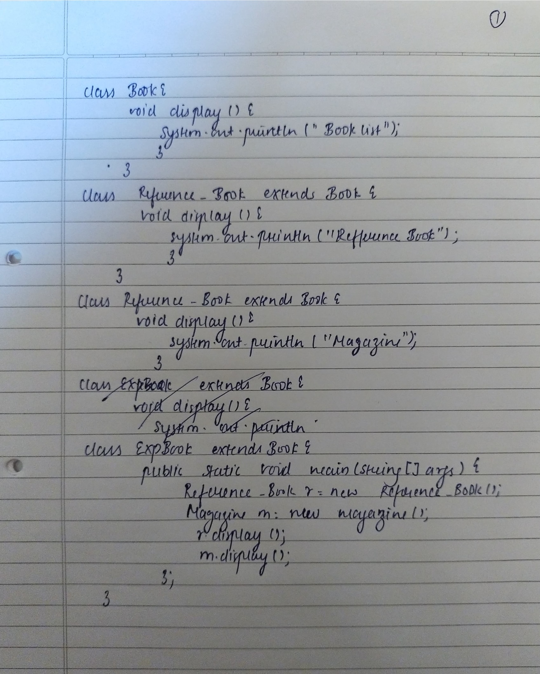

**Output: -**

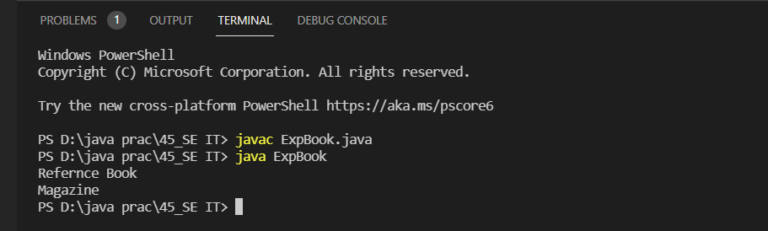

**Conclusion:**

Able to implement the inheritance in the program.